

LCS Guidance

for

C&F Assessment

Version 5

Data Security Reminder

You must only access records with which you have a legitimate professional reason to do so. If access is inadvertently made to an inappropriate record, this should be reported to your line manager.

Improper access may be subject to disciplinary action.

Contents

**Introduction 3**

**New referral received by Safeguarding Hub & transfer of assessment to**

**District Teams 4**

**Changing a case priority 6**

**Signs of Safety C & F Assessment 8**

* **A signs of Safety Plan 9**
* **Neglect Strategy 9**
* **Completing the C & F Assessment 10**

**C & F Assessment for CIN 10**

**C & F Assessment for CP 12**

**C & F Assessment for CLA 14**

**Appendix A – Workflow from Safeguarding Hub to District team 15**

**Appendix B – Triggering a full further assessment 16**

**Appendix C – Alerts for C & F Assessments 17**

**Introduction**

# Signs of Safety

Signs of Safety is the practice model in Cumbria.

On 3rd November 2022 Cumbria implemented the Signs of Safety IT Solution to our System C (Liquidlogic) Social Care Case Management system.

A user will complete the Contact and Referral & Information records when concerns about a child living in the Local Authority are received.

This process in most cases is carried out by the Safeguarding Hub as described in next chapter *(see also appendix A for transfer flow from Safeguarding Hub to District Teams)* although there are occasions where a District Team will start a Contact and Referral, for example when additional siblings in a household are identified and require assessment also.

**Useful links for Signs of Safety Practice information:-**

[Signs of Safety - Home (sharepoint.com)](https://cumbria.sharepoint.com/sites/signsofsafety)

<https://www.signsofsafety.net/what-is-sofs/>

# New Referral received by Safeguarding Hub and transfer of Assessment Decision to District Teams

Contacts received into the Safeguarding Hub will be progressed through EHM by a multi-agency team of professionals. Where threshold is met for Social Care intervention the Contact and supporting information will be transferred to LCS and progressed to Referral by the Safeguarding Hub Team as per existing processes. The referral is authorised by the Safeguarding Hub Team Manager and then assigned to the relevant Duty Manager group tray in the Social Care locality.

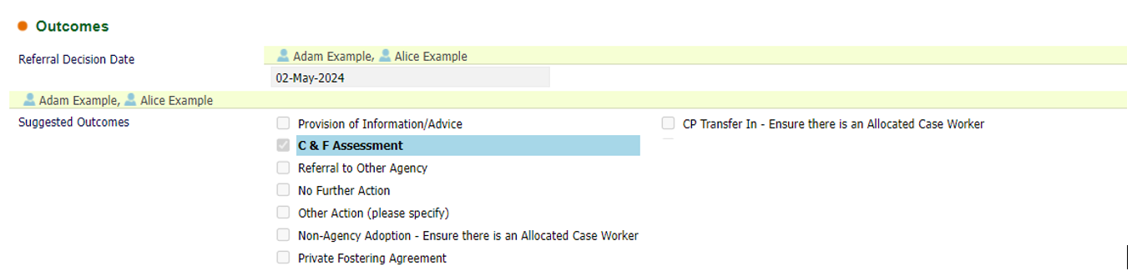

**The Social Care Duty Team Manager** will then pick up the referral from the Duty Tray to progress to C&F Assessment and allocate a Social Worker:-

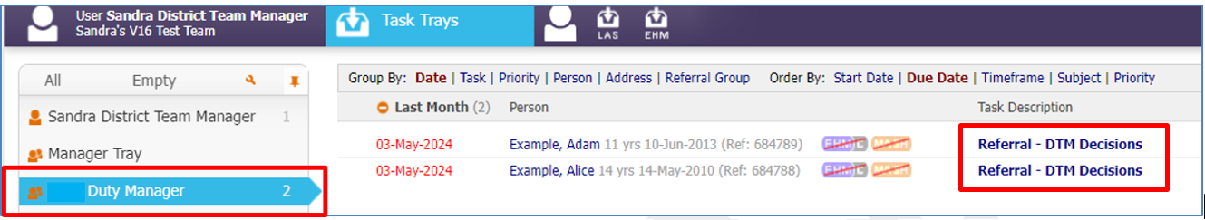

* The Team Manager reviews the forms transferred from the Safeguarding Hub MASH and any other relevant information/attachments in the record. Consider the reasons for assessment and set the appropriate timeframe from the listed priorities based on the needs of child/ren, nature and level of risk:-

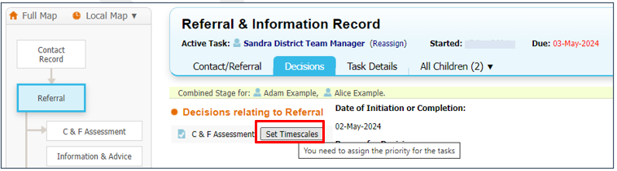

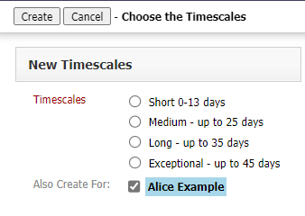

* On the next screen click ‘Assign’, then search for & select the Social Worker to create ‘Allocated Case Worker’:-

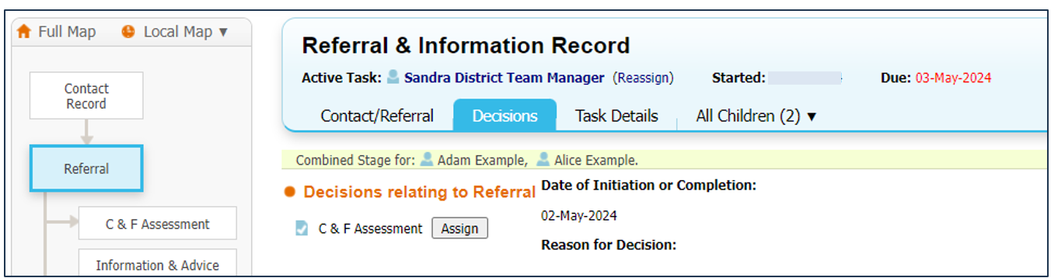

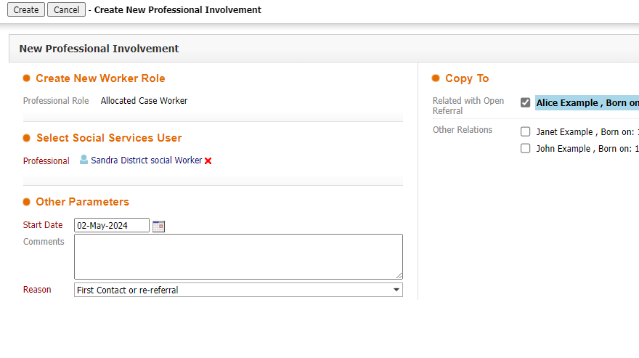

* Team Manager will then click ‘Start’ and then click ‘Confirm’ on the next pop up screen to start the C&F Assessment task:-

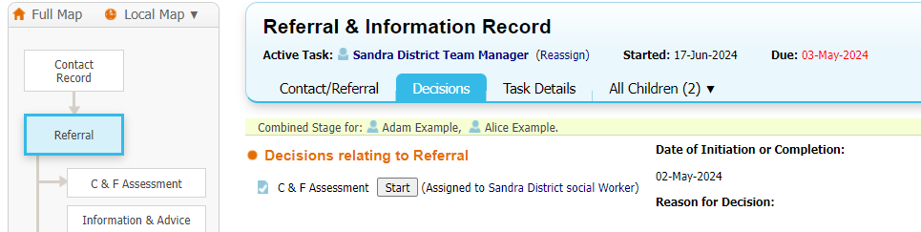

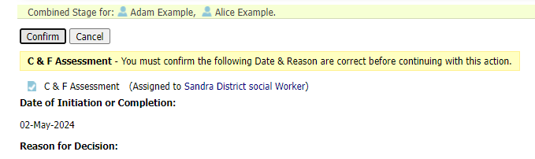

* The C&F Assessment will now show in the Social Worker worktray:-

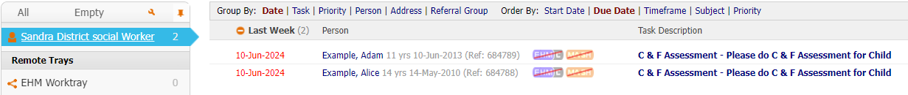

* The priority is shown in the child’s demographics within the CIN Tab :-

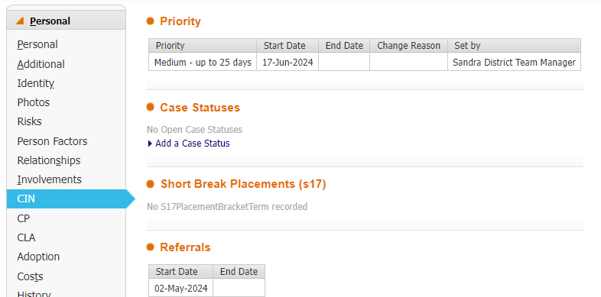

**Changing a Case Priority**

Only Manager’s and Advanced Practitioners have the profile right to change a case priority

This is changed from the CIN tab. Firstly click on the *Change Priority* link:-

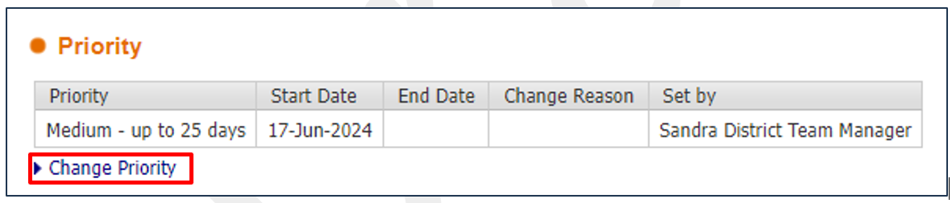

This will then bring up a screen to select the new priority and provide a reason for changing the case priority. Then click *Create*.

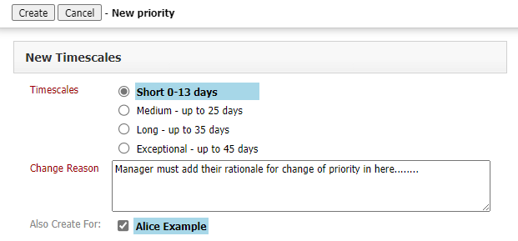

This will change the end date and start date of the new priority to ‘today’s’ date. These will appear in a list on the CIN tab.

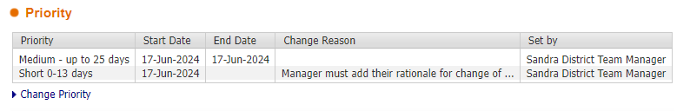

This will then automatically update any existing tasks in the workers tray with due dates set by priorities, so that we use the new timeframe.

**Signs of Safety – C & F Assessment**

The design of the C&F Assessment form allows for it to be used as a report to ICPC as well as a generic C&F Assessment.

**C&F Assessment – copy forward**

The Signs of Safety IT Solution allows for automatic ‘copy forward’ of information in previous form and in these instances when a Social Worker starts the assessment relevant previous forms will automatically be selected for copy forward. The Social Worker then has the option of ‘Copy forward selected’ or alternatively ‘Start a Blank’ if they do not want to copy forward any answers:-

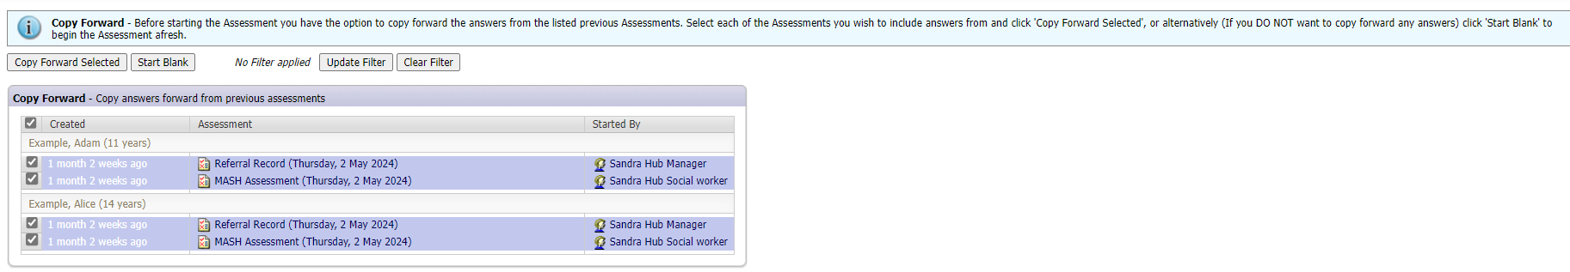

**C&F Assessment Type**

The Signs of Safety IT Solution allows the Social Worker to choose the assessment form type to be completed based on the harm to the child and likelihood of future danger. The Social Worker will have choice of 3 formats:-

* Signs of Wellbeing = CiN
* Signs of Safety = CiN/CP
* Signs of Success = CLA and Care Leavers

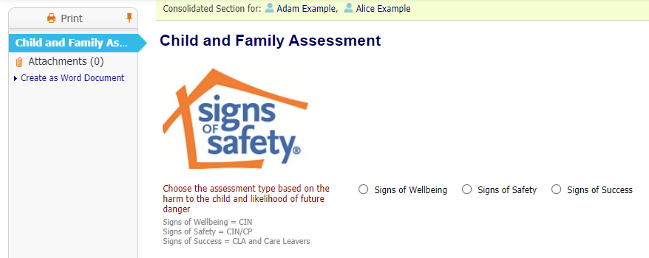

Once the relevant format has been selected this will create the appropriate sections of the assessment form for consideration:-

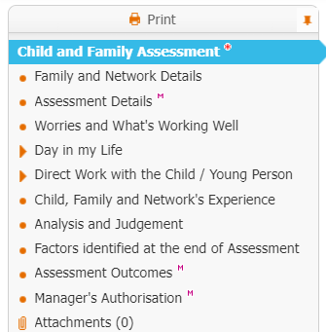

**A Child’s/Young Person’s Plan**

Working Together December 2023 states:-

*The maximum timeframe for the assessment to conclude, such that it is possible to reach a decision on next steps, should be no longer than 45 working days from the point of referral. If, in discussion with a child and their family and other practitioners, an assessment exceeds 45 working days, the lead practitioner should record the reasons for exceeding the time limit. In some cases, the needs of the child will mean that a quick assessment will be required.* ***In all cases, as practitioners identify needs during the assessment, they do not need to wait until the assessment concludes before providing support or commissioning services to support the child and their family.***

It is therefore important that a plan can be created within the C&F Assessment as soon as needs and support are identified and provided. The plan is started from the Analysis & Judgement tab and selecting ‘Yes’ to the question ‘To increase the safety or wellbeing of this child, does this child need a plan?’:-

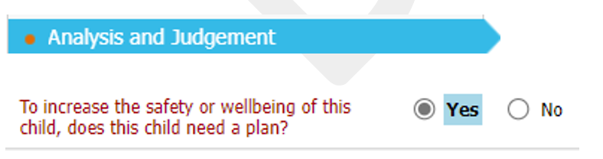

This activates the section **‘What needs to happen?** For recording the required elements of a Signs of Safety or Signs of Wellbeing plan.



Elements of the plan include:-

* Bottom Lines *(not to be confused with plan rules. Bottom lines do not need to be completed unless in CP or planning for reunification)*
* Timeline *(This is a timeline not a timetable. Worked in weeks and demonstrates how we are going to work through our safety plan)*
* Who is involved in the plan  *(network/family and other professional partners – how often they will see the child & what they are doing)*
* Plan rules *(these are the network rules – not our rules – set out who is going to do what when problems arise)*

**Neglect Strategy**

**‘Day in my Life’**

The Cumbria Neglect Strategy has been developed to set out strategic aims and objectives of Cumbria’s approach to tackling neglect. The ‘Day in my Life’ toolkit templates have been incorporated into LCS C&F Assessment and as standalone forms to assist those working with children, to reflect on whether a child is experiencing neglect and what type of neglect the child may be experiencing.

The toolkit templates within the C&F Assessment are completed within this tab:-



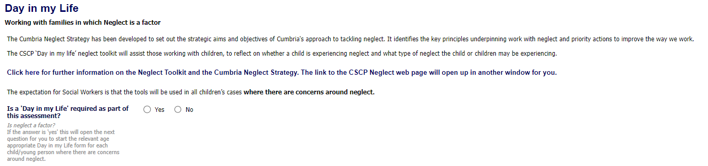

This is the link to the Cumbria Neglect Strategy:-

[Neglect : Cumbria (cumbriasafeguardingchildren.co.uk)](https://cumbriasafeguardingchildren.co.uk/professionals/neglect/default.asp?cookies=disable)

**Completing the C&F Assessment**

Once the assessment is complete, select the appropriate outcome for next course of action from the Assessment Outcomes tab, then click ‘Finalise Assessment’ for the assessment to go to Team Manager for authorisation:-

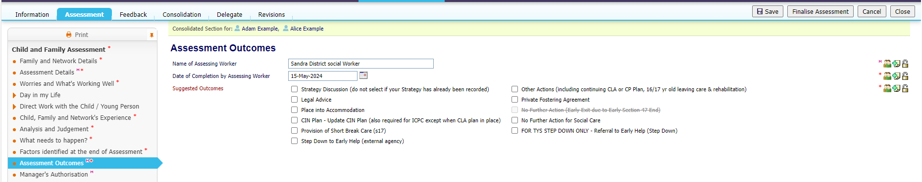

Team Manager will then Authorise the C&F Assessment which will trigger the following tasks depending on the outcome selected.

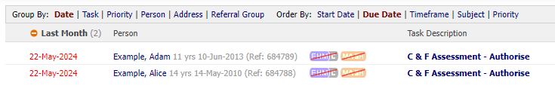

**C&F Assessment & Child in Need**

**CIN Active Child’s Plan**

As per existing processes, if Child’s Plan is selected as an outcome, once the assessment and update plan is authorised the Allocated Worker will have an Active Child’s Plan in their worktray, from which the CIN Review is automatically started, and other options can be started from the decisions tab:-

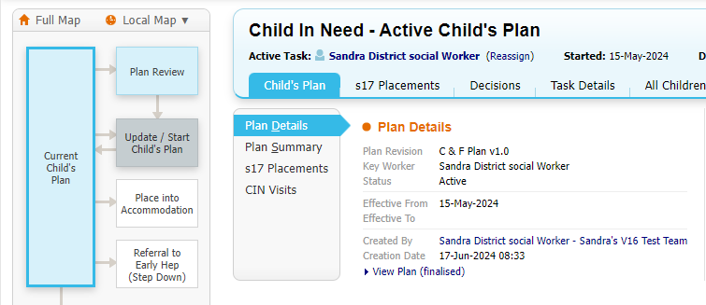

**CIN Review**

It is important that the CIN Review meeting is scheduled as per current CIN practice guidance. Update the meeeting details and scheduling to set the first planned meeting date. (Refer to CIN Guidance for further details of review process recording):-

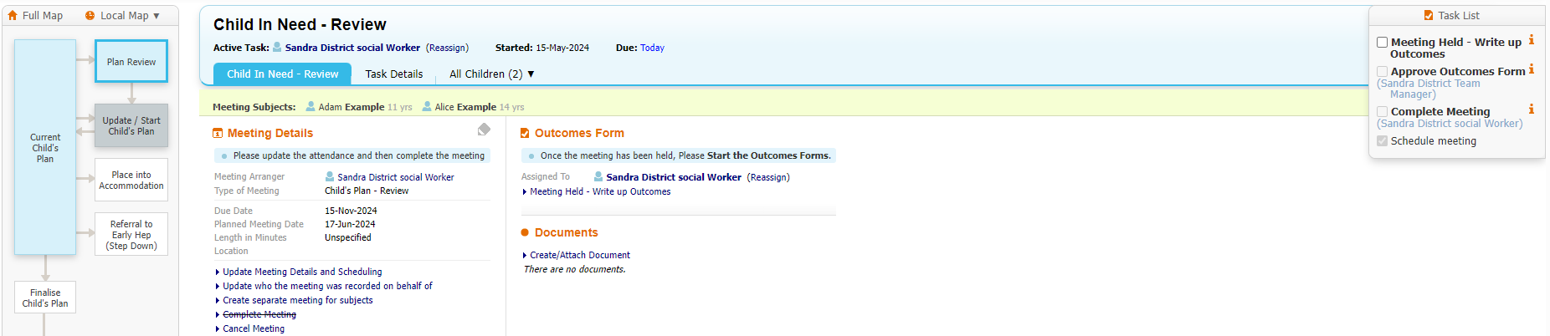

**S17 Short Breaks**

From the Active CIN Plan s17 Short Breaks can also be recorded (see s17SB Guidance for full details):-

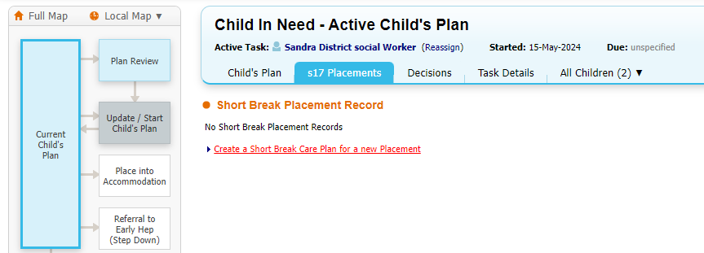

**C & F Assessment for CP**

**Immediate Action**

In circumstance when immediate action is required a Strategy Discussion task can also be started by clicking into the full pathway and selecting ‘Strategy Discussion:-

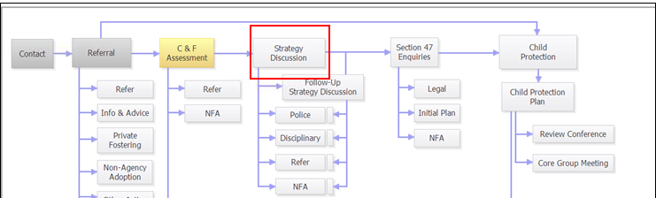

And start the task from the next box presented:-

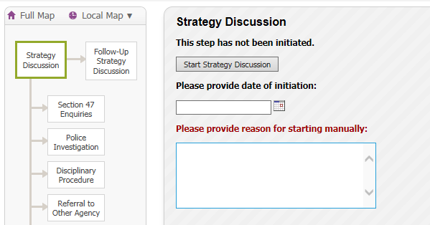

**Strategy Discussion**

The Strategy Discussion is completed as existing procedures

**S47 Enquiries**

Where the outcome of the Strategy Discussion is S47/C&F Assessment, the system will trigger the S47 task to the Allocated Worker. No additional C&F Assessment task is triggered when there is still a C&F Assessment task in progress. If no C&F Assessment in progress system will automatically trigger a new one:-

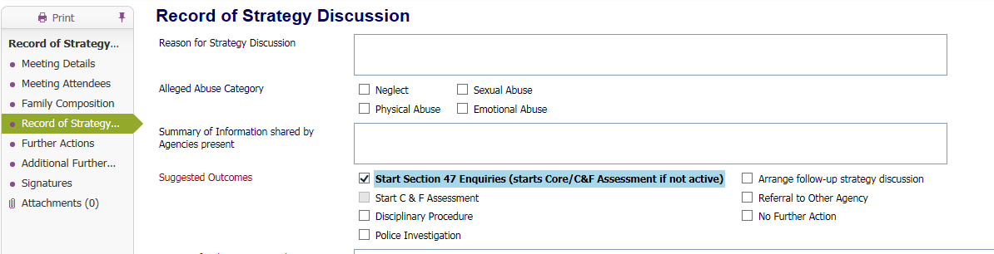

The timescale for S47 Enquires to be completed is 10 working days.

Where the decision is made to progress to ICPC, the Allocated Worker continue’s recording the C&F Assessment as their report to ICPC. This must be authroised and ready to share with family and conferenc attendees 2 days prior to the ICPC.

**CP concerns on Open CIN Case**

Where Child Protection concerns are identified on an open case and a strategy discussion is required, follow existing recording procedures and set short priority:-

* From full pathway map ‘Start Strategy Discussion’
* Where the outcome of the Strategy Discussion is ‘S47/C&F Assessment’, this will trigger 2 tasks to the Allocated Worker – S47 and C&F Assessment.
* From CIN tab of child’s file, Manager to change case priority to ‘Short – up to 13 days’ to re-set the Assessment timescale
* Complete S47 enquiries within 10 days
* If outcome of S47 is ICPC, then complete the C&F assessment as report for ICPC and ensure that the SoS Plan (‘What Needs to Happen’) is updated within the Assessment. In this case where there is already an active CIN plan select ‘Other Actions’ as your outcome of the assessment.

**C & F Assessment for CLA**

Where a child becomes looked after, the C&F Assessment will be the baseline for work with the family while the child is away. The Council must assess the child’s needs to draw up the careplan which sets out the services which will be provided to meet the child’s identified needs.

Additionally, an assessment by a Social worker is required before the child returns home under the Care Planning regulations 2010. This will provide evidence of whether the necessary changes and improvements have been made to ensure the child’s safety when they return home.

To trigger a new assessment at any time that it is required click into the full pathway, and click into C&F Assessment box:-

## 

## Then on the next screen select the ‘Re-start’ tab and enter start date of assessment and then click Start C&F Assessment:-

## 

Then the Manager will be required to set the appropriate priority/timeframe for this assessment (see Changing Case Priority above).

**Appendix A**

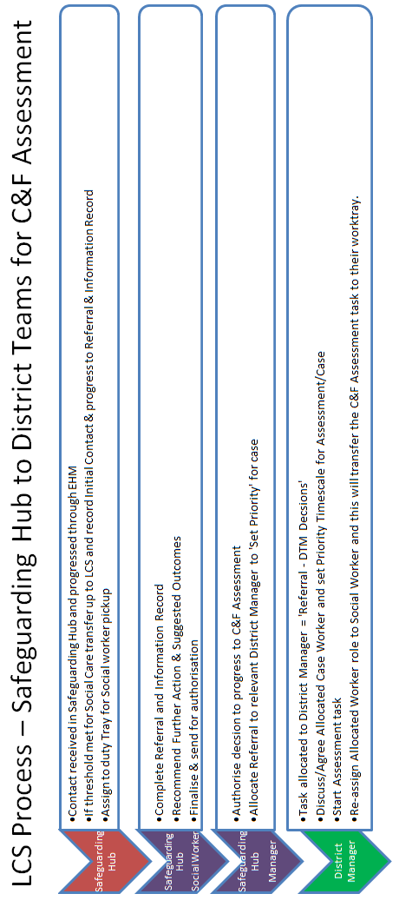

**Appendix B**

**Triggering a further full C&F Assessment**

|  |
| --- |
| **CiN**  Triggers when a full child and family assessment must be completed - minimum standards  Within a 12 month period a C&F Assessment must be updated. Management oversight case note or Supervision Record to be made within 5 working days.  S47 automatically starts a new C&F Assessment if one not already in progress – this must be completed as part of the S47 and should not be cancelled if case does not progress to ICPC. The assessment completed should be proportionate to the child’s needs and circumstances. This can be a brief assessment but must be fully completed. |
| **CP** triggers when a full child and family assessment must be completed – minimum standards  S47 on open CP would automatically start a new C&F Assessment; this must be completed as part of the S47 and should not be cancelled. The assessment completed should be proportionate to the child’s needs and circumstances. This can be a brief assessment but must be fully completed.  A full C&F Assessment **must** be completed following a CP Transfer In Conference. |
| CLA triggers when a full child and family assessment must be completed – minimum standards  When a child becomes looked after – these must be an up to date assessment completed within the previous 3 months.  When a child’s care plan is to return home to parents then a C&F Assessment must be completed prior to the child going home, this is endorsed by service manager  When a child is leaving care and is 16/17, decision is made by Director Children’s Social Care prior to the young person leaving care. |

**Additional Trigger prompts for Management Oversight to show rationale that the change in circumstances have been risk assessed & a decision taken whether a full C&F Assessment is needed or not and identify where the assessment will be found:-**

* As part of the QA of CP Plans the Service Manager and Senior Manager will review the quality of the assessment within the RCPC documentation within agreed intervals
* Another adult living in the household with the child or an adult leaving the household.
* Additional children living or leaving the household
* CLA cases – another sibling born
* CLA cases – 3 placement moves
* Stage 2 Missing From Home – Management decision between Service Manager and Team Manager e.g. trigger full C&F Assessment or bring forward review.
* Preceding an application for an Education Supervision Order if there is not an up to date C&F assessment completed in the last 3 months.
* Preceding an application to Adoption Support Fund for a child subject to an SGO if there is not an up to date C&F assessment completed in the last 3 months

**Appendix C**

**Alerts**

The following alerts are configured within LCS to support teams in timely management of completion of their assessments :-

