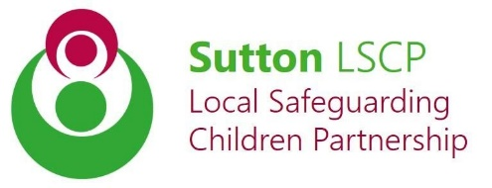
Multi-agency Early Help Assessment Closure & Outcomes Tool (EHAT-C)
If you have any queries regarding an EHAT please contact CFCS@sutton.gov.uk or 020 8770 6001. If you have urgent safeguarding concerns, first discuss them with the Multi Agency Safeguarding Hub (MASH) Team on 020 8770 6001.

Guidance Notes can be accessed via: www.sutton.gov.uk/earlyhelp

Child’s Name:

Address:

Date of Birth/EDD
(DD/MM/YYYY):

Date EHAT-C Form completed:
Name:
Job Title:

Agency:

Telephone Number/ Email Address:

Person completing this Form: Child’s Details:

Reason for EHAT Closure: | Please confirm reason
The family’s situation has improved and the desired outcomes in the action plan have been achieved | ☐
Consent has been withdrawn by young person or parent | ☐
The young person or parent failed to engage with services once the EHAT was completed | ☐
Agency are no longer the lead professional or no longer working with the family due to them leaving the service. | ☐
The family have moved out of the London Borough of Sutton | ☐
The child / young person have been “stepped up” to Children’s Services. | ☐
No appropriate services available to meet the child / young person or family’s needs | ☐
Other reason (please list): | ☐

Outcomes from the EHAT
What were the known issues within the family & the outcomes after EHAT?
Choose a known issue | Choose a known issue | Choose a known issue | Choose a known issue | Choose a known issue
No change | No change | No change | Choose an outcome | Choose an outcome
Professional Relationships / Agencies Involved:
 | Status of involvement
Name of Service / Agency | Engaging with Service | Engaged & outcome achieved. Now closed | Referral made & on waiting list | Referral made status unknown | Referral made, but family failed to engage | Comments ( where required)
 | ☐ | ☐ | ☐ | ☐ | ☐
 | ☐ | ☐ | ☐ | ☐ | ☐
 | ☐ | ☐ | ☐ | ☐ | ☐

As a result of the EHAT being completed was a TAC / TAF meeting held? | ☐ Yes ☒ No

Professionals Comments on EHAT Outcomes (where appropriate)

Parents and /or Young Persons comment on Early Help Support (where appropriate)

THIS EARLY HELP ASSESSMENT IS FORMALLY CLOSED ON:

Submitting your EHAT-C Closure and Outcomes: Please send your completed form to CFCS@sutton.gov.uk.

