

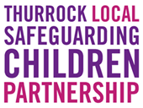


Management of Suspicious, Unexplained Injuries or Bruising in Children for all Frontline Practitioners

Date of document: | June 2025
Date of previous publication: | May 2022
Author: | SET Procedures Working Group

Contents
1. Introduction 4
1.1 Purpose of the guidance 4
1.2 Who this guidance is for 4
2. Non-accidental injuries and bruising 4
3. Underpinning research on bruising 5
3.1 Can a bruise be accurately aged? 6
3.2 Where there is plausible and valid explanation 6
4. Non-accidental injuries and bruising in non-mobile infants and non-independently mobile children 6
4.1 Unexplained or suspicious injuries in non-mobile and non-independently mobile children 6
4.2 Other harms 7
4.3 Making enquiries 7
4.4 Birth marks 8
4.5 Recognising bruising and injuries in diverse skin tones 8
4.5 Actions required when a suspicious injury is identified 8
4.6 Request support from Children’s Social Care 9
5. Injury, bruise, suspicious mark, unexplained pain or reduced movement of limb in mobile children 9
5.1 Actions required when a suspicious injury is identified for a child 10
6. Flowchart for unusual injury, bruise, suspicious mark, unexplained pain or reduced movement of limb 11
6.1 Children’s Social Care Referrals 12
6.2 Police – for all referrals 12
7. Wider considerations 13
7.1 Informing parents 13
7.2 Educational setting 13
7.3 Children with disabilities 13
7.4 Diversity factors 14
8. Escalation process 14
Appendix 1: Body Map 16
Appendix 2: Contacts 17
Appendix 3: The growing child 18
References 20

Introduction

1.1 Purpose of the guidance

This guidance provides an overview of suspicious and unexplained injuries in children and outlines the pathways practitioners and individual agencies are expected to follow when concerns are identified. The guidance should be read in conjunction with the Southend, Essex, and Thurrock (SET) Safeguarding and Child Protection Procedures.

Who this guidance is for

This guidance applies to all those who may come into contact with children in their everyday duties and the actions they are expected to initiate in accordance with their responsibilities, as outlined within Working Together to Safeguard Children 2023.

Throughout this document, the term child is used to refer to children and young people who are under 18. It is important to note that special consideration will be non-mobile children (under 1) and children who are unable to mobilise due to health needs or disability.

Non-accidental injuries and bruising

Bruising is the most common injury to a child who has been physically abused. It is therefore vital to differentiate accidental from non-accidental bruises and other suspicious injuries, and to avoid common assumptions about such injuries which cannot be substantiated. The possibility of child maltreatment or neglect should always be considered until there is sufficient evidence to prove otherwise.

Non-accidental injuries are injuries that are suspected or proven to have been inflicted upon a child by someone else, or in the care of someone else. Any bruising, fractures, bleeding, and any other injuries (such as burns) should be treated as a matter for enquiry and potential abuse considered, unless a consistent plausible explanation is provided, and relevant history has been considered.

Bruising, though the most common presenting feature of physical abuse in children, may also be as the result of the child experiencing other forms of abuse such as neglect or sexual abuse.

Child Safeguarding Practice Reviews nationally and locally across Southend, Essex, and Thurrock (SET) highlight how practitioners underestimate the prediction that abuse is a likely cause of bruising, particularly in young babies. Practitioners should remain curious.

The Child Safeguarding Practice Review National Panel reviews cases where children have died or been seriously harmed, and abuse or neglect is known or suspected. A large proportion of the serious incidents notified to the Panel are about young infants. For example, 36% of serious incident notifications in 2024 were about children less than a year old. In the rapid reviews and local child safeguarding practice reviews (LCSPRs) submitted to the Panel, there are often cases where young infants have previously presented with apparently minor injuries – with visible minor bruising – and a failure to follow established guidance, or inconsistencies within such guidance, have been highlighted as potential contributory factors to a subsequent serious incident or, ultimately, the child’s death.

Bruising in non-mobile infants (publishing.service.gov.uk)

NICE guidance (2009, updated 2017) states that bruising in any child who is non-mobile should prompt suspicion of maltreatment as these children are the least likely to sustain accidental bruises.

If at any time you are unsure what action to take, then consult your line manager or designated safeguarding lead.

Underpinning research on bruising
Key findings from two Royal College of Paediatrics and Child Health (RCPCH, 2020a; RCPCH, 2020b) systematic reviews evidence that:

- Bruising was the most common injury in children who have been abused and a common injury in non-abused children, the exception to this being in pre-mobile infants where accidental bruising is rare (<1%).
- Bruising can be viewed as a common presentation in children; however, this should trigger professional curiosity to exclude more severe underlying injuries.
- This highlights the importance of recognition of abnormal patterns of bruising in young infants, enabling detection as early as possible and potentially preventing escalation of abuse with avoidance of serious injury or death.
- In a study of 77 infants with abusive fractures, 32% had missed opportunities for the diagnosis of child abuse. The most common sign on examination was bruising or swelling.
- In another study of 146 infants less than six months of age presenting to child abuse physicians with an isolated bruise, 23.3% had skull fractures identified on skeletal survey.
- Absence of abdominal bruising does not rule out a significant abdominal injury just as the absence of bruising does not preclude Abusive Head Trauma (AHT) (RCPCH, 2019).

A bruise must never be interpreted in isolation. It must always be assessed in the context of medical and social history, developmental stage, explanation given, full clinical examination and relevant investigations. If at any point you are unsure on the action to take consult your line manager or designated safeguarding lead.

Characteristics of bruising that are suggestive of physical abuse:

- Bruising in children who are not independently mobile.
- Bruises that are seen away from bony prominences (i.e., areas of bone that are close to the skin surface).
- Bruises to the face, abdomen, arms, buttocks, genitalia, ears, neck, and hands.
- Multiple bruises in clusters.
- Multiple bruises of uniform shape.
- Bruises that carry the imprint of an implement used and/or a ligature.
- Bruises that are accompanied by petechiae (tiny dots of blood under the skin), in the absence of underlying bleeding disorders.
- Petechiae (tiny dots of blood under the skin), in the absence of bruising may occur as a consequence of suffocation.
- Petechiae (tiny dots of blood under the skin), that are located on the skin of the face and throat, the upper chest, the shoulders and inside the mouth.

Can a bruise be accurately aged?
- The scientific evidence concludes that a bruise cannot be accurately aged from clinical assessment or from a photograph.
- Any clinician who offers a definitive estimate of the age of a bruise in a child by assessment with the naked eye is doing so without adequate published evidence.

3.2 Where there is plausible and valid explanation
If there is agreement that the history given is consistent with the bruise/mark/injury observed, the child’s developmental age, and mobility, ensure you:

- Review all previous records for any similar history or risk factors.
- Document all observations and what has been reported by the child and parent/carer/s within child’s records.
- Document clearly bruising/marks observed on a body map (appendix 1) and record in the child’s record.
- Consider safety assessment and advice to prevent further incident/s.
- If there are safeguarding concerns, obtain consent to share relevant information with Health Visiting/School Nursing Service, GP or any other relevant agency. If consent is not given consult your safeguarding lead.

Children become mobile over a period of time (see guidance in appendix 3).

Non-accidental injuries and bruising in non-mobile infants and non-independently mobile children
A child who is not independently mobile is a child who is unable to move independently through crawling, cruising or bottom shuffling. Particular attention should be given to the risks in those children who are unable to rollover.

4.1 Unexplained or suspicious injuries in non-mobile and non-independently mobile children
Any injuries are unusual in this group, (accidental bruises in non-mobile babies <1%) and therefore a review by a health professional who has the appropriate expertise to assess the nature and presentation of the suspicious injury is required. This will provide an assessment of the circumstances of the presentation including the developmental stage of the child, whether there is any evidence of a medical condition that could have caused or contributed to the suspicious injury, or a plausible explanation. Even small injuries may be significant, and they may be a sign that another hidden injury is already present.

Such injuries include:
- Small single bruises e.g. on face, cheeks, ears, chest, arms or legs, hands or feet or trunk.
- Bruised lip or torn frenulum (small area of skin between the inside of the upper and lower lip and gum).
- Lacerations, abrasions, scratches, or scars.
- Burns and scalds.
- Pain, tenderness or failing to use an arm or leg which may indicate an underlying fracture.
- Small bleeds into the whites of the eyes or other eye injuries.

4.2 Other harms

Occasionally a child can be harmed in other ways, for example:

- Deliberate poisoning.
- Suffocation which can present as collapse, absence of breathing (apnoeic attack), bleeding from the mouth and nose.
- Accidental ingestion of prescribed medication or illicit drugs.

4.3 Making enquiries

If there is a suspicion of a non-accidental injury or bruising, enquiries should be made about the following at the earliest opportunity and recorded:

- Nature and site of injury.
- History provided by accompanying adult.
- History provided by child if able.
- Plausibility of the explanation given.
- Curiosity regarding any other care givers as well as the primary carer.
- Timing of the alleged injury and any delay in seeking medical attention for which there is no satisfactory explanation.
- Child’s appearance, behaviour, and demeanour.
- Child’s development.
- Interaction between parent/s, carer/s, and child.
- Family and social circumstances and other relevant information available on the child’s records.

An explanation for an injury or presentation must be questioned if implausible, inadequate, or inconsistent:

- With the child’s presentation, normal activities, existing medical condition, age, or developmental stage, when compared to the account given by parent/carer/s.
- Between parent/s or carer/s.
- Accounts differing in detail over time.
- If no explanation can be given by the parent or carer.
- Cultural practice should never be used as a justification for injuries or their presentation.

If you are unsure on what action to take, consult your line manager or designated safeguarding lead.

Birth marks

Congenital dermal melanocytosis (flat blue-grey skin marking) and strawberry marks or haemangioma are present at birth or appear in the first few days of life and can be seen anywhere on the body. These should be recorded in the child’s health records, parental held child’s health record (‘red book’) and body map.

If a practitioner is unsure regarding whether a mark is a birthmark, then the child should be reviewed by an appropriate health professional to confirm this within the next working day. (See section 7.4 Diversity factors.)

4.5 Recognising bruising and injuries in diverse skin tones

Practitioners should approach assessments with cultural awareness. It can be harder to detect bruising on darker skin, and we need to be mindful of birthmarks which could resemble bruising however, staff should also look out for tenderness or minor swelling over the injured area.

For further information on recognising bruising and injuries in diverse skin tones see Mind the Gap.

4.5 Actions required when a suspicious injury is identified

Life threatening emergency medical condition or injury
Any child with suspicious bruises or marks and is seriously ill or injured, or in need of urgent treatment should be immediately referred to hospital.

Do not delay call 999 request an emergency ambulance and consider requesting police attendance if appropriate

Unexplained pain or reduced movement
Any child with unexplained pain or reduced movement should be taken to A&E and the acute safeguarding process followed at hospital.

Non-life-threatening condition or injury for non-mobile infant / non-independently mobile child

It is the responsibility of the practitioner who identifies the suspicious mark/injury on the child to:

- Contact their safeguarding lead to discuss and agree actions to be taken.
- Where possible discuss with a health professionals to exclude no medical conditions or birthmarks.
- Must have a consultation with Children Social Care and consider contacting the Paediatrician at the nearest Emergency Department to inform of the concerns and arrange for attendance.
- Transportation available for the transfer of the child to hospital:
  - consider transfer by ambulance in all situations.
  - are parent/carer/s able to take their child to hospital unaccompanied by a practitioner – is this a safe option?

It is the responsibility of the referring and receiving practitioners to agree arrangements confirming the following:

- Referral to Children’s Social Care has been completed by the person who identified the concerns (see appendix 2).
- If the child is not taken by parent/s or carer/s to Emergency Department: immediate escalation to Children’s Social Care and Police.
- Practitioners to be transparent with parents/carer/s explaining reasons for referral to Children’s Social Care and for a medical assessment.

4.6 Request support from Children’s Social Care

For non-health professionals in non-mobile infants and non-independently mobile children the presence of any bruising of any size and in any site requires consultation and referral to Children’s Social Care and consideration may be given to contacting the Police.

For health professionals in all non-mobile infants and non-independently a second opinion from an experienced health professional must be sought.
Once a full clinical assessment (as outlined above) has taken place and possibilities such as birth marks ruled out a referral to Children’s Social Care should be made.

If experienced clinical health professional agrees there are no concerns this needs to be included in the record with the clinical health professional’s name. If there is any doubts, this should be treated as a suspicious injury and referral to Children Social Care and further assessment required.

5. Injury, bruise, suspicious mark, unexplained pain or reduced movement of limb in mobile children

- Bruising appropriate to learning to walk is common when most children have started ‘cruising’. It is typically distributed on the front of legs/below knee and the knee, followed by the upper legs and forehead.
- A pattern of bruising may indicate physical abuse has taken place; clusters of bruises are a common feature in abused children.
- Bruises don’t often occur on soft parts of the body such as the abdomen, back and buttocks. This pattern is suggestive of abuse.
- The head is the most common site of bruising found in child abuse, other common sites include the ear and the neck.
- As a result of defending themselves, abused children may have bruising on the forearm, upper arm, back of the leg, hands, or feet.
- Bruises can often carry the imprint of the implement used or the hand.
- Non-accidental head injury or fractures can occur without bruising.
- Severe bruising to the scalp, with swelling around the eyes and no skull fracture may occur if the child has been “scalped” – i.e. had their hair pulled violently.
- Genital bruising could indicate child sexual abuse. (NSPCC, 2021)

5.1 Actions required when a suspicious injury is identified for a child

Life threatening emergency medical condition or injury
Any child with suspicious bruises or marks and is seriously ill or injured, or in need of urgent treatment should be immediately referred to hospital.

Do not delay call 999 request an emergency ambulance and consider requesting police attendance if appropriate

Non-life-threatening condition or injury:
If urgent safeguarding concern contact their safeguarding lead to discuss and agree actions to be taken.

Request support from Children’s Social Care:

- The presence of suspicious marks or bruising without a clear and consistent explanation or, a disclosure made by child/ren, requires an immediate referral to Children’s Social Care.
- Practitioners should ensure that they have sufficient information to assist Children’s Social Care in responding to their concerns including any other relevant background information that is known to referring agency.
It is good practice to inform the parent/s or carer/s that a referral will be made to Children’s Social Care, unless this places the child/ren at greater risk.

6. Flowchart for unusual injury, bruise, suspicious mark, unexplained pain or reduced movement of limb
Practitioner observes an unusual injury, bruise, mark or unexplained pain or reduced movement of limb. Consider safeguarding processes as per SET Safeguarding and Child Protection Procedures.

If the infant/child is seriously ill and requires emergency treatment call 999 and request ambulance and police attendance if appropriate. Call Children Social Care.
If unexplained pain or reduced movement child should be taken to A&E and acute safeguarding process at hospital followed. If you have concerns child may not be taken follow organisational policy.
For bruising if child is well, seek an explanation and record accurately. This should include family history, details of parents/carers and siblings, any disclosure and other relevant information from child.

Speak to Safeguarding lead within organisation. If unsure contact the Children & Families hub (Essex)/ Multi-Agency Safeguarding Hub (Thurrock) or Children Single Point of Contact (Southend).

Do you have access to a health professional who can review with the appropriate expertise to assess the nature and presentation of the suspicious injury, and to appraise the circumstances of the presentation including the developmental stage of the child.

YES
Is there any evidence of a medical condition that could have caused or contributed to the bruising, or a plausible explanation.
NO

YES
Bruising/mark/injury is explained and there are no further safeguarding concerns.

Record information including practitioner that has made this decision and feedback to parents/carers.

Explain to parents/carers the reason for an immediate request for support to Children Social Care. If child is at risk of immediate significant harm consider calling the priority or consultation line (page14).

Likelihood of Non-Accidental Injury
Strategy meeting to consider any other information on the child and family and any known risks, and to jointly decide whether any further assessment, investigation or action is needed to support the family or protect the child.

No significant safeguarding concerns identified.
Consider Early Help offer.
Section 47 investigation commenced.
Child Protection Medical requested
Child and Family Assessment

See Appendix 2 for Paediatrician hospital contact details.

6.1 Children’s Social Care Referrals

Children’s Social Care will consider any referral made under this protocol in line with normal safeguarding practice.

For non-mobile children with suspicious injury or bruising a strategy meeting will be convened to determine whether there is a risk of significant harm to the child.

For mobile children, social care will:

- Consider holding a Strategy Meeting if the threshold for significant harm is met.
- Consider whether to undertake a Child Protection Medical.

Child protection medical to be undertaken as soon as possible. Consideration should also be given to child protection medicals for any siblings/children.

Child Protection Medical not required: Social Worker should consider the medical needs of the child, following discussion with relevant health practitioners, and ascertain whether a medical assessment is still required.

Delayed Child Protection Medical (for any reason), bruising /mark is no longer visible, a Paediatrician to examine the child/ren to assess general health, signs of other injuries or maltreatment and to exclude any medical cause. Outcomes to be shared with Social Worker.

When sexual abuse is suspected professionals should follow the Sexual Assault Referral Centre (SARC) pathway. Any professional can refer children over the age of 13, with their consent. Children under 13 will need to be referred via the Police and/or Social Care.
Link to SARC pathway https://oakwoodplace.org.uk/

6.2 Police – for all referrals

The Police on receipt of a referral made under this protocol will consider:

- Conducting a review to consider the need for any immediate safeguarding measures to be implemented in order to safeguard the child involved.
- Undertaking further multi-agency investigation including:
  - Notify partner organisations of the referral and the requirement for strategy meeting to be convened.
  - Police will attend strategy meeting with any relevant information that they hold.
  - Undertake such actions to ensure the safety of all identified child/ren and if deemed appropriate secure and preserve evidence in accordance with legislation and best practice.

7. Wider considerations

7.1 Informing parents

Parent/s and carer/s to be informed at an early stage of:

- The nature of the concern.
- Progress of decision-making process and reasons for this - unless to do so will further jeopardise information gathering or pose further risk to the child.
- This process is to be carried out sensitively and in a private place to avoid further distress to parent/s or carer/s.
- In communicating with the infant/child, parent/s, or carer/s, consideration should be given to any learning difficulty / disability, language barriers (including the need for an independent interpreter) or lack of awareness/knowledge of UK legislation.
- Consideration being given to who is within the family network.

7.2 Educational setting

If an education setting observes a child/ren with suspicious marks or bruises or a child discloses physical abuse, the education setting should enquire with the child how it happened and then contact the appropriate local authority:

- Essex County Council Children & Families Hub by calling 0345 603 7627 and asking for the consultation line.
- Southend Children’s Single Point of Contact (C-SPOC) consultation line on 01702 215 007.
- Thurrock Multi-Agency Safeguarding Hub (MASH) on 01375 652 802 out of hours 01375 372 468.

The Essex County Council Children & Families Hub or Southend Single Point of Contact or Thurrock Multi-Agency Safeguarding Hub (MASH) will then advise on how to proceed, whether the concerns reach the threshold for a request for support to be submitted and whether to speak with the parents/carer/s prior to taking any further action.

7.3 Children with disabilities

Children with disabilities are at increased risk of suffering maltreatment therefore practitioners should ensure:

- Effective communication – awareness of need to identify assistance that is required to support the child (e.g., Makaton, British sign language, braille).
- Inability to speak, read or write English – practitioners to seek assistance of independent interpreter.
- Disability should not hinder the assessment of suspicious marks or bruises on child.
- Health practitioners should contact the learning disabilities nurse /safeguarding team if further advice or support is required.
- The nature of the presentation of certain disabilities may lead to injuries sustained. It is important therefore to consider whether these are appropriately addressed or whether there is a pattern of repeated injuries that may be considered neglectful/abusive.
- Consideration is given to prescribed/used equipment and the impact of this if ill-fitting and/or misused – practitioners should consult with appropriate therapists for guidance.
- Manual handling is carried out appropriately; incorrect handling can result in injury – practitioners should consult with therapists for guidance.
- The environment in which the child is residing in, or attending, is accessible without hazard or barriers which could result in injury.

7.4 Diversity factors

- Consideration should be given to the cultural needs of child, young people, parent/s, family, and carer/s. However, cultural practices that are abusive are not acceptable reasons for child maltreatment.
- The assessment should consider the child’s skin colour and how this may influence the clinical assessment.
- Practitioners should develop an understanding of the cultural contexts of the families they work with. This includes being aware of cultural norms, values, and practices that may influence family dynamics and child-rearing practices
- Practitioners should at all times be aware of, and sensitive to, any difficulties in communicating this protocol to the child, parent/s, or carer/s. This may be due to learning difficulty/disability, language barriers (including the need for an independent interpreter) or lack of awareness/knowledge of UK legislation.
- It is important that the child/ren are seen promptly with the required provision to assist effective communication and this should not delay immediate referral.
- Consideration must always be given to the mental capacity of the parents when decisions are to be made. The provisions and framework of the Mental Capacity Act 2005 should be applied to those of 16 plus years with those principles used to support decision-making (Chapter 12 of MCA 2005 Code of Practice gives more details and exceptions (MCA 2005). This may include referral to the Court of Protection in specific circumstances where appropriate legal advice has been sought.
- There should also be thought given to when adult social care teams should be involved for those over 18.
  - Building Trust: Establishing trust with families from different cultural backgrounds is crucial. Practitioners should approach families with respect, empathy, and an open mind, avoiding assumptions and stereotypes.
  - Effective Communication: Communication should be clear, respectful, and culturally sensitive. Practitioners should use language that is easily understood and avoid jargon. When necessary, use independent interpreters to ensure accurate communication.

8. Escalation process

If you are concerned about the lack of response to a safeguarding concern from any agency, discuss with your Safeguarding Lead/Line Manager who will assist to review own agency Safeguarding /Child Protection procedure/s escalation process with the support of the SET Safeguarding and Child Protection Procedures.

Appendix 1: Body Map

Child’s name:
Date of birth:
Date/time skin markings/ injuries observed:
Who injuries observed by:
Information recorded:
Include how the injury has occurred
Date:
Time:
Name:
Signature:

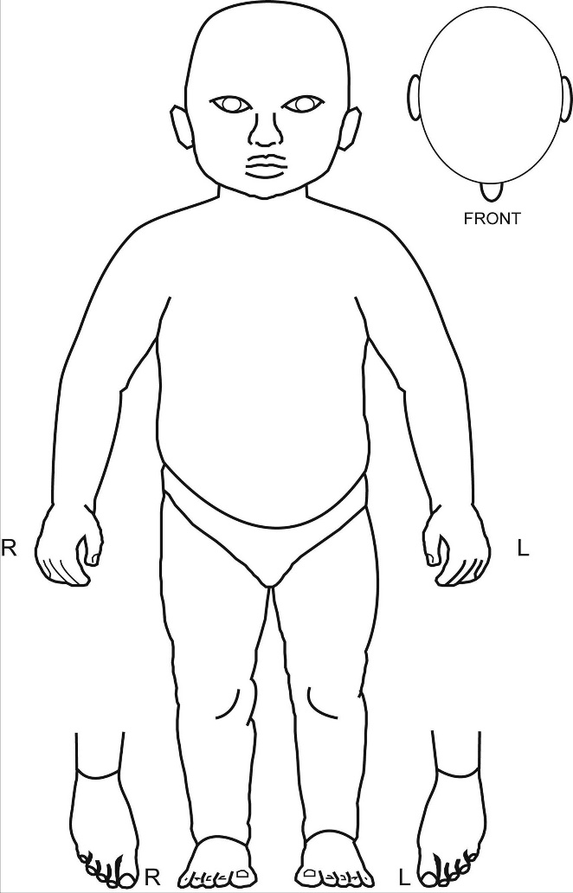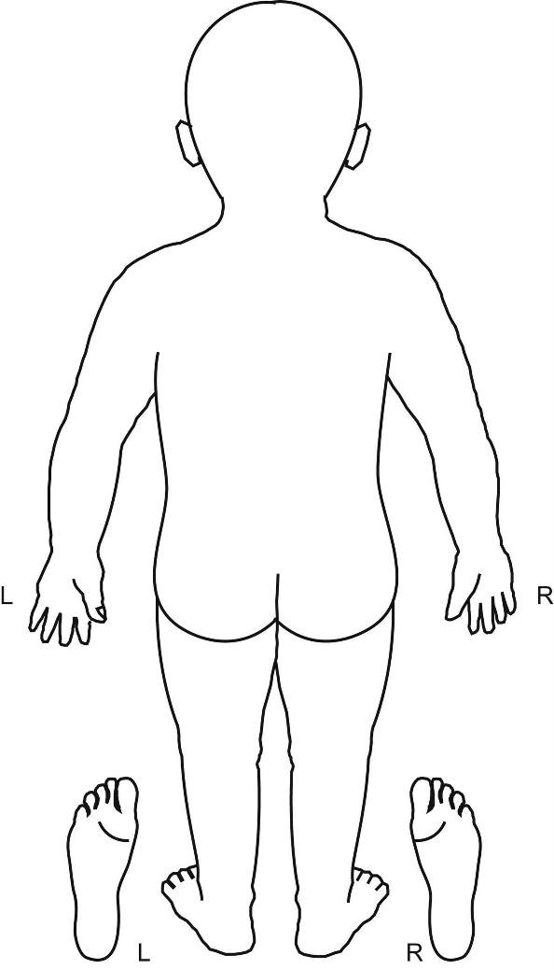

Appendix 2: Contacts
Contacting Paediatrician at nearest Emergency Departments
Hospital | Contact numbers
Basildon & Thurrock University Hospital | 01268 524900
Broomfield Hospital, Chelmsford | 01245 362000
Colchester Hospital | 01206 747474
Princess Alexandra Hospital, Harlow | 01279 444455
Southend Hospital | 01702 435555
Queens Hospital | 0208 970 5719

Community Referral for a Child Protection Medical
Hospital/ Community Services | Contact numbers
Basildon, Brentwood & Thurrock localities | nem-tr.cpsafeguarding@nhs.net
Broomfield Hospital, Chelmsford | 01245 362000  Request on call paediatric consultant
Colchester Hospital | 01206 747474  Mon-Fri 07949 279 406
Princess Alexandra Hospital, Harlow | tpa-tr.pahsafeguardingchildren@nhs.net  Named Nurse: 07912 486480  Safeguarding Admin: 01279 962645  01279 444455
Southend Hospital | 01702 435555  Request on call paediatric consultant

Links to the Children’s Social Care
Essex | Children & Families Hub 0345 603 7627  Essex (Request for Support online portal):  Report a concern about a child: Report a concern about a child - Essex County Council
Thurrock | 01375 652 8020 out of hours 01375 372 468  Thurrock (CAF submitted to Thurrock MASH):  https://www.thurrock.gov.uk/childrens-care-professionals-processes/referral-pathways-and-services
Southend | Southend City Council – Children’s Single Point of Contact (C-SPOC)  To make a safeguarding referral please use the Southend Children’s Services Portal - Welcome to the Southend Children's Services Portal  Southend City Council Out of Hours Emergency Duty Team: 0345 606 1212

Appendix 3: The growing child

Children do not all develop at the same rate; children with a health condition or those with a disability may well be significantly behind other children; some parents may engage in a range of activities with their children that encourages them to develop earlier than others. It is therefore important to take account of the child’s age, development, and circumstances rather than using blanket terms. In general:
Pre-mobile:
By 2 months, a baby is likely to be able to:
- Whilst laying on tummy, turn their head to the side;
- Whilst laying on back, wave arms, legs and wiggle / squirm;
- Briefly holds a toy when placed in their hand;
- Follows an object or person with both eyes.
By 4 months, a baby is likely to be able to:
- When laying on tummy, hold their head straight up and look around;
- When in a sitting position, hold their head steady, without support;
- Whilst laying on back, bring hands together over the chest, touching their fingers;
- When in a sitting position, start to reach for a toy close by;
- When baby has a toy in their hand, they will hold it whilst looking at it, waving it about and attempting to chew it;
By 6 months, a baby is likely to be able to:
- Roll from their back to their tummy;
- Sit up with support;
- Get into a crawling position;
- Grasp a toy using both hands at once;
- Reach a small object using their finger and pick it up using their thumb and all fingers;
- Be able to pick up a small toy with one hand and pass it to the other;
- Plays with feet when laying on back.
By 9 months, a baby is likely to be able to:
- Sit without support;
- Get into sitting position from lying down;
- Pull to stand and take weight on feet;
- May crawl;
- Roll over both ways.
By 12 months, a baby is likely to be able to:
- Sit well and gets into sitting position alone;
- Pull to stand from sitting position and sit down again;
- Walk around furniture;
- May crawl or bottom shuffle;
- May stand alone;
- Help turn the pages of a book;
- Throw a small ball;
- Be able to pick up a piece of string with first finger and thumb.
Mobile:

By 18 months, child is likely to be able to:
- Walk well;
- Walk upstairs holding an adults hand;
- Stack blocks on top of each other;
- Turn the pages of a book;
- Put a small spoon in their mouth, right side up.
By 2 years, a child is likely to be able to:
- Try to kick a ball;
- Run well;
- Jump with both feet leaving the floor at the same time;
- Hold a pencil by using thumb and first two fingers;
- Can string small items such as beads, pasta onto a string;
- Drinks from a cup with no lid.
By 3 years, a child is likely to be able to:
- Walk on tip toes when shown;
- Walk upstairs with alternate feet, still puts both feet on each step when coming down;
- Catch a large ball;
- Pedal a tricycle;
- Climb walls.
At about 4 years, a child is likely to be able to:
- Walks up and down stairs using alternate feet;
- Good on a tricycle;
- Hops and stands on one foot;
- Can throw, catch and kick well;
- Draws a person with recognisable body parts eg head, arms and legs;
- Uses a fork and spoon well.
At about 5 years, a child is likely to be able to:
- Balance and stand on one foot for about 10 seconds;
- Hop;
- Dance;
- Swing and climb;
- Slides down a slide;
- Can now get dressed and undressed by self.

References

Essex Safeguarding Children Board (ESCB) (2022) Southend, Essex and Thurrock (SET) Child Protection and Safeguarding Procedures
https://www.escb.co.uk/working-with-children/safeguarding-policies-procedures/

HM Government (2023) Working Together to Safeguard Children
https://www.gov.uk/government/publications/working-together-to-safeguard-children--2

Mukwende, M., Dr Tamony, P. and Turner, M. (2020) Mind the Gap: A Handbook of Clinical Signs in Black and Brown Skin. First Ed. St George’s University of London.
https://www.blackandbrownskin.co.uk/mindthegap

NICE Guidance (2009) Child maltreatment: when to suspect maltreatment in under 18s (Updated October 2017)
https://www.nice.org.uk/guidance/CG89

NSPCC Sexual Abuse: https://www.nspcc.org.uk/what-is-child-abuse/types-of-abuse/child-sexual-abuse/

The Royal College of Paediatrics and Child Health (RCPCH) (2019) Abusive Head Trauma
https://childprotection.rcpch.ac.uk/child-protection-evidence/head-and-spinal-injuries-systematic-review/

The Royal College of Paediatrics and Child Health (RCPCH) (2020a) Child Protection
Evidence: Systematic review on Bruising
https://childprotection.rcpch.ac.uk/child-protection-evidence/bruising-systematic-review/

The Royal College of Paediatrics and Child Health (RCPCH) (2020b) Child Protection
Evidence: Systematic review on Fractures
https://childprotection.rcpch.ac.uk/child-protection-evidence/fractures-systematic-review/

