Cared for Children Sufficiency Statement 2023 -2025



Cared for Children

Sufficiency Statement

June 2023

1

# Foreword

The relationship that the Council has with cared for children and care experienced young people in Sefton is different to our relationship with all other children and young people as we are their Corporate Parents. As Corporate parents we must be loving, caring and aspirational for all children and young people who are

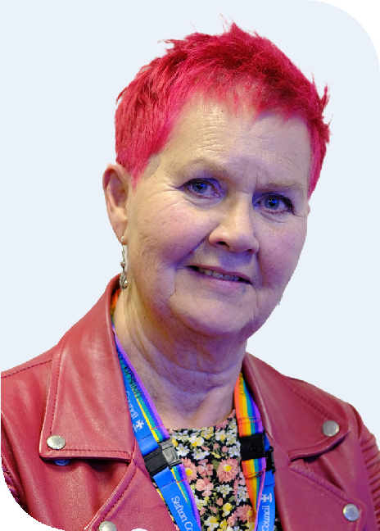

in our care, or who have recently left our care as adults. We must ensure their safety, provide help and support when and where this is needed whilst also creating opportunities to develop resilience and independence as they move towards adulthood.

**Councillor Mhairi Doyle Cabinet Member Children’s Social Care**

We want cared for children to have safe, permanent, stable loving homes. Part of our work includes continuing to work with families so that children and young people can return home where it is safe to do so. We must also make timely decisions around adoption to maximise successful matches. For those children who do need

to come into care, we want them to feel the benefit of living in safe family-focused households whether this is with friends and families within their support network or with foster families. We are proud of our in-house foster carers, and we want to do all we can to support them and increase the number of local foster carers. However, we recognise that for a small number of children and young people residential care best meets their needs.

The Sefton Cared for Children Sufficiency Strategy sets out how the Council and its partners plan to commission safe and supportive accommodation for children in care and care experienced young people over the next three years. This includes plans to manage demand in the market by working to reduce the number of children in our care and to provide safe and nurturing homes.

Where appropriate, we want Sefton children to be placed in Sefton. We will work with our partners and the provider market to develop more locally based resources where OUR children can live happily. We will keep a sharp

focus on these children through outcome focused care planning, listening to children’s voices and encouraging their ambitions.”

Table of Contents

Foreword 2

Introduction 4

The Sufficiency Duty 5

The Current Context 6

Profile of Sefton 7

Children & Young People Population 7

Cared For Children Population 7

Cared for Children Demographics 8

Sufficiency of Provision 9

Cared for Children Placement Types 10

Forecast of Placement Types 12

Placements within the Family/with Relatives 12

Foster Care 12

Residential Provision 13

Our Principles & Aspirations 14

Voice of the Child 15

Young Inspectors Programme 15

Evidence-based & Outcomes-focused 16

Children’s Improvement Plan 18

The Approach 19

Support to Remain at Home 19

Family Group Conferencing 20

Domestic Abuse 20

Going Home 20

Local, Family Placements 21

Residential Provision 22

Good Quality Placements 23

Universal, Targeted and Specialist Services 23

Child Sexual Exploitation (CSE) 24

Young People at Risk of Criminal Exploitation (YARC) 24

MySpace 25

Permanency via Adoption and Special Guardianship 26

Preparation for Independence 26

Improving Sufficiency - Action Plan 28

Conclusion 34

Appendix 35

# Introduction

This Cared for Children Sufficiency Statement outlines the Council’s plan to provide safe and appropriate accommodation and support to children in care and care-experienced young people over the next three years. Partners recognise that while most children and young people in Sefton are raised in their own families, a small number require additional services and support.

# Our Vision

1. Children will always be supported to stay with their birth families wherever it is safe and appropriate to do so.
2. Where it is not in their best interests to live with birth parents, we will support children to live within their wider family network.
3. When it is not possible for children to live with their family network, we will help them live in a local family placement (a fostering arrangement)
4. For the small number of children and young people with the most complex needs we will provide high quality therapeutic homes, with timely access to health care but will always see this as ‘an intervention, not a destination.’
5. Where it is necessary, we will focus on achieving permanency for children in a timely manner through adoption and special guardianship.
6. Everything we do will be focused on providing the highest quality care and homes for cared for children. We will actively work with cared for children and carers to improve and always ask ‘would this be good enough for my child?’

This plan will inform strategic commissioning arrangements and progress will be reported to the Corporate Parenting Board, and the Health and Wellbeing Board. It will also support the delivery of key priorities in our Corporate Plan and Improvement Plan. Key linked strategies can be found here:

[Sefton Integrated Early Help Strategy for Children, Young People and Families 2020- 2025](https://www.sefton.gov.uk/media/2100/sefton-early-help-strategy-2019-2025-final.pdf)

[Vision and Core Purpose (sefton.gov.uk)](https://www.sefton.gov.uk/your-council/vision-and-core-purpose/)

[Sefton Health and Wellbeing Strategy 2020-2025](https://www.sefton.gov.uk/media/4509/sefton-health-and-wellbeing-strategy-2020-2025.pdf)

[Sefton Council Corporate Plan 2023 to 2026](https://www.sefton.gov.uk/media/6921/sefton-council-corporate-plan-2023-to-2026-updated-26-june-2023.pdf)

[Emotional Health and Wellbeing Strategy](https://www.sefton.gov.uk/media/4575/emotional-wellbeing-strategy-2021-2026-85.pdf) (2021 – 2026)

We recognise that some of our Cared for Children will have special educational needs and disabilities. We will ensure that the care and support for these children by suitably qualified and experienced providers to meet their unique needs will be addressed through commissioning plans and will be subject to the SEND commissioning arrangements.

This is a ‘live’ document and will be reviewed annually to ensure that it remains current and effective in meeting the needs of our Cared for Children.

Finally, as corporate parents, our aspirations for young people leaving our care continues well into their adulthood. Transition pathways will be strengthened enabling continuity of support based on life course principles and outcomes. We will engage with Adult Social Care and will work across the system as a natural leader to develop the resilience of young people and

the commissioned market offer. Furthermore, Sefton Borough Council and our partners are committed to preventing homelessness and as a Corporate Parent we will ensure that children in our care are prioritised. Our [Housing Strategy](https://www.sefton.gov.uk/housing/housing-strategies-and-policies/housing-strategy-2022-2027/) reinforces this commitment and reflects the priorities in relation to suitable and good quality housing provision for our care experienced young people to enable a smooth transition into independence.

# 

# The Sufficiency Duty

The Children Act 1989 requires local authorities to have a strategy in place to provide sufficient care placements for children in care, known as Cared for Children. The introduction of the Sufficiency Statutory Guidance (2010) and the Care Planning, Placement and Case Review Regulations (implemented in April 2011) further clarified the requirements for local authorities to secure appropriate and sufficient placements for these children.

The Statutory Guidance emphasises the importance of local authorities working with key partners to secure, where reasonably possible, accommodation that meets the needs of children in care and is located within the local authority’s area. It also stresses that the provision of sufficient accommodation should not only be measured by the number of beds available, but also by the availability of a range of providers and services that can meet the diverse needs of these children.

Furthermore, the Guidance lays out commissioning standards for securing sufficient accommodation for children who may need to be in our care.



# The Current Context

Over the past 20 years, the number of children in care in Sefton has more than doubled, with the steepest increase happening in the last 5-6 years. This increase is higher than the national average, indicating a higher baseline of need in Sefton compared to other regions. This has placed increasing demands on Sefton’s Children’s Services and partner organisations who provide support and care for families. It’s important to note that according to national sufficiency data, the Northwest region currently faces one of the greatest systemic risks should there be any increase in demand, based on a variety of factors.

Additionally, Sefton’s Children’s Services has an inadequate rating from Ofsted and is currently undergoing a rigorous improvement drive to strengthen core services for children. This includes reviewing expenditure and improving capacity and capabilities.

Currently there is a system review of Early Help taking place with a view to maximising the use of this valuable resource and ultimately support more families earlier and reduce the numbers of children and young people coming into care.

Currently, there are over 600 children in Sefton who are cared for, with about 200 placed in private provision and around 90 in independent residential homes. The sufficiency of markets to meet demand is a growing concern, with issues related to quality, instability of placements and a lack of alternative move-on and step-down support from residential to fostering. Private and independent provision is playing an increasing role in the fostering and residential market, with escalating costs and an increasingly fragile financial position for service providers. Like other Local Authorities, Sefton is finding it increasingly difficult to find placements for children as the overall demand across all sectors is outstripping supply.

Furthermore, Sefton attracts a number of children from other areas, which has had a significant impact on the ability to place Sefton children in Sefton homes. There are currently 25 independent residential providers in Sefton with a total bed capacity of 103. Additionally, the Council’s internal care homes are currently not in operation, and our internal fostering service

is looking to increase the number of local foster carers and has recently reviewed payments to foster carers with the aim of creating additional capacity through more foster carers supporting more than one child.

We are ambitious for the future of Children’s services in Sefton recognizing that we have a duty to ensure children in Sefton are safe, happy and thriving. When this doesn’t happen, or when families need some extra support to make it happen, we work with you to make this a reality.

Our promise is to respect you and your family regardless of any religious belief, ethnicity, sexuality, gender identity or disability, and support you on your journey to be a resilient and confident family.

We will

* respect you.
* make sure we support you in a kind, compassionate, considerate and timely way.
* listen to you and involve you in decisions and plans about your life.
* make sure we provide a stable environment for you to live and learn in.
* make sure you live with people who care about and support you.
* support you in any pathways you choose beyond school or college, including going to university or into an apprenticeship.
* encourage you to be the best you can be and achieve the goals and dreams you have set.

# Profile of Sefton

# The following information tells us that Sefton has a greater number of cared for children than it should, and the impact of the cost-of-living crisis is being acutely felt. Information on Sefton’s response to child poverty can be viewed here: [Sefton Child Poverty Strategy](https://www.sefton.gov.uk/public-health/sefton-child-poverty-strategy/)

## Children & Young People Population

* The 2021 ONS mid-year population estimates state that there are 54,098 children and young people aged between 0 and 17 residing in Sefton, this makes up a fifth of the borough’s total population.
* The children and young people population in Sefton has slightly more males (51%) than females (49%).
* Approximately 94% of Sefton’s children and young people have an ethnicity deemed as White.
* Since 2014/15 there has been an increase in the levels of children living in relative low- income families (CiLIF) within Sefton, comparative with that seen nationally, and it is estimated that there are approximately 10,655 children in low-income families which equates to 18% of all 0-19-year-olds. The highest density of deprivation is in the south of the Borough.
* 31 of the 189 LSOAs in Sefton fall within the top 10% of deprived areas in England, 5 of them in the top 1% of deprived areas national and a further 19 in the top 5% nationally. The pattern matches the high density of (CiLIF) in the south of the Borough.
* Latest figures show that the rate of children aged 10-17 cautioned or sentenced for an offence in Sefton is below the national average, however the percentage of young offenders in Sefton who re-offend is higher than the Northwest and statistical neighbour averages.

## Cared For Children Population

* Sefton has more Cared for Children (Cared for Children) than average when adjusted for population size. There are currently 606 Cared for Children as of 1 January 2023.
* Sefton’s rate of children in care in has been at its highest in recent years, approximately 110 per 10000 CYP. Compared to the National average, approximately 71 per 10000, this represents a significant gap, which – if recent patterns continue - isn’t likely to be closed for many years to come.
* Forecasts demonstrate a peak in the Cared for Children rate around 2027 – between 115 and 122 Children and Young People per 10000 (630 – 670 Cared for Children) - which also reflects expected changes in Children and Young People demographics.

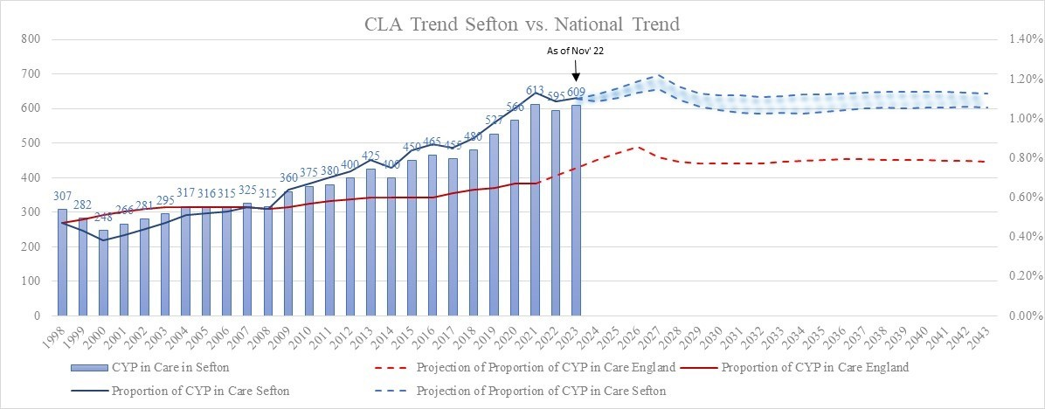

* The Average Cared for Children turnover rate for all Children and Young People aged 0-17 has trended towards a steady increase of people entering care since 2001. This trend has underpinned the increase in total Cared for Children over the past decade, most notably in numbers of 16+ Cared for Children.

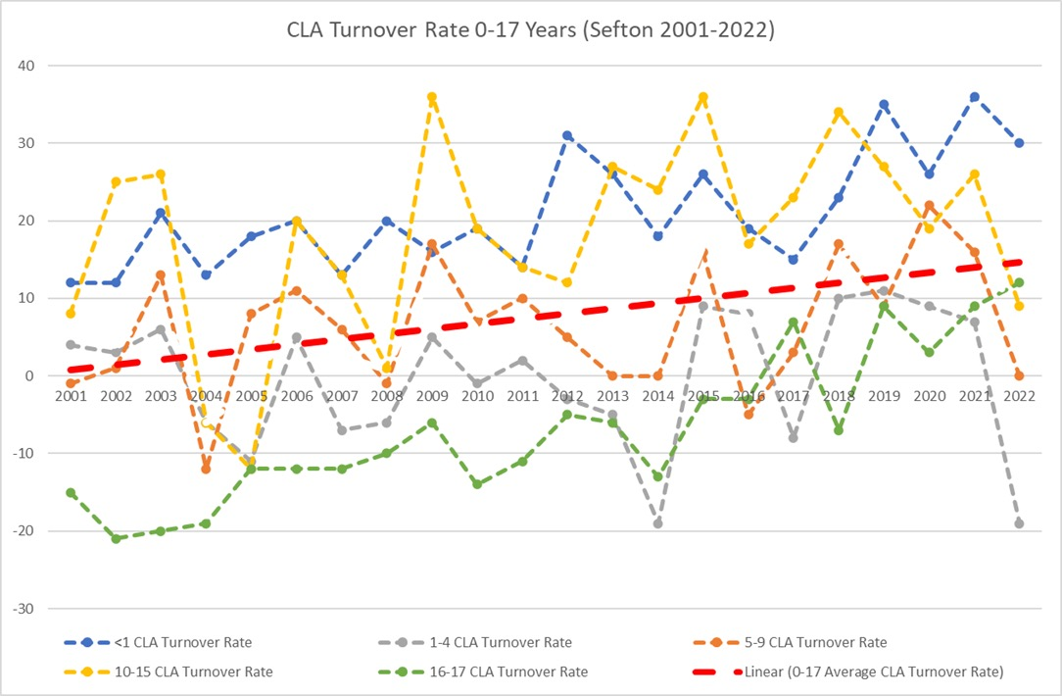

* For the past two decades, deprivation data has correlated well with Cared for Children numbers. Sefton has a higher rate of Cared for Children expected for the levels of recorded deprivation in area, potentially indicating higher levels of disparity in the region, when compared nationally. This highlights the difficulties LAs in the region face regarding demand as only 6 of the 23 LAs in the Northwest have a Cared for Children rate per recorded deprivation levels below the national averages.
* Free School Meals Eligibility data per English LA shows an even stronger correlation, highlighting poverty as potentially the most significant factor effecting the care of Children & Young People. In 2021, Sefton recorded 8061 children eligible for Free School Meals, which usually indicates a Cared for Children population of between 400-550.

## Cared for Children Demographics

* Much like the wider population, the profile of Sefton’s children is ageing. Estimated birth rates in the borough have plateaued and indicate that they’re reducing.
* In the coming years, there’s likely to be a much greater pressure of teenagers entering care, whereas other cohorts are not likely to see any increase in demand.
* The estimated average age of CARED FOR CHILDREN in Sefton is expected to move towards ~10 years old by 2026 before plateauing. Demand relating to CYP over 10 years old will likely exacerbate existent challenges in placement matching.

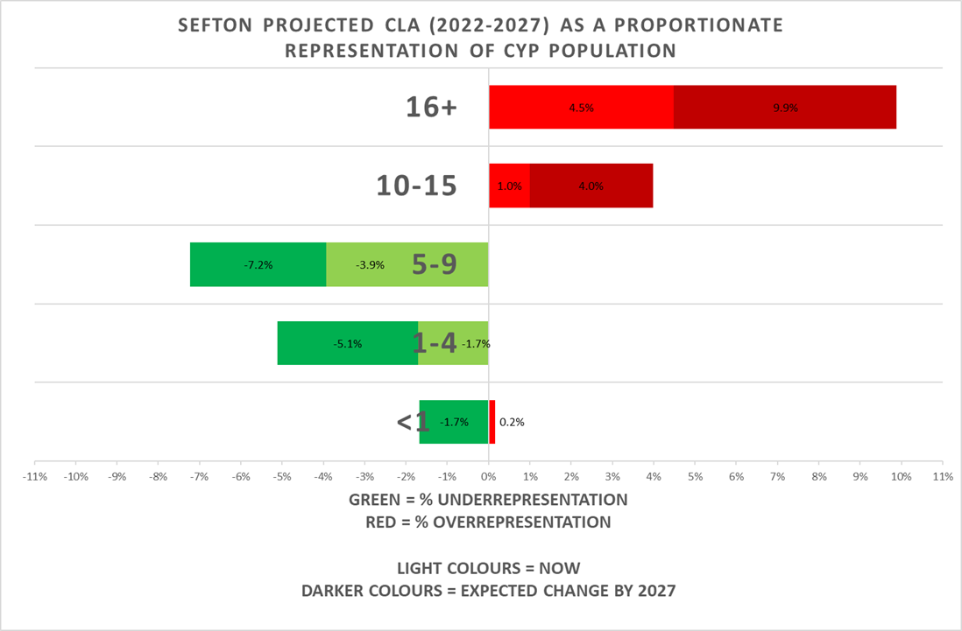

* Average ages of children and young people entering Care in Sefton have been variable over the years. This could be due to several reasons, such as regular change in social work practice, including Early Intervention & Prevention Strategies or even further indication of the many challenges LAs in the Northwest face because of internal and external economic pressures.
* The average age children and young people are now entering care in Sefton (7 years old) is close to the national average (6.5). Historic low average ages of Cared for Children and recent higher average ages of children and young people entering care further demonstrate the challenges Sefton has faced when considering the rate of turnover of Cared for Children.

## Sufficiency of Provision

* According to national sufficiency data, the Northwest region currently faces one of the greatest systemic risks should there be any increase in demand, based on a variety of factors. Furthermore, the risk in densely populated regions is exacerbated by being densely populated which signifies increased difficulties when considering level of demand and availability of resources.
* The Northwest, particularly Merseyside, would be at risk of systemic failure should there be any increase in demand for Cared for Children provision and/or reduction in regional supply. The cluster of boroughs in Merseyside represents a significant risk when considering several of the key metrics and Sefton’s ability to overcome such risks, namely: **availability of Foster Care Provision, availability of residential provision, availability of Cared for Children provision in the local authority, availability of suitably located local Cared for Children provision**.
* Even with increased internal resources focused on expanding the supply of any one of the four metrics, the probability of sustainably achieving sufficiency goals will be challenging.
* One of the main issues Sefton has in respect to appropriate provision within the borough is related to the high number of non-Sefton Cared for Children placed in Sefton by other LAs (approx. 283, 44% of all Cared for Children in the borough), compared to only placing 39% of Sefton Cared for Children out of the borough, making Sefton a net importer. For reference, Blackpool – the LA most at risk from systemic failure relating to increased demand – manages to occupy 67% of its local Cared for Children provision.
* The risk of Sefton not finding suitable non-local (>20miles from home address) out-of-Sefton placements is a below-average when compared nationally.
* Positively, 91% of Sefton children are placed within 20 miles or less of their home, which is a higher number than in similar authorities. Nationally this figure is reported as 1 in 5 children being placed more than 20 miles from home, for Sefton this is 0.2 children for every 5.

## Cared for Children Placement Types

* In general, Northern regions use care provision at a greater proclivity than the rest of the and these regions may experience increasing issues if they’re not able to increase their supply of provision.
* The Northwest region has the highest concentration of provision usage across Internal and External sectors and some of the greatest propensity for Foster Care and Residential provision.
* Northern local authorities are more likely to choose Internal provision over external provision and vice- versa is true for Southern councils. This has led to enormous matching difficulties for already under-pressure Northern local authorities as there’s a disproportionately greater number of private providers there.

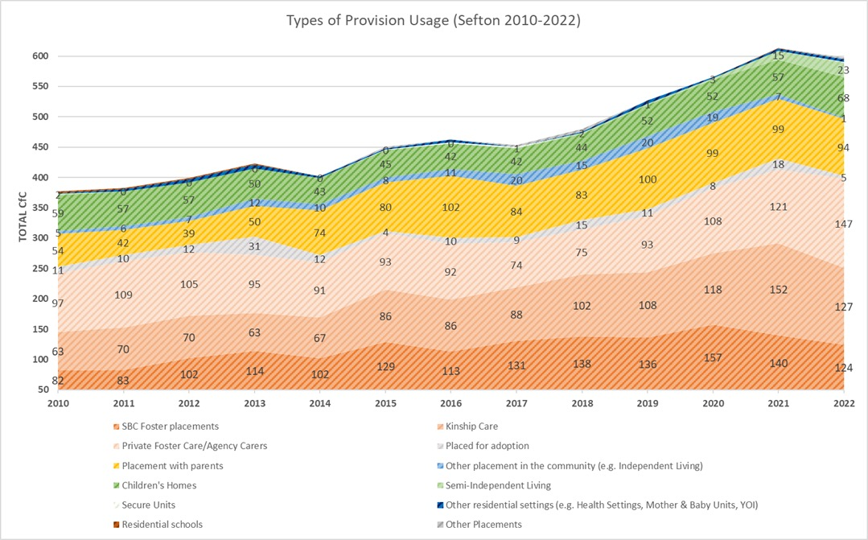

* Sefton’s demand for Cared for Children placements has increased over the years:
  + A greater number of children, especially new Cared for Children, are being placed in Kinship Care and this is a priority for us as we recognise that when children remain connected to kinship, they achieve better outcomes.
  + Sefton’s ability to place within its own cohort of foster carers peaked in 2018 and has been in rapid decline since then. In 2022, only 79 placements were made with foster carers registered with the Council.
  + In 2022, for the first time ever, placements with Private Foster Care Agencies exceeded internal numbers. It is now more likely that new Cared for Children will be placed in Private Foster Care.
  + In 2010, almost 30% of all placements made were with Children’s Homes. In 2022, only 12% of the required placements were absorbed by this placement type. This demonstrates the decreasing availability of residential placements which contributes to driving the current costs. It is right that we should have less residential placements and a focus on keeping families at home or fostering as an alternative therefore we would see this position changing over time.



# Forecast of Placement Types

Care markets are changing, and we can no longer rely on traditional methods of commissioning and placements to find the right solutions for our children and young people, a drastic shift in strategic approach is needed.

In Sefton there have been a reduction in placement break down overall and in addition children have not moved out of residential care (either permanency or back to their families) which is now being addressed with a focus on professional practice. So overall we have seen in Sefton increasing numbers of Children and Young People placed in Care settings compared to children who leave to go back home.

## Children who are placed with their family.

* Children who are placed within the family or with relatives and kinship carers will continue to be the preferred model and with a strong focus on social work practice and support to parents and families at an earlier stage we would expect to see a reduction in formal arrangements and in children placed within residential settings. At present there is a significant number of children placed with parents.

## Foster Care

* At present trends are indicating that placements within house fostering arrangements have declined over time. Whereas Foster Placements with fostering agencies have increased slightly. However, the Council is taking steps to address this, early indications are that changes to policy will increase capacity in this area with a shift in investment from residential care.
* One of the main factors underpinning the pressures in placement matching in Foster Care nationally is the reduction in approved Foster Carers/Fostering Households.
* Since 2017, there has been a gradual reduction in approved foster care places nationally, culminating in a reduction of almost 10,000 approved places in 5 years. This equates to an 11% reduction and highlights a trend towards approvals for fewer children.
* Despite the quantity of people enquiring about becoming a foster carer increasing nationally over recent years, it is becoming less likely that these enquiries culminate in a newly approved fostering household. The number of enquiries that have led to an approved foster care household has reduced from 7% in 2013 to 1% in 2022, seemingly due to two factors:

1. Fewer enquiries are progressing to formal applications, and,
2. The number of applications being withdrawn by the applicant have been on the rise since 2013. Now, almost half of all Foster Carer applications are withdrawn.

* The median age of a Foster Care Household is 55. If Carers are not replenished as they retire, we will see a dramatic reduction in the total number in the years to come. However, when considering the median age of newly approved foster carers (48) and the median age of Sefton’s population (47), conditions for growing the local cohort are favourable.

## Residential Provision

* Children’s Home places will continue to be difficult to source, especially if current workforce recruitment issues within the market persist. In Sefton we are a net importer of Children which reduces availability, it is key for us to have robust market engagement approach.
* To sustainably maintain a similar rate of residential provision usage, Sefton would need to reduce its rate of Cared for Children per 10000 Children and Young People to around 80. The last time Sefton registered such low levels was during 2014. In 2023, to achieve this reduction this would mean 165 children and young people returning to a permanent home with families or alternative permanent arrangements.
* The complexity of some of our children will mean we will need good care and support providers to wrap around families and prevent the need for placements in residential care settings.



# Our Principles & Aspirations

The Strategy links directly to the 4 aims of the current Children and Young People’s Plan 2020 - 2025: Happy, Healthy, Heard, Achieving.

Moreover, the Council and its partners are committed to the seven principles of corporate parenting outlined in the 2017 Children and Social Work Act. These are:

1. To act in the best interests and promote the physical and mental health and wellbeing of children and young people.
2. To encourage children and young people to express their views, wishes and feelings.
3. To consider the view, wishes and feelings of children and young people.
4. To help children and young people gain access to and make the best use of services provided by the Council.
5. To promote high aspirations, and seek to secure the best outcomes, for children and young people.
6. For children and young people to be safe, and for stability in their home lives, relationships and education or work; and,
7. To prepare children and young people for adulthood and independent living.

These principles will guide how we work to support children in care to deliver the following aspirations:

1. Children will be supported to stay with their birth families wherever it is safe and appropriate to do so.
2. Where it is not in their best interests, to live with birth parents, we will support children to live within their wider family network.
3. When it is not possible for children to live with their family network, we will then help them live in a local family placement.
4. For the small number of children and young people with the most complex needs we will provide high quality therapeutic homes but will always see this as ‘an intervention, not a destination’.
5. Where it is necessary, we will focus on achieving permanency for children in a timely manner through adoption and special guardianship.
6. Everything we do will be focused on providing the highest quality care and homes for cared for children. We will actively work with cared for children and carers to improve and always ask ‘would this be good enough for my child?’

# Voice of the Child

Sefton places a strong emphasis on valuing and giving a platform to the voice of the child. We strive to actively listen to the perspectives and experiences of children and young people in our care through a variety of means and in a range of forums. This approach is at the core of our Sufficiency Statement as we strive to empower children and young people ensuring that they are heard, understood and responded to too.

To achieve this, we will work to co-produce and co-design services and strategies with children and young people, building trust and creating safe and engaging spaces for them to share their perspectives. Our approach to co-production will include both active participation in service design and redesign, as well as ongoing engagement to ensure their voices are heard in the day-to-day experience of the service. Furthermore, we will involve children and young people in the commissioning process to ensure that services are designed in the most appropriate and effective way. This will be critical to delivering excellent outcomes and shaping the future market.

## Young Inspectors Programme

We plan to launch a ‘Young Inspectors’ programme to ensure that services are meeting quality standards and that children and young people’s voices are being heard and acted upon.



# Evidence-based & Outcomes-focused

Our commissioning approach rethinks services and the way we work with families and, recommendations, wherever possible, will be outcome-based.

We will endeavour to invest in the right support at the right time, enhancing early help and prevention so that fewer children come into care. We encourage participation by engaging providers, children, young people, and their families to support us to design services and influence the way in which they are delivered wherever possible.

As Corporate Parents we will provide scrutiny and seek assurance that the Strategy and the actions are owned and implemented by all professionals and partner organisations working with children, young people, their parents, and carers to secure the best outcomes for our children.

We are transitioning to a relational approach to ensuring that we work with our stakeholders. We are committed to sustainable relationships between internal and external stakeholders that build confidence with our statutory partners and the voluntary and community faith sector in Sefton.

To enable this, we will continue to be honest, transparent, and always keep the child or young person at the centre of all considerations. Wherever possible our communication to stakeholders will be timely, clear, and inclusive.

We aim to develop provision with key providers to ensure a range of local specialist support and choice. We will focus on ensuring that the local market is developed over time so children and young people who remain in our care are able to continue to live in a family setting with the right support within or close to the Borough.

We understand that in Sefton all our providers want to work with us to achieve the best outcomes for our children. Our objective is to take a facilitative rather than punitive approach to problem solving when things go wrong. This does not mean that we will not be brave and swift in challenge when our children are unsafe or not getting the best possible service.

We will develop a value model of accommodation and support with providers as experts in delivery, taking account of value for money in all decisions and providing information to enable robust performance management both in relation to quality and efficiency and we will joint commission with the ICB’s to address current gaps in relation to identifying and meeting children’s health needs.

Effective delivery is assured through robust monitoring, recording and evaluation. Contract compliance and quality is now being monitored through a scheduled programme of quality assurance visits which will be carried out alongside service and will account for the lived experience of the child or young person. Commissioning activity and performance will be managed proactively deploying a programme approach to the market which will give assurance of grip and pace during this period of improvement and transformation.

## New Commissioning Model

Sefton has recently established a local framework of providers, which provides the platform for a strategic partnership approach based on the child’s journey, with residential providers and independent fostering agencies at its core. Such an approach

will inform a local market offer which will focus on outcomes for children, be cost effective and enable a collective provider led approach to supporting the step down from residential to fostering, thereby mitigating the risk of drift.

The framework will enable a local commissioning grip on quality and cost, a strong line of sight to the child and facilitate the shaping of a commissioning relationship with providers based on the improvement of outcomes and value for money. It will also enable the introduction of social value with a focus on local provision for local children. As identified in the National Procurement Strategy 2015; building strong relationships with social care providers is an important facet of good social care procurement, not least because it is a crucial factor in fostering innovation. Contracts were awarded in May 2023.

Moreover, we will continue to develop our strategic commissioning model and approach not just to retain existing services or commission new ones but, where necessary, to decommission services which are inefficient, ineffective, inequitable, or unsustainable.



# Children’s Improvement Plan

Alongside the general approach to meeting demand within the borough, [Sefton Children’s](https://www.sefton.gov.uk/media/5708/sefton-children-improvement-plan.pdf) [Improvement Plan](https://www.sefton.gov.uk/media/5708/sefton-children-improvement-plan.pdf) recognises the change needed to improve outcomes for vulnerable children and young people in Sefton.

Phase 1 of the plan highlighted four themes for improvement:

### Improving Quality

### Improving Implementation of Learning

### Improving Tools

### Improving Strategic Partnerships

The Improving Strategic Partnerships module identifies one key outcome related to Sefton’s ability to meet demand regarding sufficiency of Cared for Children provision:

#### “Commissioned services provide sufficient care and support to meet the needs of children and young people and enable continuous improvement in order to increase the positive outcomes achieved”.

The objective is:

* To strengthen partnerships between, Children’s Services, Health, Public Health, Education, Housing, and Commissioners; that roles and contributions from partners are clearly understood and outcomes for children and young people are achieved.
* Social Care and Early Help workforce can access the right quality and type of service to meet the needs of the children and young people they support.

To achieve this, specific actions were identified and are being rolled out:

* **Integrate the Strategic Commissioning function between the NHS and Council:** There will be a clear plan with clear lines of accountability and timescales for the Executive Integrated Commissioning Group to monitor progress.
* **Publish the Sufficiency Statement** so local providers can easily identify areas where they can contribute to delivery and meet the wide-ranging needs of cared for children and young people.
* **Develop the Sufficiency Strategy Action Plan** with clear lines of accountability and timescales that identifies our priorities.
* **Improve market engagement and management**. There will be provider forums where commissioners meet with providers to share strategic plans and priorities. There will be co-designed service specifications co-produced with children and young people in our

care. Local providers will be working with the Children’s workforce to improve outcomes for children and young people.

* **Voice of Care Experienced Children and Young People**. Children and young people will be integral partners in the redesign and recommissioning of services with service specifications that reflect the voice of the child.
* **Establish a Youth Inspectors team to work with commissioners to identify service improvements that will in turn improve standards of care.** A Team manager will co- ordinate a team of young people with care experience to review and monitor services alongside commissioners. This will place young people at the heart of inspecting and quality assuring services and ensure that the views and experiences of care experienced young people will inform commissioning activity.

# The Approach

## Support to Remain at Home

The Council is committed to supporting children and families to stay together whenever it is safe to do so. We understand that preventing problems from developing early on is better for

children, young people, and their families. To achieve this, have integrated our early help services with clearly defined thresholds to focus on those families that will benefit the most from early support. This will help to reduce the need for care proceedings and the need for statutory accommodation-based support.

For children and young people on the edge of care, we will ensure that they are supported to stay with their parents or extended family and only come into care when it is necessary and justified in the best interests of the child or young person. All support options and strategies will be exhausted before a child is placed in care. The diagram below captures our future approach:

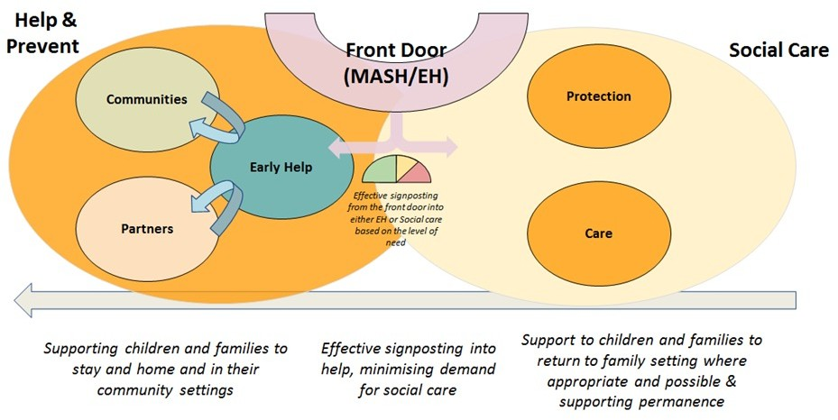

To further support this, we will be establishing an “Edge of Care” model by mobilising a dedicated natural team of practitioners who will work across traditional organizational boundaries to offer a range of services to support children to remain living safely with their immediate or extended families. They will be given the best chance to thrive without long-term reliance on services.

Furthermore, we are committed to strengthening and consolidating our offer to young families to effectively manage demand and have started to develop more robust edge of care practices through the establishment of effective early and pre-birth pathways. We are embedding earlier

identification of pre-birth concerns and providing additional support to children and parents. We have developed Targeted Family Support Service which will focus on those families for whom there are repeat referrals to Children’s Social Care. The focus of their work will be on family breakdown, emerging neglect (including school attendance) and the impact of Domestic Abuse. This approach will ensure that the needs of these young children are met as early as possible and that they have the best chance to thrive within their families. This work is underpinned by DFE- funded Family Valued grant which provides £3m over 2 years. The grant will also cover potential work around Family Group Conferencing and MySpace.

**Family Group Conferencing**

We have established Family Group Conferencing (FGC) as our child-centred, family-led decision- making and planning process, which will develop existing strengths to build safety for children. Targeting services at children and young people at an earlier stage of their journey is likely to reduce the number of children subject to a child protection plan and consequently reduce the numbers that escalate to Public Law Outline care proceedings and ultimately entering care.

**Domestic Abuse**

The Council is committed to taking a proactive and comprehensive approach to addressing domestic abuse, especially as it is a key element of the Violence Against Women and Girls (VAWG) agenda, detailed in our [Sefton Domestic and Sexual Abuse Strategy 2023-2028](https://www.sefton.gov.uk/media/6479/sefton-domestic-and-sexual-abuse-strategy.pdf). We recognise that domestic abuse affects individuals and families across all communities and can have long-term, devastating effects on children and young people.

To address this issue, we have established a Local Domestic Abuse Partnership Board (LDAPB) that, alongside our Independent Domestic Violence Advisory Team (IDVA) staffed by trained professionals, will specialise in directing a response to - and providing support for - victims of domestic violence abuse. This approach will help coordinate and deliver a range of services including crisis intervention, counselling, legal advocacy, and case management.

Our approach also includes Commit to Change, a perpetrator programme, aimed at providing education and treatment to individuals who have been identified as perpetrators of domestic violence abuse. The goal aim of the programme is to prevent future incidents of domestic violence abuse by delivering long term behaviour change and to protect the safety of victims/ survivors, their **children**, and their families.

**Going Home**

The Council recognises the importance of Going Home for children in care and aims to reunite children with their families whenever it is in the best interest of the child. To support this, we will develop and implement a comprehensive Going Home plan for each child that includes clear goals, timelines, and strategies to address any barriers to Going Home, following the NSPCC Going Home approach. This approach emphasizes the importance of involving children and young people in the process, preparing families, and providing ongoing support for both children and families. Additionally, we will provide ongoing support to families during and after the Going Home process to ensure the best possible outcome for the child. We will also collaborate with community organizations and other partners to provide additional resources and support to

families in need. Furthermore, we will continuously monitor the progress of Going Home efforts and make necessary adjustments to the plan to ensure that the child’s safety and well-being are always the top priority.

Overall, our approach is focused on providing early and targeted support to children and families, while also ensuring that we have the right systems in place to provide appropriate care and support for children who need it. We continue to review and improve our approach to ensure that we are providing the best possible outcomes for Sefton’s children.

Local, Family Placements

On Local, family-based provision: Most children in Sefton will live in a local, family placement which also minimizes the disruption to their education or training. To achieve this, we aim to increase the proportion of children living with friends, family, connected people and foster care placements, with a focus on in-house placements to ensure more choice when matching children with families. Our recruitment efforts will also be geared towards securing specialist placements, such as respite care for children with disabilities and placements for larger sibling groups.

To achieve this, we have restructured our fostering service to improve our recruitment efforts and targeting specific types of carers to match the current and predicted needs of our children. This has involved introducing a Skills 4 Skills Fee Level – a significant increase on the previous fee - to generate some in-house specialist care provision for complex cases. Sefton has also increased the Skills Fee from 50% to 100% for all carers who care for more than one child – this removes the financial barrier which prevents some carers from caring for more than one child and has improved our ability to keep sibling groups together. As the number of carers being able to take more than one child increases this will reduce the reliance on external provision. Since introducing this policy in April 2022, 10 carers have come forward to offer two places or more.

Furthermore, we have improved support for our Special Guardians via a standalone support offer and we are building processes to have better oversight of SGO applications. Since Jan 2022, 22 Cared for Children have achieved permanence via SGO from Foster Care.

Additionally, we have taken a ‘back to basics’ approach that focusses on the fundamentals of delivery a ‘Good’ foster care service, ensuring that carers are represented via an improvement panel and annual reviews are conducted on time. Within the next few months, we aim to have completed all annual reviews within a timely manner. Regarding temporary foster carers, we will increase the quality and timeliness of Regulation 24 assessments. The Fostering team is now responsible for Regulation 24 assessments and there’s been a marked improvement in consistency. The assessment back log has now been removed and Regulation 38(6) is now only used when appropriate.

These measures go some way towards increasing our foster carers morale, appropriately recognising and rewarding them for their skills and experience whilst re-emphasising the Council’s expectations of carers and the tasks they undertake. It ensures carers are encouraged to take advantage of training and learning opportunities to help them develop their skills and be able to progress through the fee levels and recognises the skills and experience of new carers, including those who are transferring from independent fostering agencies or from other local authorities.

In addition to the internal changes, we will work closely with Independent Foster Agencies to secure better value and quality in terms of placements and outcomes, while reducing our reliance on out-of-authority residential provision.

Furthermore, we will continue to pilot our foster care link programme for our children with complex needs. This pilot has shown positive outcomes in enabling children to remain at home but also given them a context of family life when they are away from the family home. We have seen a reduction in the use of high-cost residential placements for those children. Within the Children with Complex Needs Service, we have now developed our Family Support Team which works alongside families and offers direct support to enable children to remain at home. The positive impact of this is we have seen a reduction in the use of high-cost external agencies whilst improving outcomes for children and families.

Ultimately, we are committed to building a skilled workforce that can deliver support to children and young people and achieving good outcomes for our children. This requires strong leadership within the market, shared intelligence on trends, and co-production.

Residential Provision

It is our responsibility to ensure that we provide safe and appropriate placements for all children in our care, including those who require residential care. Our goal is to maintain a sufficient supply of residential placements while gradually reducing the number of out-of-borough placements to minimize disruptions to children’s education and social connections.

Currently, approximately 15% of children in our care are placed in residential settings, which is slightly lower than the national average of 17%. While some of these placements are within the Liverpool City Region, a significant portion are located outside of our local authority boundaries. We recognize the importance of local placements in providing continuity of care and access to local resources, such as healthcare and education.

To achieve this goal, we will be working with providers to develop appropriate services for future needs. We will also be utilizing innovative and collaborative agreements, such as the Sefton commissioning model, which went live in May 2023 and will prioritise new models of wrap around care and support for children and families. This system will enable us to prioritize the needs of children and families and ensure that placements are tailored to meet their specific needs.

At the present time, residential provision is primarily externally purchased through the Northwest Framework. Sefton is also part of the Cheshire & Mersey Regional Framework (C&M PPA) which also incorporates Halton, Knowsley, Liverpool, St Helens and Wirral from Merseyside and Cheshire East, Cheshire West & Chester, and Warrington. We will continue to work closely with these authorities to ensure that services are structured according to the specific needs and challenges of children and young people in our local communities. We also collaborate with these authorities to ensure that we can provide a sustainable and cost-effective provision of residential care for children in our region.

In addition, the commissioning recommendation is that we only explore establishing council operated residential homes where there is a need for specialised support linked to strategic transformation plans which could involve health partners. This new focus would include assessment, outreach, and support for children and families at the edge of care, as well as preparation to move to a more permeant settings.

Good Quality Placements

Cared for Children are a particularly vulnerable group and are at high risk of social exclusion, health inequalities, inequalities in educational attainment, and wider negative outcomes. To ensure that we place Cared for Children in the most appropriate placements available, we must understand their needs and capture their views effectively. This will also help prevent and reduce the

risk of placement breakdown. We will only place our children in facilities judged as ‘good’ or ‘outstanding’ by Ofsted and aim to secure the most appropriate placements for Cared for Children as quickly as possible to prevent drift and delay.

To support children and young people in having placement stability and the most opportunities to achieve positive outcomes, we will:

1. Co-produce and deliver a model that will evaluate the social value opportunity and provide the ‘right’ support to those with the most complex needs. This will ensure that our placements are not just meeting national minimum standards but are of high quality to secure the specific outcomes identified in the care plans of Cared for Children.
2. Implement a market engagement and review programme that listens to the voice of the child and young person to drive up quality and improve outcomes for children and young people.
3. Continuously measure the engagement and satisfaction of young people, parents & carers, and prospective delivery partners using new and existing forums.

We are also working with social workers to understand how to use the commissioning process to get the right placement and support for their child and review our internal decision-making processes to assure ourselves that there is no duplication of effort or unnecessary hurdles that might introduce undue delay to the timeliness of securing placements on offer. Furthermore, we will review and improve the documentation we use when finding placements for children to make the matching of a child’s needs with that a placement offers better and review the placement finding function in the context of reach, resource, processes, and skills to ensure we maximise access and opportunities to secure best fit local placements, as and when needed.

Lastly, we will continue to collect and collate data about local placement quality and availability and have recently adopted a much more proactive and rigorous approach in this area of work to inform strategic commissioning intentions.

Universal, Targeted and Specialist Services

We recognise the importance of providing a range of universal, targeted, and specialist interventions to meet the unique needs of our Cared for Children population. A significant proportion of these children have complex needs, including mental health issues, trauma-related behaviours, a history of involvement with the secure welfare or Youth Justice system, patterns of missing and risk of exploitation, self-harm, and a need for evidence-based therapeutic support.

To effectively address these needs, we have started to work more closely with our partners to ensure that a comprehensive and holistic support system is in place. This includes partnering with Health to provide a more responsive Community Mental Health service and linking providers to the full range of universal, targeted, and specialist services available. We will also focus on building a deeper understanding of the unique needs of our children and young people and match them with appropriate placements that meet their emotional, social, and physical needs.

Our goal is to provide a “holistic service all under one roof” for our children and young people, emphasizing our commitment as corporate parents to provide not just appropriate accommodation, but also places to live that meet their developmental needs. We will also work to address emerging issues, such as high numbers of adolescents with complex mental health challenges, increasing instances of child sexual exploitation, and a growing number of Unaccompanied Asylum-Seeking Children.

In addition, we are working to improve the support available to carers, especially those dealing with children with complex and challenging behaviours, to ensure stability in placements and ultimately, better outcomes for our children and young people.

**Child Sexual Exploitation (CSE)**

CSE can have devastating consequences for vulnerable young people.

In response to this issue, the Council has implemented several measures to protect cared for children from CSE. These include:

* Providing training and education to all staff and foster carers on the signs and indicators of CSE, as well as appropriate responses to any concerns that may arise.
* Closely monitoring and supervising cared for children who may be at higher risk of CSE, such as those with a history of running away or those who have previously been exploited.
* MySpace: Collaborating with other agencies and organisations, such as the police and local youth organizations, to identify and support young people at risk of CSE.
* Providing specialised support and services for cared for children who have been affected by CSE, including counselling and therapeutic services.

It is important to note that CSE is a complex and nuanced issue, and there is no one-size-fits- all solution, however, by taking a multi-disciplinary approach and working closely with other

agencies and organizations, we are committed to protecting and supporting cared for children in our area from the harms of CSE.

**Young People at Risk of Criminal Exploitation (YARC)**

Similarly, Sefton is committed to protecting young people from the dangers of organised crime and exploitation. We recognize that young people can be targeted and groomed by criminal groups for various purposes such as drug trafficking, money laundering, and illegal activities.

We work closely with our partners in law enforcement to identify and disrupt criminal networks that target young people. We also aim to take a proactive approach to preventing young people from becoming involved in organised crime by providing early intervention and support services. These can include mentoring programs, educational and vocational training, and support for families at risk of criminal involvement.

We aspire to raise awareness among young people and their families about the dangers of organised crime and the signs of grooming. This will include delivering presentations and workshops in schools and community centres, as well as distributing informational materials to key stakeholders.

Finally, similar to Young People at risk of CSE, we are working to improve the support available to carers, especially those dealing with children with complex and challenging behaviours, to ensure stability in placements and ultimately, better outcomes for our children and young people.

**MySpace**

MySpace is a partnership approach to children who are at risk of CSE and/or YARC. It the direct influences on children and young people who suffer or likely to suffer harm arising from extra- familial risk specifically where there is risk of sexual and/or criminal exploitation. Sefton aims to ensure we have a solid understanding and response to different forms of exploitation of children, young people, and vulnerable adults.

For Sefton, the Complex Safeguarding Hub approach has functions for Child Sexual Exploitation, Child Criminal Exploitation, Organised Crime and Gangs, County Lines, Modern Slavery and Trafficking within one service. MySpace combines the three key partners for safeguarding as an integrated service for response, consultation, and intervention.

Our vision is that all children, young people, and adults who are vulnerable to exploitation, either criminal or sexual, are provided with a clear targeted response which enables and promotes a targeted multi-agency response to need and risk.

The Multi-agency Complex Safeguarding Hub will work with any child up to the age of 18 years who have a completed assessment which indicates the child/young person is or likely to suffer significant harm through exploitation.

Team Structure:

* Team Manager
* Interventions workers
* Missing from Home Coordinator
* Missing from Home intervention workers
* Social Workers
* Voluntary representative
* Health
* Police
* Community Adolescent Mental Health Service

It is envisaged that the team will include a representation from the Youth Offending Service YOS, housing health, PACE, St Giles. Further virtual key links with place-based services to ensure a response that reflects the communities which we serve.

The team have close links with the Multi Agency Safeguarding Hub (MASH), Children’s Social Care teams and the Youth Justice Team; as each service provision is based within walking distance of one another. The multi-agency development of Sefton’s Complex Safeguarding offer will ensure consistent partnership working.

The team also work with several partner agencies and third sector services, in particular to ensure appropriate information sharing and timely signposting to key services.

Permanency via Adoption and Special Guardianship

In 2022/3, 3 Sefton children were adopted, which represents 2% of all children who were discharged from care during that period. This is lower than the national average of adoption rate, which is 3.5%. Our goal in the next 3 years is to achieve a proportion of children adopted from care that is at least in line with the national average.

Preparation for Independence

All Cared for Children will be prepared for independence and a healthy adulthood. Young people approaching adulthood need nurturing care, positive boundaries, and guidance to make that transition. We will ensure they are well-prepared to leave our care and have a good range of options for their accommodation.

In getting the care and accommodation right for our children and young people who are cared for or care experienced we are giving them a stable platform upon which to develop as individuals and access education, employment and relationships as an adult which leads to happy, healthy, fulfilled and contributing citizens of our communities and wider society.

Delivery will be aligned with programmes of work which enable us to intervene as early as possible with children and families and drive forward how we work in partnership with our statutory partners, providers, young people with care experience and the voluntary and community and faith sector in Sefton. We aim to;

1. Strengthen our leadership and governance in relation to transitions and preparation for adulthood, improving our whole system pathways, outcomes for young people and our whole system commissioned offer, and
2. plan and discuss future service options for Move-On and Transition with and for our young people. Part of this is engaging with care experienced young people about the type of accommodation they require but also what other services can be provided to ensure

that they can enjoy independence. This includes for example, assistance with looking for employment opportunities, financial advice, health support which could be provided by social landlords or personal advisors.

In relation to Semi-Independent Accommodation for post 16 and care experienced young people, we are acutely aware that this unregulated area is soon to fall under the remit of Ofsted regulation and, therefore, needs careful oversight and robust due diligence with the

commissioning processes to ensure that organizations are supported through this process so that young people are appropriately safeguarded and experience none – if not, minimal – disruptions to support. We are already in regular and routine discussions with our current providers to ensure quality and consistency in delivery including their progress towards achieving registration. They are also keen to explore with us increased local provision. Our colleagues in Housing are also involved in monitoring lease agreements with the providers. Our plans moving forward include looking for new and innovative approaches to partnership working that will ensure better quality provision for this cohort of young people.



# Improving Sufficiency - Action Plan

Our action plan is informed by the analysis, priorities and principles set out in the sections above. As set out in the sections above, after talking to children, families and partner agencies, the Council’s principles when considering securing stable, loving homes for children and young people are as follows:

1. Children will be supported to stay with their birth families wherever it is safe and appropriate to do so.
2. Where it is not in their best interests to live with birth parents, we will support children to live within their wider family network.
3. When it is not possible for children to live with their family network, we will help then live in local, family placement (a fostering arrangement).
4. For the small number of children and young people with the most complex needs we will provide high quality therapeutic homes, but will always see this as ‘an intervention, not a destination’.
5. Where it is necessary, we will focus on achieving permanency for children in a timely manner through adoption and special guardianship.
6. Everything we do will be focused on providing the highest quality care and homes for cared for children.
7. We will actively work with cared for children and carers to improve and always ask ‘would this be good enough for my child?’

Our priorities and actions are set out below:

**Priority 1 – safely and appropriately reducing the need for children to be cared for by the Council.**

Our strategy and plans for reducing the need for children to be cared for are set out in detail in the Sefton Children’s Services Improvement Plan. For more details see: [Childrens Improvement](https://www.sefton.gov.uk/media/5708/sefton-children-improvement-plan.pdf) [Plan (sefton.gov.uk)](https://www.sefton.gov.uk/media/5708/sefton-children-improvement-plan.pdf)

**Priority 2 - reducing the number of children ‘placed with parents’.**

Sefton has more cared for children who, despite their legal status, live at home with their birth parents and some of these arrangements have been in place for a long time. This reflects both a regional trend and past weak practice in Sefton. Whilst this is suitable in rare situations there is no reason why there are twice as many children in this situation in Sefton compared to the national average. This means that for these children there is unnecessary interference in family life from social workers and other professionals when other, safe but less intrusive, help could be provided.

To address this we will:

* and legal advice to work with these children, families and the Family Courts to rescind care orders where it is safe to do so. We will focus our intervention and support to discharge the orders over the next 6 months.
* There are also many children living under Foster Care Regulations with relatives who could be discharged from care by way of the relative securing a special Guardianship order we will achieve this by introducing a ‘’no detriment policy’’ for those who meet the criteria for SGO.
* We will introduce a permanence tracker meeting that will address some of the gaps in evidence put before the court that causes delay for children and undermines the courts confidence in the authority.

How we will know we have succeeded:

* The proportion of cared for children who are ‘placed with parents’ will be reduced to be in line with similar areas. Currently we have 16% of cared for children living with parents. By Mar 24 we aim to be in line with the region (12%) and by 2025 to be in line with the national average (7%)

**Priority 3 – proactively explore potential for Going Home**

We know that many looked after young people as they get older into their later teens return to their families in an unplanned way which impacts upon and increases the risk of a further breakdown in family relationships. We understand that a careful assessment of the potential for Going Home involving open and honest conversations with parents can enable children and young people to successfully return to their families with quality and informed support being offered for as long as it is needed. We are keen to learn from the experiences of other local authorities who have successfully supported Going Home with young people for whom the care system was not working and who had experiences of multiple high-cost placements which did not meet their needs.

What we will do to improve:

* Establish best practice to build relationships with the parents of children and young people who are Cared for to understand their current circumstances.
* Ensure information is sought to ensure we have a good understanding of the extended family and support network.
* Develop a framework for consideration of the potential for Going Home within our looked after service to promote a systematic, consistent and rigorous approach.
* Work with partner agencies to ensure young people and their families are supported to achieve a successful Going Home.

How will we know we have succeeded?

* Framework developed and successfully implemented with a rigorous, consistent approach to Going Home.
* Greater proportion of children and young people successfully Going Home with established wraparound support.
* Reduction in number of children and young people who have multiple high-cost placements that do not meet their needs.

**Priority 4 – supporting more children to live within their wider family network.**

If children can’t live safely with their birth parents, then research has shown that they will do best in childhood and throughout their adult life if they are supported to live with their wider family network. As a result, ‘kinship’ or ‘connected’ care was promoted in the recent national Care Review and will be a national priority. At present Sefton does better than most areas – around 25% of cared for children live with their family network compared to 15% nationally. But it is possible to do more – some Councils have over 40%.

To continue to raise the number of cared for children living with their family network we will:

* Strengthen social work practice as part of our wider improvement work to ensure that the wider family is better identified and engaged at every stage.
* Work with local Early Help services to develop suite of Urgent Care services to stem flow of Children coming into care, such as improved non-statutory support for family network carers.
* Embed the use of Family Group Conferences (FGCs) at key points in works with family – e.g., when there is a risk that a child might need to be cared for.
* Review and improve our financial support to family network carers.
* Work with local family network carers to review wider help for family network carers, including access to support and advice and peer support.
* Continue to improve the quality and timeliness of assessments of relatives who can help with fostering provision.

How we will know when we have succeeded:

* The proportion of cared for children who live within their family network is increased by 2025.

**Priority 5 – local, loving homes for cared for children.**

When cared for children cannot live with their family network, we want them to be able to continue to live close to home whenever possible. This is important to maintain the important relationships in their lives that will be vital to their lifelong wellbeing – brothers and sisters friends, schools, wider family. At present there are challenges in securing enough foster carers in Sefton due to regional issues and competition for carers. We want to grow the range of different foster carers in order to meet the differing needs of cared for children, including longer term carers, those with room for big sibling groups and those who will support cared for children ‘staying put’ in their care after they turn 18.

To increase the number of local foster carers and retain them we will:

* Conduct a Strategic Review of our Fostering Service, with recommendations actioned against by 01/11/2023.
* Use our recently improved fostering allowance fees to actively promote foster carer recruitment.
* Work with the local partnership to promote foster carers through initiatives like ‘Foster Friendly Employers’
* Work with local foster carers to review our current support and agree a plan for further improvements.
* Work with local foster carers and cared for children to review placement breakdowns and carer ‘de-registrations’ in order to agree how we can continue to improve support.
* Introduce therapeutic parenting training for all foster carers and supervising social workers.
* Invest in the fostering service to focus on recruitment and retention of foster carers and carers who seek Special Guardianship orders.
* Encourage Foster carers and young people to stay together as in most birth families late into their teens or early 20’s by increasing the support and finance for ‘staying put’.
* Link Foster carers to children in our local residential provision to encourage them to move ready to ‘stay put’ at 18 thus improving stability and outcomes.

How will we know we have succeeded?

* The number of children in in house foster care will be increased.
* The proportion of cared for children living within Sefton will be increased to be in line with Statistical Neighbours (65%)

**Priority 6 – Focused, therapeutic residential care for young people with complex needs**

Residential care can provide the right home and support for some cared for young people with more complex needs but there are problems with how this works locally and nationally. The Care Review identified significant problems with the ‘market’ for residential care and whilst costs are escalating sharply quality is still variable and often poor. In addition to these problems, residential care has common problems – they can never be like a family home and so restrict relationships and preparation for adult life and they are often far from the cared for child’s home community. Sefton mirrors the national trend, with around 15% of cared for children in residential care. Over time we want to reduce this, using residential care as an ‘intervention not a destination’ – a place where cared for children can go for some time to have specialist support and care but then moving on to live safely with their family network or in foster care.

What we will do to improve:

* Our Commissioning Team will proactively work with local providers to improve the use of local residential homes for Sefton cared for children, including developing improved communication and a vacancy alert system.
* Strengthen local planning arrangements to ensure children’s services are involved with all applications to build new residential care for children and young people.
* Work with social workers and commissioners to train and improve planning and practice to ensure residential care is used effectively to meet cared for children’s needs and successful move back to family or foster care.
* Develop Therapeutic Parenting Framework for Workforce to promote better relationships with Cared For Children.
* Review all 16+ supported accommodation to ensure it meets new regulations for October 2023
* Implement new joint policy and practice with Merseyside Police to reduce the unnecessary criminalisation of cared for children and reduce police call outs to residential care homes.
* Encourage young people to live in Staying put or supported lodgings accommodation thus reducing the risks associated with semi-independence.

How will we know we have succeeded?

* A reduction in the number of cared for children living in residential care outside of Sefton.
* An increase in the number of cared for children moving on from residential care to return to family or live in foster care
* All Supported Accommodation used is judged by Ofsted to be of good quality.

**Priority 7 – Permanency**

Permanence is fundamental to wellbeing– a life with a sense of security, continuity, commitment and identity. It is particularly important that cared for children secure permanence in line with their emotional development time line, this is significantly reduced with each disruption. . Permanence begins at home with birth family. We will do all we can to support families to live together safely with minimal state intervention. When this is not possible, we will ensure we have identified extended family members who can offer alternative permanent care at the child’s developmental pace. When this is not possible, we will ensure Adoptive families are ready to be matched with children as they are needed, or long-term foster families are available for older children.

What we will do to improve:

* Introduce a permanence tracker meeting that identifies resources to speed the child’s journey to permanence.
* Strengthen permanency planning through improved decision-making and oversight and rigorous quality assurance.
* Work with carers to review our improved financial and wider support for Special Guardians to ensure that it is effective.

How will we know we have succeeded?

* Significant reduction in children being cared for by the State.
* Children placed for Adoption within 6 months of the decision being made.
* Increase in the number of cared for children leaving care through a Special Guardianship Order

**Priority 8 – Is this good enough for my child?**

Cared for children deserve the best that Sefton can offer. They have already had difficult lives at home with their family before they become cared for – we need to make sure that everything we do is focused on making sure they have the very best home and care possible. But at present, both nationally and locally we know that this is not always the case. The Care Review strategy

is called ‘Stable homes, built on love’ and that is an ambition we support. To improve what we do we know we need to work differently – we need to strengthen the involvement, voice and influence of cared for children, carers and partners from across Sefton to make sure we all work together better. Of all these, we know that the strengthening the voice of cared for children will be the most important in driving change.

What we will do to improve:

* Develop a programme of regular involvement for cared for children about their homes.
* Set up a programme of regular visits for the Director of Children’s Services and Lead Member to see where children are livings and meet cared for children and carers.
* Review and strengthen the role of Corporate Parenting Board to provide support and challenge to help improve the quality of places where children live.
* Work with corporate colleagues and Elected Members to develop wider roles for councillors in support and challenge, including Scrutiny and local members in wards where there are residential homes.
* Work with cared for children and carers to agree a stronger framework for local quality assurance of placements and homes, including a stronger voice for children and carers in the process.
* As set out in the sections above:
* Work with local family network carers to review wider help for family network carers, including access to support and advice and peer support.
* Work with local foster carers to review our current support and agree a plan for further improvements
* Work with local foster carers and cared for children to review placement breakdowns and carer ‘de-registrations’ in order to agree how we can continue to improve support.

How will we know we have succeeded?

* Improved Ofsted judgements for Sefton residential homes
* Positive Ofsted assessment for the impact of local Elected Members and Corporate Parenting Board
* Improved feedback from Cared For Children.

This strategy sets out our broad approach. This will be used by the Council to agree a detailed action plan which will be led by the Head of Service for Cared for Children and monitored by both the Corporate Parenting Board and the Improvement Board.

# Conclusion

This Strategy outlines the current challenges faced in meeting our sufficiency duty in Sefton. Strategic priorities have been identified and actions and interventions outlined that when implemented will mean we are better placed to meet our Sufficiency Challenge and deliver a financially sustainable Children’s Services. The outcome of the Strategy will be to reduce the number of young people requiring care safely and appropriately. Our intention is to:

* Strengthen and consolidate the early help offer and develop a range of preventative support services, some of which may require investment to facilitate the reduction in numbers and deliver the necessary cost reductions and improved outcomes.
* Support children and young people on the ‘edge of care’ to stay at home.
* Carers to meet the individual needs of the child/young person.
* Reduce the number of children needing our care by better use of legal orders.

This Strategy outlines how Sefton will be able to ensure that demand levels are met through the creative use of existing provision. We need to:

* Assess the suitability of current provision through robust quality assurance and set the required standards of future provision.
* Establishing excellent working relationships with providers and partners in all sectors will be critical to increase trust, transparency, and ownership across the system.
* Develop a self- improving system, encouraging system leaders will be key within this context to ensure effective implementation and sustainability.

The core commissioning outcomes this Strategy will achieve are:

* Local Homes for the local Children and Young People of Sefton
* Line of sight strengthened to safeguard the most vulnerable Children
* Effective market management and improvement of the relationship with providers to build a more collaborative approach and subsequent shaping of new and alternative models of support
* Improve quality through the consistent application of local quality assurance standards.
* Deliver cost reductions and a value model of accommodation and support.
* Increase local placement choice whilst reducing the risk of unregulated placements.
* Collaborative development of services to care for children at a lower level of need following intervention with a commitment to supporting step down and increasing supported lodgings and staying put provision.
* Joint commissioning with the NHS Place Team and address current gaps in relation to clinical support.
* Social Value with providers committed to promoting local skills and employment, sustainable and local business growth, healthier, safer, and resilient communities, promoting and enabling innovation, fair and ethical employment practice.

This Strategy will remain a ‘live’ document and, throughout its life, we will continue to work with our children in care, care experienced young people and key stakeholders.

# Appendix

Appendix A – Population Needs Assessment

Appendix B - On the subject of sufficiency in Cared for Children placements - Chapter 1: How many CLA can Sefton expect to have?

Appendix C - On the subject of sufficiency in Cared for Children placements - Chapter 2: Sefton is growing up!!!

Appendix D - On the subject of sufficiency in Cared for Children placements - Chapter 3: Local, Regional & National Sufficiency

Appendix E - On the subject of sufficiency in Cared for Children placements - Chapter 4: A Forecast of Cared for Children Placement Types

Cared for Children Sufficiency Statement 2023 -2025



36