LCS Child’s Record
Complex Child in Need
User Guide

Document History
Date | Version | Produced By | Comments
09/02/2021 | 1.0 | Sharon Winsor | Created document
29/10/2021 | 2.0 | Sharon Winsor | Updated to include process map

Table of Contents

Complex Child In Need Process 1
Starting a complex Child in Need (CIN) Episode 2
Starting a Complex CIN Meeting 3
Scheduling the Meeting 4
Completing the Pre-Meeting Report 4
Completing the Meeting Outcomes and Safety Plan 5
Closing the Complex CIN Episode 10

Complex Child In Need Process

Starting a complex Child in Need (CIN) Episode

A Complex CIN Episode can be started as an outcome from CIN Panel, ICPC or MACE from the Child's Demographics, Start and Episode section, clicking the hyperlink Start a Complex CIN Episode
At the family pathways screen deselect (remove the tick) any adults from the episode and only include relevant siblings.
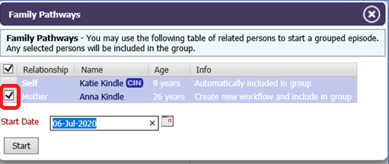
Enter the date you want the episode to start and click the start button
Once started, the task to Start a Complex CIN Episode will be sent to the Complex CIN Group Tray
The IRO picks up the task to start a Complex CIN Episode either from the group tray or from the green pick up button within the episode
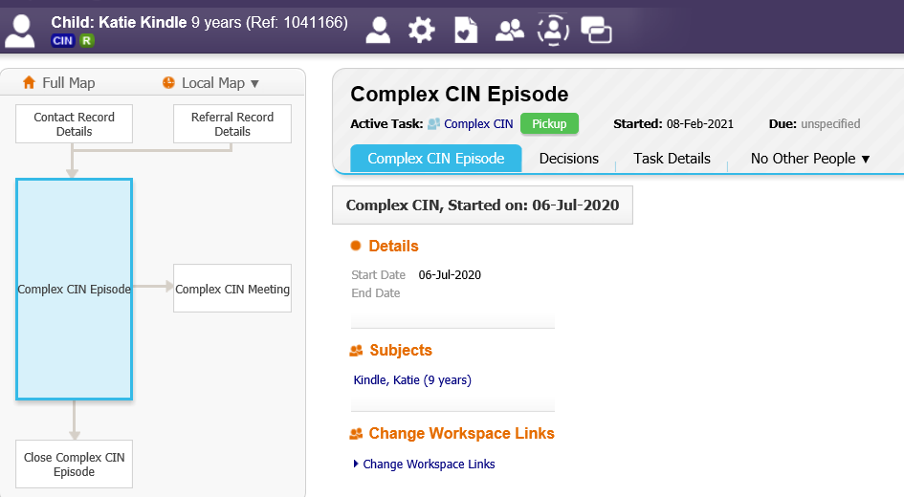
Once picked, the IRO selects the Decisions tab.
There are two decisions available within the Complex CIN Process:
- Start Complex CIN Meeting – this should be used for the first and subsequent Complex CIN Meetings/Reviews
- Close Complex CIN Episode – this should be used to completely end the Episode
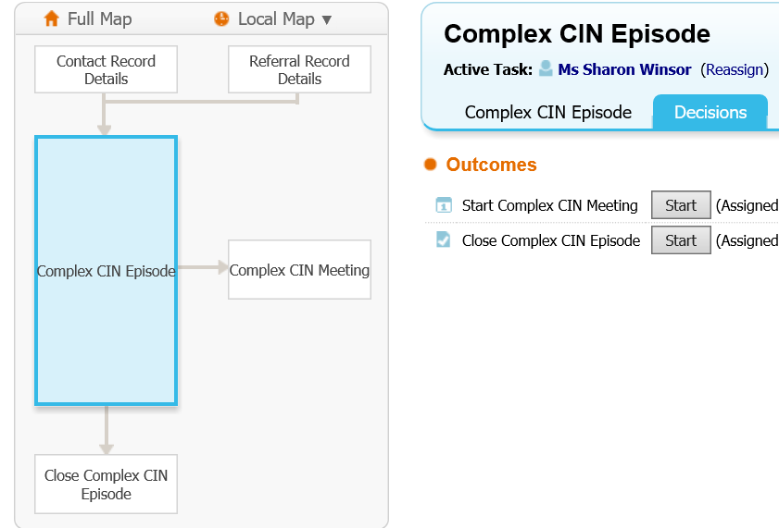

Starting a Complex CIN Meeting

To start the Complex CIN Meeting an involvement role of IRO must be added to the child's involvements.
This will ensure that once started the meeting and the outcomes form will automatically go to the IRO. The Social Work Pre-Meeting Report will automatically go to the Social Worker
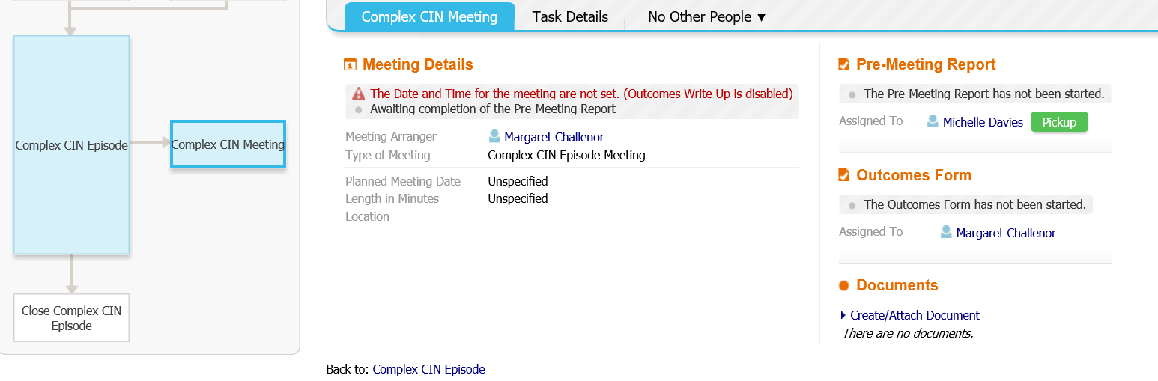
The IRO will get the task in their tray Organise a Complex CIN Meeting
Social Worker with get the task in their tray Complete Complex CIN Social Work Report

Scheduling the Meeting

The IRO selects the task in their tray Organise a Complex CIN Meeting then
updates the Meeting details and scheduling and when scheduled can export the event to their outlook calendar
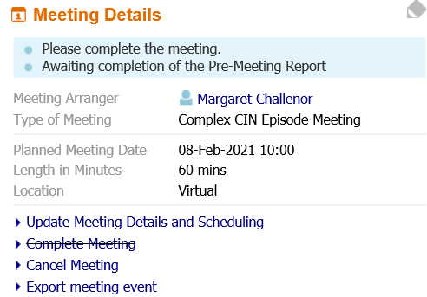

Completing the Pre-Meeting Report

The Social worker selects the task in their tray Complete Complex CIN Social Work Report, then clicks the hyperlink link to write the pre meeting report
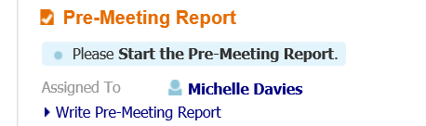
The Social Work completes a brief report for the meeting then finalises the form
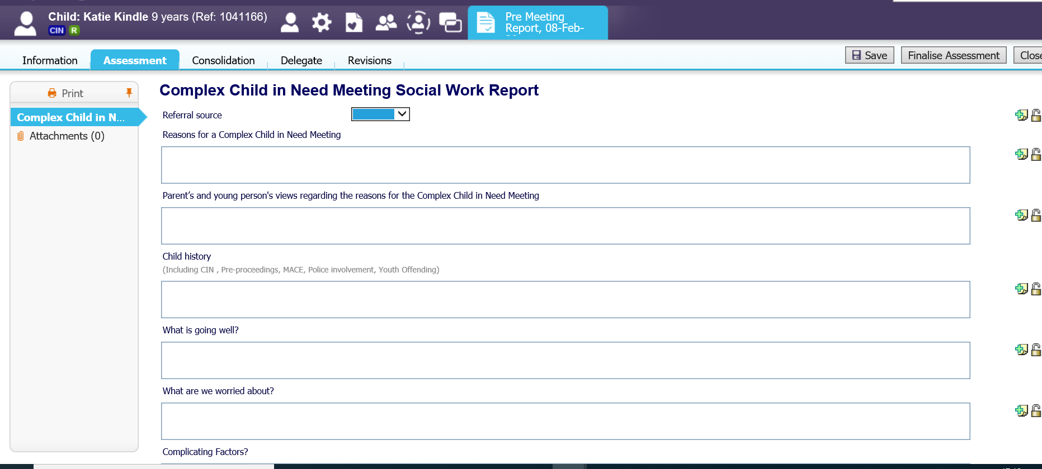
Once finalised the Social Worker Team manager gets the task to approve or reject the pre meeting report
The Team Manger selects the task, clicks the Pre Meeting Report hyperlink to read the report then either
- Approve Report – will complete the task
- Reject Report – sends the task back to the social worker to update the report
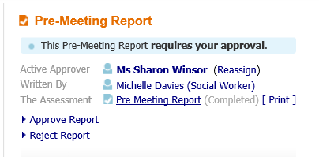

Completing the Meeting Outcomes and Safety Plan

Once the meeting is scheduled, the IRO gets the task in their tray Complete Complex CIN meeting Outcomes
When the meeting takes place, the IRO selects the link Complete Complex CIN meeting Outcomes then clicks the link Meeting Held – Write up Outcomes to record the Outcomes and Safety Plan
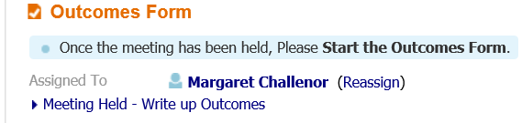
The IRO has to confirm the actual meeting details (excluding time) then clicks update
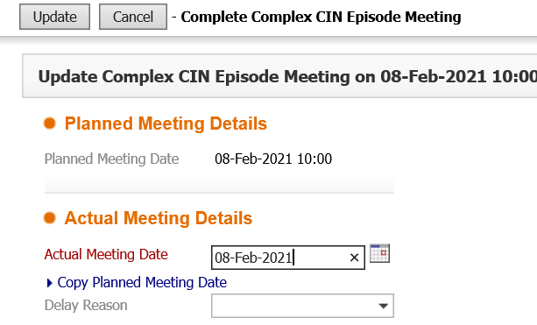
Then completes the Complex Child in Need Outcomes and Safety Plan Form including:
- the details of the meeting including attendees
- Record of Discussion
- Date of Next Complex CIN Meeting/Review of the Safety Plan (if applicable)

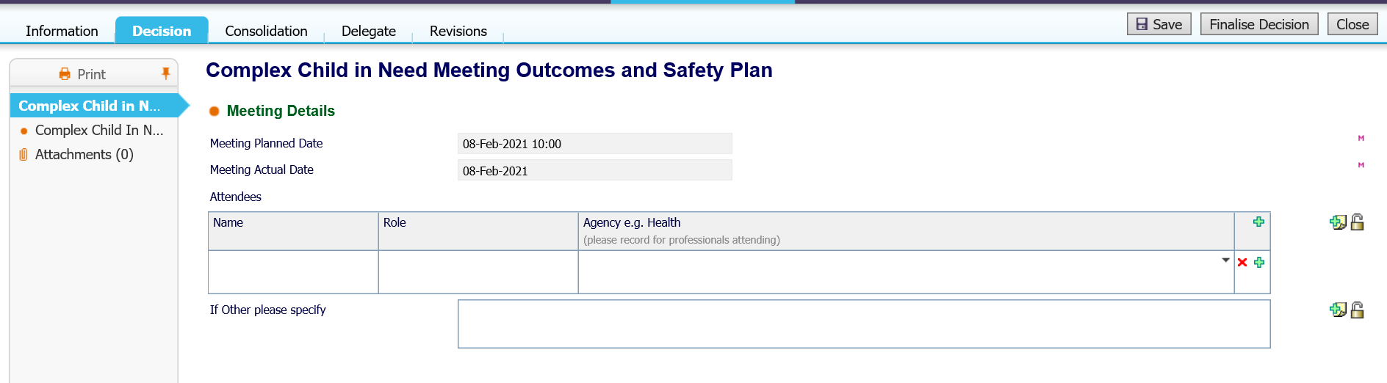
- The Complex Child in Need safety Plan
- The outcome steps i.e.
  - Start next Complex Child in Need Meeting to review the safety plan
  - Continue with exiting process/close to either keep the episode open without scheduling the review at that point in time or to enable the IRO to close the Complex Child in Need Episode
  - Reasons for the outcomes
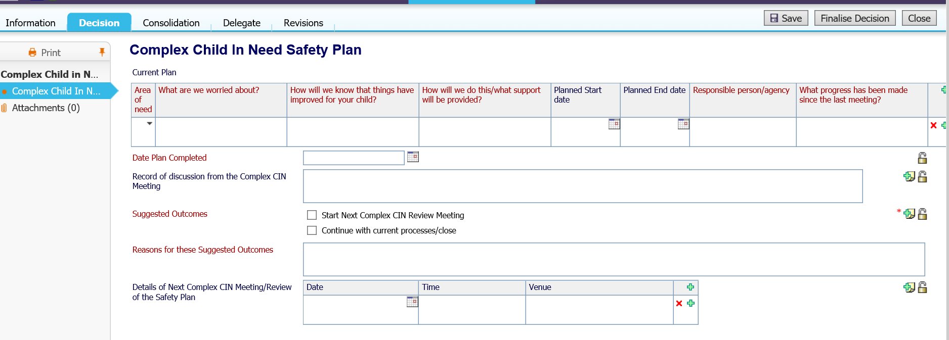
Once complete, the IRO saves the Form then prints a family friendly copy for the family and professionals at the meeting using the Print in Sefton Format hyperlink on the left of the form.

Enter the date that the document is being printed and choose the type Complex CIN Outcomes and Safety Plan
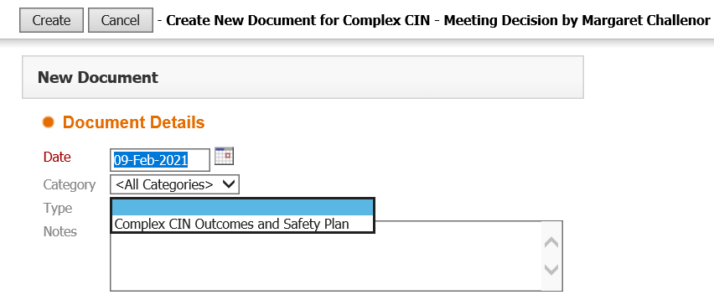
Click Download to download the printed word version of the document
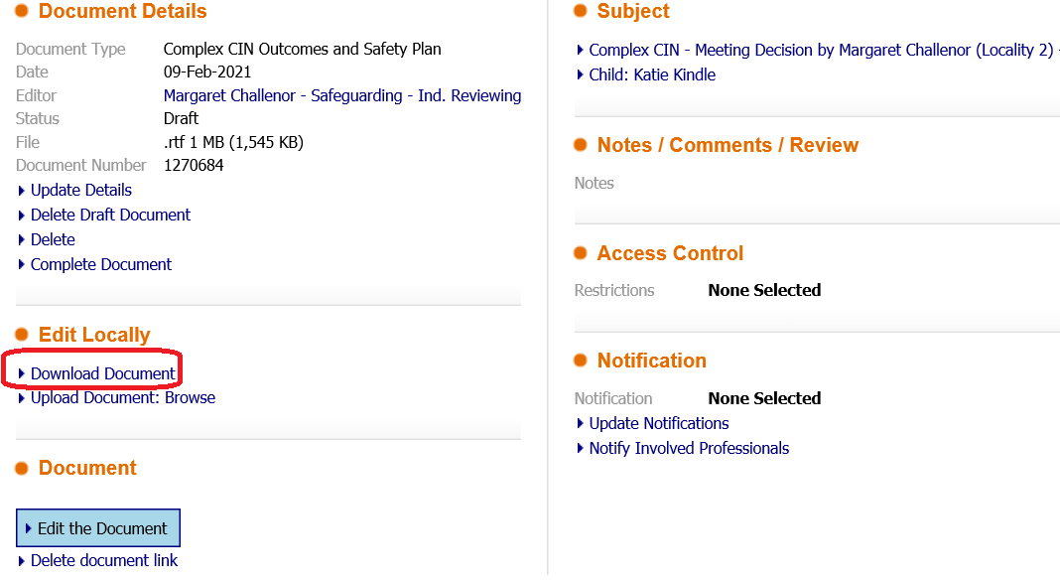

A family friendly document of the Complex Child in Need Meeting Outcomes and Safety Plan will be created to be shared securely with families and professionals.
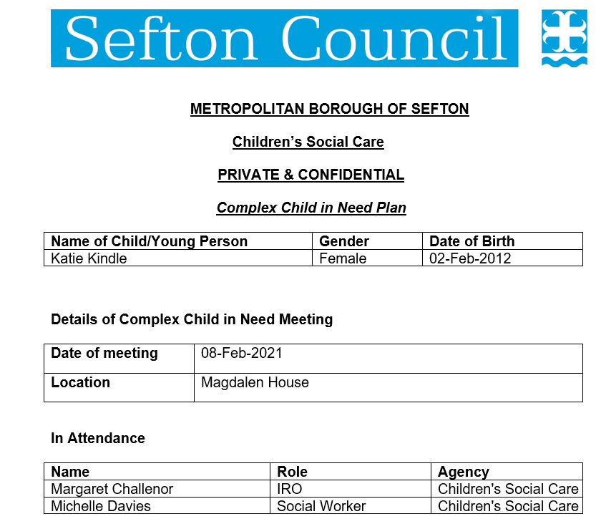
Complete the document
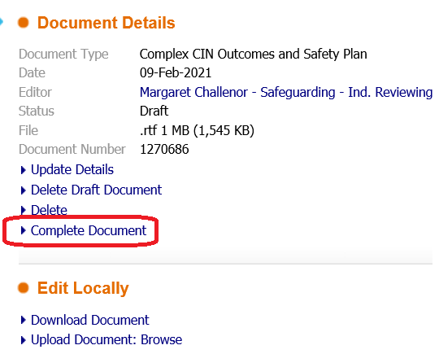
A copy of this document will also be available in the attachment of the form and in the child's documents
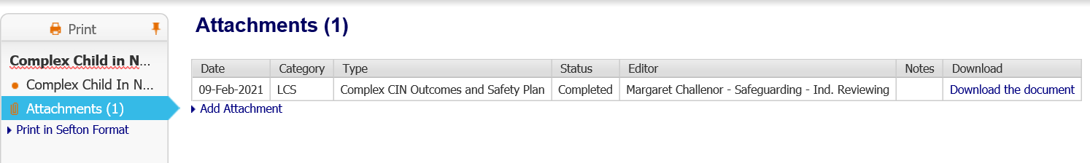
Once completed the IRO finalises the form by clicking Finalise Decisions
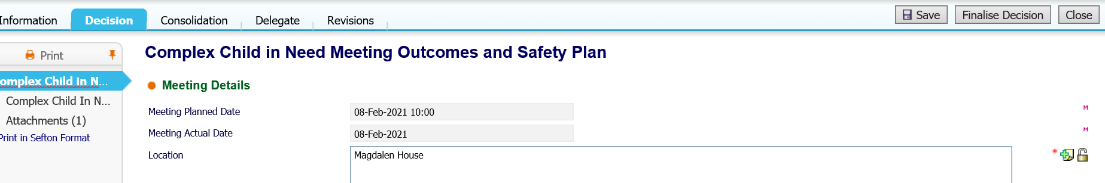
Depending on what Outcome was selected in the form, the IRO will be presented with that Decision to start
Starting Next Complex CIN Review Meeting will start the meeting process again for a future meeting to be scheduled (as process above)
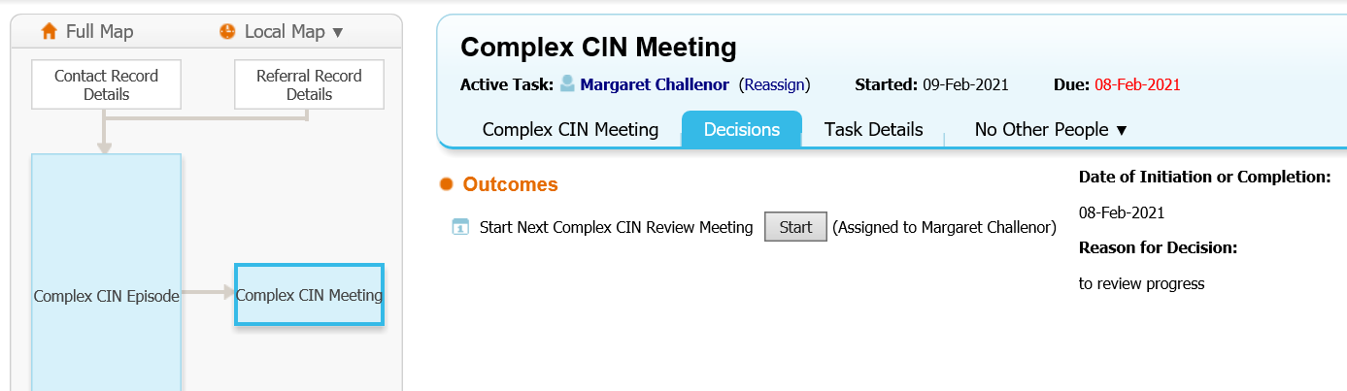
Continue with exiting process/close is a self-completing task which then enables the IRO to either restart a Complex CIN meeting or start the closure process
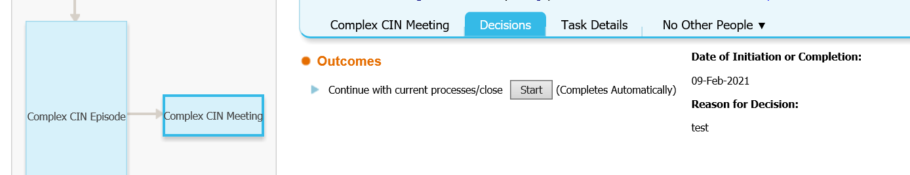

Closing the Complex CIN Episode

To close the Complex CIN Episode, click on the Complex CIN Episode hub, then go to decisions. Click the Start button to the right of the Close Complex CIN Episode Outcome
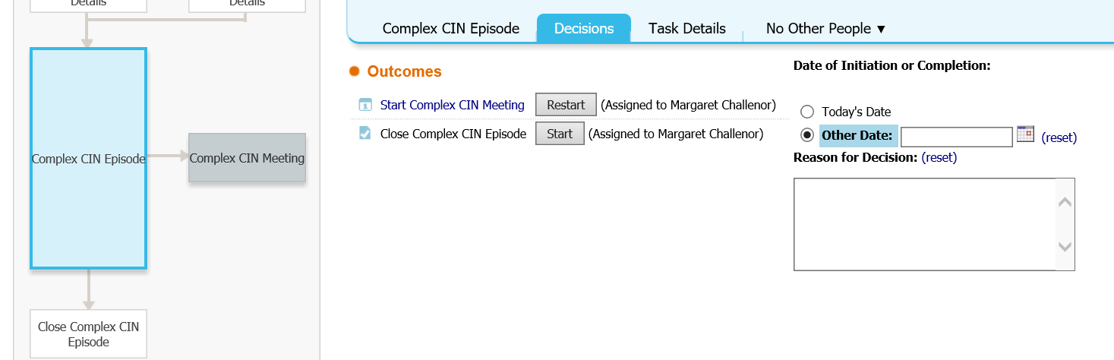
Click the button Start the Complex CIN Episode Closure
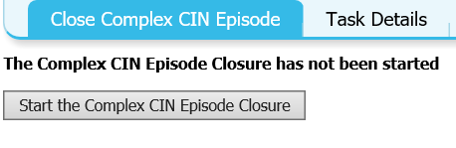
IRO completes the Episode Closure reason and finalises the form
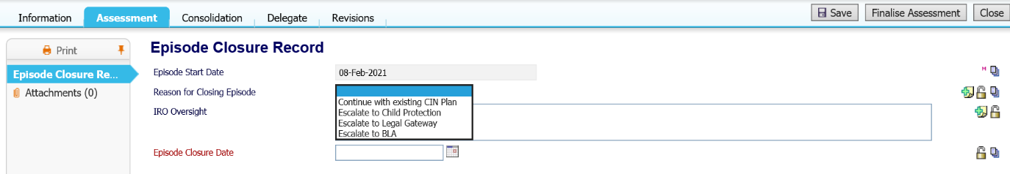
This closes down the Complex CIN Episode
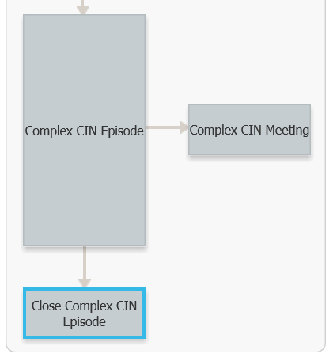
Historic episodes can be access via the Episode tab in the child's record
