How to add hours worked and Social Work England Registration Number to your profile on Liquidlogic.
- Login to Liquidlogic and go to your ‘User’ (1) and pick Account (2) from the drop down list:
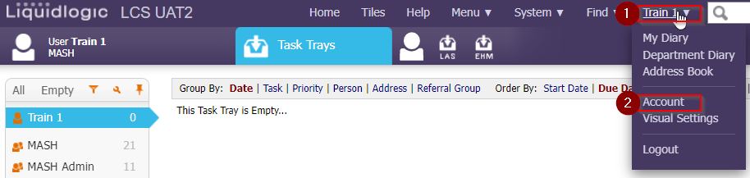

- You will be presented with the following screen, where you will go to ‘Add contact number’ hyperlink:
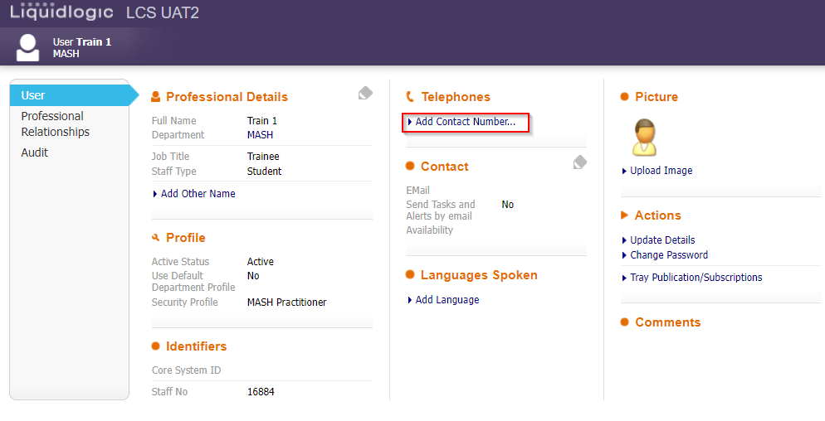
- In the next screen, click on ‘Type’ and pick ‘Working hours’ from the pick list:
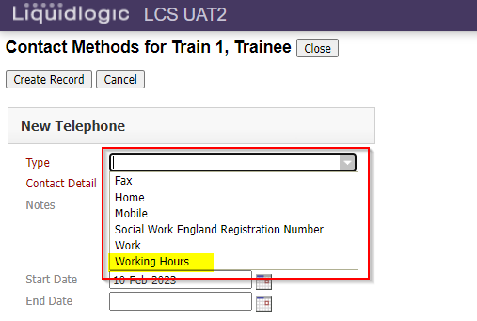
- Once ‘Type’ has been chosen (1), complete the ‘Contact Detail’ field with the number of hours worked per week (2) and click on ‘Create Record’ (3):

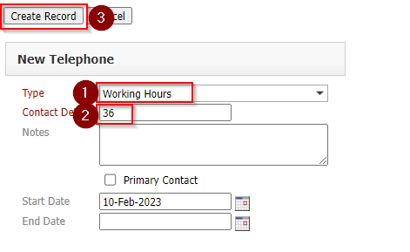
- You have now created record of your contracted hours and you’ll be taken to the next screen, where you can add your SWE Registration number. If you wish to do so, click on ‘New Contact’:
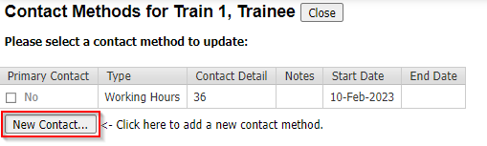
- You will be taken back to Create Contact Methods screen. This time, go to ‘Type’ and pick ‘Social Work England Registration Number’:
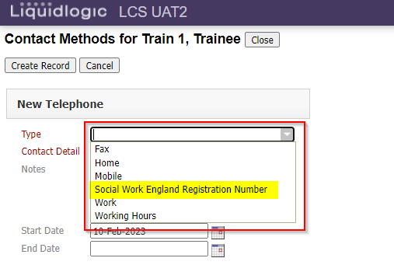
- Once ‘Type’ has been chosen (1), complete the ‘Contact Detail’ field with your SWE Registration Number without the SW pre-fix (2) and click on ‘Create Record’ (3):
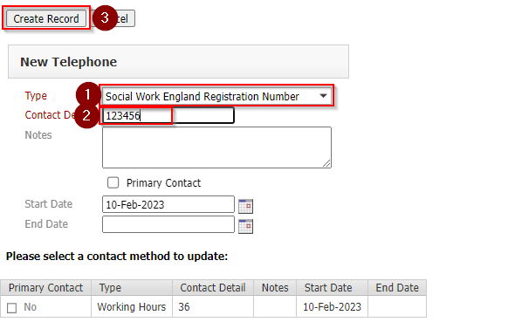
- As you can see, these details have been added and you can now close this section:
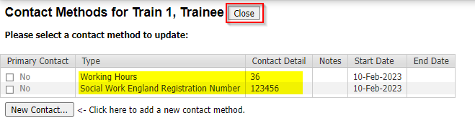
- These details are now visible in your User Account under ‘Telephones’ section:
