Referral Process to Sexual Assault Referral Centre (SARC)

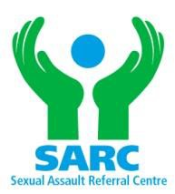
South Yorkshire SARC Referral Form
South Yorkshire Sexual Assault Referral Centre, Rotherham District General Hospital, Moorgate Road, Rotherham, S60 2UD, 01709 427327

Organisation: Contact Name:

Contact No: Email:_

Client Details

Name: D.O.B:

Address:

Postcode: Contact Number:

Temporary address (state whose):

Other contact numbers (state who will answer):

Are they aware of the situation: Yes / No is it ok to leave a message? Yes / No

Are we able to send correspondence to the address given? Yes / No

Brief Outline of referral:

Does the client wish to be contacted by the ISVA/CHISVA Yes/No Concerns/medical issues:
_

Safeguarding referral made? | Yes | No | N/A | (please circle)
DASH assessment completed? | Yes | No | N/A | (please circle)

Submitted by whom:

Client MUST be aware of referral and have given consent. By signing this form you agree that consent has been obtained.

Referrer:

Date Referred:

Signature:

Email this completed form to: sy.sarc@nhs.net

