

JOINT CHESHIRE, HALTON AND WARRINGTON PROTOCOL FOR THE PROVISION OF LOCAL AUTHORITY ACCOMMODATION FOR JUVENILE DETAINEES





Procedure Review Date – April 2021

1.0 Aims

  - The aim of this protocol is to safeguard children and young people through avoiding, so far as is practicable, their detention overnight in police custody following charge and the denial of bail.

1.2 The protocol is also intended to clarify the duties and responsibilities of agencies in the management of arrangements for the transfer to Local Authority Accommodation (LAA) of children and young people (aged 10 to 17 years) charged and denied police bail.

2.0 Scope

2.1 This protocol applies to children and young people (aged 10 to 17 years) who have been charged with offences and refused bail. It does not apply to young people who are charged with breach of bail, breach of the peace or arrested on warrant.

2.2 This protocol represents a voluntary agreement between the following organisations:

- Cheshire Police
- Cheshire West and Chester Council
- Cheshire East Council
- Halton Borough Council
- Warrington Borough Council

2.3 There will be instances where a child resident in one Local Authority Area is held in a custody suite situated within another Local Authority area. To avoid confusion the Local Authority in whose area the child resides will be the responsible authority, but, in the first instance the custody suite where the child or young person is being held will contact the Local Authority for that locality.

2.4 The protocol will be subject to regular review to ensure it is effective in meeting the key aims set out above.

3.0 Background

3.1 Her Majesty's Inspectorate of Probation (HMIP) report 'Who's Looking Out for the Children' (2011) identified a number of significant safeguarding concerns relating to the experiences of children whilst in police detention. Local Authority Safeguarding Boards are responsible for overseeing the recommendations within this report. A key concern identified in the report is the overnight detention of children in police cells after police bail is denied, as opposed to transfer to accommodation provided by a Local Authority (LAA).

3.2 HMIP reiterated that Section 11 of the Children Act 2004, which "places a duty on key people and bodies to make arrangements to ensure their functions are discharged with regard to the need to safeguard and promote the welfare of children," applies equally to the police as it does to NHS bodies, local authorities and YOS. Working Together to Safeguard Children (2013) outlines how agencies should work together to safeguard and promote the welfare of children. This protocol sets out how this will be achieved for children and young people processed through police custody.

In conclusion, the HMIP report ‘Who’s Looking Out for Children’ stated that: “…the children and young people who are processed through police custody are potentially the most vulnerable of the vulnerable, and the least able to represent their own best interests, control their behaviour, and communicate their needs.”

4.0 Legal Context

4.1 Police Powers to Deny Bail

4.1.1 When the police decide they have sufficient evidence to charge a child or young person with an offence, they have a number of options (depending on the circumstances) and any final decision would be undertaken in consultation with the relevant Youth Offending Service (YOS).

4.1.2 Under the Bail Act 1976, there is a general presumption that bail will be granted without conditions but there are exceptions that apply to children and young people as well as adults. Section 38 of the Police and Criminal Evidence Act (1984) (PACE) stipulates that, where the police charge a child or young person with an offence, the custody officer must decide whether to grant or deny bail (with or without conditions).

4.1.3 PACE specifies that a person may be refused bail and continue to be detained following charge if the custody officer believes the person would:

• Fail to appear in court
• Commit further offences

Or it is necessary:

• For their own protection
• To prevent harm to others
• To prevent interference with justice/investigation, or
• There is doubt about their identity/name & address

Additionally, for a child or young person:

• If the custody officer believes that he ought to be detained in his own interests.

4.1.4 Section 38 PACE (1984) details the requirements that a custody officer must consider before deciding to detain a person after he/she has been charged: Where a custody officer authorises an arrested child or young person to be kept in police detention under subsection (1), the custody officer shall ensure that the arrested child or young person is moved to local authority accommodation unless he/she certifies -

(a) That, by reason of circumstances as are specified in the certificate (PACE 5
Certificate of Youth Detention - Appendix C), it is impracticable to do so;

It is acknowledged that whilst thick fog/heavy snow/ no available beds within a reasonable distance may meet the impractability test as defined in the Home Office circular 78/1992, a suspicion that he/she would abscond would not.

The Local Authority has sole discretion as to the type of accommodation provided and Home Office Guidance states this is not a factor the custody officer is allowed to consider when deciding if the transfer is 'impracticable'.

(b) Police request secure accommodation due to the serious nature of the offence— In the case of an arrested juvenile who has attained the age of 12 years, and where no secure accommodation is available and that keeping him/her in other local authority accommodation would not be adequate to protect the public from serious harm from him/her, then the rationale will need certifying before the next available court

(PACE) 1984 states that 'serious harm for a juvenile (charged with a violent or sexual offence) shall be construed as death or serious injury, either physical or psychological'. (This represents a very high threshold to pass and in reality is seldom met.)

4.1.5 In order to ensure compliance with PACE, the certificated reasons will be provided to the court in all cases where a juvenile remains in custody. This shall be produced to the court before which he/she is first brought.

.
4.2 Local Authority Duty to Accommodate Child on Police Request

4.2.1 Section 20 of the Children Act 1989 directs that the Local Authority has an absolute duty to accept the child or young person in response to a request from the police made under Section 38(6) PACE 1984.

4.2.2 It is for the Local Authority to determine the type of accommodation prodded taking into consideration the best interest of the child or young person. The response should be proportionate in relation to identified risks.

4.2.3 Agreement should be reached between agencies in terms of arrangements for transport.

4.2.4 If the child has attained 12 years of age and it is necessary to protect the public from serious harm a request for secure accommodation will be made to the Local Authority. A clear rationale for the request will be provided to them.

4.2.5 When a child or young person is refused bail, immediate contact must be made with the Local Authority Children’s Social Care Service during office hours and the children’s social care Emergency Duty Team (EDT) out of hours when requesting appropriate accommodation under the above.

4.2.6 The Custody Officer shall make a detention log entry detailing to whom they spoke and the outcome, including the reasons why appropriate accommodation cannot be provided. A similar record of the discussions shall be kept by the Local Authority. The Law does not recognise or allow a situation in which secure accommodation is not required and yet a child remains in police cells post charge. In such circumstances the Local Authority has an absolute duty to provide accommodation when requested (Children’s Act 1989 Section 21 (2b).

5.0 Arrangements for transfer

5.1 During normal office hours of 9am and 5pm, Monday to Friday, Police shall contact the court to establish if the young person will appear before 5pm.

5.2 If, within normal office hours (above), the court indicates that this will not be possible, the police should contact the Local Authority Social Care Team directly to request a transfer to local authority accommodation.

5.3 Outside normal office hours (above) all requests for transfer should be made to the relevant Emergency Duty Team (EDT).

5. 4 The Police must nevertheless make *arrangements for the transfer of the young person to local authority accommodation in every case unless:
- It is impracticable
- There is a risk to the public of serious harm from that juvenile and no secure accommodation is available.
*The actual physical transfer of the juvenile detainee away from the custody block to the alternate accommodation shall be the responsibility of the Local Authority. However, it is recognised that should such transfer prove impossible in any circumstance, Cheshire Police will seek to assist.

5.5 The lack of secure accommodation does not provide a justification for not transferring the young person to local authority accommodation unless the young person is charged with a violent or sexual offence and there is evidence of a risk of a further offence resulting in 'death or serious personal injury.' In such cases, the police shall consult with the relevant EDT who have indicated that secure accommodation cannot be made available.

5.6 Should police make the decision not to transfer a young person to local authority accommodation, the reasons under the PACE Code of Practice (16.10) shall be clearly recorded on the form PACE 5 which must be sent (fax\secure email) to the local YOS and presented to the court the next morning.

5.7 If the charging decision is made by the police late at night it is acknowledged that transfer to Local Authority accommodation will be more challenging but may still be in the best interests of the child or young person. The Local Authority should be informed of any situations where a Child is thought likely to be remanded as far in advance as possible enabling them to make enquiries in advance. This should be documented by the Police and the Local Authority and these decisions should also take account of the child’s individual circumstances and the location of Local Authority accommodation. The decision shall be clearly recorded and any requests made very near to this time should ensure that the young person is ‘transfer ready’.

5.8 Where a young person originates from Cheshire, Halton or Warrington, police will contact the Local Authority or EDT (out of hours) relevant to that custody suite. Once notified, the Local Authority will in turn notify the responsible Local Authority for them to take responsibility for delivering the requirements of this protocol.
5.9 If the young person requires medical assessment or treatment whilst detained the police will ensure that it is provided, in line with current custody health care arrangements.
5.10 The Local Authority and Cheshire Police will work together to ensure the placement provider receives sufficient information about the child or young person to ensure they can meet their needs and deal with any presenting risks.
5.11 The Police will complete and provide the placement provider with a copy of the form PER Form (Prisoner Escort Record), to provide relevant information to the placement.
5.12 The Local Authority will make arrangements, appropriate to the accommodation arrangement put in place, to transport the child or young person to the next available court.
5.13 EDT must notify the YOS by email/phone of all cases where the transfer to local authority accommodation did not take place and the rationale given by the police.
6.0 Escalation
6.1 It is acknowledged that on occasion there might be a disagreement between Local Authority social care staff and Police custody staff on how a child or young person should be dealt with under the protocol. If matters cannot be resolved either party shall request that matters are escalated for review by senior officers.

6.2 The Duty Custody Inspector with responsibility for the custody suite where the child or young person is held shall perform this role for Cheshire Police. A senior Children’s Social Care/ EDT Manager (time dependent) shall provide this function on behalf of the Local Authority.

6.3 Both parties shall ensure an accurate record of any escalation is kept.

6.4 Ultimately, the Local Safeguarding Children Board oversees practice and performance across the partnership; therefore practice, performance or unresolved escalation matters should be referred to the responsible LSCB for review without delay.

7.0 Monitoring and Review

7.1 This protocol shall be kept under regular review to ensure that it delivers it key aims, in particular reducing to a minimum the numbers of children and young people detained in police custody. A formal review of the document will be undertaken every 12 months.
7.2 Local Authority Safeguarding Boards have a key role to play in monitoring the numbers of children and young people denied bail and the effectiveness of this protocol in meeting their needs.
7.3 Cheshire Police will provide regular data reports on the numbers of children and young people detained by police; those denied bail and those for whom accommodation is requested from the Local Authority. This data will support the monitoring arrangements put in place by the LSCBs to determine the effectiveness of this protocol in safeguarding children and young people.

8.0 Authorisation

8.1 This protocol has been authorised by each of the participating agencies as set out below.

………………………………………
Signed on behalf of Cheshire Police

Date.………………………………..

……………………………………...
Signed on behalf of Cheshire West and Chester Council

Date………………………………...

………………………………………
Signed on behalf of Cheshire East Council

Date…………………………………

………………………………………
Signed on behalf of Halton Borough Council

Date ………………………………..

………………………………………
Signed on behalf of Warrington Borough Council

Date …………………………………

……………………………………….

Appendices

Appendix A – Local Authority Process for Secure Accommodation (CH&W protocol)

Appendix B – Revised Procedure for dealing with Youths after Charge (CH&W protocol)

Appendix C - PACE 5 - Youth Detention Record

Procedure Review Date – April 2020
Appendix A - LA Process for Secure Accommodation
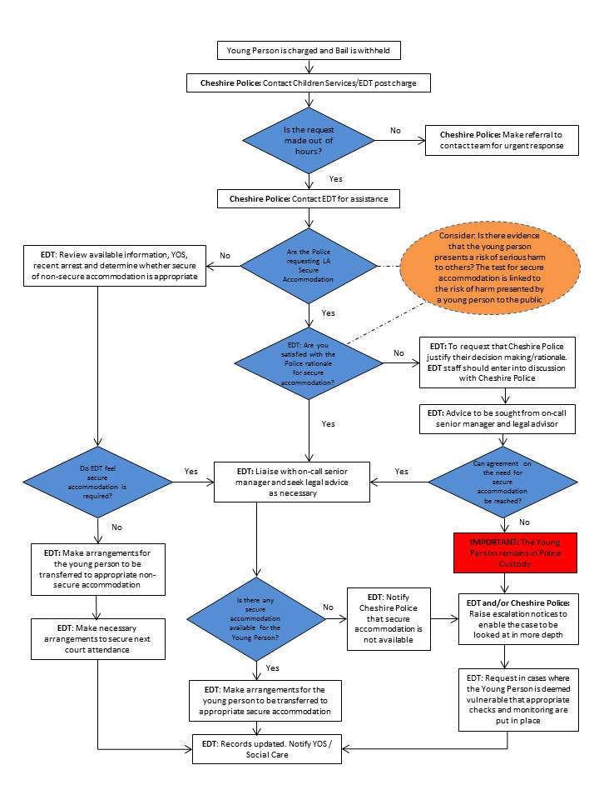
Process Map – Procedure for Dealing with Youths after Charge
To Comply With Legal Aid, Sentencing and Punishment of Offenders Act 2012 (LAPSO)
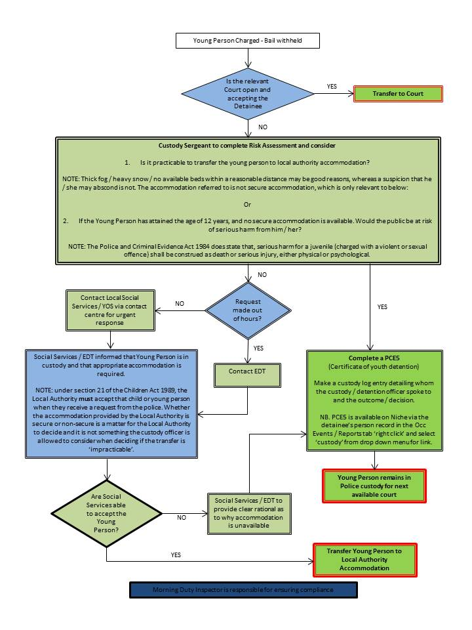
Are Children’s Social Care able to accept the young person?
Childrens Social Care to provide a clear rationale as to why this is not possible.
Children’s Social Care/EDT informed that Young Person is in custody and that appropriate accommodation is required.

Note: under section 21 of the Childrens Act 1989 the Local Authority must accept a request from the Police. Whether the accommodation provided by the Local Authority is secure or non-secure is a matter for the Local Authority to decide and is not something the custody officer is allowed to consider when deciding if the transfer is ‘impracticable’.
CHESHIRE POLICE

CERTIFICATE OF DETENTION
‘YOUTH’

Case Number:
From: The Custody Officer |  |  |  | To: *The Clerk to the Justices
Station:
 |  |  |  | *The Care Officer
Date:
Detained Person : |  |  |  | Date of Birth:
Charged With :
Or
In need of care or control
Court: |  |  |  |  | Date:

The Custody Officer hereby certifies that the above named person (who has apparently attained the age of 12 years) has been detained in police detention for the following reasons:

* His/Her name or address cannot be ascertained. (The Custody Officer has reasonable grounds for doubting whether a name or address furnished by him/her as his/her name and address is his/her real name and address).

* The Custody Officer has reasonable grounds for believing that the detention of the person arrested is necessary for;
His/Her own protection
To prevent him/her from causing physical injury to any other person
To prevent him/her from causing loss of, or damage to property

* The Custody Officer has reasonable grounds for believing that the person arrested;
Will fail to appear in court in answer to bail
That his/her detention is necessary to prevent him/her from interfering with the administration of justice
That his/her detention is necessary to prevent him/her from interfering with the investigation of offences or of a particular offence

* The Custody Officer has reasonable grounds for believing that he/she ought to be detained in his/her own interests.

AND

* The Custody Officer believes that it is impracticable to detain him/her in authority accommodation
OR

* The Custody Officer believes, in the case of a young person aged 12 or more, the public is at risk of serious harm if he/she is not detained in secure accommodation in which he/she could be placed.

Signed:

* INDICATE AS APPROPRIATE

