Multi-Agency Hoarding Panel Referral Form

This referral form should be used as per below criteria:
- Individual won't engage or accept support.
- Safeguarding, risk or care plans have not led to risk reduction.
- Two or more safeguarding concerns raised.
- Support for partner/agency engagement is required.
- Clutter rating scale is 7 or above.
- If the person is subject to another risk process panel complete hoarding referral stating which risk panel person is known to and if representation of hoarding panel member is required and why
- Care co-ordinator or allocated worker should make the referral to Hoarding Panel (where possible).

If there is no evidence that the criteria have been met or there is insufficient information the referral will not be considered and will be returned to you.

Completed referral forms and queries should be sent to multiagencyhoarding@bedsfire.gov.uk

Please continue to support the person that you have referred. Any support from the Multi Agency Hoarding Panel is in addition to what you are already doing and not instead of.

All blue sections of the form must be completed.

Action Already Taken (MUST BE COMPLETED!)
Actions: | Yes  No | Date Completed:  Completed by: | Applicable; unable to complete, state reason:
Two safeguarding concerns raised: |  | Date:  By whom:  Date:  By whom:
Multi-Agency Hoarding Panel Risk Assessment completed and attached: |  | Date Completed:  Completed by:
Clutter rating scale of the most cluttered room: |  | Date Completed:  Completed by:
Care co-ordinator or allocated worker identified: |  | Name:  Contact E-mail:
Mental capacity (Please consider executive capacity) assessment re: hoarding: |  | Date Completed:  Completed by:
Alternative risk groups considered: |  | Group considers:
Best practice from other agencies utilised:  (Examples include social care assessment, mental health support, health check from GP, home fire safety visit) |  | Details:

Referrer Details:
Date of referral:
Name:
Job title:
Organisation:
Involvement with client
Contact details: | Email: |  | Tel:

Details of the Person to be Referred
Name:
Address:
Date of birth:
Gender:
Preferred language of communication:
Has the person being referred consented to this referral? | Yes: |  | No:
If not, why not?

Has a mental capacity assessment taken place? | Yes: |  | No:
If yes, what was the outcome?
If no, why not?
Please include any other additional information relating to mental capacity, e.g., has executive capacity been considered?

Is the client subject to another risk group panel? | Yes: |  | No:
If yes, do you want to request for a panel member to attend the already ongoing risk panel meeting. | Yes: |  | No:
Name and contact details of risk panel group.
If they are not subject to another risk group panel, why not? E.g., previously discharged for non-engagement.

Does the person have care and support needs arising from:

Physical Disability, Frailty |  | Learning Disability
Sensory Impairment |  | Substance/Alcohol Misuse
Mental Health |  | Dementia
Neurodiversity (Autism, Autistic Spectrum, Attention Deficit Hyperactive Disorder, Tourette Syndrome, etc) |  | Medical or Health issues
Other (Please describe):

Support Needs
Are these needs being effectively managed?
If yes, how?
If no, why not?
Please explain how the health needs and hoarding are impacting each other?
Do they have social care needs? | Yes: |  | No:
Explanation of social care needs.

Are these needs being effectively managed?
If yes, how?
If no, why not?
Please explain how the social care needs and hoarding impacting each other?

Property Details
Number of people living in the property:
Number of children under 18 living or regularly visiting the property:
Are there any animals in the property? |  | Yes: |  |  | No:
Types of animals?
How many animals?
Are the animals considered to be at risk? |  | Yes: |  |  | No:
How has the risk to the animals been reduced?
e.g. referral to RSPCA
Do any other occupants have health and or social care needs? |  | Yes: |  |  | No:
If yes, please explain:
Property type:  (House, flat, maisonette etc.) |  | Type of tenure:  (Privately rented, owner occupier etc.)
Landlord details (if known/relevant)
Does anyone in the household smoke? |  | Yes: |  |  | No:
Type of fuel supply:
(Examples include gas, electric, wood burner)
Are amenities accessible and in use? E.g. bathroom, heating, water

Desired Outcomes
What is the referrer hoping to achieve from this referral?
What would the person being referred like to happen (if anything)?

Hoarding Clutter Scale:
Please select the photo that most accurately reflects the amount of clutter in the most cluttered room within the household:

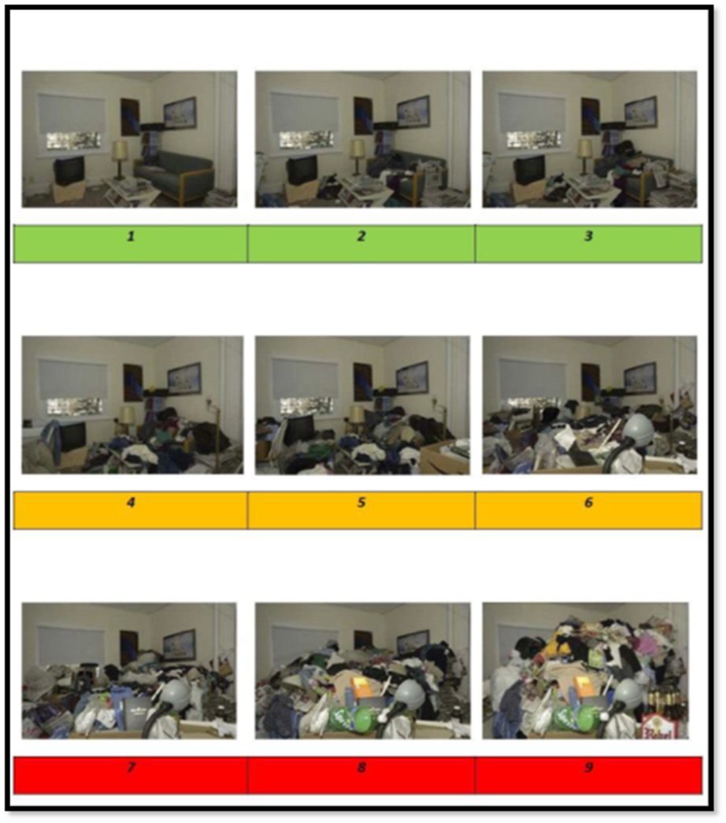

To be completed by the Multi-Agency Hoarding Panel as part of the triage process.

Multi-Agency Hoarding Panel Decision Outcome
Will this case proceed to an initial panel meeting?  If yes complete Key Professionals details. |  | Yes: |  | No:
If no, why not? E.g. additional information required.

Comments and signposting

Case number
Date of meeting
Meeting attendees

Other Key Professional’s to be Invited to the Panel Meeting:
(To be completed post triage)
Name:
Job title and organisation:
Contact details: | Email: |  | Tel:

Name:
Job title and organisation:
Contact details: | Email: |  | Tel:

Name:
Job title and organisation:
Contact details: | Email: |  | Tel:

NOTE: Once hoarding triage is completed the completed referral form will be returned to the referrer.

