Appendix 3: Form to Document Case Identified Requiring Escalation for the Purposes of Safeguarding a Child/ren

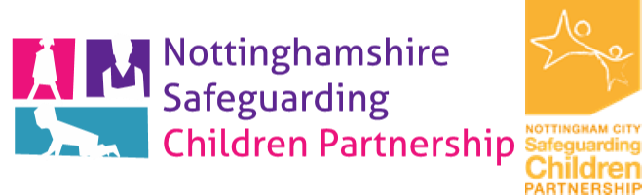
Please use this form to record cases requiring escalation at Staged Four, under the Nottinghamshire and Nottingham City Safeguarding Children Partnership Escalation Procedures and send a copy to your Safeguarding lead within your organisation and a copy to the safeguarding children partnership.

STRICTLY CONFIDENTIAL
Case Identified Requiring Escalation for the purposes of Safeguarding a Child/ren

Name of child/ren of concern | Date of birth | Address

Name of significant adult/s involved | Date of birth | Address | Relationship to child

Name of Professionals involved | Designation | Organisation | Contact No

Summary of initial concerns identified by practitioner (please embed the original referral form if this form is being used electronically)

Details of the Manager of the partner organisation and outcome of discussions.

Issues resolved? Yes/No
If unresolved, record details of subsequent management discussions including agreed actions and timescales should be recorded below (please use a continuation sheet if required)

Final outcome and resolution please summarise below (include date and time)

Signature of staff member completing this form
Printed name:
Designation:
A copy of this form should be placed in the records of all relevant children and/or adults
Please send a copy of this form to your safeguarding lead and a copy to the safeguarding children partnership.
Nottingham City: safeguarding.partnerships@nottinghamcity.gov.uk
Nottinghamshire County Council: info.nscp@nottscc.gov.uk

