Family Time Guidance

For Children, Young People and Families

Version 2 March 2022

**Introduction**

We want to make sure you get to spend quality time with the people who you love and care about including family, friends or people in your community. It may be referred to as *‘contact’,* ‘*Family Time’* or *‘Family Seeing’.* This guidance is for you and us to see how we can work together to make sure everyone is safe and happy when spending time together

It will cover things like:

* What makes good quality time with the people you love and care about
* How you can prepare for this time and who you will need to speak to
* Who is around to support you – this is called a network
* How we can make sure everyone is safe
* How we can communicate with each other

Your worker will be happy to answer any questions you have about what you have read in this guidance or about spending time with the people you love and care about

**Your time with those you love and care about:**

Family time is your time to see and have fun with those you love and care about so it should feel special. We wanted to know what makes good quality family time and how you would like it to work, so we spoke to some children and families to hear their ideas. These can be seen below:

|  |
| --- |
| What makes good quality time with those you love and care about? |
| * Parents, carers and young people wanted a mixture of virtual and face to face contact for Family Time – they valued the flexibility of virtual contact but felt it was difficult to maintain a relationship without physical contact * Both parents and children expressed an interest for more frequent Family Time, with children expressing how they treasured the time they could spend with their birth family * Children wanted Family Time to feel more ‘natural’ – they suggested activities such as playing football, seeing their pets and playing games with their family as it would feel less formal * Parents and carers shared the opinion that they should work together for the sake of the children – parents felt that organising Family Time directly with the carers was easier than going through a social worker * Carers felt they needed more control over family time, such as the ability to prolong or stop contact in response to the child’s needs |

One of the most important things you told us was that you wanted more control over how they spent their time with those you love and care about, to make it feel more natural to you as a family. We want to understand how we can safely ensure that relationships, feelings of love and belonging are always a priority and that we offer time with each other in a variety of ways to keep you all connected as family, network and community. This will look and feel different for all families, but let’s think about the possibilities and plan together.

Here are some of the things that we would like to discuss with families.

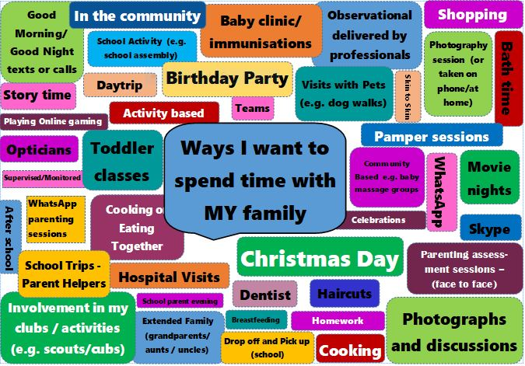**Preparing for time spent with those you love and care about:**

Before we set up time between you and your child/ren we will help organise a conversation (previously called an ‘icebreaker conversation’) between you and your child’s carer. The purpose of having these conversations is to help you and your child’s carers get to know each other and start building a positive relationship. Conversations should focus on your child and look at sharing important information about them, such as their home setting, routine, needs and likes and dislikes. They can also focus conversations around what you would like the time you spend with them to look like. This can be done virtually or face to face, whichever suits you and your family best.

We spoke to some families who have had icebreaker conversations to find out what how they found them. This is what they said:

*I met [my daughter’s] foster carer...she was lovely...it is nice to know who your children are living with. It puts your mind at ease...* (Mother)

*I can't fault the foster carers …They’ve done everything and more that I've asked them to do with my child. They’ve stuck to the routine that she’d got into...the foster carers actually gave me a bunch of flowers for Mother's Day... it means a lot…I can see that my child is happy. (Mother)*

*If [my children] see us getting along, then they are getting along with the carers and listen to them as well. With them being teenagers, because they see us get on, they get on. (Mother)*

*I've seen his room. It's nice...We actually had another meeting yesterday to plan different visits...they are lovely they let us ring when we want and let him ring us when he's in the mood to ring us...* (Grandmother, grandchild in children’s home)

*Mum was able to share exactly what the children like...what they didn't like, their routine...the older little girl she likes to play with certain toys. (Foster carer)*

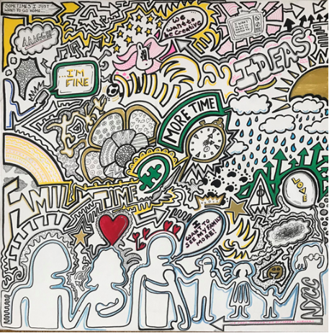

Visual representation of Young People’s views on Family Time

Below is some guidance about how these conversations will work:

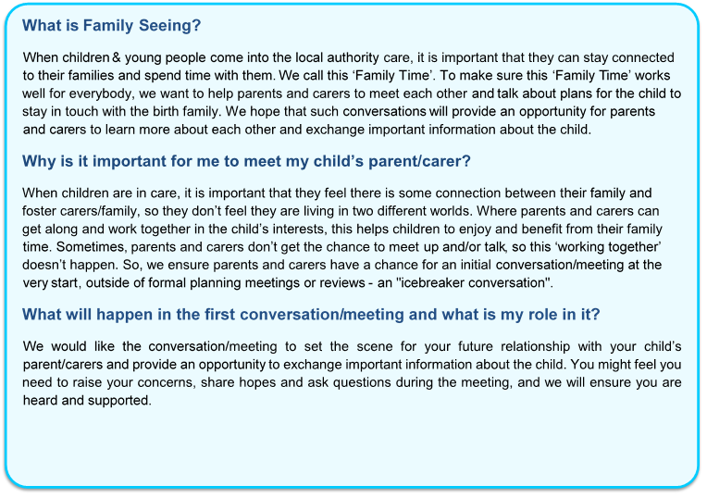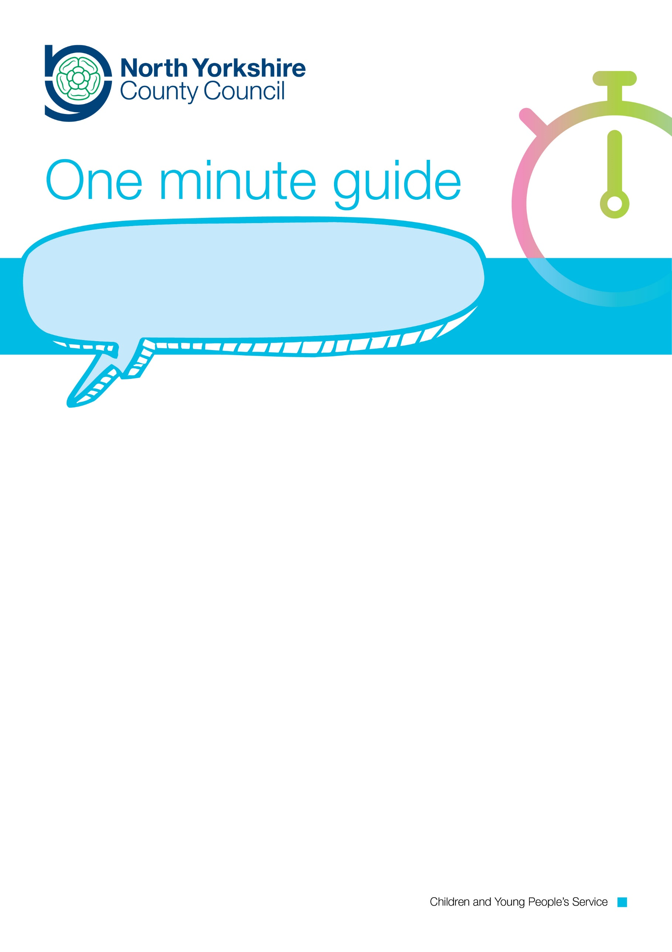

FAMILY SEEING

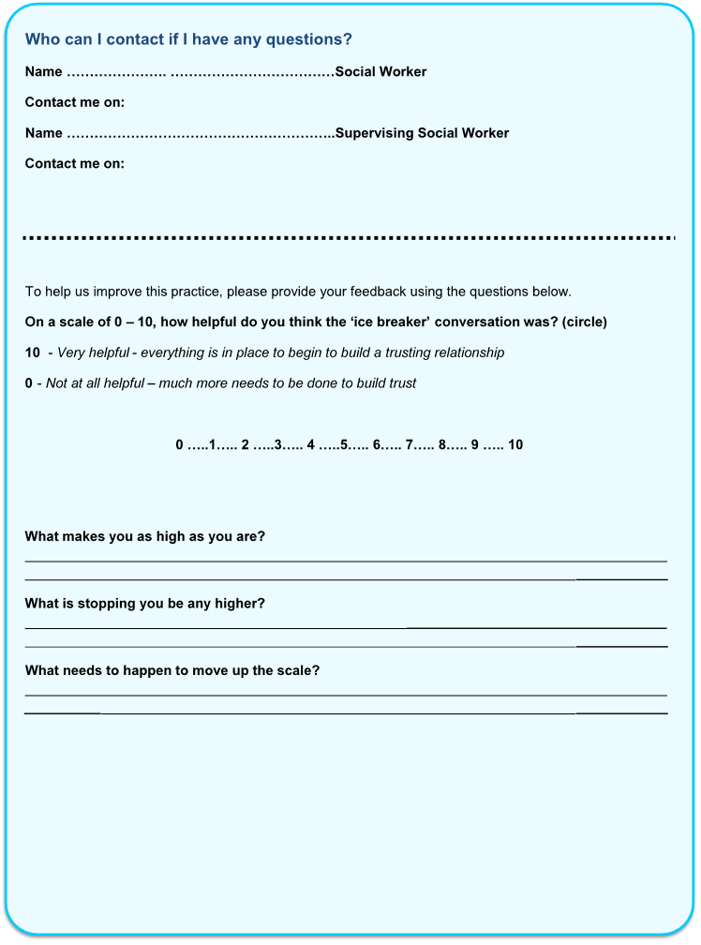

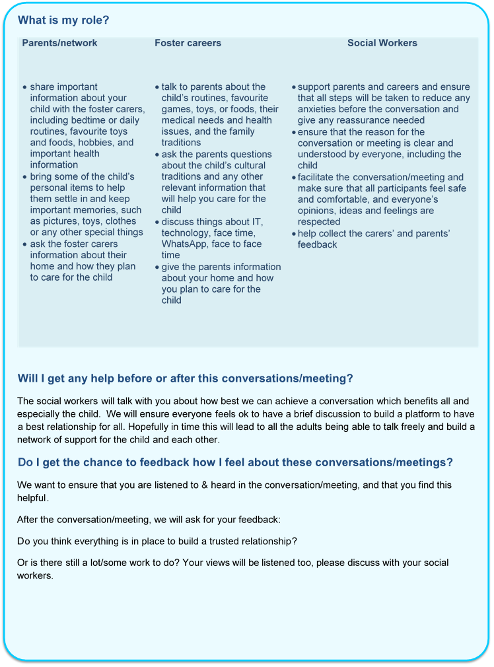

**Spending Time Together**

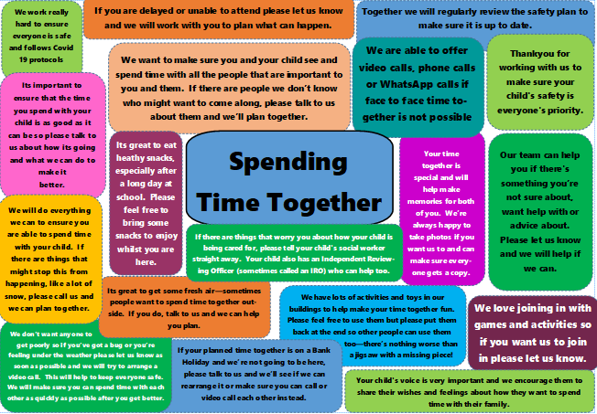

**Who will be there to support me?**

As well as your worker, we will also help you to set up a network when we start working with you. A network is a group of people with a connection to you, your family and your children. For example, it could be friends, other family members, neighbours or pets! We will help you to hold gatherings with your network. They don’t need to be big or formal, a friend sat on the sofa with a cup of tea is a gathering! They are there to support you and your family so they will need to know anything that you or your children might be worried about and what to do if they are worried. Their priority is to make sure that the children and young people are safe and happy. We would like to aim to have network gatherings with you and your people about aims, aspirations and hopes for the future. Building momentum to have children returned to their family of origin if safe and agreed.

|  |  |
| --- | --- |
| What do workers need to know about your network? | What does your network need to know from your workers? |
| Who do you want to include in your network? | What the concerns are for the children and young people in your family, including any risk or requirements for safety. |
| Is there anyone you don’t want in your network? | Your strengths in looking after the children |
| Who would the children/young people want or need to include in their network? | How the network has helped keep your family safe in the past |
| Is there anyone the children/young people wouldn’t want in their network | What needs to happen to close your families’ file |

The picture below shows some examples of the questions we might ask you to help you decide who you would like in your network You don’t need to wait for us, you can start thinking about these questions in your family and start building your own network!



Who might love you?

Who could learn to love you?

Who loves you?

Who do you love?

Who taught you about love?

Who taught you about belonging?

More information about networks can be found at the end of this booklet

**Networks and Safety Planning**

Networks should be involved in the safety planning process so they are aware of any good times, successes, worries or danger. They can then agree to help at specific times or in specific circumstances to keep the children and young people safe when things are difficult. When your plan is agreed and ready, you and your network can test the plan out and make any changes you need. We will help you, your family and your network to finalise the plan and encourage Words and Pictures to be used to explain the plan to children. When we are confident the plan is working, your network can take responsibility for it. When we write up your network plan we will use your words and language to make sure it makes sense to your family. An example of a safety plan can be found at the end of this document:

**Words and Pictures**

We can help you to make a Words and Pictures to help you explain situations to your children and family. The example below was used to explain what was happening with Family Time during the pandemic:

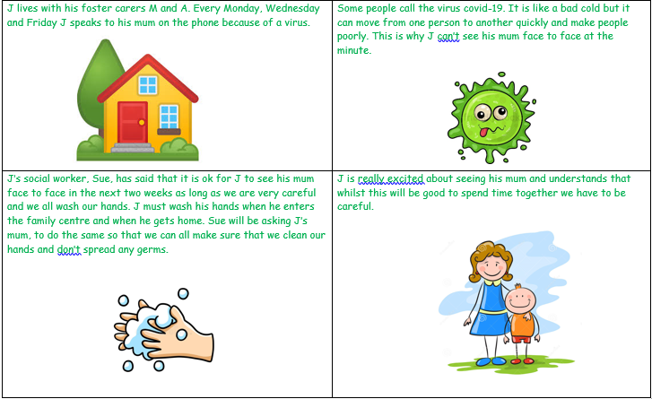

Words and pictures are an opportunity for you a parent or carer to explain to your child/ren what is happening in your words. It is good to include:

* Who is worried
* What they are worried about
* What happened
* What we are doing about it

We can support you with this but it would be great for you to consider what words and pictures you would like to include. For example, you could use Words and Pictures to help explain to your child how your network are going to be involved and how you will be spending time together in the future

**Mind Of My Own:**

[](https://mindofmyown.org.uk/)

Mind of My Own is an app you can use to share your thoughts and feelings with your worker in a time and place that suits you! The app has lots of ways to share how you are feeling and things that are going on in your life including:

* Good news
* Information that is important to you
* Anything you are worried about

It can also help you feel ready for any meetings that you have coming up

If you think this would be useful for you speak to your worker – they can show you some videos that tell you more about Mind of My Own and help you set up an account

You can use Mind of My Own when you are getting ready to spend time with those you love and care about – such as letting your worker know who you would like to see, what games you would like to play and anything that you would not like to happen. This can help to make sure your time with those you love and care about is fun for everyone!

**Next steps:**

On the next few pages you can find some of the other documents you may be given, for example a safety plan. All the information you have been shown in this guidance can be printed off and given to you separately if you would like



|  |
| --- |
| Our  Network |

Safety and Support for Children and Families during Covid-19

Our Network

This booklet is for families who are building their network during a difficult time. It explains what a network is for and how we will work with you and your network.

What is a Network?

A network is a group of people who have a connection with you, your children, and family.

They might be family, friends, neighbours or members of your community.

Some network members will live close by and some might live far away.

When it's not possible to see each other in person, networks use many different ways of connecting such as over the phone, texting, or video calls.

Networks always know how the children and family members are doing. They also know the things that might make them worry about the children and what to do if they are worried.

WHAT MAKES A NETWORK NECESSARY?

People on a network support you, the children, and young people at home, especially when life is difficult.

People on a network make sure the children and young people are safe, have the care they need, and are connected to family and their community.

For children and young people, this is a priority.

What to Expect

We will…

Talk with you and ask questions to help you decide who

* you want on your network
* you do not want on your network
* the children or young people would need on the network
* the children or young people would not want on the network

Understanding Together

Your Network will need to understand

* What the concerns are for the children or young people
* The best strengths in how the children and young people are looked after and all the times the network have been able to keep the kids safe in the past
* What the agency needs to see happening to close their file

Families can share this information by reading their Words and Pictures story.

A Words and Pictures Story is an agreed story that parents and caregivers and workers work on together to give the children and explanation why their family is working with the agency and what is going to happen now to make things better for everyone.

Making a Safety Plan

We will ask lots of questions to guide you and your network in making a safety plan. Sometimes these questions will be hard to think about. The workers are here to help the family and network with this.

Safety planning conversations may be over the phone or video call. If the conversation is in person and the world is preventing the spread of Covid-19, physical distancing and Personal Protection Equipment will be used.

There might be several safety planning conversations. Each conversation will look at a worry or danger and agree on rules about who will do what to make sure the children and young people are safe when things are difficult at home.

The Safety Plan in Action

When the Safety Plan is ready, you and the network can try the plan out to see what works well and what needs to change to make it stronger. More conversations with the workers will help get to a final plan that everyone knows can work.

When everyone agrees on the final safety plan, you and the network can make a simple Words and Pictures version for the children so they know what will happen and who will help if a worry comes up.

Once you, the network, and professionals are confident that the plan works, and will continue to work, the network can take over full responsibility for the plan.

Who are the people In Our Network?

Name

Name

Name

Name

Name

Who are the people In Our Network who are available to the children or young people?

Name

Name

Name

Name

Name

Who would I like to ask to join Our Network?

Name

Name

Name

Who would the children like to ask to join Our Network?

Name

Name

Name

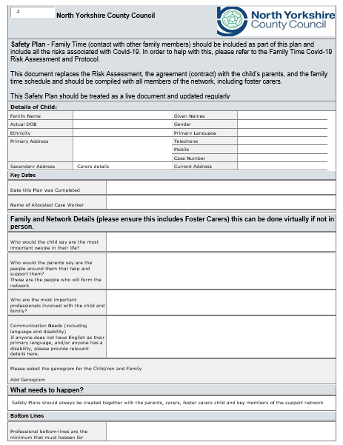

**Prototype**

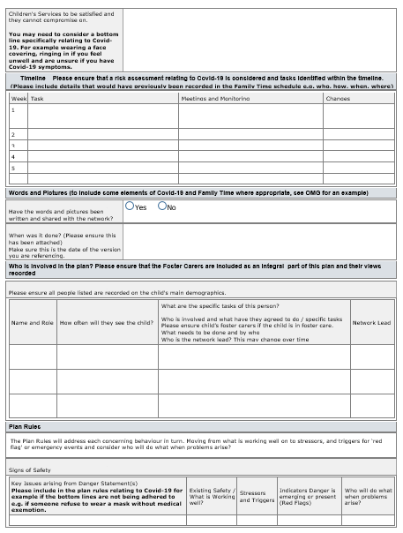

**Prototype**

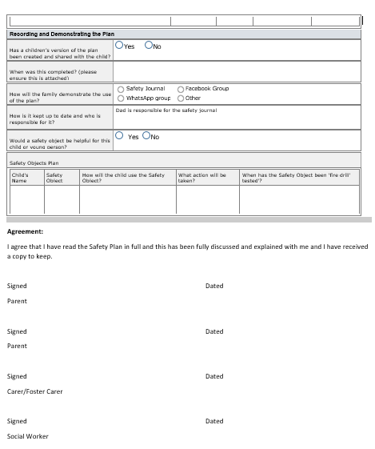

**Prototype**