APPENDIX 3

Merton Transition Plan
All About Me

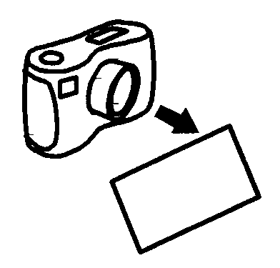

You can add a photo/picture here if you would like.

Insert photo/picture here, if you would like.
 | Name:
 | Address:
 | Telephone number:
 | Birth date:
 | School:
 | Ethnicity:
 | Gender:
 | First Language:
Parents/Primary Carers name
Address & contact number if different from above
 | Other family members/friends
 | Children’s Social Worker
 | Adult Social Worker
 | Class teacher/Tutor/key worker
 | LDD/SEN Personal Adviser
 | GP
 | Shortbreaks Co-ordinator
All about me:  Where I live and who I live with  People who are important to me (my family, friends, at school, other people)  To be successful in supporting me and communicating with me  Things people like about me  What I am good at and what I enjoy doing (at home, at school and out and about)  What I need to stay healthy  What I need to stay safe |  |  |  | Pages 4-5
What I can do and the help and support I need  What can I do for myself  The help and support I need  Getting out and about and using transport etc.  Reading, writing, counting and managing my money etc.  Making friends and getting along with people  My cultural and religious needs |  |  |  | Pages 6-7
My hopes and dreams for the future  Learning (School, College, Adult Education)  Work/Employment What would I like to do?  Where and Who I would like to live with in the future  Any Other Hopes and Dreams for the Future |  |  |  | Page 8
My Step-Up action plan |  |  |  | Page 9
Health & Well-being |  |  |  | Page 10
The Team Around Me |  |  |  | Page 12
Parents/Carers views |  |  |  | Page 13
My Step-Up review |  |  |  | Page 14
All about me
Where I live and who I live with:
People who are important to me (my family, friends, at school, other people):

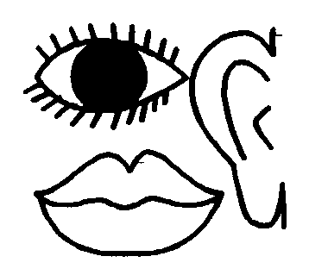 | To be successful in supporting me and communicating with me, you need to:

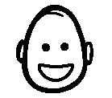 | Things people like about me:

 | My religious and cultural needs:

What I am good at and what I enjoy doing (at home, at school and out and about):
.

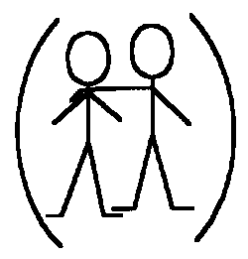 | To stay healthy and safe I need to:  .
What I can do and the help and support that I need
This part is about washing, dressing, cleaning my teeth, brushing my hair, choosing my clothes, bathing, showering, going to the toilet, eating, drinking, shaving, help with transferring, getting in and out of bed, looking after my personal hygiene etc.

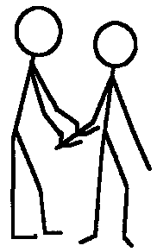 | Washing, dressing, cleaning my teeth, brushing my hair, choosing my clothes, bathing, showering, going to the toilet, eating, drinking, shaving, help with transferring, getting in and out of bed, looking after my personal hygiene, preparing off etc.  I

Getting out and about and using transport etc:

Reading, writing, counting and managing my money etc:

Making friends and getting along with people:

My hopes and dreams for the future

Learning (School, College, Adult Education)

Work/Employment What would I like to do?

Where I would like to live with in the future:
Who I would like to live with:

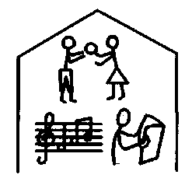 | Any Other Hopes and Dreams for the Future

My Step-Up action plan
Date:

Key Hopes and Dreams about the future | What I want to do | How can we make it happen? | Who will take responsibility & who will be involved? | By when?
My Learning (school, college, Adult Education)
How I will support myself in the future (work, employment)
Where I want to live

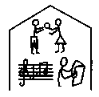
Any other hopes and dreams
Health & Well-Being
Transition Health Profile: This section of the Step-Up Plan, should be completed with the help of the school nurse, GP, specialist health professional (i.e. paediatrician, hospital consultant, nurse specialist, occupational therapist psychiatrists etc) parents/carers &/or significant other.

Nature of Disability

Medical services, therapies & interventions used (include names and contact details of known individuals).

Medical issues (i.e. pain, continence, sleeping, mobility, weight, allergies, etc)
Medication (what it is prescribed for, how often, if the young person is self medicating, known side effects)
Mental Health (are there any concerns related to depression, anxiety, self-harm etc)
Behaviour (are there any behaviours which cause concern or prevent the person from participating in activities)

Does the young person use any specialist equipment, who provides this equipment and how often is it reviewed?
How will this young person access this equipment once they leave school move to adult health care?
What are the plans for this young person’s transition to adult health services?

Name |  | Designation |  | Contact Details | Attended Meeting  (Yes/No/NA) | Needs to action point in plan (yes/no)
 | Parents/Carers’ views
 | Key Hopes and Dreams about the future of my son/daughter
 | Learning (School, college, university, Adult Education, work-based training)
 | How my son, daughter will support themselves in the future (training, work, employment)
 | Where and how he/she will live (independent life skills).
 | Any other hopes and dreams
The Team Around Me
My Step-Up plan review Date:
Key hopes and dreams about: |  | What has happened? | What needs to happen now – what actions do we take or do we need to change the plan? | Who will take responsibility, others involved | When will this happen?
My Learning (school, college, work-based training)
How I will support myself in the future (work, employment)
Where I want to live

Any other hopes and dreams
Name: Job Title: Contact No:

