Ref: Joint Working Protocol for YJ and other teams  Effective: May 2025 Review date: May 2027  Author: Michelle Waldron and Malcolm Pacey (Youth Justice) Rosemary Frimpong and Tara Tweedie (CSC) | CHILDREN’S SOCIAL CARE & YOUTH INCLUSION  POLICIES & PROCEDURES CHILDREN’S SERVICES


TITLE: Joint Working Protocol for Youth Justice and other teams in Children’s Social Care

PURPOSE OF PROTOCOL:
To clarify the arrangements between the Youth Justice Service (YJS), who act as the local Youth Justice Service and other services within the Children, Life Long Learning and Families Department (Children’s Social Care & Youth Inclusion) to deliver services effectively and efficiently through partnership to help prevent the likelihood of reoffending, manage child protection issues, safeguarding concerns and to keep children and the community safe.

This protocol is continually reviewed by all members of staff for suitability, effectiveness and customer focus to ensure we can improve upon the service we provide. If you have any comments on this protocol, please complete an improvement form included in the ‘Issue,
Control and Revision’ procedure (1.0).

APPROVED BY:

JOB TITLE: Executive Director Children’s Life Long Learning and Families DATE: May 2025

Contents
PURPOSE OF PROTOCOL 1
- Introduction 3
- Principles 3
- Information sharing 4
- Roles and Responsibilities 5
- Appropriate / Responsible Adults 7
Police interviews 7
Court appearances 8
- Remands to LA Accommodation or Youth Detention 8
Risk of Remand contingency planning 9
Remands to Local Authority Accommodation (RiLA) 9
Remands to Youth Detention Accommodation 10
Initial care review / IRO allocation 10
Child Protection / Safeguarding 11
Planning for release 11
Released without sentence or conditions 11
- Custody Sentences 12
Custody Licences and Electronically Monitored Early Release 13
Summary of Timeframes for young people remanded or sentenced 13
- Youth Rehabilitation Orders with requirements 15
- Offender Management 15
- Other areas related to Partnership working Error! Bookmark not defined.
Triage and Caution Scheme Error! Bookmark not defined.
Liaison and Diversion Error! Bookmark not defined.
Anti Social Behaviour and Criminal Behaviour Orders Error! Bookmark not
defined.
- The Education of Young People who offend Error! Bookmark not defined.
Appendix 1 – Diagram of Roles and Responsibilities 17
Appendix 2 – LASPO / remand responsibilities 18

Introduction

  - This protocol represents the arrangements between the Youth Justice Service and other sections within the Children, Life Long Learning and Families Department (Children’s Social Care and Youth Inclusion) to deliver services effectively and efficiently through partnership to help prevent the likelihood of reoffending, manage safeguarding concerns and care processes where children are open to multiple services.

  - It outlines the principles of our shared approach before describing an overview of some roles and responsibilities of the Children’s Social Care and the Youth Justice Teams.

  - This protocol will be reviewed every two years to ensure that it accurately represents the practice and related legislation of the YJS, CSC and Education teams. Any changes to the protocol must be agreed by the respective parties

Principles
  - Child First is a guiding framework in youth justice in England and Wales that emphasises:
    - Treating children as children, recognising their developmental differences from adults.
    - Focusing on their needs, rights, and potential, rather than their offences.
    - Prioritising their best interests, aiming to support positive outcomes.
    - Diverting them from the formal justice system wherever possible, to reduce harm and promote rehabilitation.
  - Children and Young People are best cared for and supported within their own families. It is of paramount importance that agencies work together in the best interests of the child/young person, carers, families, victims and their communities. This will mean providing support to young people and their families and minimising risk factors that may be causing concern.

  - All those who come into contact with children, their parents and families in their everyday work, including staff who do not have a specific role in relation to child protection, have a duty to safeguard and promote the welfare of the child and help reduce their risk of harm to themselves and others and any risk of offending.
  - Risk to children is reduced through effective multi-agency and multi- disciplinary working and when information is shared effectively across agencies.

  - A multi-agency approach to assessment and service provision is in the best interests of children and their parent and/or carers and the public.

  - Assessments and interventions should seek to address the wider needs of the family to prevent wider offending and case managers should deploy whatever possible resources to help meet the wider safeguarding agenda. To ensure sustainable access to support, workers are encouraged to utilise voluntary sector and community services.
  - The link between school attendance and offending is well known. All case managers should ensure they are helping to increase compliance around school attendance as an important role in supervision and consider the need for increasing attendance through the use of requirements (Education, Curfew or Non-Association) within the Youth Rehabilitation Order. This may also require close liaison with the Education Welfare Service.

  - It is expected that where agreement is not immediately reached between staff in different services, that the workers involved will attempt to resolve this themselves, in the first instance. If they are unable to come to an agreement, the workers must refer the matter to appropriate line managers.

  - We need to work together in the best interests of the child / young person to determine who is best placed to deliver the required action, maintaining the balance between ‘care and control’ and where possible understand that these two drivers are not contradictory.

Information sharing
  - Proper consideration must be given to issues of confidentiality to ensure that children and young people are protected by the sharing of information in accordance with both the London Safeguarding Children Procedures and the Crime and Disorder Act 1998. Consideration must be given to the General Data Protection Regulations 2018.

  - It is essential for both services to accurately record the names, dates of birth, addresses, legal status of both family and youth justice proceedings and any involvement of other agencies and areas of concern for all children and families known to them. In line with good practice the YJS and CSC teams will check whether the child, young person or family is known to the other service particularly at the initial assessment stage.

  - CSC and YJS must record the involvement of the other agency on the electronic case record – Core plus (YJS) and Mosaic (CSC) - when both are working with a young person

  - Where there is close joint working between Youth Justice Service and Children’s Social Care, the Youth Justice case worker is expected to review Mosaic on a regular basis and send a copy of the most recently quality assured AssetPlus to the allocated social worker

  - If a young person has not yet been convicted of an offence (they are awaiting a return date to the Police station or awaiting a court date or trial) then workers need to be aware of any disclosures made by the young person could be used in court as a witness statement. Therefore best practice is to avoid discussing the offence until after conviction, which is primarily the role of the YJ worker, while jointly seeking to understand the needs being presented as a result of the offence.

Roles and Responsibilities
  - The Children’s Social Care teams will be primarily responsible for providing services under the Children Act 2004 and the Children and Families Act 2014 and other associated legislation.

  - The Youth Justice Service will primarily be responsible for providing services under the Crime and Disorder Act 1998 and The Criminal Justice and Immigration Act 2008 and other associated legislation.
  - See Appendix 1 for a diagram of the separate and joint functions.

Main Responsibilities of the Youth Justice Service to promote the safety and well-being of children

  - The Children Act 2004 sets out a requirement for Youth Justice Services to co-operate with all local children’s services in their duty to promote the safety and well-being of children and young people. This will be achieved by a general overview in the following areas:

    - YJ managers will ensure that all YJ staff members are aware of, have access to and follow the London Safeguarding Children Procedures

    - The YJS will provide youth justice court duties and provide timely information regarding decisions made at youth court to CSC about children already known to that service.

    - The YJS will refer child protection concerns to Children’s Social Care (Hub) and contribute towards child in need or child protection plans while the young person remains on a formal disposal or court order.

    - The YJS is responsible for completing all specialist youth justice documentation, including the assessment tool ASSETPlus, which provides judgements in regard to a young person’s likelihood of reoffending, risk of harm to others and risk of adverse outcomes due to safety and wellbeing concerns. CSC has responsibility for its own documentation, e.g. Child Protection or Child in Care paperwork.

    - The YJS will contribute to reviews of children in care who are also on a court order and be invited to all statutory reviews.

    - Plans for interventions carried out by the YJS for a young person known to CSC will inform and complement the overall social care plan.

    - The YJS will work closely with the relevant Social Care Team concerning all Remands into Local Authority accommodation (RiLA) and Youth Detention Accommodation (YDA) remands. The child will become a child in care and require joint planning.

    - To ensure good contingency planning, the YJS will liaise with CSC regarding the transfer of looked-after children from custody to the community at least 2 months before the potential release date.

    - The YJS will prepare resettlement services for young people leaving custody and where the child or young person cannot return to their family home will plan in advance with Children’s Social Care and the Housing Department for their release. Consideration for the ‘Southwark Ruling’ should be given in regard to young people aged 16 and 17 who can seek local authority care without the need for a parent entering into a S.20 voluntary care agreement.

    - The YJS will share, through the MAPPA (multi-agency public protection arrangements) process information on children who pose a risk to the local community. The CSC safeguarding manager also attends MAPPA and will cascade information to the relevant CSC team.

    - The YJS will provide Out of Borough youth justice services with information if offences are committed by children placed in our area by other authorities. This may involve liaison with the respective Children’s Social Care Team if there are any concerns which may require investigation under Section 47 of the Children Act 1989.

    - The YJS is represented on the Merton Local Safeguarding Children Partnership Executive Board by the Director. The YJS is also represented at the Subgroup ‘Promote and Protect’ and Children Missing and Pre-Mace panel.

Main Responsibilities of children’s services under section 17 of the Crime and Disorder Act 1998 to prevent offending by children

  - Children’s Social Care work with children, young people and families where there are multiple concerns about the child or young person and/or where difficulties have already caused significant adverse effects. CSC contributes to fulfilling the statutory aims of the youth justice system by the following:-
- CSC will ensure that Children in Need assessments are undertaken within the statutory timeframes and once an assessment is completed, undertake direct work with the family to ensure the young person remains with their family. On rare occasions the young person may need to be accommodated under S.20 but this is very much a last resort.

- Provision of social care services to meet the assessed needs of young people who offend under Children’s legislation may include children in need and family support services, commissioning services to meet specific needs of the child or family and if needed statutory services.

- CSC Services will ensure that reviews for children in care are conducted within statutory timeframes. For young people who offend and are in care, that the YJS participate in any care planning arising from those reviews. This group of children will include those in custody.

- Liaise closely with and refer to services that the YJS may also be working closely with – e.g. Catch22, MyFutures, Family Wellbeing Service, Jigsaw4U, Unique Talent.

- CSC staff should contact the YJS directly when there is an identified need relating to offending or risk of offending. While it is a matter for the YJS to decide what response is appropriate, a decision will be made based upon our commitment to partnership working and our principal aim to prevent youth offending.

- CSC staff will invite the YJS to any strategy meetings that involve Harmful Sexual Behaviour by children aged 8years or over to ensure a specialist multi-agency response and planning of assessment. Also see the Harmful Sexual Behaviour Protocol for more information (on MSCP webpage or via TriX).

- As per Chapter 12 of the London Child Protection Procedures, CSC and YJS should jointly consider the risks and needs of young people affected by or involved in gangs. Also see the Serious Youth Violence and Contextual harm protocol or the Pre-Mace protocol for more information (also on MSCP webpage or go via TriX).

- When a young person is due to be detained overnight by Police, the police are required to consult with the local authority about transferring him/her to local authority care (seeking a ‘PACE bed’). This call will be made to the CSC Emergency Duty Team if after hours. If the Custody Sargeant deems it necessary for Public Protection then this may be a request for secure accommodation. Only unless it is impracticable to do so the young person should not remain in Police Custody overnight. Also see the Concordat on Custody and Summary information on TriX for more information.

Appropriate / Responsible Adults
  - There are a number of stages in the youth justice system process that an appropriate or responsible adult is required to support the young person. For children in care, it is expected that the social worker will either act in this capacity or arrange necessary cover, including the oversight of any involvement of family members meeting this role.

Police interviews

  - All young people under the age of 18 years who are arrested and booked into custody for a police interview require an Appropriate Adult (AA). The Police can also arrange a voluntary interview (known as Caution +3) that should also have an Appropriate Adult present. The role of the AA includes specific duties at various points, from booking into custody to interview, through to charge or release.

  - The London Borough of Merton does not have any active Police Stations with Custody Suites (where children would be detained) therefore we do not have responsibility to provide appropriate Adults when a parent/carer is unable to attend for their child. Children arrested in Merton will be detained at either to Wandsworth or Kingston Police stations and the duty to provide an Appropriate Adult is incumbent on these two authorities if a parent/or carer is unable to attend.

  - Irrespective of the above there may be occasions where an allocated Merton social worker, youth justice worker or Uturn worker may be best placed to attend (when a parent/carer is unable to attend) and the child is open to one of the services and the child has been arrested in relation to a very serious matter or is deemed to be particularly vulnerable.

Court appearances

  - The YJS will be responsible for liaising with court officials in respect of forthcoming appearances, provision of background information and written reports. YJS Court Duty Officers can provide advice and support to children/young people when they appear at the Wimbledon Youth Court if notified in advance of their attendance by the allocated Social Worker.

  - The YJS court officer is not able to act as a Responsible Adult for the purposes of the court hearing due to their role acting for the court and as a neutral party. Wherever possible parents and or carers should accompany the young person to court. Exceptions may be where carer or parent is a witness or victim in criminal matters.

  - As soon as the YJS are notified that child/young person open to CSC is due to appear in court, the YJT will inform the relevant CSC Team. For all child in care it will be the responsibility of the social worker to ensure there are suitable arrangements in place to accompany the young person to court and ensure that they have access to appropriate advice and representation. Wherever possible arrangements for accompanying a child to court should be clearly defined in all Placement Plans.

Remands to LA Accommodation or Youth Detention

  - The YJS will advise Children’s Social Care Heads of Service in advance if there is a possibility of a young person appearing at court where bail is being opposed and may be refused by the court and therefore being remanded into the care of the Local Authority or to Youth Detention Accommodation, both of which will result in the young person becoming a Child in Care.

Risk of Remand contingency planning

  - Wherever possible planning and liaison between YJS and CSC should happen prior to any court date giving sufficient time to enable decisions to be made in regard to resources, which can then inform the court and outcome.

  - This could take the form of a strategy meeting / multi-professional meeting or ideally, if enough warning is provided, a family group conference or safety network meeting to identify appropriate family members that could offer a bail address and support a bail package.

  - If the young person is not open to any service in Children’s Social Care then the Youth Justice Service can refer to the family group conference process to support contingency planning.

  - If the young person is not open to the Youth Justice Service but due to the young person’s offending and pattern of breach then a representative, at least the Operational manager for court, will attend any multiagency meeting.

  - If the young person is remanded unexpectedly the meetings can still help to consider bail packages that are likely to be sought by the defense. Bail applications can be made up to three times however this usually requires a change in situation and a family network meeting could provide this opportunity.

Remands to Local Authority Accommodation (RiLA)
  - Remands to LA Accommodation should only be used as a last resort after establishing that there are no suitable family members or other ‘committed’ person able to assume the care of the young person. The YJS will undertake a Bail Recommendation assessment to consider suitability for bail and the conditions that can reduce the concerns of the court or prosecution.

  - Young people who are Remanded into Local Authority accommodation (RiLA) become children in care by virtue of S.21 of the Children Act 1989. The statutory responsibility for their welfare rests with the local authority, and will be managed by the CSC, including child in care reviews and completion of relevant forms.

  - Placement arrangements for RiLA children/young people are the responsibility of the relevant CSC team and their Manager. These will require

a referral to the Access to Resources Team if a non-family member placement is required. However, workers need to be aware that if a young person is placed with family while they remain a child in care, the family placement requires authorisation from the Director (reg 24). The Court can also direct conditions in relation to the RiLA that can be similar to bail conditions and can include electronic monitored curfew and restricted names or addresses where the young person cannot live.

  - Social workers should make arrangements with the foster carer or care provider to take the young person to court for their next appearance.

Remands to Youth Detention Accommodation

  - Where a young person is subject to a court ordered remand to youth detention accommodation (whether they are placed in a secure children’s home, secure training centre or young offenders institute), the young person automatically becomes a child in care. Also see TriX in regard to LASPO procedures. Summary is provided on Appendix 2

  - Youth Detention Accommodation (YDA) placements are arranged by the Youth Custody Service (YCS) and jointly funded by the YJB and the local CSC Placement Team. The placement decision is based on the information received by the YJS Court Officer in regard to the child/young person’s vulnerability and risk to others, which will also be determined by their age. The YCS arrange the secure transport for YDAs

Initial care review / IRO allocation

  - CSC remain responsible for providing appropriate local authority remand placements and fulfilling statutory responsibilities for reviewing and monitoring placements for Children in Care.

  - Reviews for Children and young people who are accommodated following youth justice proceedings will be mutually arranged by the allocated workers ensuring that the Social Worker takes responsibility for notifying the Independent Reviewing Officer.

  - If the child is new to care due to the remand then a detention placement plan1, in place of a care plan, is to be prepared within 5 working days. Then an Initial Care Review Meeting needs to be held within 20 working days

  - If a young person was already in care at the time of the remand, they will remain in care by virtue of the remand. The detention placement plan is to be prepared within 10 working days and should be aligned with the original care plan. The care review meeting would need to be brought forward due to the unplanned change.

¹ The particulars of the detention placement plan are outlined in Schedule 2A of The Care Planning, Placement and Case Review (England) (Miscellaneous Amendments) Regulations 2013. Also see the link here (from 8.28)

Child Protection / Safeguarding

  - The YJS is responsible for all input relating to offending behavior. The YJS will also be responsible for liaising with court officials in respect of forthcoming appearances, supporting the placement, provision of bail packages and pre-sentence reports. The YJS will fulfil its obligations to the young person as defined by National Standards in regard to contact, targeted interventions and enforcement of court conditions. Any changes will be incorporated into the care plan by the social worker.

  - If information is received by the YJS or by the local authority indicating that a young person in custody or secure accommodation is suffering or is likely to suffer significant harm, it is the local authority children’s social care service in whose area the custodial establishment is located which is responsible for carrying out section 47 enquiries in relation to any child in custody who they have reasonable cause to suspect is suffering, or likely to suffer, significant harm. (See “Local Authority Circular Looked After Children (2004)26”). The YJS and CSC will liaise to ensure appropriate representation at any strategy meeting or child protection conference arising out of section 47 enquiries.

  - The YJS will co-ordinate appropriate through care support during the period of the remand. The YJS will be responsible for the provision of youth justice services, including preparation of the Court Report and relevant documentation including the ASSETPlus (YJB assessment tool).

Planning for release

  - Planning should start at the earliest opportunity for when a remand episode may end, particularly if a community sentence is being proposed. Should the need for Local Authority accommodation be indicated beyond the remand episode, this should be considered and approved by the relevant Children’s Social Care Head of Service. It is the YJS responsibility to notify CSC of the critical time scale and the responsibility of CSC to make any resource requests if approved.

  - Young People who are entitled to services under the Leaving Care Act 2000 will continue to receive such services alongside any statutory responsibilities discharged by YJS.

Released without sentence or conditions

  - If a young person is released without sentence (e.g. acquitted at trial) a post remand meeting, within 5 working days, is to be arranged by the Youth Justice Service to agree the roles and responsibilities of each of the services.

  - This is to ensure that services are in place if required as the YJS will no longer have a statutory role and the role of CSC and other services will require clarification and agreement, particularly if they were not in care prior

to the remand and do not meet eligibility for Care Leaving services but are a Qualifying young person due to the remand.

  - This process should also occur if a young person is recalled on their custodial license and ends their order in custody.

Custodial Sentences
  - The YJS will have overall responsibility for initial sentence planning, ongoing review and subsequent planning for discharge during the custodial part of the custodial sentence.
  - The YJS will also be responsible for the supervision plan on return to the community.

  - In relation to children and young people who are subject to Care Orders (Section 31 Children’s Act 89) CSC has a particular responsibility as a corporate parent to participate in the sentence planning process throughout the entire sentence.

  - If a young person has been on remand prior to a custodial sentence, the care status as part of that remand ceases. However, where young people have been accommodated under Section 20 immediately prior to a remand or DTO being imposed, CSC has a responsibility to ensure that there are appropriate care arrangements available on release. The extent to which the case remains open and active will depend on factors such as the period of detention, the length of time the young person has been accommodated, the current care plan, the involvement of parents and the likely care needs at the point of discharge.

  - Section 15 of the children and Young Persons Act 2008, inserted a new section 23ZA into the 1989 Act, imposing a duty on the local authority to visit children who cease to be in care as a result of being sentenced to custody and who are not eligible for leaving care support. This applies to young people who were either in care under section 20 of the 1989 Act prior to being remanded or sentenced to custody and those who were in care by virtue of having been remanded to local authority care under section 23(1) of the CYP Act 1969 on being sentenced.

  - This will be the allocated social worker at the time of sentencing who would have been overseeing either the s20 or remand period. They are to visit the young person within 10 working days of their entering custody to complete an assessment of the young person’s needs whilst in custody and on release. The role must not be fulfilled by a YJS worker. However, any future support should be provided in conjunction with any on-going interventions provided by the YJS case practitioners.

  - The social worker’s team manager is to receive reports from the social worker and decide on how the local authority will act on their recommendations. If the manager does not accept the recommendations

about ongoing support, the Youth Justice Service should be informed.

  - Any disputes arising from this decision will be resolved by the relevant senior managers no later than 28 days prior to the young person’s potential release date.

Planning for release
  - It will be the responsibility of the YJS to convene a final review 4 weeks prior to release to ensure adequate planning. The allocated CSC team will be invited to this meeting.
  - In the event of a young person being closed or held on a dormant basis and where the need for local authority accommodation is subsequently identified, the YJS worker will make a referral to Children and Families Hub outlining specifically the reasons why the young person cannot return to their family. The length of care and young person’s circumstances prior to remand or sentence will be taken into account.

  - The final release meeting is held 10 days prior to release and the address of where the young person will live on release should be available at this meeting. If it has been agreed by the relevant Head of Service that the child will be placed in care on release, then the address is to be provided no later than 3 working days prior to release to allow the relevant paperwork and license conditions to be prepared.

  - If this address is likely to be out of borough then the YJS will need to liaise with that relevant borough’s YJS to agree their supervision of the license conditions and therefore the least amount of delay will be required to support this process.

Custody Licences and Electronically Monitored Early Release

  - Where a young person subject to a Care Order (Section.31 Children’s Act 89) or previously in care under Section 20 is being returned to accommodation, the agreement of the relevant registered care provider should be sought prior to any installation of electronic monitoring equipment within the property relating to that accommodation.

  - The necessary permissions and contractual arrangements need to be in place. It is expected that arrangements will be in place prior to the young person’s release from custody or at the latest on the day of release.

  - It will be the responsibility of the YJS to ascertain which cases these measures will apply and to contact the allocated CSC team to obtain agreement from the carer for the measures to be in place.

Summary of Timeframes for young people remanded or sentenced
- Prior to court date if possible –YJS notification to Children’s Social Care of

risk of remand and liaise about potential bail options / conditions. Contingency planning and safety planning to occur for those open to CSC.
- On the day of court – liaise about the remand and status of young person, Children’s Social Care to allocate social worker and IRO. YJS to send documents to the Youth Justice Custody Service
- By the following day – YJ worker and social worker agree when both can attend the remand hearing.
- Within 5 working days – for a child new to care due to remand – Detention Placement Plan to be prepared by social worker in place of Care Plan.
- Within 5 working days – Remand review held, must be attended by YJ worker and ideally by the social worker to inform the report for care review meeting. This could be supported with dialing into meetings.
- Within 10 working days – for a child in care prior to remand – Detention Placement Plan to be prepared by social worker, aligned with Care Plan.
- Within 10 working days – ETE worker in the YJS to ensure that the EHCP is transferred to the secure estate and that SEND team engaged with planning processes.
- Within 20 working days – initial care review meeting held, must be chaired by IRO and attended by Social worker, ideally by the YJ worker too.
- Every month a remand review meeting to be held – more often if there are any safety incidents requiring joint planning.
- 5 days after release – if no sentence or conditions – a meeting to be arranged by YJS with relevant professionals to identify appropriate services.
- 10 days after sentence, if the young person is sentenced to custody and was in care prior to sentence (due to s20 or remand), CSC must appoint a representative, who should be a qualified social worker, to visit the young person to complete an assessment of their needs (in custody and on release)
- 2 months prior to release from custodial sentence - YJS to inform CSC of any potential accommodation needs due to the young person’s status.
- 4 weeks prior to release - a pre-release meeting is held to consider license
- 10 days prior to release - final release meeting to agree license conditions
- 3 working days prior to release a placement address, if assessed as required and approved by relevant Head of Service, must be provided.

Youth Rehabilitation Orders with requirements
  - The Criminal Justice and Immigration Act introduced the Youth Rehabilitation Order (YRO) in November 2009. The YRO contains up to 18 requirements, many of them have relevance to joint work with other agencies including Social Care.

  - The residence requirement (for 16 and 17 year olds) and local authority residence requirement (from age 14) can be made by the Court on the recommendation of the YJS. The YJS will complete an assessment and then liaise with relevant CSC staff when either of these requirements are proposed. This would mean the young person becomes a child in care for the period of the requirement (3 or 6 months)

  - The oversight of a number of prohibitive restrictions that can be incorporated into the requirements of orders may involve support from the local police. These include doorstep curfews, exclusions and prohibitive activities. All these measures provide tools to help safeguard and promote issues of public protection and the reduction of reoffending.

  - An Education requirement can be imposed to insist that a young person is to attend a named education setting for up to 6 months

Offender Management
  - Children at risk of missing, sexual exploitation, criminal exploitation and at risk of harm to others are discussed at the local monthly Pre MACE meeting. If any cases discussed at this panel have an allocated social worker and/or youth justice worker they will be expected to attend the panel within the allotted time. An update should be provided in regard to the young person’s home situation or placement, education, engagement in positive activities and any other information that will assist the panel in regard to risk management.
  - YJS are informed directly by courts of Schedule 1 convictions. Any MAPPA subject moving out of the area is notified between MAPPA’s and the

respective police Jigsaw teams. Any cases heard at MAPPA Level 2 will not be heard at Pre MACE, however Level 1 is covered by the Pre MACE panel (e.g. young people with a custodial sentence of longer than 12 months for violent or a registered sex offender).

  - Representatives of both the YJS and CSC attend (as necessary) MAPPA, where information about new sex offender registrations and existing cases are shared by the police. The YJS have a specific protocol relating to MAPPA referral arrangements and responsibilities under its ‘duty to cooperate’.

  - A Serious Youth Violence Protocol is in place to assist the YJS and CSC workers in considering how to respond to young people who may be at risk of involvement in serious youth violence, either as an offender or victim. This includes consideration for Chapters 8, 12 and 15 of the London Child Protection Procedures.

  - The MSCP have updated a Harmful Sexual Behavior Protocol that includes guidance in regard to identifying and responding to harmful sexual behavior by children / young people. This outlines how the YJS should be invited to Strategy discussions and meetings in regard to young people aged 8 years or older, whether or not they are subject to a current court order or YJS intervention.

Appendix 1 – Diagram of Roles and Responsibilities

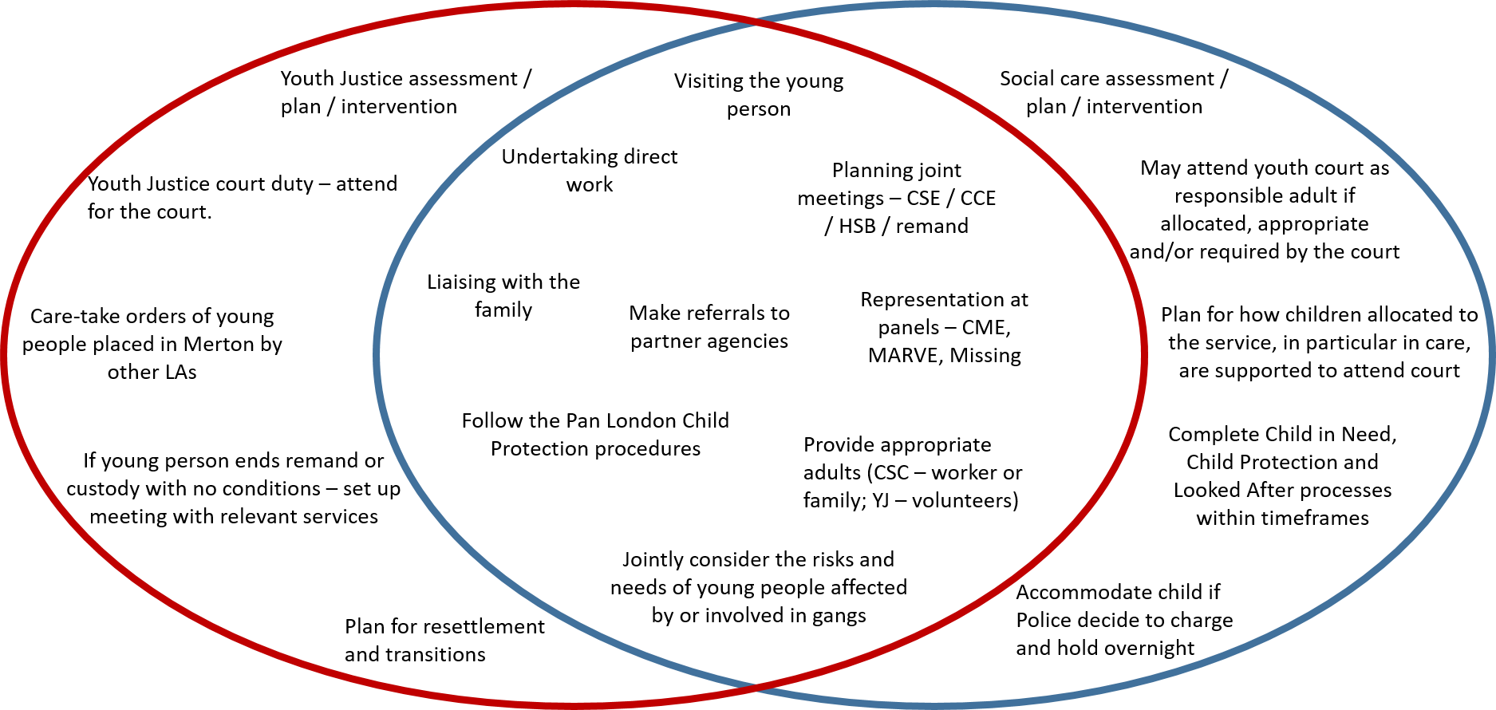

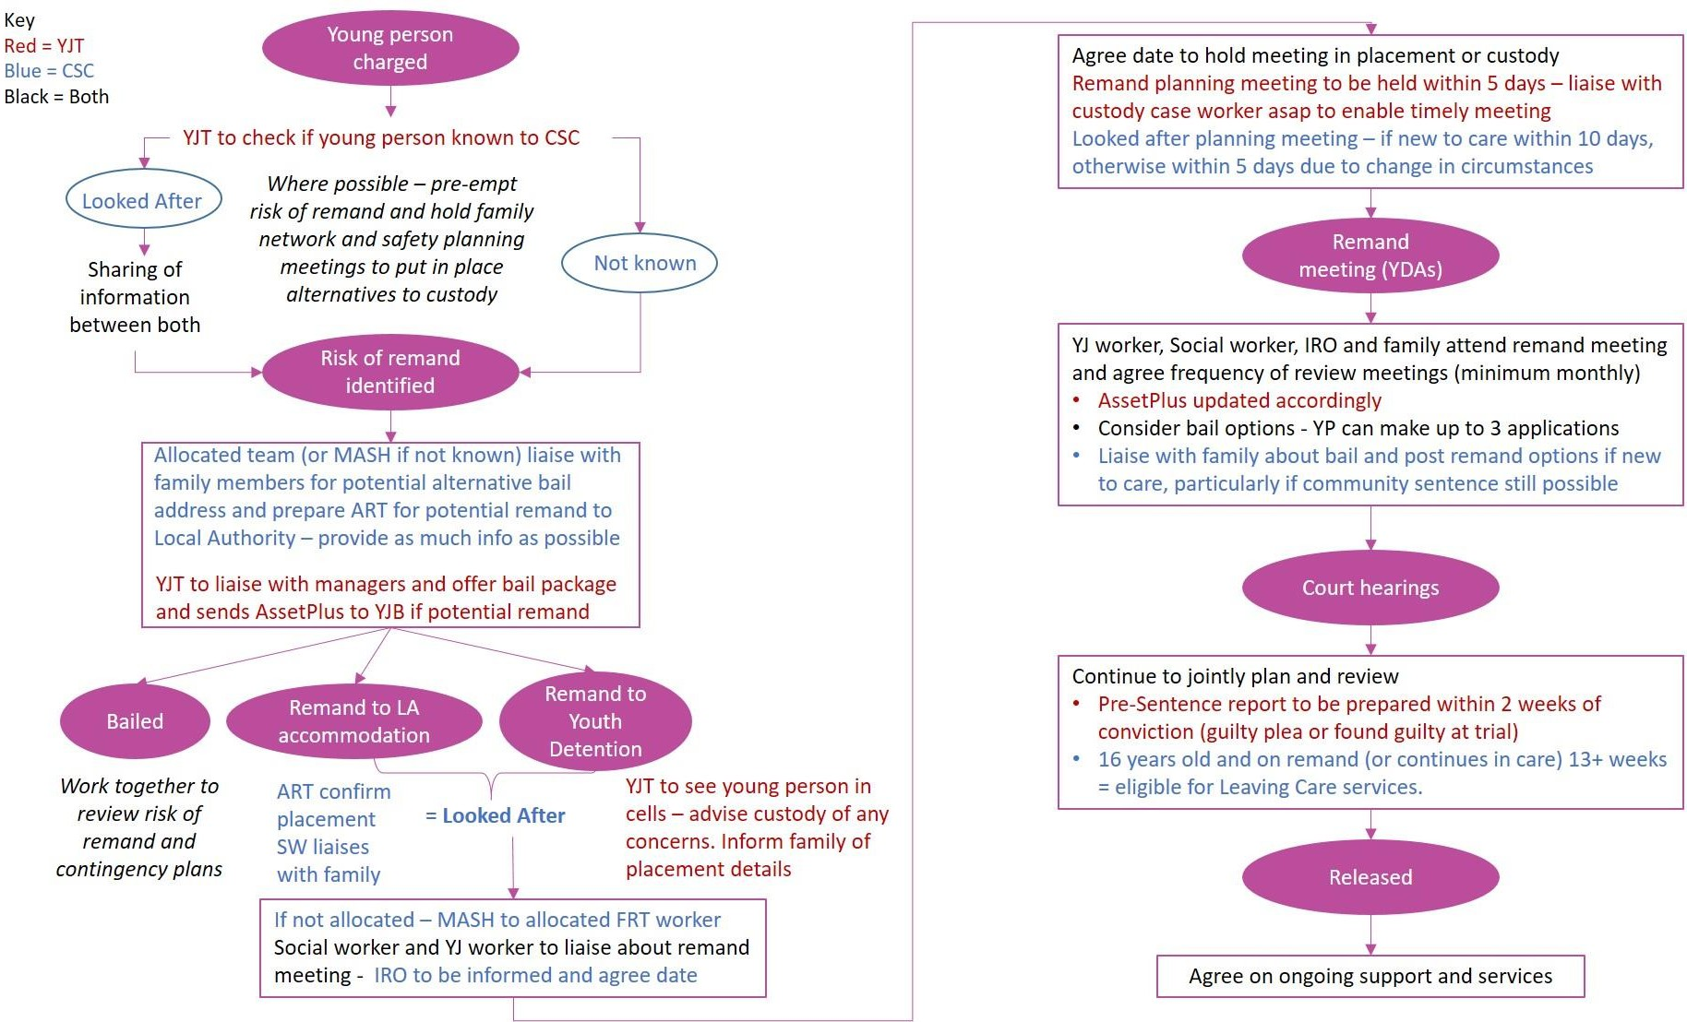
Appendix 2 – LASPO / remand responsibilities

