All About Me
An opportunity to have your say on the things that are important to you so that your Manager and Supervisor knows you better. What you want, like and feel!
The document is used to work with young people and family to get to know them better. It was the view of your supervisor that it would be good to know you better and understand your goals and aims.
Many supervisees have said that little is discussed about their needs, and as we are building better relationships we thought it would be helpful for you to have the opportunity to share information about yourself.
The All About Me document was developed by young people as an opportunity for you to have your say on the things that are important to you. This gives you an opportunity to show who you are instead of what other people think of you.
You can write, draw or include some pictures. This will be attached to file so that your supervisor can see who you are and what is important to you!
About Me
Please insert a photo of you here!
To insert a new image into the PDF from an image file,
go to the
Tools Panel
and choose “
Content
” and “
Edit
Object
.” Then right-click in your document where you
want the new image to go, and choose “
Place Image
”
from the menu that appears. You can
scale down
the
image by putting your cursor at the corner of the image,
hold down the
shift key
and drag your mouse to make
smaller into the space provided.
I see myself as a:
Boy | Girl | Other | Prefer not to say
If other, please specify:
I like animals:
Yes | No | Other | Don’t Know
If yes, let us know what kind of animal here:

My Religion is:
(Please give some information about rules etc. or draw a picture)
Hobbies and activities I enjoy: |  | A few of my favourite things:
 |  | (Please tell us about your favourite things or draw them)

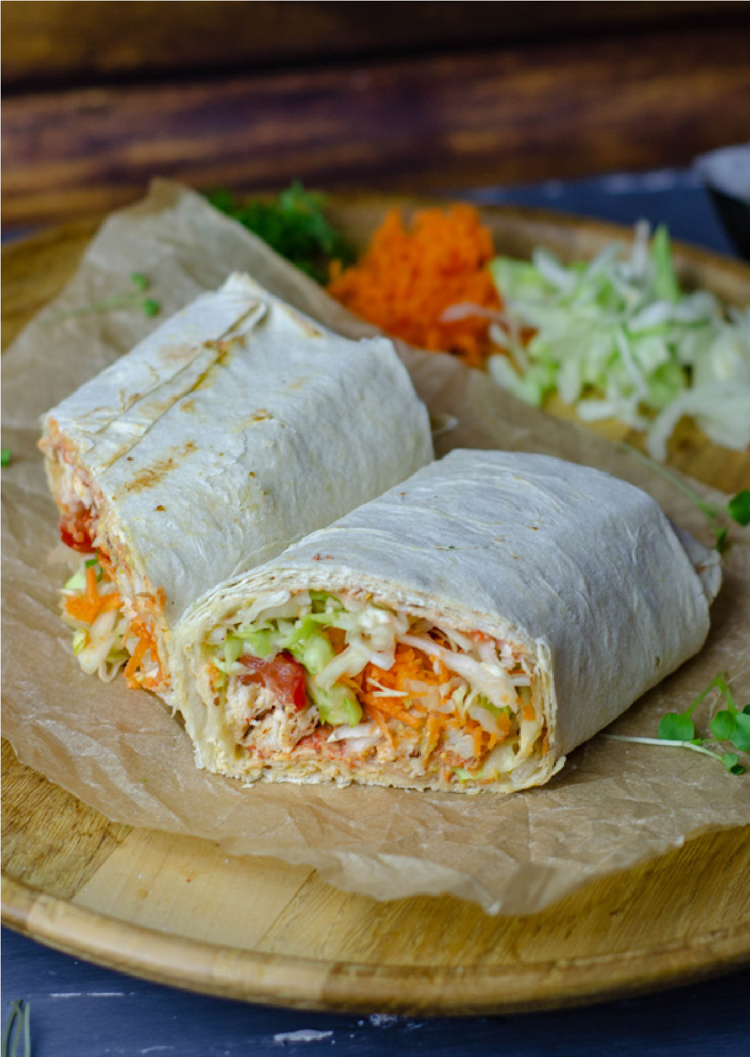
Food!
My favourite foods are:
Foods that I do not like or cannot eat:
I would like to cook sometimes:
Yes
No
Don’t Know
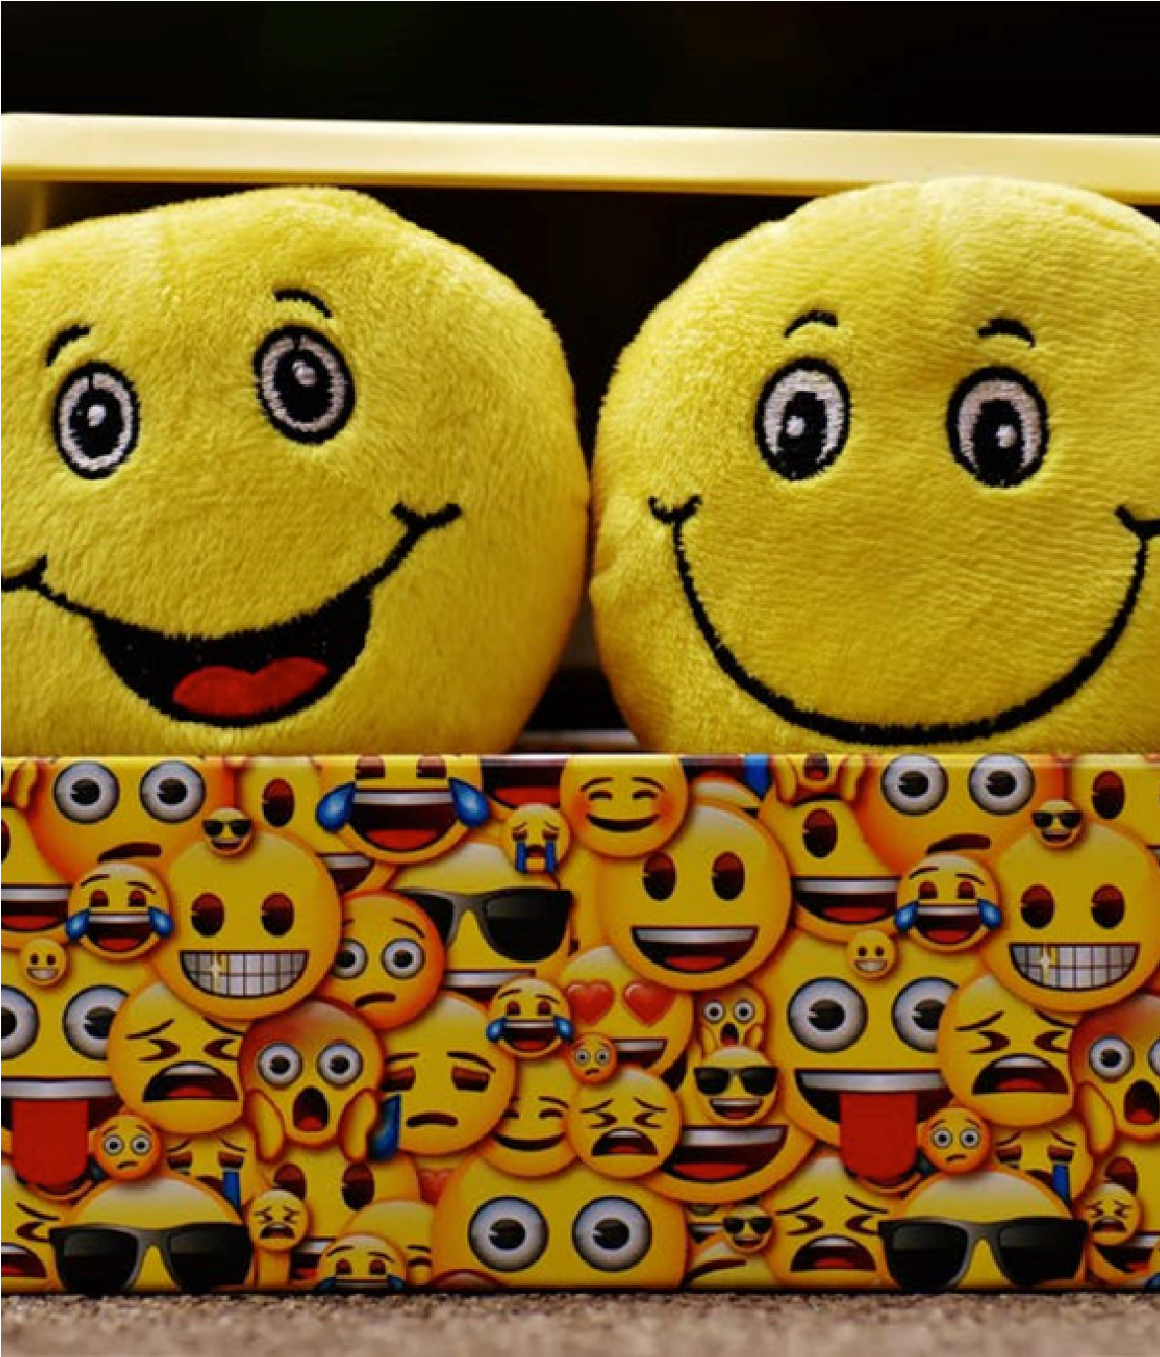
What makes
me happy or
sad?
Things that make me happy:
Things that make me sad or I don’t like:
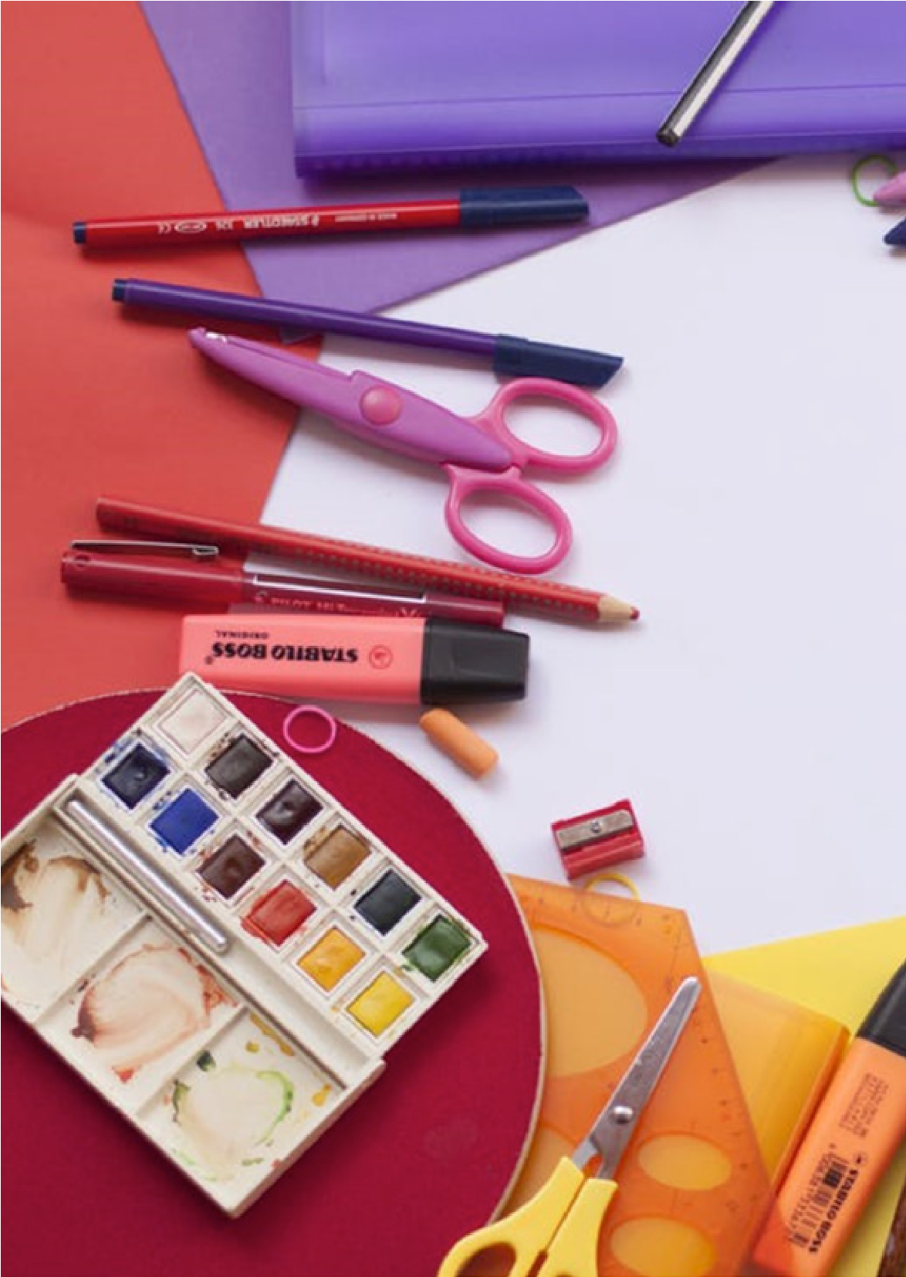
Education
I would like to further my education:
Yes
No
Don’t Know

The things I like/ liked about learning are:
The things I do not like about learning and training are:
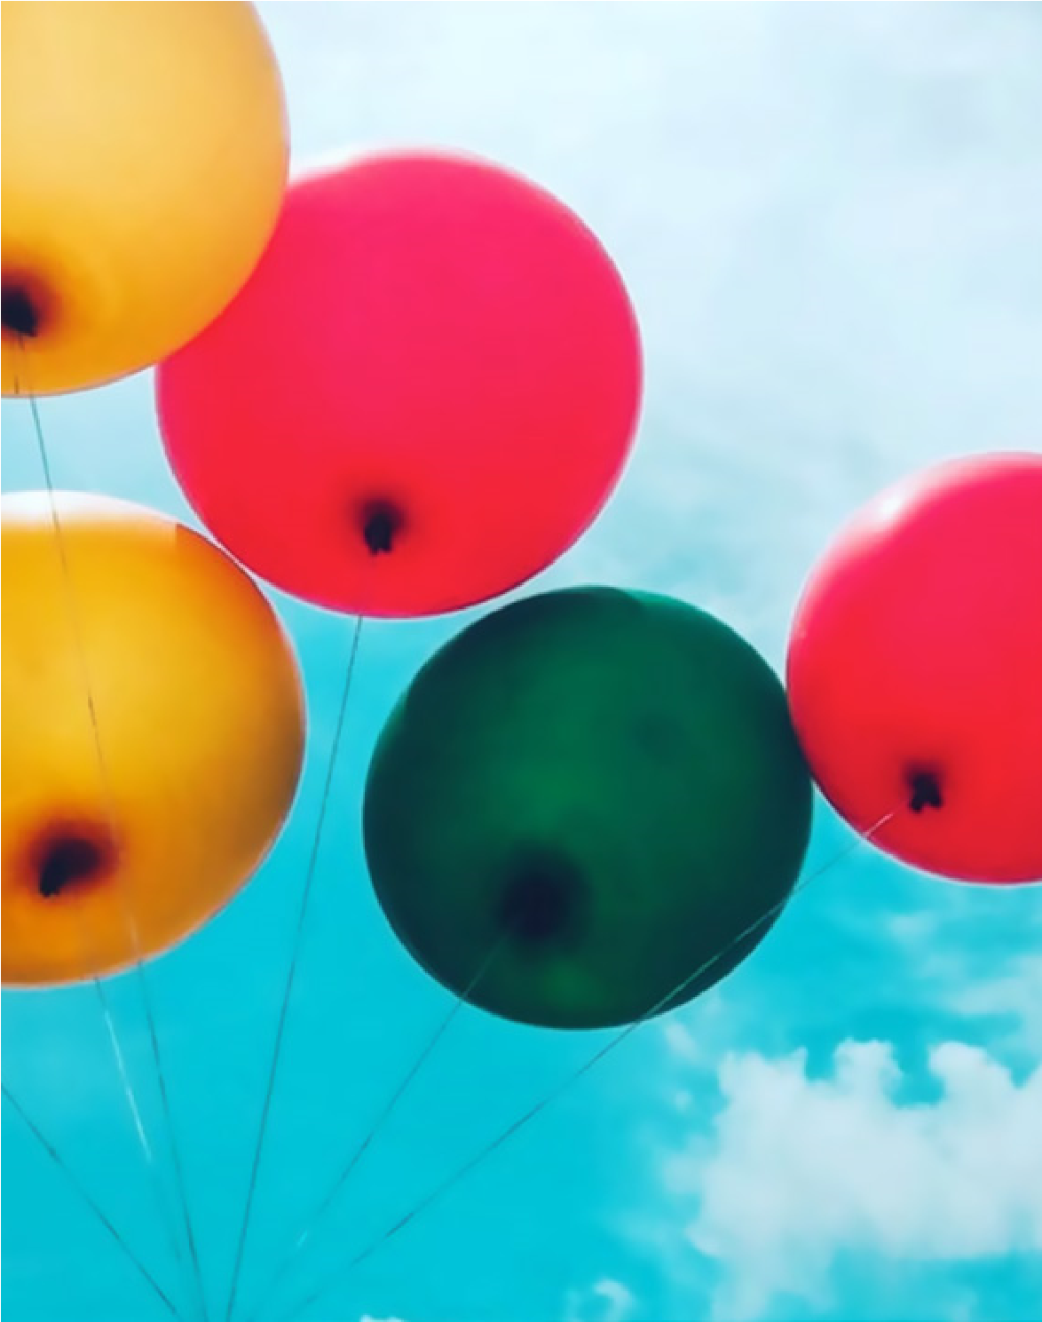
Dreams
and Goals
My work goal is to become:

Things that might help me get there: |  | Skills I would like to learn outside of work:
 |  | (i.e. Swimming)

Family
Please insert a picture of anything you like here!

Tools Panel
and choose “

Object
.” Then right-click in your document where you
want the new image to go, and choose “
Place Image
”
from the menu that appears. You can
scale down
the
image by putting your cursor at the corner of the image,
hold down the
shift key
and drag your mouse to make
smaller into the space provided.
Would you like to talk about your family?
Yes | No |  | Don’t Know
If yes, where, with who and why?
Do you spend time with your family?
Yes | No |  | Don’t Know
Are you happy with it and do you need support?

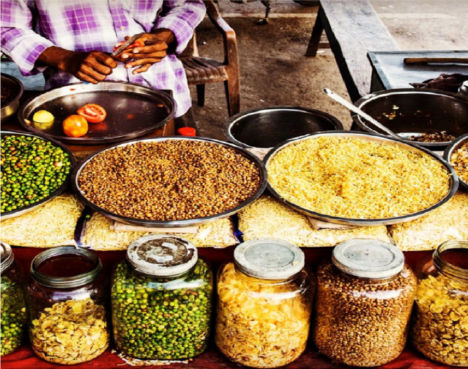
My Culture and What it means to me:
(Use this space to tell us about your culture and what’s important to you. Tell us about food, rules, routines etc.)

I like to learn this way :
Yes | No | Don’t Know
I want to talk about my past:
Yes | No | Don’t Know
I need support for my emotions:
Yes | No | Don’t Know
I would like to talk about it:
Yes | No | Don’t Know
take care of my wellbeing:
Yes | No | Don’t Know

My
Emotions

When I am happy I: |  |  | When I am angry I:
When I am sad I: |  |  | When I am nervous or frightened I:

ds
Anything
else?
Here is some free space for you to include anything else you may want your future supervisor to know

