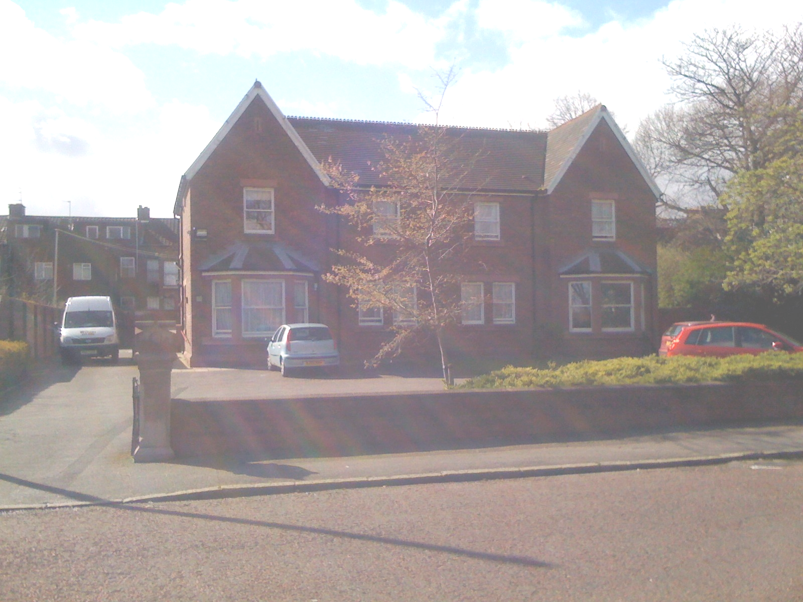

Short Breaks
at
Important information to help the people at Prescot Drive to meet my needs

40%

My name is:

I like to be called:

My birthday is:

I was born on: ___ ___ ___
day month year
My phone numbers are:
My e-mail address is:
I live at:
My family and other important people in my life are:
My school is:

I wear uniform Yes / No

It is:

I take a packed lunch Yes / No
I take:

My class teacher is:

Other staff in my class are:

My friends at school are:

I travel to school by:

My driver is:

My escort is:
I go to activity clubs at:

My doctor is:

My dentist is:
Other people who look after my health are:
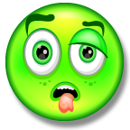
To keep me well I take these medicines:
This is how I take my medicine:
I am Allergic to:

I have medical conditions which mean that I need some extra support.

Medical condition Support needed

I have received inoculations to protect me from:
My religion is:
I need this help to meet my cultural and religious needs:
This is my morning routine on a school day:
This is my morning routine when I am off school:
My routine when I get home from school is:
My night time routine is:
To help me settle to sleep and keep me safe at night I need:
This is how I communicate:
When I am upset I like to be comforted by:
These things make me happy:
When I am happy I will:
These things make me sad:
When I am sad I will:
These things make me scared:
When I am scared I:
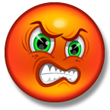
These things make me cross and upset:
When I am upset I:
When I am tired I:
When I am poorly I:

My favourite activities are:
My favourite toys are:

My favourite television/DVDs are:

My favourite music is:

I need this help bathing:
I need this help with my teeth:

I need this help with my hair:

I need this help toileting:

I need this help dressing/undressing:

To help me move around you need to:

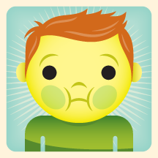
I need this help and equipment to enjoy mealtimes:
My favourite foods:
My favourite drinks:
Food and drink I don’t like
Foods that make me poorly
I need this to help me to manage my behaviours:

Other things that I would like to share with you about me:

