Introduction

Lincolnshire County Council is changing the way residential care and residential nursing care is paid for. We are improving the experience for people by simplifying the process.

This change will see Lincolnshire County Council pay the care home for the full cost of care. This means that the individual or their representative will now pay Lincolnshire County Council for the contribution to their care.

What does this mean for people already placed in a care setting?

Individuals receiving support do not need to worry about the change, and do not need to do anything right now. Lincolnshire County Council will be in touch with those who are placed in the care homes affected to discuss and set up suitable payment arrangements with them and answer any queries they may have as and when that home moves over to Gross payment.

How does the new process differ from the existing one?

Existing Process | New Process
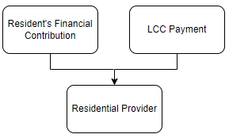 | 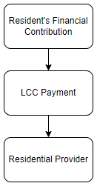

The change will take place in phases, not all care homes will operate the new process straight away.

If the residents care home has not moved over to the new process the resident or their representative will be asked to follow the existing process, where they continue to
pay their contribution direct to the care home.

How will I know if a home is operating the new process or not?

The net or gross status of the care homes will be recorded in the Care Home Contract Information Tool. Care Home Contract Information Tool

When using the Care Home Contract Information Tool whilst making a placement, search for the care home either through location or detailed search. When you have found the care home click to highlight this then click on the ‘Show Information’ icon in the left-hand pane which will bring up details of the care home including ‘Paid Gross’ status.

What if there is a First or Third Party Top Up?

If there is a First or Third Party Top Up you will need to check if the respective home has moved to being paid gross. Your Finance Champion can provide you with a copy of the top up form to be used if the home has moved to the gross payment system.

The following process map helps explain the above:

What if a person is moving homes from a home that is paid gross to one that is not?

In the event someone moves from a GROSS paid home to another home which is still being paid NET the agreed principal is that the individual in receipt of care should remain on the GROSS payments arrangement. The project team shall ensure that all parties involved will be appropriately supported, with suitable payment arrangements put in place to ensure a smooth transition.

If you do have any questions about this process, please raise them via your Finance Champion

.

