Activities of Daily Living – Assessment Information
OFFICE USE ONLY:
Mosaic number:
Please return to: @lincolnshire.gov.uk

About this form

The information you provide in this form will help the Occupational Therapy Team to build a picture of your abilities and needs.

Please complete all sections of this form and either email it to:
or post it using the SAE provided.

Top tips on how to complete the form

- Please take care if you are obtaining measurements and information yourself – it is important that measurements are as accurate as possible
- If you are unable to answer all of the questions do not worry – just do as much as you can.
- You may need to ask for help and can ask a member of your family (who is currently staying with you under the current COVID-19 restrictions) or a carer who is visiting you.
- If you feel able to, you may want to take pictures of your home or chair/bed/stairs in order to help us to get a better understanding of your needs.

What will happen next?

The information you provide together with the discussion you have had with the Occupational Therapy Team may indicate that you need a further assessment at home or some specialist equipment that could help you be more independent at home. This will be discussed with you so that together we can agree a plan.

Tell us about you and your home

Please tell us your height in feet/inches/metres

Please tell us your weight in stones/pounds/kilos

Please tell us the measurement from the back of your heel to the back of your knee (please take this measurement when you are sitting and are wearing your normal slippers / footwear).

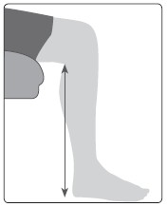

cm or inches

Section 1: Bathroom and Toilet

- What is the shape of your toilet bowl? - Please tick the picture that best matches yours:

☐ ☐ ☐

☐ None of these – please describe

- What is the height from the floor to the top of the toilet bowl (without the lid or the seat)?

cm or inches

- When facing the toilet, are there any pipes or obstructions to the side of the toilet? Please tick any which applies:
☐ No obstruction or pipes
☐ Obstruction or pipes left hand side
☐ Obstruction or pipes right hand side
☐ Obstruction or pipes both sides
☐ Boxed in pipes

Baths & Showers

- Do you have a shower or a bath? Please tick:
☐ Shower only – please continue to question 12
☐ Over bath shower
☐ Bath- please continue onto question below
☐ Bath & shower (is shower electric ☐ power ☐ tap attachment ☐

- Shape of the bath, please tick the one that best matches your bath:
☐ Standard (straight)
☐ Corner
☐ Other

- Please describe in words or draw a rough layout in the box below if applicable - see example bathroom layout on the right

Your bathroom | Door  Example

- Is the bottom of the bath smooth or dimpled or ridged? Please tick one that best matches your bath:
☐ Smooth
☐ Dimpled or ridged

- What is the full length of your bath – outside edges? cm or inches

- What is the width of your bath? - measure from the wall to the outside edge of the bath:
cm or inches

- What is the height of your bath? (measured at its highest point)

cm or inches

- What is the width of the bath edge on the side nearest the wall? (but don’t worry if this is too difficult to reach and measure).

cm or inches
☐ I have no rim on the wall side
Are the sides of the bath decorative or fluted? Yes / No
Are there rails fitted onto the bath and if so, do they protrude above the top of the bath? Yes/No
Are there rails fixed onto the wall near the bath? Yes/No

Shower base/trays
- Please describe in words or draw a rough plan of your shower room, if applicable, please include shower door/s if any – see example on the right.
Example

Door

- What is the size and shape of your shower tray? Measure the internal standing area rather than the overall size. What is it made from? Is it plastic or solid?

Depth cm or inches Width cm or inches

- Are the walls solid/tiled/hollow? Please describe:

- What is the height from the top of the shower tray to the bathroom floor? Do you have to step up to get into the shower?
Height cm or inches

Section 2: Bedroom

- Make a note in the box of the type and shape of the bed you have, i.e. divan type, metal frame, sleigh etc. Any photos or information provided will help, as we need to identify the structure of the bed, this is important when providing equipment (if needed).

- Is it a: Double/Single/Queen size? (underline which)

- Does it have drawers? Yes/No (underline which)

- If yes, are the drawers at the Side/Bottom/ Base lifting with storage underneath? (underline which)

- How many legs or castors does it have? (some double beds have 6 or 8)

Number of legs Number of castors

If possible, please describe the shape and size of the leg / castor:

- Please sit on the edge of the bed and measure the compressed height of the mattress from underneath the back of your leg to the floor to take account of how it squashes down to the floor.

cm or inches

- Please lift the mattress, a little, and slide your hand underneath and make a note of the base
☐ Spring base/soft to touch
☐ Firm base
☐ Wooden slats/metal rods – are these securely fixed? For example, are they screwed down?

- How big is the gap under the bed? cm or inches

Section 3: Living room - Chairs and sofas

- Make a note of the type of legs your chair/sofa has in case we need to raise it, for example castors, straight wooden legs, carved or decorative shaped legs. A photo of your chair/sofa including the legs would be really useful.

- If a sofa – how many legs does it have?

- Please measure the depth of the seat, by measuring the distance from the front edge of the chair to the back of the seat.

Height cm or inches Depth cm or inches

- Sit on the chair/sofa and measure the compressed height from the edge of the chair/sofa under your leg (measure from the ‘squashed bit under your legs down to the floor).

Height cm or inches

Section 4: Internal access - steps and stairs

- Which side of the staircase is the banister on? (please underline) Left ascending / Right ascending / None
- Can you describe the wall that does not have a banister on? Is it a stud wall (does it sound hollow when you knock it)?
- Please use the pictures below to indicate if you can, the shape and design of your stairs (please tick)

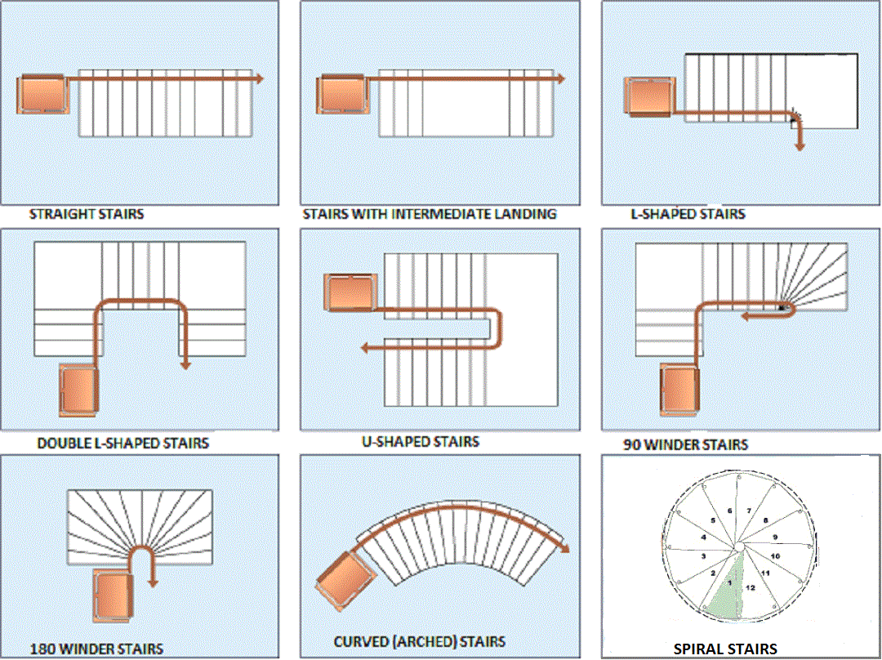

- If you need to, please provide more detail about your stairs. Please include details of any internal steps e.g. steps into the kitchen:

Section 5: External Access to your property

- Please use the box below to tell us about any steps to your door. Please also specify if the steps are to the front or rear of your property and whether this is your main access point to your home. Do you have a UPVC threshold at your access door?

- Please measure the height and depth of your steps

Depth cm or inches

Height cm or inches

- Please use the box below to insert a diagram of the access to your property. Alternatively, please take a photo and send it to us. Please state if this access is the front or rear of the property and if possible, state what the door and surrounding structure is made of i.e. wood/plastic/brick.

Section 6: General

- If you have any equipment or adaptations already fitted such as grab rails, hand rails, bath boards, etc. please list them below.

Section 7: Home ownership

- If your home is privately rented or is a housing association property, please supply the name, address and telephone number details of the landlord as, should we recommend any adaptations, we would need to seek the permission of the landlord.

This form was completed by:
Name:

Relationship (if applicable):

Date:

Thank you for your patience in filling out this form.

