Strengths Based Assessment
This document is for Adult Care and Community Wellbeing only.

01/08/2022 Version 1
KEY POINTS

- Always ensure people are as prepared as they can be for their assessment.

- Strengths based conversations are more important than seeking specific answers to specific questions.

- Be guided by what is strong not what is wrong; and what matters not what’s the matter.

- Your skills as an assessor and solution finder can be the most powerful intervention at your disposal.

Contents
Introduction 2
Preparation for Assessment: Pre Assessment Information 3
Pre Allocation Correspondence 3
Assessment Knowledge and Skills Guide: Golden Rules 3
Supported Self-Assessment 4
Strengths-based Approach to Assessment 4
Strengths-based Approaches: Changing our Mindset, Organisational Culture and our Practice 5

Introduction
Chapter 6. Assessment and Eligibility of the Care and Support Statutory Guidance states:

The assessment and eligibility process is one of the most important elements of the care and support system. The assessment is one of the key interactions between a local authority and an individual, whether an adult needing care or a carer. The process must be person centred throughout, involving the person and supporting them to have choice and control.

The assessment process starts from when local authorities begin to collect information about the person, and will be an integral part of the person’s journey through the care and support system as their needs change. It should not just be seen as a gateway to care and support, but should be a critical intervention in its own right, which can help people to understand their situation and the needs they have, to reduce or delay the onset of greater needs and to access support when they require it. It can also help people to understand their strengths and capabilities, and the support available to them in the community and through other networks and services.

The purpose of an assessment is to identify the person’s needs and how these impact on their wellbeing, and the outcomes that the person wishes to achieve in their day-to-day life. The assessment will support the determination of whether needs are eligible for care and support from the local authority, and understanding how the provision of care and support may assist the adult in achieving their desired outcomes. An assessment must be person centred, involving the individual and any carer that the adult has, or any other person they might want involved. An adult with care needs could for example ask for their GP or a district nurse to be contacted to provide information relevant to their needs.

Overview of the assessment process: Care and Support Statutory Guidance
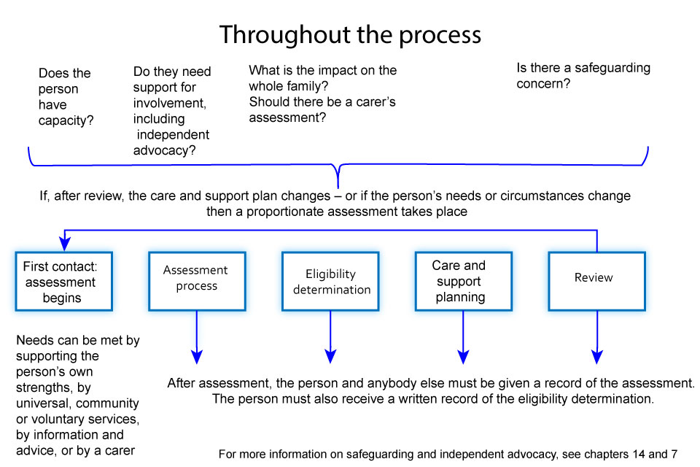

Preparation for Assessment: Pre Assessment Information
Quality Practice Standard 1 – Engaging with our customers sets out the importance of ensuring people are given every opportunity to be as fully engaged as possible in the assessment process.
Assessment should be an empowering experience and having information and advice about the process is vital to ensuring that assessment does not feel that it has ‘been done to’ the person being assessed.
Consequently, except in urgent situations, everybody being assessed should have access to information and advice about what to expect from an assessment, in a format that is suitable to them prior to the substantive element of their assessment happening. They should have the opportunity to prepare, to think about what they need to get over to their assessor and make an informed choice about whether they wish to be assessed as a supported self-assessment.

Pre Allocation Correspondence
The Adult Care Pre Allocation work step has been created in Mosaic to enable Business Support to be tasked with providing pre-assessment information and advice to people. This step can be used by duty officers or by practitioners when allocated and preparing to visit. It should always be used to ensure information can be received in a timely way prior to visiting.

Important: Using the Mosaic work step enables business support to add to the record what factsheets and information and advice has been sent to whom. It is important that we record information and advice given within the person’s record.
Practitioners can, if they choose, send out the letter and information and advice themselves.

If you choose to do this, you must use the Mosaic step to record what information and advice has been sent.

All the documents requested in the Mosaic step can be found in the Local Resource Library under Leaflets, Booklets and Customer Information.

Assessment Knowledge and Skills Guide: Golden Rules
Lincolnshire Adult Care has produced an Assessment Skills and Knowledge Guide including ‘the golden rules’, first developed with assessment practitioners, to provide good practice guidance for assessment. It has been written in conjunction with extracts from the Strengths-based approaches for assessment and eligibility under the Care act 2014 (SCIE, 2015).

Assessments should always be carried out by appropriately skilled practitioners and continued development of your assessment skills should be evident in your personal development plan.

Additional resources to support professional assessment skills can be accessed through the Continuing Professional Development document available in the Local Resource Library.

Supported Self-Assessment
The Care Act requires and encourages assessments to be undertaken in a range of ways which best suit the person’s wishes and circumstances. People should be offered the opportunity to have a supported self-assessment wherever appropriate. The term supported self-assessment reflects that whilst people should be offered the opportunity and encouraged to self-assess, it will remain the role of the assessor to review the information provided, seek out clarity from the person and any other relevant people and make the eligibility determinations on the basis of their professional assessment. All assessments, but especially supported self-assessments, require the person to be given information and advice about the assessment process as soon as possible. The Adult Care Supported Self-Assessment document may be sent out as part of the pre assessment work step. It provides an opportunity for people to explore in as much detail as they are able:
- their own strengths;
- what they can do for themselves;
- what help and support is around them;
- if they have difficulties;
- what outcomes they want to achieve.

This document should be posted or emailed where it is appropriate and beneficial before an assessment visit along with any other information including the Care and Support in Lincolnshire Factsheet.

Strengths-based Approach to Assessment
Key messages on a strengths-based approach for assessment and eligibility

Practitioners must consider the person’s own strengths and capabilities, and what support might be available from their wider support network or within the community to help, when also considering the provision of care and support that might assist the person in meeting the outcomes they want to achieve.

In order to do this the practitioner ‘should look at the person’s life holistically, considering their needs and agreed outcomes in the context of their skills, ambitions and priorities’.
The assessment should identify the person’s strengths – personal, community and social networks – and explore with the person how those strengths may be maximised to enable them to achieve their desired outcomes, thereby meeting their needs and improving or maintaining their wellbeing.

Any suggestion that support could be available from family and friends should be considered in light of their appropriateness, willingness and ability to provide any additional support and the impact on them of doing so. This is also subject to the agreement of the adult or carer in question (see 6.64 of the Care and Support Statutory guidance).

The objective of the strengths-based approach is to maintain and promote the person’s independence, resilience, ability to make choices and their wellbeing. Supporting the person’s strengths can help address needs (whether or not they are eligible) for support in a way that allows the person to lead, and be in control of, an ordinary and independent day-to-day life as much as possible. It may also help delay the development of further needs.

A case study based example of how to apply a strengths-based approach to assessment can be found on the Social Care Institute of Excellence website.

Further information about taking a strengths-based approach is included in Strengths-based approaches for assessment and eligibility under the Care Act 2014 (SCIE,2015) and The New Social Care: Strength-Based Approaches (2020 Public Services Hub and Shared Lives Plus).

Strengths-based Approaches: Changing our Mindset, Organisational Culture and our Practice
A strengths-based approach shifts the focus of statutory social care practice from a traditionally deficits-driven model. It encourages us to think first about people’s individual strengths, interests and what they might offer; strengths and assets in their networks of support and how we may facilitate people widening and strengthening their networks. It also challenges us to consider the relationship between care and support needs, our communities and our role in developing communities to support more people to stay independent of services. It means thinking positively about people who need care and support as well as engaging with the community to reduce isolation and draw those with care and support needs further into community networks.

The Care Act requires practitioners to have a strengths-based approach throughout the person’s journey and to enshrine it within all interventions and interactions with individuals.

This represents a significant culture shift for many of us accustomed to working in a health and care system which has focused on a more deficit based model where we understand what is wrong and missing, the risks that poses and how we can prescribe, plan and administer services to manage those deficits and risks.

Strengths-based practice requires us to reflect on and acknowledge our role individually and organisationally in supporting people to stay independent. It challenges us to be more creative in seeking solutions and many times it may require more of our time to try and nurture strengths based opportunities than the more transactional practice models of the past.

There is an ever growing body of evidence that supporting people in this more proactive way can help people stay independent longer and achieve better outcomes. Investing time and energy to support people to stay independent is a valid and vital use of practitioner time. Part of this culture change involves us all breaking the cycle of always providing services in response to a presenting situation to shift from a less reactive and more proactive model.

Practitioners need to have good knowledge and awareness of community resources and social capital, particularly within the area in which they work. Managers should allow time for practitioners to research and gain this knowledge.

Practitioners must prepare assessments thoroughly. Time for preparation of assessment should be taken. Other changes in assessment methods (for example, supported self-assessment, third-party assessment and improved prevention) should provide opportunities to regain time.

Assessment should be a collaborative process of gathering information through a conversation drawn from open questions with the person.

Assessments should be outcome-based and not output-based; they are about what needs to change rather than what someone needs to do.

The Care Act sets out specific duties in relation to assessing people who are deafblind (see the ‘Legal Requirements’ chapter in the Adult Care Procedures, Practice Guidance and Tools).

