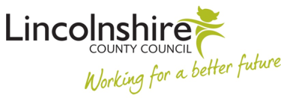

**LINCOLNSHIRE JOINT AGENCY MENTAL HEALTH AND LEARING DISABILITY SERVICES**

**DATA AND CONSENT**

**Data protection**

This assessment/care planning is being undertaken under Lincolnshire County Council, Lincolnshire Integrated Commissioning Board and Lincolnshire Partnership Foundation Trust

statutory duties. The assessment and any care and support planning that follows will require us to record information in our electronic systems and share information with relevant organisations involved in your care and support.

'General Data Protection Regulation' provides the assessing authorities with a framework to safeguard your personal information. Please see the information on the relevant authority website (links below) for information about how your information will be handled.

Lincolnshire County Council: [www.lincolnshire.gov.uk/privacy](http://www.lincolnshire.gov.uk/privacy)

Lincolnshire Partnership Foundation Trust: [www.lpft.nhs/privacy-policy](http://www.lpft.nhs/privacy-policy)

Lincolnshire Integrated Commissioning Board: [www.lincolnshireccg.nhs.uk/privacy](http://www.lincolnshireccg.nhs.uk/privacy)

**Consent**

We ask for and record your consent before doing the assessment. For people who do not have capacity to consent we will record why we believe you lack capacity. We will also record details of any decisions to continue with the assessment, taken in your best interests by either your formally appointed representative or your assessor.