Name |  | Date:
Title | e.g. My first DST
CPD Domain Met | e.g. Knowledge and Skills
Outcome | Copy and paste the bullet point outcome
Reflective Log
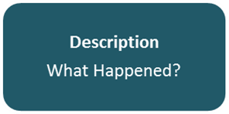
Description

Description - This is a brief overview of the event or activity you are reflecting on. There is no need to make this too long or overly detailed, just focus on the relevant points.

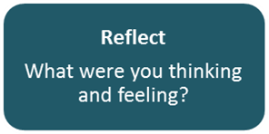
Reflection

Reflection - Try and capture the situation, context and what you were thinking. Also try and describe how you were feeling, why you may have made a certain decision, or taken a specific action.

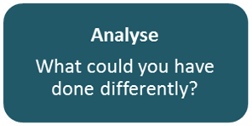
Analyse

Analyse – This section is about what you have learnt from the experience and what alternatives you may use in the future.

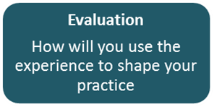
Evaluation – How will you use the experience and what you have learnt to shape your practice in the future?

Evaluation

