Your Section 117 After-care Explained

What is Section117 After-care?  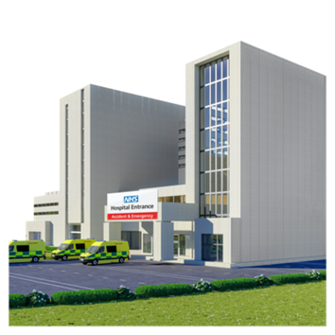 | Section117 After-care is the free help you get when you leave hospital if:  • You have been mentally unwell and been detained on a qualifying section, in hospital under the Mental Health Act 1983
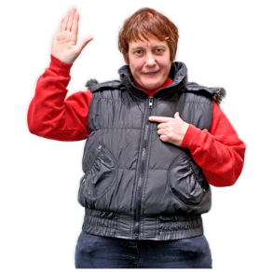 | It begins when you leave hospital  Professionals should start to plan the help you need as soon as you go into hospital
Will I get Section 117 After-care?  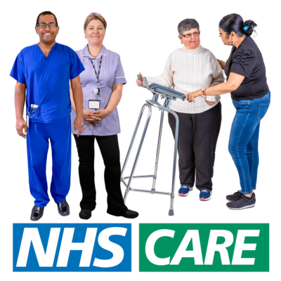 | Yes.  You will get free after-care because you have been detained in hospital for treatment, under a Section of the mental health act that means you are eligible for section 117 aftercare

You will still get free Section117 Aftercare if : | • You stay in hospital by choice (“Informal”) after being on a qualifying section.  • You are discharged from hospital under a Community Treatment Order or Guardianship
What help can I get?  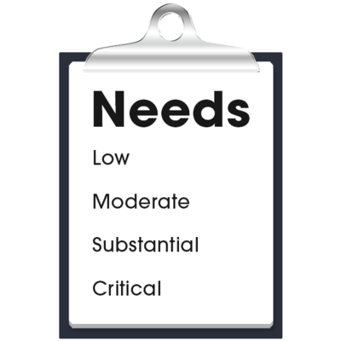 | Your mental illness might make it harder for you to do some things for yourself. These are called your “needs”  You should be offered services that help you to deal with these problems. This is called “meeting your needs”  These services should also reduce the chances of you having to go back into hospital  When everyone agrees what help you need, they will write this down. This is called your “care plan”
Your Patient-Centred Care Plan will include:  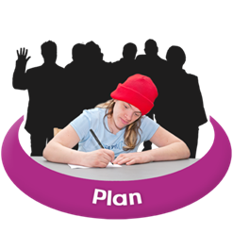 | • Where you live  • What treatment you will receive (e.g. medication or talking to a nurse, or carer to assist you in meeting your needs)  • Things you can do during the day  • What help you will get with managing your money  • What help you will get to go to work or to study  Your Care Plan will include your choices of how  you want your needs to be met
Can I get free housing?  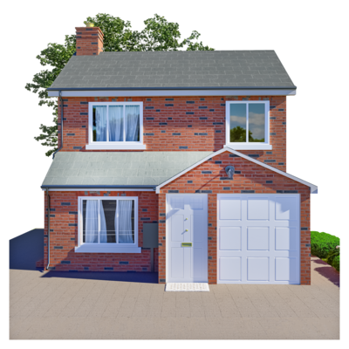 | A house or flat that you rent from a landlord is called your “basic housing need”. This is not usually free, but you might be entitled to housing benefit  Housing where you can get extra care, support or supervision is called “supported accommodation”  You might have to pay the rent, but your Section 17 Aftercare will be free
Who will be involved in deciding my Section 117 After-care?  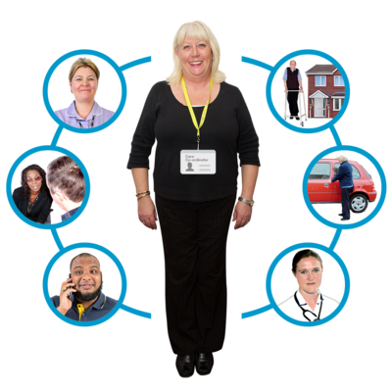 | 1) Your “Carer” if you want them to be. This is the person who looks after you  2) Your “Nearest Relative” if you want them to be. This is usually someone in your family, but the law says who this is. It is the job of your Nearest Relative to look out for you and make sure your wishes and choices are heard and understood  3) Your “Lead professional”. This is the person who is your main point of contact and support from the Community Mental Health Team  4) You can also get help to understand your care plan from an IMHA or Independent Mental Health Advocate in the community  5) Your Social Services in the area where you lived before hospital  6) Your local NHS “Integrated Care Board” (ICB) or Lead Professional. In the area where you are registered with your GP.

When will my free after-care end? | You are entitled to be given Section 117 Aftercare for as long as you need the support  Your local Social Services and your local ICB must decide when you no longer need any after-care services. This is called “discharge” from aftercare  Professionals shouldn’t discharge you from Section117 just because:  • You have been discharged from your community mental health team  • Some time has passed since you left hospital  • You have gone back to hospital by choice (“voluntary patient”) or Under Section 2 MHA  • Your Community Treatment Order ends  • You don’t want Section 117 Aftercare services

What happens when I am going to be discharged? | Professionals will hold a Section 117 Discharge Meeting and invite you to this  You will be able to bring an advocate with you  You will also be able to bring your Carer and/or your Nearest Relative if you want
What if I am not happy about the help I am having?  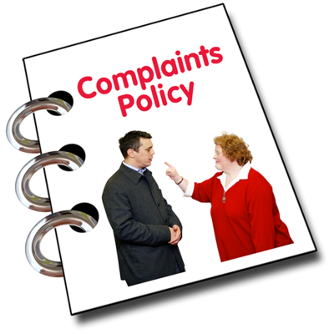  NHS Lincolnshire Integrated Care Board Telephone number is:  Lincolnshire Adult Social Care Telephone Number is: | You can complain about anything to do with your care and treatment by talking to:  • A member of your staff, Your Lead Professional, Your Advocate, or NHS Lincolnshire ICB  • A member of the complaints team at Lincolnshire County Council Adult Social Care Team  Lincolnshire County Council  CustomerRelationsTeam@lincolnshire.gov.uk  Lincolnshire Partnership  Foundation Trust  PALS@lpft.nhs.uk  NHS Lincolnshire  Integrated Care Board (ICB)  LHNT.LincsPALS@nhs.net  01522 309318  01522 552222
Updated 20.07.2022
Neil Chadwick

