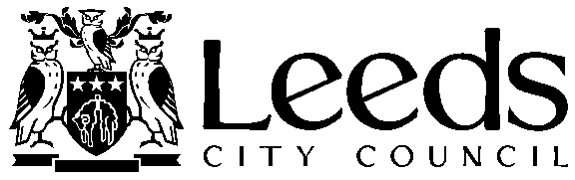
Leeds Children’s Social Work Service
13+ Children Looked After Service
Contact Name:
Tel:
Email:
Date:

NO STATUTORY DUTY TO PROVIDE SERVICES UNDER THE CHILDREN ACT 1989

To: WHOM IT MAY CONCERN
RE:
The above person was seen at the ………………………….on the ……………….., claiming to be a minor. The above person has not produced any official documentation that we can confirm has been verified as authentic in support of his claim.
Two social workers have found the above person to be over the age of 18 years. The two workers are from a Leeds Children’s Social Work Service 13+ Looked After Children’s Team and have training and experience in age assessments and working with children and young people seeking asylum.
Their decision is based on the physical appearance and presentation of the above person and is Merton Compliant: “There may be cause where it is very obvious that a person is under or over 18. In such cases there is normally no need for prolonged inquiry….” (see below*).
It is considered that the above person is a “Clear and Obvious case” of being over the age of 25. “No full assessment (is) required in clear cases. It (is) lawful for the authority to proceed in this manner without a full assessment. A full detailed age assessment (is) reserved for cases of doubt” (see below**).
As the above person has been assessed as not to be a minor, the Local Authority is under no Statutory duty to carry out a further assessment nor to provide services under the Children Act 1989.
The above person and been informed of the decision.
Yours sincerely

* B,R (on application of) V London Borough of Merton (2003) EWHC1689
** R (K) v Milton Kenes Council (2019)

