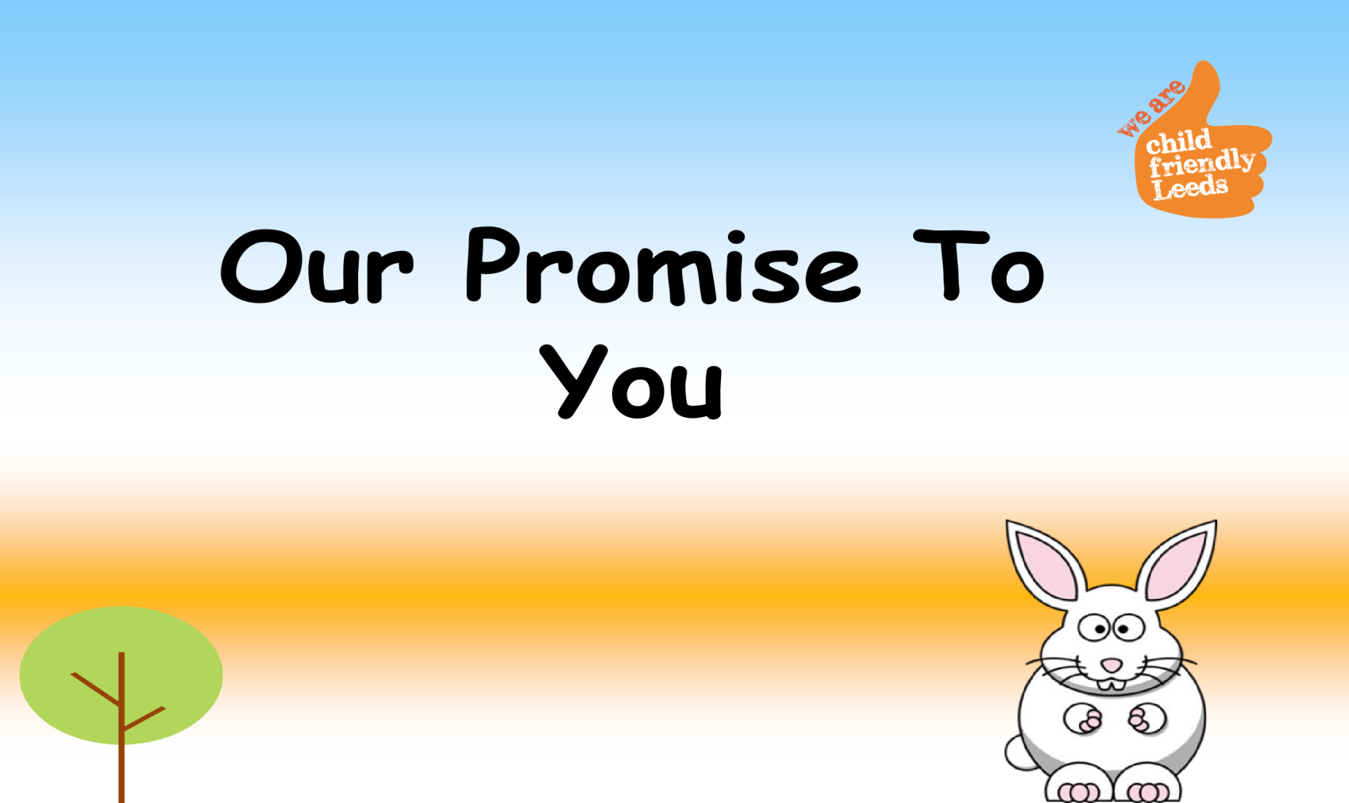

**Once upon a time, there**

**was a rabbit called Robby.**

**Robby lived with Gerry and**

**Gail in their nice forest.**



**Robby couldn’t live with his**

**mummy and daddy, but there**

**were lots of people who**

**wanted to help Robby and keep**

**him safe.**

**The kind buzzy Bee wanted to**

**make sure Robby was happy**

**and safe.**



**The buzzy bee had an**

**important job…**

**It was the Bee’s job to make**

**sure Robby was happy where**

**he lived and with who he sees.**

**The Bee made a PROMISE to**

**Robby.**



**The Bee promised…**

**To help Robby to stay**

**safe and healthy.**



**The Bee promised…**

**To help Robby to make**

**decisions and choices**

**about his life.**



**The Bee promised…**

**To encourage Robby to**

**try hard and do his**

**best.**



**The Bee promised…**

**To help Robby to enjoy**

**learning and work hard**

**in school.**



**The Bee promised…**

**To listen to Robby and**

**to make sure he knows**

**what will happen next.**



**The Bee promised…**

**To celebrate with**

**Robby when he does**

**well!**



**The Bee promised…**

**To make sure Robby**

**has lots of people who**

**will help him.**



**The Bee**

**promised…**

**To help Robby to do**

**activities that are fun**

**and to try new things!**



**Robby was really happy that the**

**Bee could help him, it made him**

**feel safe.**

**Robby told Gerry and Gail he**

**was happy with the Bee!**

**Yippee!**



**Just like Robby, you have a kind Bee to help you!**

**Your Bee is your social worker.**

**Your social worker promises you…**

**To help you to stay safe and healthy.**

**To help you to**

**make decisions and choices about your life.**

**To encourage you to try hard and do your best.**

**To help you enjoy learning and work hard in school.**

**To listen to you and make sure you know what will happen next.**

**To celebrate with you**

**when you do well.**

**To make sure you have lots of people who will help you.**

**To help you to do activities that are fun and to try new th**

[**ing**](http://sweetclipart.com/multisite/sweetclipart/files/little_girl_daisy_2.png)

[**s**](http://sweetclipart.com/multisite/sweetclipart/files/little_girl_daisy_2.png)

[**.**](http://sweetclipart.com/multisite/sweetclipart/files/little_girl_daisy_2.png)