**Our Promise To**

**You**

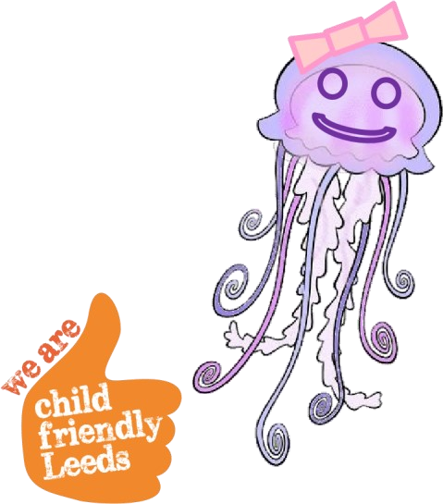

**Once upon a time, there was a jellyfish called**

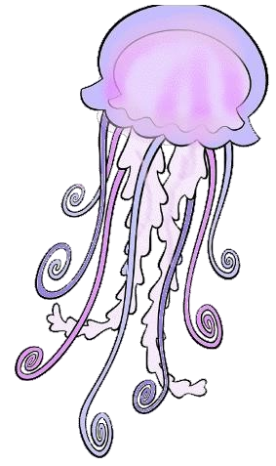

**nice seabed.**

**Jenny. Jenny lived with**

**Owen and Olivia on the**

# Jenny couldn’t live with her mummy and daddy, but there

**were lots of people who wanted to help Jenny and keep her safe.**



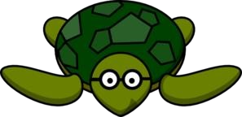**The clever turtle wanted to make sure Jenny was happy and safe.**



**The clever** **turtle had an**  **important job…**

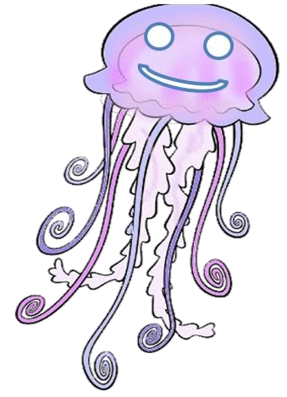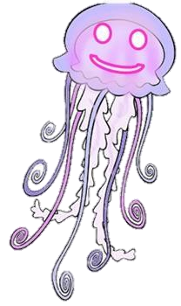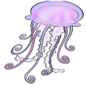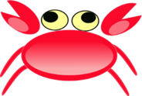

**It was the Turtle’s job to make**

**sure Jenny was happy where she**

**lived and with who she sees.**

**The Turtle made a PROMISE to**

**Jenny.**

# The Turtle promised…



**To help Jenny to stay safe**

**and healthy.**



**The Turtle promised…**

**To help Jenny to make decisions and choices about**



**her life.**

[**Decisio**](http://www.google.com/url?url=http://www.iconsdb.com/orange-icons/speech-bubble-icon.html&rct=j&frm=1&q=&esrc=s&sa=U&ei=x8gWVOGBFsS57AawqoGAAQ&ved=0CBgQ9QEwAA&usg=AFQjCNHSL05jRbfo5BuTGBNy6BL8oS66WQ)

[**n**](http://www.google.com/url?url=http://www.iconsdb.com/orange-icons/speech-bubble-icon.html&rct=j&frm=1&q=&esrc=s&sa=U&ei=x8gWVOGBFsS57AawqoGAAQ&ved=0CBgQ9QEwAA&usg=AFQjCNHSL05jRbfo5BuTGBNy6BL8oS66WQ)

[**s**](http://www.google.com/url?url=http://www.iconsdb.com/orange-icons/speech-bubble-icon.html&rct=j&frm=1&q=&esrc=s&sa=U&ei=x8gWVOGBFsS57AawqoGAAQ&ved=0CBgQ9QEwAA&usg=AFQjCNHSL05jRbfo5BuTGBNy6BL8oS66WQ)

[**Choic**](http://www.google.com/url?url=http://www.iconsdb.com/orange-icons/speech-bubble-icon.html&rct=j&frm=1&q=&esrc=s&sa=U&ei=x8gWVOGBFsS57AawqoGAAQ&ved=0CBgQ9QEwAA&usg=AFQjCNHSL05jRbfo5BuTGBNy6BL8oS66WQ)

[**e**](http://www.google.com/url?url=http://www.iconsdb.com/orange-icons/speech-bubble-icon.html&rct=j&frm=1&q=&esrc=s&sa=U&ei=x8gWVOGBFsS57AawqoGAAQ&ved=0CBgQ9QEwAA&usg=AFQjCNHSL05jRbfo5BuTGBNy6BL8oS66WQ)

[**s**](http://www.google.com/url?url=http://www.iconsdb.com/orange-icons/speech-bubble-icon.html&rct=j&frm=1&q=&esrc=s&sa=U&ei=x8gWVOGBFsS57AawqoGAAQ&ved=0CBgQ9QEwAA&usg=AFQjCNHSL05jRbfo5BuTGBNy6BL8oS66WQ)

# The Turtle promised…

**To encourage Jenny to try hard and do her best.**



# The Turtle promised…

**To help Jenny to enjoy learning**

# and work hard in

**school.**

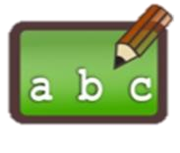

# The Turtle promised… To listen to Jenny and



**to make sure**



**she knows what will happen next.**



# The Turtle promised…



**To celebrate with Jenny**

**when she**



**does well!**

**The Turtle promised…**

**To make sure Jenny has lots of people who will help her.**

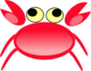

**The Turtle promised**



**To help Jenny to do activities that are fun and**

**to try**

**new thi**

**~~n~~**

**gs!**



**Jenny was really happy that the Turtle could help her it made her feel safe.**

**Jenny told Owen and**

**Olivia she was happy with the**

**Just li**

**k**

**e Jenny, you have a clever Turtle to help you!**

**Your Turtle is your social worker.**

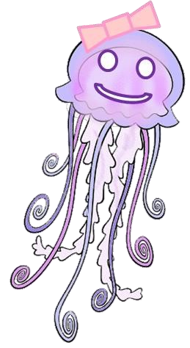

**Turtle!**

**Yippee!**

**Your social worker promises you…**

**To help you to stay safe and healthy.**

**To help you to make decisions and choices about your life.**

**To encourage you to try hard and do your best.**

**To help you enjoy learning and work hard in school.**

**To listen to you and make sure you know what will happen next.**

**To celebrate with you when you do well.**

**To make sure you have lots of people who will help you.**

**To help you to do activities that are fun and to try new** [**things.**](http://sweetclipart.com/multisite/sweetclipart/files/little_girl_daisy_2.png)

