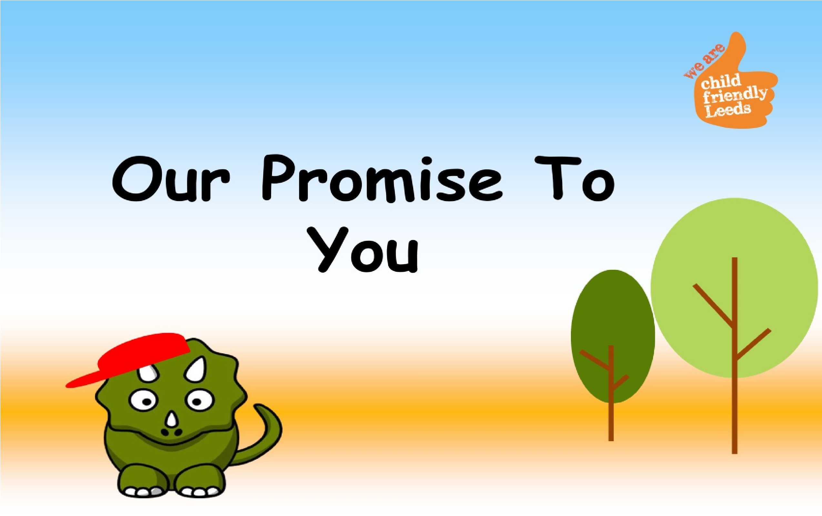

**Once upon a time, there**

**was a dinosaur called Dino.**

**Dino lived with Doris and**

**Derek in their nice forest.**



**Dino couldn’t live with his mummy**

**and daddy, but there were lots of**

**people who wanted to help Dino**

**and keep him safe.**

**The wise Owl wanted to make**

**sure Dino was happy and safe.**

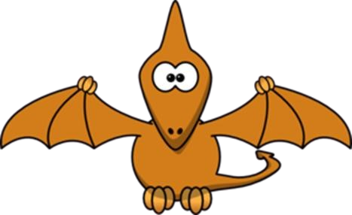

**The wise Owl had an important**

**job…**

**It was the Owl’s job to make**

**sure Dino was happy where he**

**lived and with who he sees.**

**The Owl made a PROMISE**

**to Dino.**



**The Owl promised…**

**To help Dino to stay safe**

**and healthy.**



**The Owl promised…**

**To help Dino to make**

**decisions and choices**

**about his life.**

[**n**](http://www.clker.com/clipart-4755.html)

[**Decisio**](http://www.clker.com/clipart-4755.html)

[**s**](http://www.clker.com/clipart-4755.html)

[**Choic**](http://www.clker.com/clipart-4755.html)

[**e**](http://www.clker.com/clipart-4755.html)

[**s**](http://www.clker.com/clipart-4755.html)



**Th**

**e Owl promised…**

**To encourage Dino to try**

**hard and do his best.**



**The Owl promised…**

**To help Dino to enjoy**

**learning and work hard in**

**school.**



**The Owl promised…**

**To listen to Dino and to**

**make sure he knows what**

**will happen next.**

|  |
| --- |
| **The Owl promised…**    **To celebrate with Dino** **when he does well!** |







**The Owl promised…**

**To make sure Dino has**

**lots of people who will**

**help him.**



**The Owl promised…**

**To help Dino to do**

**activities that are fun**

**and to try new things!**



**Dino was really happy that the**

**Owl could help him, it made him**

**feel safe.**

**Dino told Derek and Doris he**

**was happy with the Owl!**

**ROAR!**

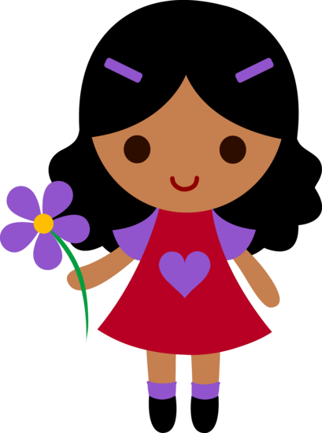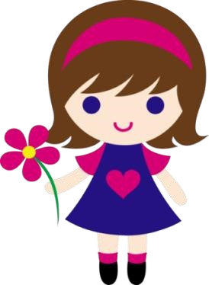

**Just like Dino, you have a wise Owl to help you!**

**Your Owl is your social worker.**

**Your social worker promises you…**

**To help you to stay safe and**

**healthy.**

**To help you to make decisions and choices about your life.**

**To encourage you to try hard and do your best.**

**To help you enjoy learning and work hard in school.**

**To listen to you and make sure you know what will happen**

**next.**

**To celebrate with you when you do well.**

**To make sure you have lots of people who will help you.**

**To help you to do activities that are fun and to try new thi**

[**s**](http://sweetclipart.com/multisite/sweetclipart/files/little_girl_daisy_2.png)

[**ng**](http://sweetclipart.com/multisite/sweetclipart/files/little_girl_daisy_2.png)

[**.**](http://sweetclipart.com/multisite/sweetclipart/files/little_girl_daisy_2.png)