

**Our Promise To You**





**Once upon a time, there was a Lion called Lola. Lola lived with Henry and Helen in their nice forest.**



# Lola couldn’t live with her mummy and daddy, but

**there were lots of people**

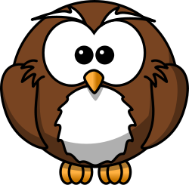

**who wanted to help Lola and keep her safe.**

**The wise owl wanted to** [**make sure**](http://openclipart.org/people/StudioFibonacci/StudioFibonacci_Cartoon_lion.svg) **Lola was happy and safe. The wise owl had an important job…**



# It was the Owl’s job to make sure Lola was happy

**where she lived and with who she sees.**

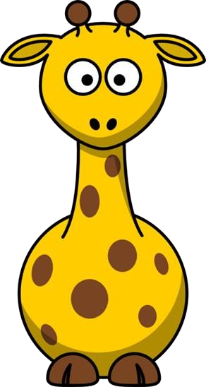

**The Owl made a PROMISE to Lola.**



# The Owl promised…



**To help Lola to stay safe and healthy.**

# The Owl promised…

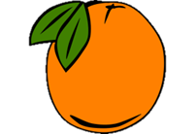

**To help Lola to make**



**decisions and choices**

**about her life.**



# The Owl promised…



**To encourage Lola to try hard and do her best.**



# The Owl promised…

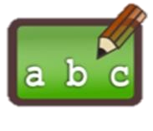

**learning and work hard in**

**school.**

**To help Lola to enjoy**

# The Owl promised…

**To listen to Lola and to make sure she knows what will happen next.**



**The Owl promised…**

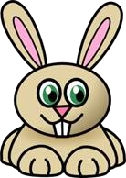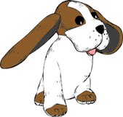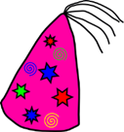

**To celebrate with Lola when she does well!**



# The Owl promised…

**To make sure Lola has lots of people who will help her.**



**The Owl promised…**

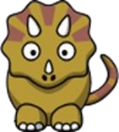

**To help Lola to do activities that are fun and to try new things!**



**Lola was really happy that the**

**Owl could help her, it made her feel safe.**



**Lola told Helen and Henry she**

**was happy with the Owl!**

**ROAR!**

**Just like Lola, you have a wise Owl to help you!**

**Your Owl is your social worker.**

**Your social worker promises you…**

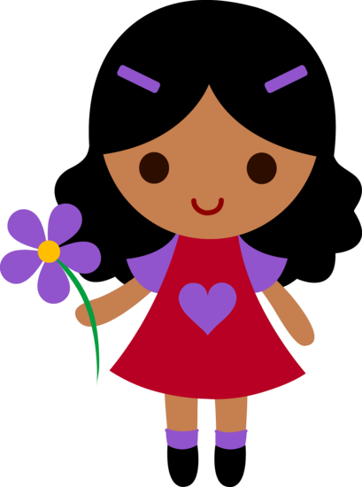

**To help you to stay safe and healthy.**

**To help you to make decisions and choices about your life.**

**To encourage you to try hard and do your best.**

**To help you enjoy learning and work hard in school.**

**To listen to you and make sure you know what will happen next.**

**To celebrate with you when you do well.**

**To make sure you have lots of people who will help you.**

**To help you to do activities that are fun and to try new thi**[**ngs.**](http://sweetclipart.com/multisite/sweetclipart/files/little_girl_daisy_2.png)

