Knowsley Early Help Assessment for Children, Young People and Families

Section 1

Date assessment started

Immediate family information
Children and Young People

Name | Date of birth (due | Gender | Ethnicity | Disability | Who has parental
 | date) | M/F |  |  | responsibility
Parents / Carers details

Name | Date of birth (due | Gender | Ethnicity | Disability | Who has parental
 | date) | M/F |  |  | responsibility
Primary language in the family:

Family Address(es):

Contact telephone numbers:

Relevant information including immediate family and/or other significant adults details:


Those who took part in the assessment - Including family / wider family / professionals

Ethnicity Key: White British - WB; Caribbean – Ca; Indian – I; White and Black Caribbean - WBC; Chinese – Ch; White Irish – WI; African – Af; Pakistani – Pa; White and Black African – WBA; Bangladeshi – Ba; White and Asian - WA; Any other – please describe; Not given - NG

1

Practitioner details – Lead profession completing the assessment
Name | Job role and agency | Address | Contact details
 |  |  | Telephone
 |  |  | Mobile
 |  |  | Email
Name | Job role and agency | Address | Contact details
 |  |  | Telephone
 |  |  | Mobile
 |  |  | Email

Who else is working with the family
Please include Health, Education and any other agencies currently involved with the family

Agency | Main contact | Contact details
Agency | Main contact | Contact details
Agency | Main contact | Contact details
Agency | Main contact | Contact details

Additional services may include: School/College, GP, Dentist, Health Visitor, Children’s Centre, Housing provider,

Child Development Team, Therapy services, Youth Offending Service, Probation, Anti-Social Behaviour Unit, Knowsley Works, Job Centre Plus, Youth services etc


Reason for assessment

2

Section 2

Child / Young Person’s Name

 | Learning / Education / Employment – including attendance, aspirations |  | RAG
 | Physical Health |  | RAG
 | Emotional and Mental Health |  | RAG
 | Relationships – school, family, friends |  | RAG
 | Crime & Anti-Social Behaviour |  | RAG
 | Substance / Alcohol Misuse |  | RAG
 | Use the space below to note anything else you would like to include about your child(ren)?
 | How would you describe your child’s / children’s strengths or the things that they do well?
 | RAG Rating | R = RED – issues which need addressing quickly; A = AMBER – issues you may need help with; G = GREEN –
 | Key: | ositive / no issues

3
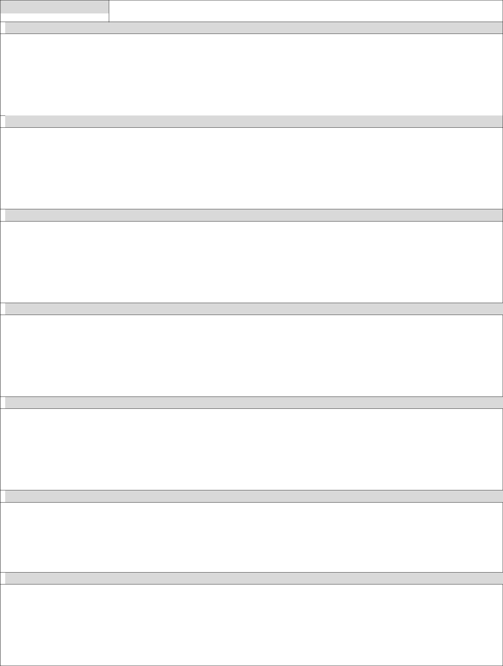
Voice of the Child use appropriate age and ability related tools to ensure the voice of the child / young person is captured
What are your biggest worries about your family?

What things do your parents or carers do well?

What are your hopes and wishes for yourself?

What are your hopes and wishes for your family?

What would you like to change the most?

What do you feel you can do to help make some positive changes?

How will you know things have changed for the better?

4

Section 3

Parent / Adult Name

 | Housing / Living Conditions |  |  | RAG
 | Physical Health |  |  | RAG
 | Emotional and Mental Health |  |  | RAG
 | Relationships – including domestic abuse |  |  | RAG
 | Parenting Skills |  |  | RAG
 | Employment / Training / Learning |  |  | RAG
 | Crime & Anti-Social Behaviour |  |  | RAG
 | Substance / Alcohol Misuse |  |  | RAG
 | Finance / Debt issues |  |  | RAG
 | RAG Rating |  | R = RED – issues which need addressing quickly; A = AMBER – issues you may need help with; G = GREEN –
 | Key: |  | positive / no issues

5
Parent / Adult Voice
What are your biggest worries about your family?

What are your hopes and goals for your family?

What has worked well for you as a family in the past?

What has not worked well for you as a family in the past?

What things as a family would you like to change the most?

What do you feel you can do as a parent/carer to help make some positive changes?

Who else can support your family to make some changes?

How will you know things have changed for the better?

6

Section 4
Summary and Analysis

Are there any dangers or risks to you and/or your child(ren) you need to deal with? If so how can we help?

Summarise the most important changes for your family – what needs to go in your family plan?

Practitioner’s analysis and conclusion

7
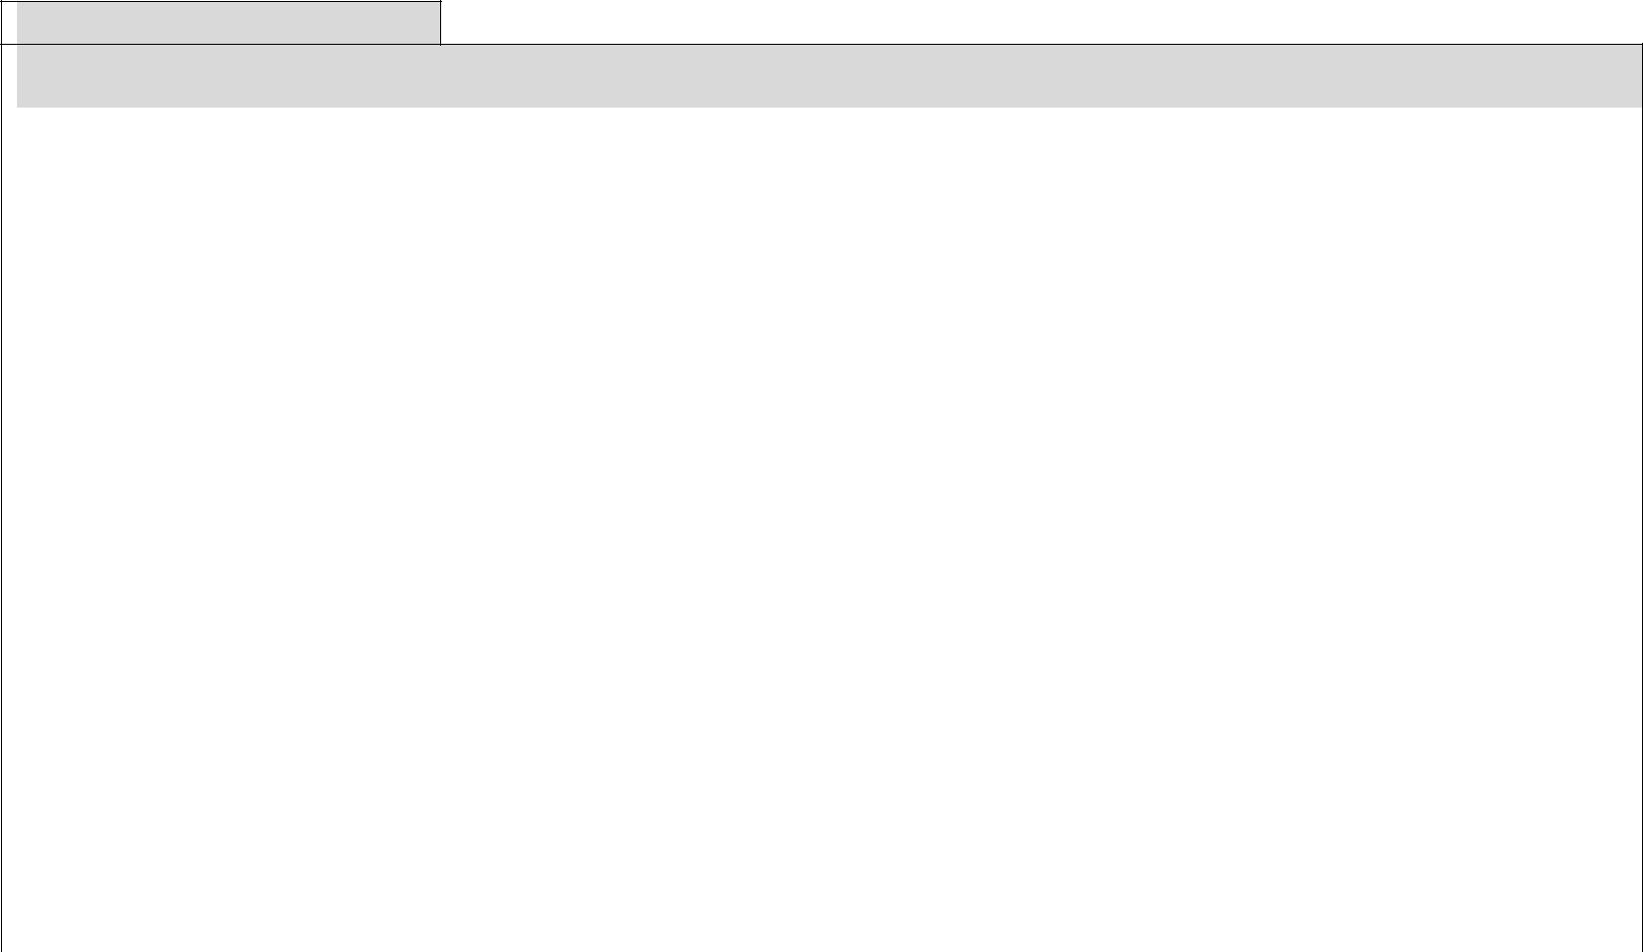
Section 5
Our Family Plan

How can change happen – what action needs to be taken? | Who | When


Agreement to share information

I understand that the information I give will be used to get the services to help me and my family.

I understand that the information I have provided may be shared only where it is necessary and the law allows it. The information may be shared with other teams and services.

The teams and services that will have my family’s information will be the teams who will be helping and supporting us. They will be named in my/our assessment and support plan.

I understand that under no circumstances will you share my/ our personal information with third parties for commercial purposes.

I understand that information that I give is kept safe and secure and treated confidentially.

I understand that my information will only be shared without my permission to protect children or vulnerable adults from harm; or to aid the prevention and detection of crime.

Below is the information I would not want to be shared with any other service or team (unless the law allows or requires it)

Name: | Signature: | Date:
Name: | Signature: | Date:

8

