IRO Dispute Resolution Guidance Notes for Practitioners

The statutory duties of the Independent Reviewing Officer (IRO) require them to monitor the performance of the local authority so that the plan for a Looked After Child continues to be appropriate and responsive to the child's individual needs.
As part of the monitoring function, the IRO also has a duty to identify any areas of poor practice, including general concerns around service delivery (not just around individual children). The IRO should immediately alert senior managers if any such practice areas are identified.
The IRO is responsible for ensuring that the wishes and feelings as well as the rights of the child and parents are given adequate attention and considered throughout the review process.
The allocated IRO is responsible for ensuring that a child's Looked After Review takes place within the statutory timescales and makes recommendations about the care plan, which, if not contested within 5 days, becomes a decision.
Where problems in care planning are identified through the review process, and in order to support their satisfactory resolution, the allocated IRO will need to be able to communicate directly with the manager who has the necessary level of seniority to seek resolution.
The issue may be addressed and resolved via informal discussion within 5 working days following the review date.
The IRO has responsibility to escalate concerns immediately in certain situations depending upon the impact and risks to the child/ren. This means that the issue will not be addressed within the informal route but will be managed via the staged dispute resolution process.
At any stage the IRO can refer the case to CAFCASS. The IRO must consider whether it is appropriate to refer a case to CAFCASS if:
- In his/her opinion, the Local Authority has failed in any significant respect to prepare the child’s Care Plan; review the child’s case or effectively implement any decision in consequence of a review; or are otherwise in breach of their duties to the child in any material respect; and
- Having drawn this to the attention of persons of appropriate seniority in the Local Authority, the issues have not been addressed to the IRO’s satisfaction within a reasonable period of time.
The IRO may bypass any stage and progress the dispute to the level s/he considers most appropriate. The formal dispute resolution process within each local authority should have timescales in total of no more than 20 working days.

IRO Dispute Resolution Flowchart
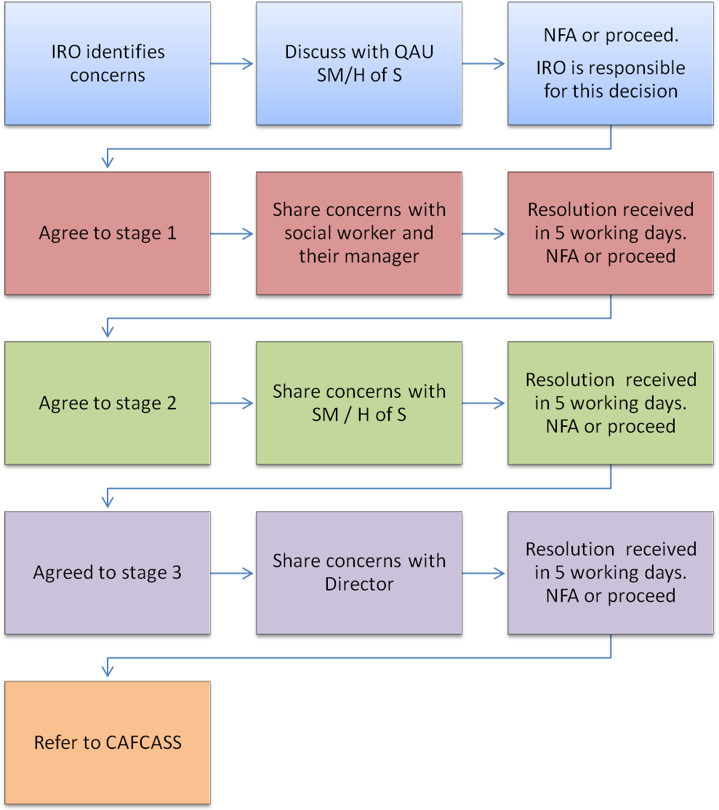
IRO Dispute Resolution Process
Name of child/ren: ICS number:
Team: Social worker:
Team Manager:
IRO: Date of review/issue:

Issues or Concerns Raised by IRO | Outcome Required
Stage 1 Issues Raised |  | Action Taken
Name of Manager:  Designation: |  | Date of response:

Stage 2 Issues Raised | Action Taken
Name of Manager:  Designation: | Date of response:

Stage 3 Issues Raised | Action Taken
Name of Manager:  Designation: | Date of response:

Stage of Resolution | Date Sent | Date of Response | Resolved | Progressed to Next Stage.
1
2
3
CAFCAS

Conclusion from IRO/SM in QAU
Name:  Designation: | Date:

