Family Placement Service
Exemptions, Extensions and Variations to Foster Care Approval
Foster Carer Name(s)

Supervising Social Worker

Identifying number of Child(ren)

Type of Request | Exemption  Extension  Variation  Tick box
Name of Carer(s) being considered  Have they consented? | Yes/No with date
Current Foster Carer Approval & date

Reasons for request

Including the History of child(ren) and why a foster placement is required

Are there any other children in placement?  If so, has the social worker been made aware? What are their views? | Yes/No (if not when)
Risk Assessment;

(To include any protective and risk factors, the impact on the child/young person; including any other household members)

Recommendation

Support Plan  (which will need to inform the Placement Agreement with Delegated Authority) | Table with headings;  1) Action required  2) By Whom  3) When
How long is the request needed for
Anticipated Panel Date (to change or seek approval)

ADM Signature;

Date;

Fostering Team Manger Signature  Date; | 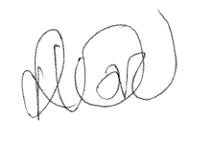
Supervising Social Worker signature

Date;

Foster Carer(s) signature

Date;

