

Click or tap here to enter text.
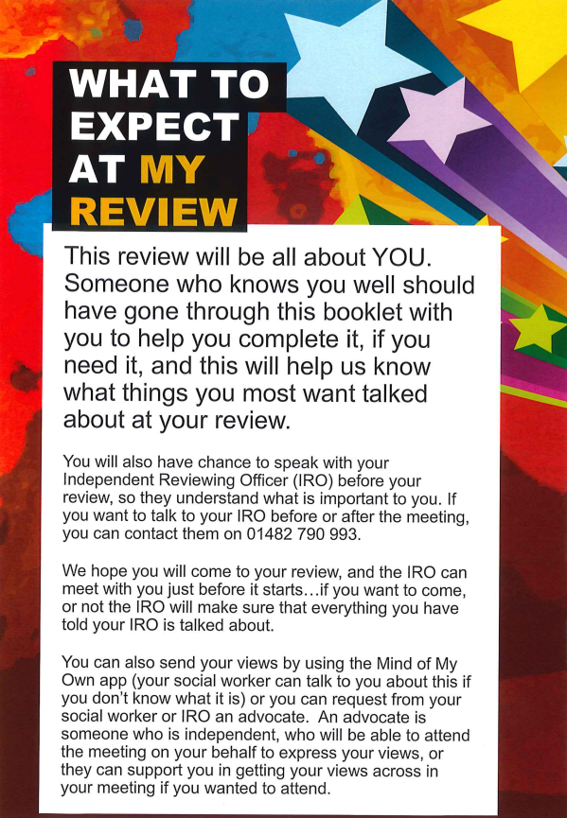

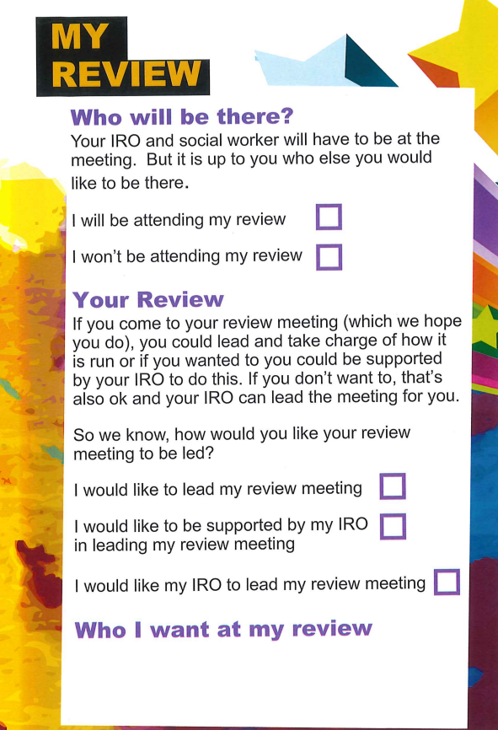


I will be attending my review ☐
I won’t be attending my review☐

I would like to lead my review meeting ☐
I would like to be supported by my IRO
In leading my review meeting ☐
I would like my IRO to lead my review meeting ☐

Click or tap here to enter text.
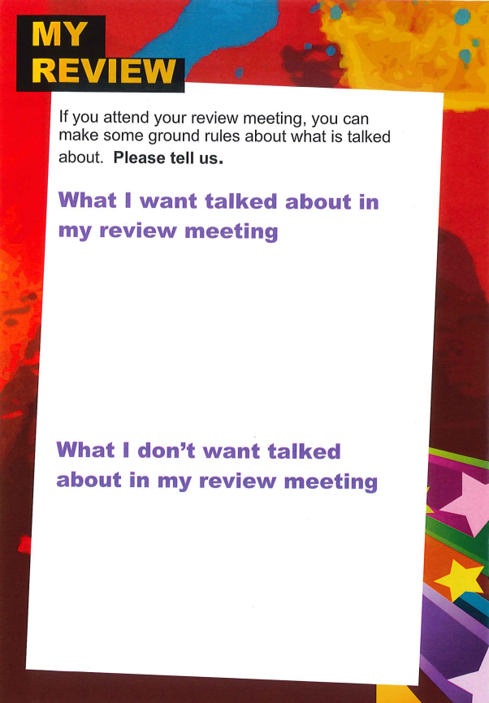

Click or tap here to enter text.

Click or tap here to enter text.


y
Click or tap here to enter text.

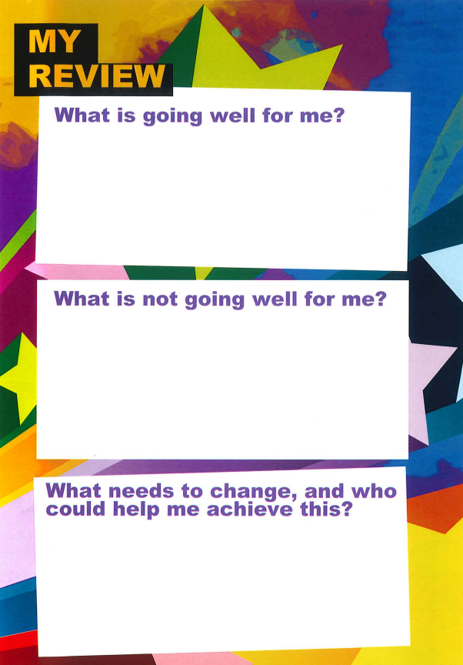

Click or tap here to enter text.

Click or tap here to enter text.

Click or tap here to enter text.


Click or tap here to enter text.

