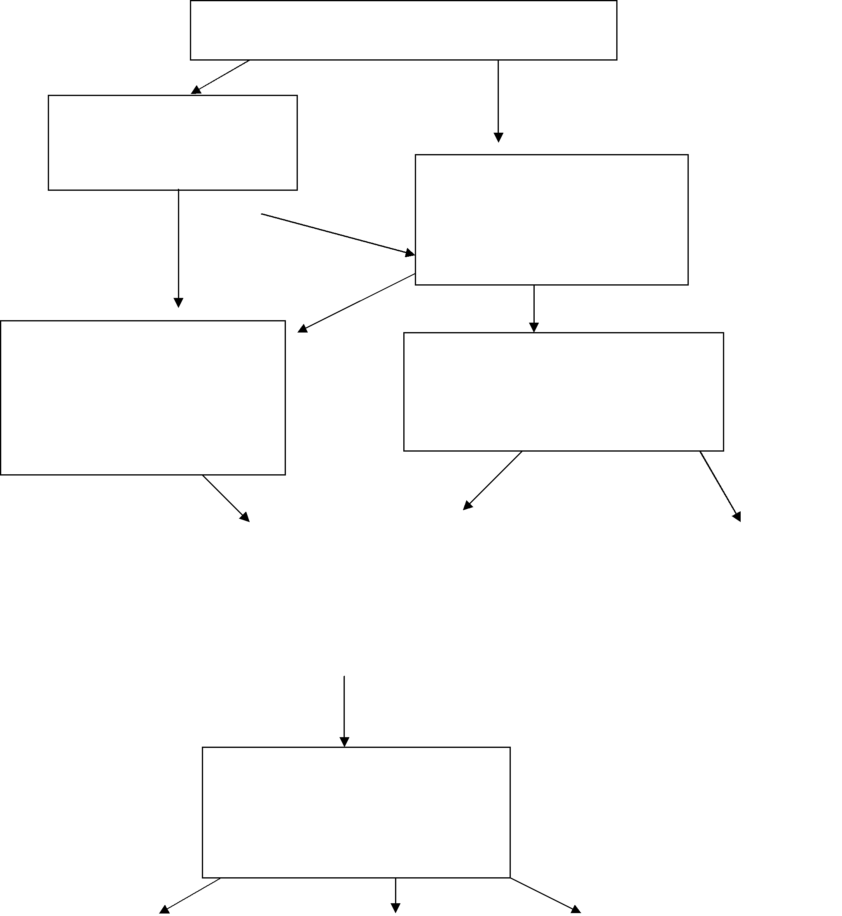
Fire Setting Behaviour

Police aware of
Fire Setting Behaviour

Issues | only
CP | only
CP | CP Issues

If Police or Fire and Rescue Service

Aware of child protection issues refer immediately to Children’s Services (CS)

Fire and Rescue Service
aware of

Fire Setting Behaviour

Fire and Rescue Service undertake assessment of risk and motivation of behaviour (within 14 days) Medium / High Low

CS undertake Initial |  | Where motivation is
Assessment or S47 |  | curiosity and no other
investigation within 10 days |  | child welfare issues, Fire
where motivation for fire |  | and Rescue Service offer
setting is more than curiosity |  | education service
and delinquent behaviour

CAMHS offer assessment of therapy needs within 28 days, using Fire and Rescue Service assessment and initial/complex needs assessment from CSF

Where Fire and |  | Where complex care |  | Where Fire and
Rescue Service |  | package needed an inter- |  | Rescue Service
education service and |  | agency Child Protection |  | education service
Social Care Service |  | Conference or Children in |  | only required this is
only required, this is |  | Need meeting held to put |  | provided
provided under a CS |  | together inter-agency plan
care plan
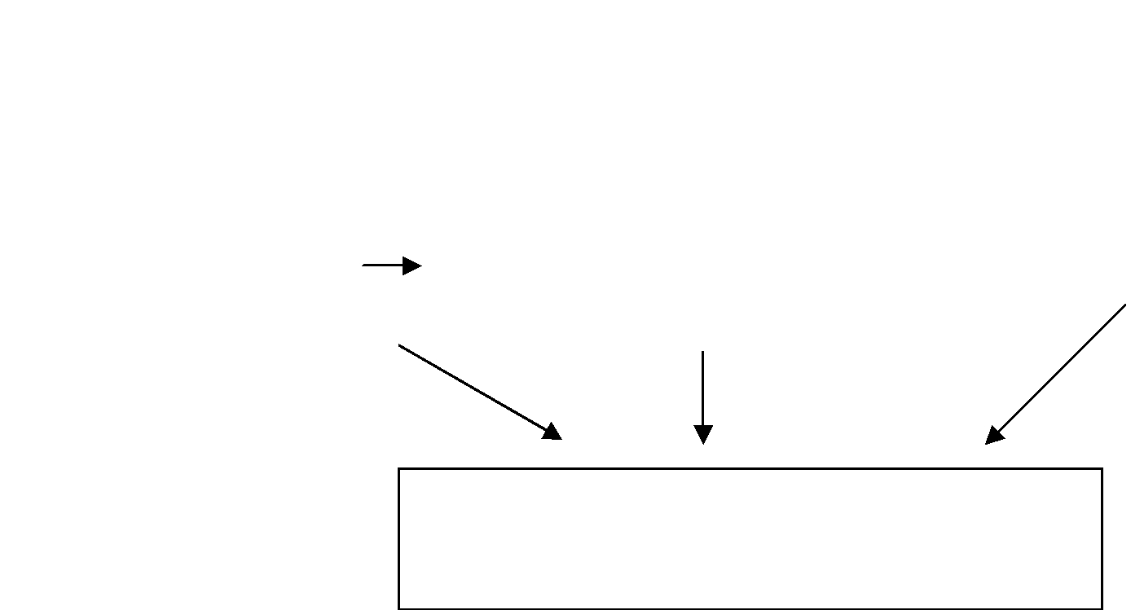

Review every 6 months until at least fire risk reduced to acceptable level.

FIRE SETTERS RISK ASSESSMENT
QUESTIONNAIRE

This assessment is for use by Fire Officers in accordance with the protocol re “Children Who Set Fires” as agreed by the Fire Service and Hertfordshire Local Safeguarding Children Board.

Many children and young people light fires

If you have lit fires, you might like to fill in this questionnaire

If you do it will help us to

Tell you what it means

Help you stop setting fire to things

Get help for you with any other problems you may have

Your name: ........................................... Your age: ....................................

Today’s date: ........................................ Boy or girl:..................................

YOU CAN FILL THIS QUESTIONNAIRE IN BY SIMPLY PUTTING A RING ROUND
YOUR ANSWERS

For example:

SOMETIMES NEVER

THANK YOU FOR YOUR HELP

Please CIRCLE your answers, e.g. YES
Section 1: WHAT HAVE YOU SET FIRE TO?
1. | Have you ever set a fire? |  | YES | NO
2. | Have you played with matches? | OFTEN | SOMETIMES | NEVER
3. | Have you set small fires in your home area? | OFTEN | SOMETIMES | NEVER
4. | Do you stay to watch a fire after you have lit | OFTEN | SOMETIMES | NEVER
 | it?
5. | Have you set fire to a pile of rubbish? |  | YES | NO
6. | Have you set fire to paper in your bedroom? |  | YES | NO
7. | Have you set fire to a dustbin? |  | YES | NO
8. | Have you set fire to other people’s things at home? |  | YES | NO
9. | Have you set fire to a rubbish skip? |  | YES | NO
10 | Have you set fire to curtains? |  | YES | NO
11 | Have you set fire to grass? |  | YES | NO
12 | Have you set fire to a haystack or a barn? |  | YES | NO
13 | Have you set fire to an empty building? |  | YES | NO
14 | Have you set fire to a car? |  | YES | NO
15 | Have your fires caused any damage? |  | YES | NO
16 | Have you set fire in your own home? |  | YES | NO
17 | Have you set fire to someone else’s house? |  | YES | NO
18 | Have you started a fire with a petrol or other bomb? |  | YES | NO
19 | Have you set fire to a school? |  | YES | NO
20 | Have you set fire to a factory or warehouse? |  | YES | NO
21 | Have you set fire to a shop, pub or cinema? |  | YES | NO
22 | Have you set fire to a library, hospital, etc.? |  | YES | NO
23 | Have you set fire to a building with people in? |  | YES | NO
24 | If you have set fire to something OTHER than the above, please write down the details
 | here:

Section 2: ABOUT MY FIRES
25 | If you light a fire, you get caught: | HARDLY EVER
26 | My fires are accidental: |  | ALWAYS
27 | Have you set fires to deliberately destroy |  | OFTEN
 | things?
28 | Do you light fires when you are upset? |  | OFTEN
29 | Do you set fires after problems at school? |  | OFTEN
30 | Do you set fires when you are bored? |  | OFTEN
31 | Does lighting a fire make you feel better, |  | OFTEN
 | rather than talking about problems?
32 | Do you set fires when you are angry? |  | OFTEN
33 | Do you set fires when things have gone |  | OFTEN
 | wrong at home?
34 | Do you plan out your fires carefully in |  | USUALLY
 | advance?
35 | Have you set fires that the Police would like |  | OFTEN
 | to know about?
36 | Do you dream about fires? |  | OFTEN
37 | Have you accidentally burnt yourself? |  | OFTEN
38 | Do you enjoy watching things burn?
39 | Do you usually light fires….? |  | ALONE
40 | Would you like to burn down your school? |  | YES
41 | Does a fire help you to get your own back |  | YES
 | on people?
42 | Does lighting a fire get rid of angry |  | OFTEN
 | feelings?
43 | Do you enjoy watching fire engines? |  | OFTEN
44 | How many of your friends have lit fires? |  | A LOT
45 | Does a fire make you feel excited? |  | ALWAYS
46 | Are you blamed for fires that you didn’t |  | ALWAYS
 | light?
47 | Do fires help you to get rid of problems on |  | OFTEN
 | your mind?

QUITE OFTEN ALWAYS

SOMETIMES NEVER

SOMETIMES NEVER

SOMETIMES NEVER

SOMETIMES NEVER

SOMETIMES NEVER

SOMETIMES NEVER

SOMETIMES NEVER

SOMETIMES NEVER

SOMETIMES NEVER

SOMETIMES NEVER

SOMETIMES NEVER

SOMETIMES NEVER

YES NO

WITH A WITH A GROUP
FRIEND

SOMETIMES NO

SOMETIMES NO

SOMETIMES NEVER

SOMETIMES NEVER

A FEW NONE

SOMETIMES NEVER

SOMETIMES NEVER

SOMETIMES NEVER

48 | Do you feel guilty after you have lit a fire? | OFTEN |  | SOMETIMES |  | NEVER
49 | Do you think about fires during the day? | OFTEN |  | SOMETIMES |  | NEVER
50 | Do you get worried about a fire before you | OFTEN |  | SOMETIMES |  | NEVER
 | light it?
51 | Do you set fires to get your own back on | OFTEN |  | SOMETIMES |  | NEVER
 | people?
Section 3: ABOUT MYSELF
52 | Do you feel “fed up” with living? | OFTEN |  | SOMETIMES |  | NEVER
53 | Have you ever taken anything that | OFTEN |  | SOMETIMES |  | NEVER
 | wasn’t yours?
54 | Do you really hate school? | YES |  | SOMETIMES |  | NO
55 | Do your parents understand you? | MOSTLY |  | SOMETIMES |  | NEVER
56 | Do you find it difficult to get on with | YES |  | SOMETIMES |  | NO
 | others?
57 | Are you upset about things at home? | OFTEN |  | SOMETIMES |  | RARELY
58 | Are you in a gang? |  |  | YES |  | NO
59 | Is there someone living at home that you |  |  | YES |  | NO
 | don’t like?
60 | As a person, do you think that you are: | A FAILURE |  | IN BETWEEN |  | SUCCESSFUL
61 | Do you miss school through truanting? | A LOT |  | SOMETIMES |  | NEVER
62 | I have lit fires for | A YEAR OR |  | 1 – 4 YEARS |  | 5 OR MORE
 |  | LESS |  |  |  | YEARS
63 | Have other people in your family also set |  |  | YES |  | NO
 | fires?
64 | How many spare time hobbies and | NONE |  | A FEW |  | QUITE A LOT
 | interests do you have?
65 | How many fires do you think that you | 1 – 5 | 6 - 10 |  | 11 – 20 | 21+
 | have started?
66 | How much help have you had to stop | A LOT |  | SOME |  | NONE
 | lighting fires?
67 | Would you like to be able to stop lighting | YES |  | SOMETIMES |  | NO
 | fires?

