Updated by Maria Hackett, Team Manager, 1/7/2019

**Haringey Single Point of Access (SPA)**

* **Defining the SPA**
* **SPA team roles & responsibilities**
* **Daily operations**
* **Referral pathways and triage process**
* **Information to aid clinical decision making**
* **Duty documentation standards**

Supporting documents:

* Business support officer (BSO) roles & responsibilities
* NHSE Discharge to Assess guidelines
* Haringey Discharge referral guidance
* Team skills matrix
* Hospital + reablement team Documentation guidelines
* Mosaic processes, workflows + actions
* Brokerage contacts

**Defining the SPA**

All referrals for Haringey residents, or out-of-borough residents with a Haringey GP requesting health input, and who are medically optimised to leave hospital, will be sent to the SPA via telephone or email.

**0208 489 1616**

[haringey.spoa@haringey.gov.uk](mailto:haringey.spoa@haringey.gov.uk)

The SPA team will make the decision on the most appropriate discharge pathway, level of care and/or appropriate service to refer to for ongoing support. This includes signposting to health, social and voluntary services.

**Duty Team**

|  |  |
| --- | --- |
| **Team member** | **Outline of**  **Roles + responsibilities** |
| Business Support Officer  Ext. 1616 | * Answer phone calls in to SPA * Action pathway 0 referrals * Record all referrals onto excel spreadsheet * Liaise with brokerage and care providers to ensure care requested is in place and confirm with ward * Collate figures from spreadsheet when requested * Send daily shrewd report |
| Business Support Officer  Ext. 1063 | * Action all emails received into GCSX email box * Create Hospital Team Referral workflow * Upload all referrals + documents from GCSX to Mosaic * Assist 2nd BSO to answer phones * Action pathway 0 referrals * Send daily MO list and DTOC list to managers |
| Duty Therapist (office) | * Triage and action Pathway 1 + 2 referrals from spreadsheet + SPA duty worker Mosaic box * Take Pathway 1 referrals over phone + discuss with refers when required |
| Duty Therapist (assessments) | * Complete same day hospital discharge assessments |
| Duty manager  2285/ 2150 | * Triage pathway 3 referrals * Oversee decision making for all referrals through the service * Escalate potential DTOCs to senior management + CCG |

**Duty Team Roles + Responsibilities**

BSO roles – *see separate document*

Duty Therapists

2 Reablement therapists will be placed on the duty SPA Rota daily to provide SPA cover.

Copy of Duty Rota can be found on shared drive:

S:\SS\DirF\AllF\Reablement\SINGLE POINT OF ACCESS TEAM 2017\Rotas

1. **SPA duty therapist**

The duty therapist will be office based at the SPA for the day

The duty therapist will monitor the SPA spreadsheet and the SPA Duty worker virtual worker on Mosaic throughout the day to triage and action Pathway 1 and 2 referrals, and any urgent provider concerns regarding clients under the service in the community.

The duty therapist will be expected to make decisions regarding the safest discharge route, set up care packages and inform the duty manager of the outcomes andreasoning for each referral actioned.

1. **SPA duty assessment therapist**

The 2nd therapist on the rota will be completing discharge assessments in the community for that day.

Urgent assessments and referrals via the ‘discharge to assess’ pathway will require same day assessments.

Availability should be left in diaries to see any same day assessments required. If there are no urgent visits required the therapist can return to the office to complete assessment/ report writing and be on hand for any later afternoon discharges.

Duty Manager

The duty manager will monitor all incoming work and all hospital discharges coming through the SPA, clearly assigning all work to the most appropriate team members in the morning.

The duty manager will action all Pathway 3 referral to either the CHC team or Hospital Social work team

The SPA duty manager will be available frequently throughout the day for urgent questions/case discussions for further support on decision making, and escalate any potential DTOCs to senior management as early as possible..

**Daily Operations**

Working hours:

Duty team working hours are **9am-5pm**. All team members to be logged in and ready to work at 9am.

2 members of the team to be logged in to SPA Hunt phones at all times through the day.

KPIs for timings of referral triage:

**Referrals to be screened in priority of discharge date on the SPA spreadsheet, first attending to all discharges planned for that day**.

S:\SS\DirF\AllF\Reablement\SINGLE POINT OF ACCESS TEAM 2017\Spreadsheet(s)

Pathway 0 – screened and actioned within 4 hours of receiving referral

Pathway 1 – screened and actioned within 4 hours of receiving referral

Pathway 2+3 – within 24 hours of receiving referral

Telephone referral from the hospital should be encouraged rather than email. SPA referral forms can be found on the Shared drive

S:\SS\DirF\AllF\Reablement\SINGLE POINT OF ACCESS TEAM 2017\Referral forms Master Copies

Setting up care packages:

SPA duty team work closely with adults brokerage team who are responsible for sourcing agencies.

Brokerage contacts should be send as early as possible to enable brokerage to source agency to support same day discharge.

**If care packages are QDS or double-handed, these must be confirmed to be in place prior to the hospital discharging the client**

To see a standard on brokerage contact see shared drive:

S:\SS\DirF\AllF\Reablement\Assessment resource

All brokerage contacts need to be sent before 4.00pm to enable same day discharge. Any changes to care packages or new brokerage requests after this time will need to be discussed with brokerage duty manager to ensure capacity to source package prior to confirming discharge with the hospital ward.

Confirming discharge with the ward

Once a decision has been made to accept the referral and brokerage contact has been sent inform the referrer of the decision to discharge and ask the ward to phone SPA as soon as the client is discharged.

Please ask the ward to send a copy of the discharge summary to GCSX. Please note this is beneficial in case medical information is missing from the referral, however it is not essential to enable discharge, and this should be made clear to the ward.

BSO officer to be informed to make necessary changes to spreadsheet and to monitor confirmation of care from brokerage.

Daily SPA Mini-huddles

The duty therapist will co-ordinate 2 daily SPA mini-huddles at **9.30 and 3pm** to ensure:

-actions are assigned to owners for each planned discharge for the day,

-identify capacity issues within the duty team

-escalate any discharge concerns from previous day or provider issues

-Lunch breaks identified

-CRS capacity identified

- brokerage capacity concerns identified

Escalating inappropriate referrals to the hospital

There are columns below on the spreadsheet for recording insufficient information on referrals. The first is for while the client is still in hospital, second is for any concerns following discharge assessment.

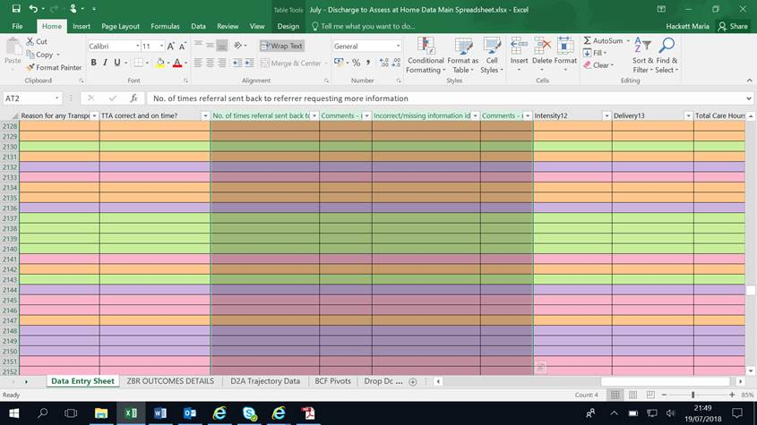

Duty therapist to ensure this is completed at end of each day.

Each week the duty manager will send the information to the CCG management for discussion with hospital therapists and D2A champions at NMH in order to improve quality of referrals

Discharge alert forms require completion if missing/ incorrect information has led or could have led to patient/worker harm.

These should be completed and sent to the duty manager for escalation

**It is the role of each duty SPA team member to clear all their incoming case note alerts each day, to clear the SPA duty worker box as far as possible, and update the SPA spreadsheet to handover to the next day’s duty team.**

**Triaging and Actioning Referrals**

Pathway 0 = Re-starts in care

***To be taken by BSO***

1. Check client’s details including address are correct.
2. If new to social services, add client to system confirming all demographic details with referrer (incl. GP, contact no’s, Next of Kin, etc). Be sure to include referrer details including direct contact number.
3. Check if there are any open safeguarding Investigations or Deprivation of Liberties (DOLS). **If there are, discuss the case with the duty manager and agree immediate actions.**
4. Check what services are currently being received, including the care agency providing the care, then inform referrer.
5. Send contact to brokerage to set up care package for identified discharge date.
6. Once confirmation email has been received from brokerage, confirm date and time of 1st care call with the ward
7. Create hospital team referral on Mosaic and close with the action – ‘NO Action – discharge via Pathway 0’
8. Record the client and discharge details on the SPA spreadsheet

Pathway 1 = therapy assessment at home if client safe to be left between care calls

**For action by duty therapist within 4 hours of referral received**

1. Follow first 3 steps as per Pathway 0 above
2. Open the Hospital Team Referral on Mosaic and ensure all information has been received from the referrer.
3. If you are receiving a telephone referral you will need to ask the BSO to create a new Hospital Team referral on Mosaic.
4. **If there are any unanswered questions on the referral form contact the ward as early as possible in order to prevent potential delays in discharge and to make sure all relevant information received prior to hospital discharge.**
5. **If any essential equipment needs ordering via Medequip this must be agreed with the referrer on who will be ordering the equipment, and ordered as early as possible. Forest mobility is also able to carry out same-day equipment delivery.**

Pathway 2 = Rehabilitation at Protheroe House or Bridges Ward

1. Home 1st should always be considered
2. If client unsafe to be left between care calls and has therapy goals Bridges ward should be considered
3. If client safe to be left in own flat and would benefit from relearning skills prior to discharge home in an extra care envioronment Protheroe House should be consider
4. Discuss with duty manager regarding bed availability

**Triaging P1+2 referrals: Clinical considerations for duty therapists**

* The most important thing to clarify is if the client is safe to be left between care calls

*SPA therapist can prompt n/staff if required by asking the following:*

* *Does the client have any cognitive impairment or confusion?*
* *can client call for help on the ward?*
* *are they trying to get up unsafely by themselves?*

**If it is felt the client would be unsafe between care calls, or has a resolving delirium, alert the duty manager for referral to Pathways 2 or 3**

* Has the client had therapy input prior to becoming medically optimised, if so what are the recommendations?

*Check on TCES to see if equipment has already been ordered and delivered*

*Are any ongoing therapy goals or other relevant information to be handed over from ward therapists, including any anticipated care recommendations that can be put in place prior to discharge visit.*

* Does the client require assistance of 2 people to transfer on the ward?

*Double handed care calls will require confirmation from brokerage prior to discharge*

* If the client is being supervised to the toilet on the ward does a commode need to be ordered for same day delivery?
* What are the client’s anticipated care needs?
* Does the Next of Kin/ carer need to be involved in decisions around hospital discharge + level of anticipated care needs?
* How will the assessor and carers access the property if client can’t provide access?

*Can the family or NOK provide spare set of keys?*

*Duty therapist may need to assist the hospital to order a key safe if access issues are highlighted (consent from client and landlord required for this)*

* Does the client have food in the fridge?
* Are then any safety concerns with the home environment?

Documentation:

**Case notes**

Case notes will be added when referrals are received, accepted (when, what, where) and when cases are assigned to a worker by an ATM.

In addition to this please ensure a case note is recorded for all contacts and discussions with the hospital.

A new case note much be started each day. Do not append a case note from a previous day. Appended case notes cannot be searched for by subsequent duty workers/managers. In any case, no more than 2 Appends should be added to any case note

Please title all case notes with **Single Point of Access –** *followed by*:

– hospital referral received, for re-start in care today

– hospital referral received, request for Reablement / Pathway 1

- hospital referral received, request for BBIC / inpatient rehab

- awaiting further information from hospital prior to accepting referral

– accepted for pathway 1, care package requested

- accepted for pathway 1, discharge confirmed with ward

- client not yet medically optimised

– request for social worker allocation

-Initial Assessment completed

The case note title trail should aim to tell a story

At the end of each case note a clear plan of next action should be documented

For further guidelines on documentation please refer to Policies folder on the Single Point of Access shared drive

S:\SS\DirF\AllF\Reablement\Policies\Documentation