 | 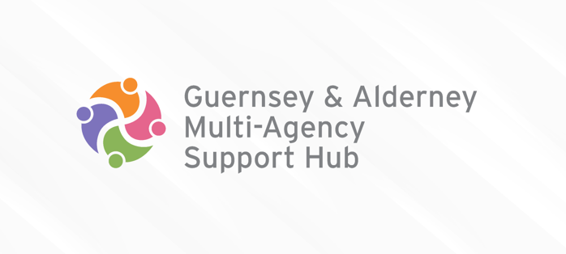
MULTI AGENCY REFERRAL FORM (MARF)
Working together for the children of Guernsey and Alderney
Date of Referral:

Child or Young Person 1
Name:

Known as:

Date of Birth:

Age:

Gender:

Ethnicity:

Disability Yes No | (If yes, please give further details):
Child Telephone Number:

Parent Telephone Number:

Address:

Place of Residence (if different from the above address):

Family Members:
Name | Date of Birth | Address | Relationship

Other Significant People:
Name | Date of Birth | Address | Relationship

Parental Responsibilities are held by:
Is the child aware that the referral has been made? Yes No
Does the main carer(s) know you have made the referral? Yes No
Consent received from: _
If no, are there sufficient grounds to waive the need for consent? Yes No
Please state grounds if yes:

Agencies working with this family (EG: School, Health Visitor, CAMHS)
Name | Agency | Telephone / email | Consent to share
 |  |  | Yes No
 |  |  | Yes No
 |  |  | Yes No
 |  |  | Yes No

What is currently working well for the family?
What support has the family received to date and what has been the impact?
Do the family have a support network (friends and family)?
What are the views of the child/ren, young person/s and their family?
If the family have been accessing early preventative services, please indicate whether there has been an Early Help Assessment completed or Team Around the Family (TAF) meetings taking place.

What are you or the family worried about?
What information/evidence has led you to make this request today?
What are you worried would happen if nothing changes for the child/family?
What are the views of the child/ren, young person/s and their family?

What needs to change?
What changes do you feel need to take place to reduce the concerns for this family?
What services/support do you feel the family would need to achieve these positive changes?
What are the views of the child/ren, young person/s and their family?

Are you concerned that risk of harm is occurring outside of the home (e.g. child exploitation)? Yes No

If yes, please provide details:

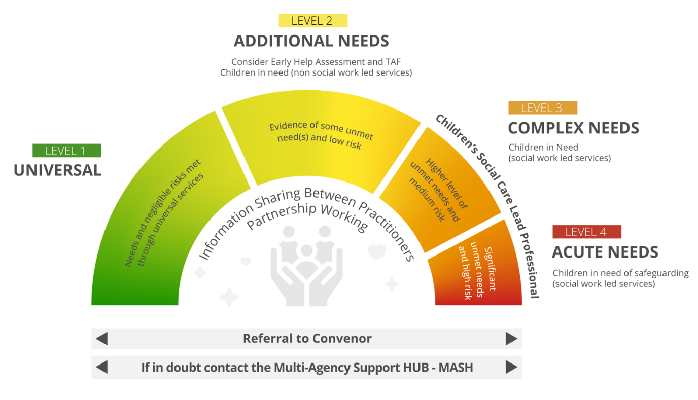
With reference to the above continuum of need, what level do you think the needs of the family meet? Please tick as appropriate

Level 1 | Level 2 | Level 3 | Level 4

Is there any additional information that may assist with the referral? Yes No
If yes, please give further details:

Referrer Details – if self-referring

Name
Tel No |  | Email

Referrer Details – if referring on behalf of a child/young person/family

Name |  | Organisation
Tel No |  | Email

