

Youth Justice Service

Joint Working Protocol
Youth Justice Service & Children’s Social Care

 | Effective Date: | May 2023
 | Review Date: | May 2024
 | Document Author | Nicholas Cordwell

Youth Justice Service

Contents
1. Introduction 3
2. Information Sharing 4
3. Expectations of Joint Working 5
4. Joint Supervision 7
5. At the Police Station 8
6. At Court 8
8. Remands to Youth Detention Accommodation 11
9. Custodial Sentences and Resettlement 12
10. Dispute Resolution 16
11. Promoting culture of joined up working 16

1. Introduction

1.1 This protocol provides a local practice guidance for partnership working between the Enfield Youth Justice Service and children social care teams where young person may be open to both services. The key driver for implementing this protocol is to enable the Youth Justice Service (the YJS) and Children’s Social Care (CSC) to work in a consistent and collaborative approach to safeguard and further prevent re-offending of young people with focus on:
- Effective and timely information sharing
- Coordination of care planning
- Setting expectation and accountabilities for effective joint working
- Supporting young people in Police custody
- Supporting young people to attend and engage with court
- Remand into the Care of the Local Authority (RLAA)
- Remands to Youth Detention Accommodation. (YDA)
- Children serving custodial sentences and their resettlement back into the community.
- Children in receipt all post court and Out of Court disposals.
- Dispute resolution
- Promoting a culture of joined up working

1.2 Research and local experience have shown the importance of the YJS and CSC working together to meet the needs of vulnerable children and to reduce the risk of harm to others and risk to themselves. For this to happen, it is vital that there is mutual understanding of respective service responsibilities and open communication and solution focused approach between the two services with the child’s needs and positive outcomes being paramount.

1.3 The involvement of one agency in a case does not preclude the legitimate involvement of another. The emphasis should be placed upon delivering a 'joined-up' service, rather than segmented interventions. This process will require clear agreed joined Case Management, and the active involvement of operational and service managers to prevent young people being left unsupported, inter-agency conflict or, alternatively, wasteful duplication of efforts.

1.4 To foster and promote a culture of joined up working there will be regular shared training, forums to discuss practice and opportunities for shadowing. Best practice would encourage joint supervision of cases that are being jointly worked.

2. Information Sharing

2.1 Information-sharing is central to improving the outcomes for these children, young people, and their families. The YJS and CSC will share information with other agencies e.g., Police as required to ensure that the young person remains safe from harm and/or to ensure the safety of others in the community. Where a child is reported missing and not currently known to CSC the YJS they will immediately make a referral to MASH. CSC and YJS will use the same return to home paperwork.

2.2 The extent of information sharing will be dictated by the complexity of the child’s needs and the legal responsibility that services hold for providing support. Where appropriate sharing of information will take place with the consent of the young person concerned (and / or parents as required). However, where it is required (e.g., Public Protection, Child Protection or Children Looked After processes) the YJS will share information relating to assessment, planning and review with CSC without necessarily seeking consent. It is important to remain transparent with children and their families about information sharing. Information sharing must take place lawfully within the parameters of the Data Protection Act 2018 and the General Data protection Regulation.

2.3 When a young person is allocated within the YJS, the YJS worker will undertake a Liquid Logic check to establish if there is any current involvement of social care with the young person. Where there is current involvement, the YJS worker will notify the Social Worker and case discussions coupled with information from the Social Care case management system (Liquid Logic) will inform the YJS assessment and subsequent care plan.

2.4 MASH/ CSC have access to the YJS CV system to be able to identify whether a young person is open to the YJS and if this is the case then further information will be requested from the YJS to aid decision making within CSC.

2.5 Where a child is LAC or on a Pathway plan, Child Protection or CIN the YJS will access any plans from Liquid Logic pertaining to that child. Wherever possible assessments and plans should align. Where a child is allocated within CSC YJS will share copies of the young person’s YJS assessment (Asset +) and relevant plans with the social worker.

2.6 Where possible case planning for a child should be aligned between YJS and CSC to avoid duplication and prevent the child and their families to keep on telling their story multiple times. The child and their family should feel they are receiving a seamless service from CSC and YJS.

2.7 Where the YJS has assessed an increase of risk of significant harm, likelihood of re-offending or health and well-being, these concerns will be immediately shared with the social worker to ensure there is a co-ordinated approach to risk minimisation approach.

3. Expectations of Joint Working

3.1 Where child is open to both services, it is essential that both case workers meet and agree their areas of responsibility, define respective roles, and determine how frequently and by what method future communications will be made. This needs to be done at the very earliest stage so it is clear to the child and family what to expect. Where the child is open to CSC the social worker will be the lead professional with the YJS focussing on offending behaviour work. However, there will often be an overlap of work and quality collaborative planning is essential to avoid duplication of work.

Meeting/ Care Planning

3.2 A YJS case worker will attend CSC strategy meetings, child protection case conferences, professional planning meetings, core group meetings and all review meetings including CIN and LAC reviews. However, if the child is placed out of area, then the local care taking YJS will send a representative to the meeting. If attendance at any of these meetings is impossible for the YJS case worker, they or his/her line manager will submit a written report or send another representative from the YJS. A YJS representative will attend the weekly placement panel meetings to ensure there is an input and information provided on those young people involved in offending being considered taken to care. A representative of the YJS will attend the weekly placement meeting.

3.3 CSC will be represented at the multi-agency YJS High Risk Panel and the YJS OOCD Panel. Where a child is known to CSC the child’s social worker will be expected to attend Referral Order Panel meetings and any TAC/TAF to share information, provide advice and assist with planning of interventions. It is the YJS case worker’s responsibility to invite the social worker to the respective meetings.

3.4 When a LAC young person is sentenced to a Referral Order, it is expected that the Social Worker will attend the Referral Offender Panels. If the child is under the age of 17 and is LAC, there is statutory duty that the child’s social worker attends these meetings. The YJS will make every effort to convene the panel at a time and place convenient for the representative (although the wishes of the victim take priority). Social Care must ensure that someone attends the panel with the young person (parent, keyworker, carer, allocated social worker). The best placed person to support the child should attend these meetings.

3.5 When a young person's case is being reviewed by the YJS, the worker will ensure that the allocated social worker is invited to all reviews, planning meetings and breach meetings, including those for young people in custody.

3.6 For LAC placed out of the area and the YJS Order is being managed by another YOT, Enfield will allocate a YJS Officer to oversee the case and liaise with the host YOT area. The home YJS will provide support, advice, and consultation about these young people to the responsible Enfield social worker.

3.7 When the YJS cease to be involved with any young person open to CSC, the YJS case manager will notify those teams that their involvement has come to an end and provide details of the YJS final review.

4. Joint Supervision

Joint supervision does not replace other supervision activities but can be a helpful learning process as the CSC and the YOS teams learn from the experience and skills of each other. Joint supervision will be held with all cases known to both services and will take place every 12 weeks. However, this can be more frequent if risk or a change of circumstance occurs.
It will take place across teams and help build a resilient work force by sharing anxieties inherent in case work by providing a strategy to deal with uncertainty and a means of obtaining emotional support.
Joint supervision across services might be particularly helpful for:

- Cases that are stuck
- Cases that are complex
- Cases where there is uncertainty about risk
- Cases where there is disagreement about risk.

The joint supervision should be facilitated by a team manager from either YOS or CSC. This should alternate each time supervision takes place. Where joint supervision has taken place, a summary should be uploaded to the child’s file. Please use the below template for joint supervision. No next steps decisions should be made unless their respective team manager has agreed these actions. Joint supervision should be used to ensure actions from any strategy meetings are being completed.

5. At the Police Station

5.1 Should a young person known to social care be arrested and an Appropriate Adult is required to attend a police station 5, it is expected that, in the first instance, the young person’s parent/carer will attend but if that is not possible it will be covered by the Appropriate Adult Service.

5.2 If the young person is in care, their foster carer/key worker should attend. If they are unable to attend and/or are the victims of the offence, the allocated social worker should attend. If all options have been explored and there is nobody available, then an Appropriate Adult will be arranged. It is best practice that if a child is known to CSC under the auspices of CIN/CP etc and the parent/ carer refuses (or it is inappropriate for them to attend) then their social worker should attend the police station. YOT staff cannot act as an appropriate adult at the police station.

5.3 YJS will provide the MASH with access to the CVYJS (YJS case management system) to enable the MASH to fully engage in the operation Harbinger and share information with the Woodgreen custody about welfare, safeguarding and current offending/risk of harm within an agreed timeframe of the arrest of a young person.

6. At Court

6.1 Highbury and Islington Youth Court is where all children who are charged with an offence committed in Enfield appear. This is unless they are held by the police either on a court issued warrant or they have taken a decision that the child cannot be released from their custody. In these circumstances they will be presented at the next available youth court. Enfield holds its youth court every Friday.

6.2 In preparation for any child attending Court checks are undertaken to ascertain if they are known to CSC. The YJS would notify the social worker at this stage. Expectations around court are discussed in detail in this protocol.

6.3 Any child under the age of 17 must be accompanied by a responsible adult (this cannot be their solicitor) to be able to appear before the Youth Court. YOT staff cannot act in loco parentis when a young person appears in court. They are Officers of the court, and it would be a conflict of interest. The young person should be accompanied by their parent or foster carer/residential worker or the responsible social worker. However, the YJS staff will be there to support any parent, social worker, and child when they are due to appear in court by providing information and liaising with court staff. The YJS and CSC will work together at Court to ensure the best interests of the child are met.

6.4 If a child is appearing in another court, the Enfield YJS will liaise with the relevant local YJS to ensure they have all the information they require to best support that child. Enfield YJS will ensure that the child’s social worker is aware of the date, court, and any other relevant information. There is the same requirement that the child is accompanied by a responsible adult.

6.5 Foster carers, residential staff and social workers are responsible for arranging transport to and from court and for ensuring that legal representation has been arranged. However, there is a duty solicitor at court who will assist if they do not have representation arranged.

7. Remands to Local Authority Accommodation (RLAA)

7.1 If the court make a Remand to Local Authority (RLAA), there is a presumption that the court does not consider it appropriate for the young person to be placed at home. However, responsibility for final placement decision rests with CSC subject to the assessment. CSC may want to consider the feasibility of placing a child at home or with family members, but this should not be done without consultation with the YJS so that any risk factors can be considered such as gang associations, poor parental supervision, victim considerations etc. The YJS will take all possible steps to contact CSC at the earliest opportunity as it is acknowledged the difficulties placing a child at short notice presents.

7.2 The court also has the power to impose a condition on CSC that the young person who has been remanded must not live with a named person or people. Should this condition be made then CSC has no option other than to comply with this condition. The court will take into an account any information supplied by CSC when they are making their decisions. CSC is responsible for making the placement arrangements and to collect the young person from the court and to transport them to their placement. A pragmatic decision may need to be made on the logistical arrangements and YJS and CSC should always make decisions that are in the best interest of the child.

7.3 In finalising these arrangements, the social worker will need to be aware that the court may also impose a requirement that the Local Authority secure compliance with any of the conditions that have been imposed on a young person. Such conditions may include restrictions on areas where the young person can be, attending appointments with teams such as the YJS and electronic monitoring of a curfew. The YJS will provide a support programme for the child whilst in subject to RLLA. Where possible care should be coordinated and aligned.

7.4 In the event a child is placed outside the area for any part of their order, the home YJS in Enfield will liaise with the YJS in the area in which the young person is placed to ensure the young person receives the necessary work in relation to their offending behaviour. The YJS Worker or suitable representative will attend the initial placement planning meeting and any other professional meetings.

7.5 The social worker from the CSC will implement LAC procedures, arranging planning meetings and reviews and completing LAC forms where required, in consultation with the allocated YJS case worker.

7.6 The YJS will provide information about subsequent court appearances and other relevant information to the social worker as soon as possible to assist in planning. The YJS will attend LAC reviews and reviews of pathway plans.

8. Remands to Youth Detention Accommodation

8.1 As a result of the changes brought in by the Legal Aid, Sentencing and Punishment of Offenders Act 2012 young people remanded to Youth Detention Accommodation are LAC. Youth Detention Accommodation (YDA) is defined as a secure children’s home, a secure training Centre (STC) or a Young Offender’s Institution (YOI). Young men aged 16/17 years old will go to a YOI unless deemed vulnerable and young women and boys under 16 will go to an STC or secure children’s home.

8.2 The decision to impose a remand to YDA for criminal matters on a child or young person is made by the court. Once the order is made the Local Authority has no option other than to comply with these directions. However, there are strict criteria that must be satisfied before the court can remand a child to YDA.

8.3 At Court the YJS will present a Bail Supervision Package or RLAA as an alternative to the YDA where appropriate. If this is refused bail can be re-applied for on two further occasions.

8.4 At Court YJS will provide information as requested by the court. If the young person is already LAC/ allocated to a social worker, s/he should attend court where possible to assist with information requirements.

8.5 YJS court staff will immediately inform CSC through a ‘need to know’ this includes a referral to MASH. and or the allocated SW of the remand to YDA so that the case can be allocated to complete the LAC paperwork, ensure the YDA placement is recorded on Liquid Logic and the IRO is advised

8.6 All arrangements for the placement of a young person in YDA will be carried out by the YJS in liaison with the YJB (who are responsible for the identification of the placement and arranging transport and transport for subsequent court hearings). If the child is known to CSC, the social worker may have additional information to support where the child is placed. E.g., health needs/ emotional well-being. However, in practice, it is very unusual for a child to be remanded to YDA without them previously being known to the YJS and therefore will have the relevant information required to place the child. The Virtual Head of Schools should be informed of all remands as a PEP needs to be held within 20 working days of coming in care

8.7 During the remand period the young person will be subject to the usual LAC review and YJS remand planning processes and plans agreed for when the remand ends. The YJS case manager and the allocated Social Worker will work jointly to ensure there is coordinated planning and review. The first planning meeting must happen within 10 working days of the child being remanded. It is usual practice that remand meetings and LAC review meetings happen concurrently. Where a child has been remanded to YDA for 13 weeks or more they will be eligible for care leavers status.

9. Custodial Sentences and Resettlement

9.1 A coordinated, individually tailored, wrap-around package of support must be in place for a child’s resettlement. This is crucial to meeting multiple and complex needs of vulnerable children returning to the community. The below diagram looks at the challenges of effective resettlement and demonstrates how a child can be supported through the process of resettlement to a positive future.

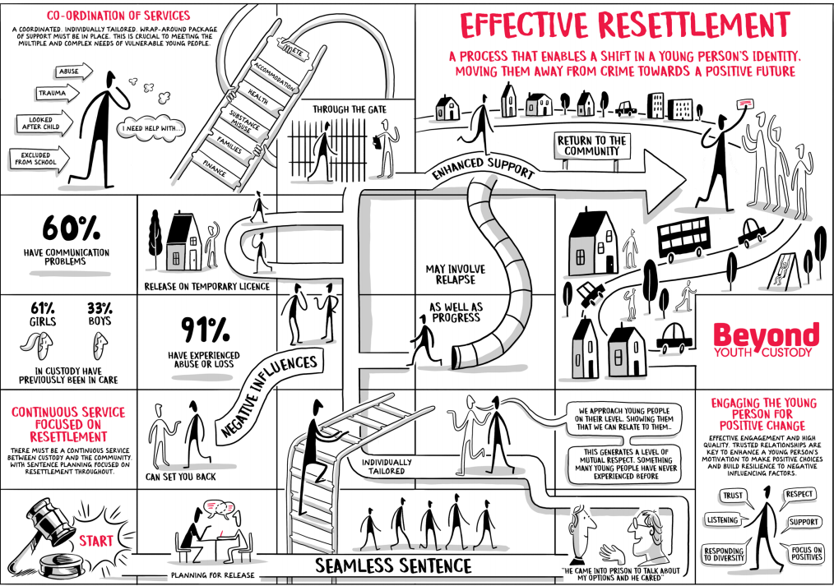
9.2 Children can be particularly vulnerable in custody and during the early days of release and may need considerable emotional and practical support. When a child receives a custodial sentence, they will usually serve half in custody and half in the community. In the community they will be subject to a Notice of Supervision. A child’s release from custody and their resettlement should be a primary consideration throughout – the child should be offered a continuous collaborative service. Research and evidence are clear that effective resettlement planning substantially reduces re-offending in children and improves positive life outcomes. There are 7 areas that are key to effective resettlement. These should be central to the professional networks planning throughout any period when a child is detained:
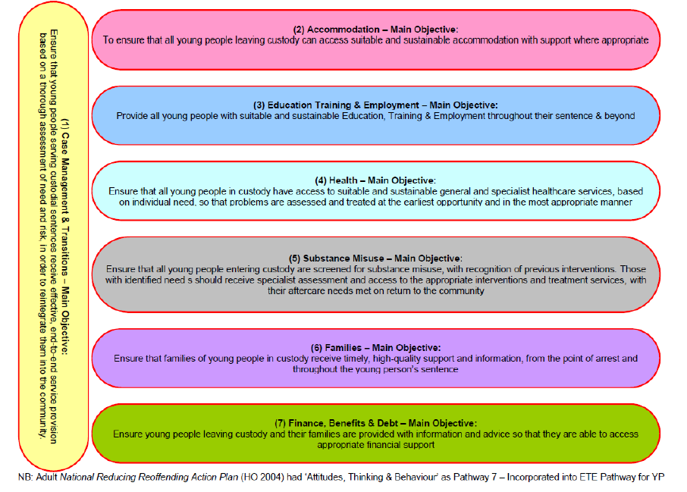

9.3 It is important to note that remand and custodial sentences remove any pre-existing s.20 arrangements. When a child is sentenced to a custodial sentence then the LAC status conferred on them by remand is removed. However, a child can still be LAC if it is decided that this is the best course of action.
9.4 The child’s social worker should attend all reviews and attend the pre-release meeting convened by the YJS.
9.5 The child’s social worker and YJS case manager must work together to co-ordinate arrangements for the child’s release and subsequent support in the community. The child will continue to have 2 separate plans: the Care Plan (which may include the Pathway Plan), and the Resettlement Plan. They must be co-ordinated. The most common issues faced by a child on release is the availability of suitable accommodation. These issues must be communicated to the professional network.
9.6 Where a review of the child’s case chaired by the IRO has not already occurred, the social worker in conjunction with the IRO must arrange for a review prior to the child’s release from custody. The timing should be scheduled so that it is co-ordinated with the release preparation meeting.
9.7 If the child is to continue being Looked After, the Local Authority will be responsible for the provision of a placement and financial support in the community. The social worker should record the plan for how this support is to be provided and make copies available to the child, the YJS case manager, the IRO, and other agencies that will be involved with supporting the child after release and family if appropriate. It is imperative that this is a collaborative process by the professional network with the child’s voice and their risks to others being central to decision making.
9.8 There will be potential areas of overlap where arrangements may be made by either the YJS case manager or the social worker (e.g., health and education). Negotiation should take place on which of them is best placed to make the arrangements in each case. The YJS will arrange all resettlement meetings.
9.9 As soon as possible, and at least by the time of the final sentence planning meeting 10 working days before release, the child must be told the content of both the Care Plan and the Notice of Supervision or Licence so that s/he is aware of:
- Who is collecting him/her;
- Where s/he will be living;
- The reporting arrangements;
- Licence conditions
- Sources of support – including out of hours;
- The arrangements for education or employment;
- Arrangements for meeting continued health needs;
- How and when s/he will receive financial support;
- When s/he will be seeing his/her social worker; and
- The roles and responsibilities of the professional network.
9.10 Where the child is serving his/her sentence (or part of it) in the community, the social worker and YJS case manager should keep each other informed of significant events, including any changes in service delivery or plans.
9.11 It is good practice to have some joint meetings involving the child, the YJS case manager and the social worker. Where the Child is having difficulty in complying with his/her Notice of Supervision a compliance meeting will be called by the YJS, the social worker should work with the YJS to put additional support in place. The child should not be recalled to YDA wherever possible.

10. Dispute Resolution

  - If there is disagreement that cannot be resolved by the workers in YJS and CSC this should be escalated to the Head of Youth Offending Service and their counterpart Head of Service in CSC with a dispute resolution response provided within 48 hours. In the unlikely event that a conflict cannot be resolved there, this should be brought to the attention of the respective HoS 3 or in their absence to the Director of Children and Families.

11. Promoting culture of joined up working

We are committed to translate this protocol of working into our practice through the following approach:
- Promote mutual respect and professional curiosity
- Actively championing integration and joined up working through joined care planning and review process
- Promoting joined up supervision to co-work the cases between CSC and YJS to maximise coordination of safeguarding of young people and focus on reduction of re-offending
- Actively promote and disseminate the protocol’s best practice guidance to all relevant teams
- Provide all new staff with the protocol as part of their induction
- Identify and disseminate lessons learnt

