

Youth Justice Service

Resettlement Policy

 | Effective Date: | August 2023
 | Review Date: | August 2024
 | Document Author | Nicholas Cordwell

Enfield Youth Justice Service Resettlement Policy

Enfield YJS focus their resettlement practice on shifting a child’s identity from pro-criminal to pro- social. This document embeds the principles of the enhanced constructive resettlement offer Enfield YJS deliver to detained children returning to our community.

Introduction

  - Enfield YJS recognises that children who are given custodial sentences have the worst reconviction rates. Enfield YJS’s re-offending rate is broadly aligned with the national average and we aspire to be well below this figure. Therefore, Enfield YJS has developed an enhanced offer to achieve this.

  - Resettlement is based on providing personal support to a child to help them shift their identity from pro-offending to pro-social. This requires an assessment and identification of their pro-offending narrative, their strengths and goals and identifying a plan to address this. It is based on ensuring a child has suitable practical support including appropriate accommodation, healthcare, education or training opportunities and constructive leisure.

  - Enfield YJS understand that relationships are key to helping a child make long lasting changes. Enfield staff are all trained and skilled trauma informed practitioners.

- The enhanced Enfield YJS offer

  - A dedicated resettlement worker
    - It is recognised that much of the positive work completed whilst a child is in custody is not rooted in the family or the communities to which our children will return. Enfield YJS has a dedicated resettlement worker.
    - Every child is seen every month by their case manager and every month by the specialist resettlement worker (this is double the number of visits compared to most children in custody).
    - The resettlement worker will focus interventions on shifting a child’s identity from pro- criminal to pro-social and will consider the 9 pathways to resettlement within this work.
    - Where a child will remain in custody past the age of 18 the resettlement worker will be key to this important transition and will continue to offer their support once they enter the adult secure estate.
    - Their support will remain once back in the community providing the child with another layer of support and stability and offer voluntary intervention for up to four months after the Notice of Supervision/ Licence Period has ended.

  - Education and training support

    - The resettlement worker will work with children whilst in custody to assist with a smooth transition to opportunities in the community. Enfield YJS aim that every child returning to the community will have an education or employment opportunity ready on their release. The minimum expectation is that every child will have an education/ employment interview within 10 day of being released from the secure estate.
    - All children of school aged will be heard at the monthly education panel. Every child will be visited by the advisory teacher who will contribute and planning meetings and ensure they have an education placement on release from custody
    - Enfield YJS has access to an Education Co-Ordinator. 6 weeks prior to release and dependent on age, the child’s ETE plans will be discussed at the Enfield YJS Educational Panel or the Enfield STAAH Panel.
    - All children with an EHCP plan will have it reviewed when they enter the secure estate. The SEN case manager will attend the Initial Planning meeting. Please see SEND protocol for further details.

  - Family support

    - Enfield YJS has dedicated family coaches that can provide additional support to families of children in custody where this is required.
    - Every child in youth detention will have the offer of a family group conference to help support their child in resettlement into the community. This will be discussed in the
‘professional network plan’ (Appendix 1).
    - A home visit to the family will be completed both after the child is sentenced to custody and a month prior to release to make sure the family are ready for their child to return home and to ensure this is a safe and appropriate living environment for the child. The bursary will be available to support this if required.
    - To assist in this re-integration into the community the release on temporary license will be sought to attend any relevant meetings.
    - If a child is Looked After then the joint responsibilities between the YJS, the secure estate and social care are addressed in the YJS/CSC Joint Working Protocol.
    - No child will leave custody without either a family member, social worker or YJS representative to take them home.

  - Keeping the Child Safe

There are several processes that need to be followed to keep a child safe when resettling into the community:

- Referral to the YouthXtra programme.
- Where required a referral to High Risk Panel.
- A safety plan to be completed where there are known risks to the child.
- Ensuring the Youth Guardian is aware of the child’s release and the universal screening tool and keep apart list is completed prior to release. The child needs to feel safe when attending appointments.
- A prompt review of Asset+ (15 days).

  - Release on Temporary License

    - There is an expectation that Release on Temporary License (ROTL) will used where appropriate. If there are no reasonable grounds to refuse ROTL then this should be escalated by the operations manager.

  - Transition to the Adult Estate

- All children turning 18 will be supported by their case manager and the resettlement worker to prepare them for this transition. This is overseen by the Y2A panel.

  - Bursary

    - Each child returning to the community will have a devolved budget. This can be used to maximise the child’s opportunities on return to the community. For example, this could be used to pay for a provisional driving license, clothes for education/ employment, equipment to support their education etc.

  - Mentoring
    - On return to the community every child will be offered a mentor who will work voluntarily with the young person to help return to the community and provide another layer of emotional and practical support that can continue even when the statutory service provided by the YJS has ended.

Victims

- The safety and wellbeing of victims is of paramount importance to Enfield YJS. To safeguard victims from future harm, discussions are undertaken at a multi-agency level. Any child who receives a custodial sentence of 12 months or more, the Senior Court Officer will notify the Victim Liaison Officer (VLO) and ascertain the thoughts of the victim in terms of safety measures that they may require when the child returns to the community. These measures are then used part of the Notice of Supervision/Licence conditions.
- Again for those Children who have received a custodial sentence of 12 months or more, if relevant (Level 2) they will be referred to MAPPA 6 months prior to release and a MAPP meeting will be convened where the VLO attends and share the views and thoughts of the victim and any additional conditions that they may have requested.
- The Victims Team at Enfield YJS contact every victim and via this process will also identify the victims ‘thoughts on Restorative Justice, Letters of Explanations and additional Notice of Supervision/ Licence conditions.
- All children being released from custody will be discussed at the Enfield High Risk Panel (HRP) 6 weeks prior to release, where the victim worker sits on the panel to represent the voice of the victim(s) and additional conditions for the Notice of Supervision/ Licence are discussed.
- Additional conditions that can proposed and discussed include:
  - Not to Contact the victim directly or indirectly including social media
  - Exclusion Zone
  - Restorative Justice interventions
  - Indirect/Direct Reparation
  - Prohibited Activities

- Guidance

  - Information Sharing

When a child enters the secure estate, information is to be shared with the following agencies:

- Where a child is remanded or is known to children’s social care then they are to be notified immediately by the court team.
- Information to be shared with SEND team within 24 hours.
- Asset+ custody module and placement information to be shared with YJB placements team immediately so the child can be placed promptly with no delays.

  - Principles of constructive resettlement

The evidence base, underpinning principles and theoretical framework for Enfield YJS’s approach to resettlement are based on the principles of constructive resettlement.

Theory of Change – Pro-offending identity is a feeling of disempowerment and seeking to gain a sense of status and security with self-defeating, destructive behaviours driven by short term motivations. Enfield YJS aim to support children to move from a pro-offending identity to a pro-social identity by empowering children to make positive choices and gain status and security by pro-social and future-oriented means thereby gaining sustainable positive outcomes. We will do this by promoting desistance, wellbeing and security by supporting them to feel socially included and contribute to society with constructive achievements.

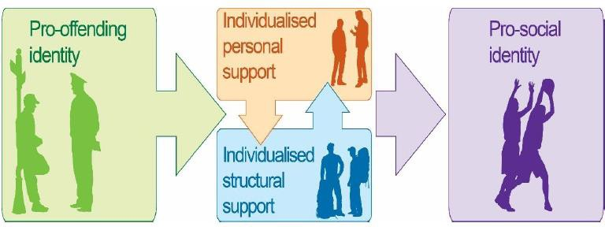

Every child will have an individualized plan created at the point of entering custody and working towards both custody and community goals from the very start of their sentence (appendix 1). This will be based around the pathways to constructive resettlement, looking at both structural and personal support.

Plans will be individualised, strengths based, positive and future focused. They will consider diversity and identify constructive activities focusing on non-criminal identity. The vision of the child will always be at the heart of decision-making. They will be kept updated on progress and options and Enfield YJS will work collaboratively with the child, parent(s)/carer(s) and other professionals to offer the right support at the right time, considering important milestones in a child’s development such as turning 18yeras old, starting college/job, becoming a parent. Plans will work towards the long-term vision of the child and incorporate contingency planning for when circumstances may change. Planning will be underpinned by 4 key questions:

- Who are you?
- Who do you want to be?
- What are your strengths, interests and goals?
- How are you going to get there?

  - 9 Pathways to resettlement

- accommodation,
- education, training and employment,
- health,
- substance misuse,
- families and finance,
- benefit and debt.
- transitions
- not offending
- lifestyle

5 C’s – 5 characteristics for effective support
- Constructive – discussions about and planning for resettlement are useful and intended to be helpful to the child and their parents/carers with a focus on their future
- Co-created – plans produced from collaboration with the child, their parents/carers and their network
- Customised – a bespoke plan made with the child and their family/carers
- Consistent – the continuous planning for resettlement that starts immediately and continues throughout the duration of custody.
- Co-ordinated – working in partnership with the network, parents/carers and the child.

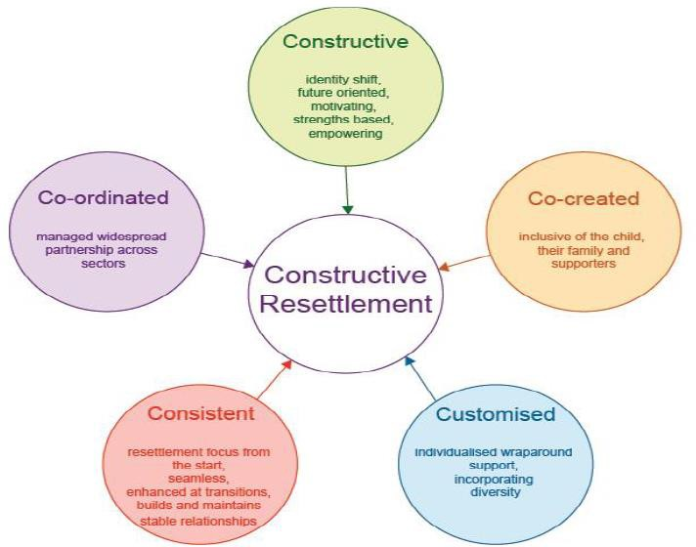

Identity Awareness

Give children fresh AIR: Enfield YJS aim to make every interaction with a child count, underline positive identity in all work with the child and ensure all agencies working together to reinforce pro-social identity. The building blocks to developing a pro-social identity are:

Activities – allow the child to ‘try on’ an identity with different experiences. This can be through opportunities around education, training and employment, or by way of leisure activities.
Interactions – look at opportunities for interactions that inform positive characteristics and offer encouragement
Roles – consider influence of roles on identity, both formal and informal, and how these impact on the child.

  - Further information can be found at the following sources:
    - Enfield YOS’s re-settlement case management guidance.
    - National Standards for children in Custody.
    - https://assets.publishing.service.gov.uk/government/uploads/system/uploads/attachment_ data/file/296274/national-standards-youth-justice-services.pdf
    - https://www.gov.uk/government/publications/custody-and-resettlement/custody-and- resettlement-section-7-case-management-guidance
    - YOS/CSC Joint Working Protocol
Appendix 1


Enfield Youth Justice Service

9 Pathways; Integrated Resettlement and Support Plan – Custody to Community

Name of child:

Who is in the child’s network:

_____________________________________________________________________________________________________________________________

Date of plan: Date of Sentence: Early Release: Early Release:

Mid-Point: Community Review: End of Order: ______________ _______

Area |  |  | What is the goal? | How will this happen? | Who will do it? | When will this be done? |  |  | Progress
Accommodation: | Custody:
Accommodation: | Community:
Education, training and employment. Including EHCP plan review if required: | Custody:
 | Community:
Health: | Custody:
Health: | Community:
Substance  Misuse: |  | Custody:
 |  | Community:
Family, carers and support: |  | Custody:
 |  | Community:
Finances: |  | Custody:
 |  | Community:
Transitions: |  | Custody:
 |  | Community:
Not offending: |  | Custody:
 |  | Community:
Lifestyle: |  | Custody:
 |  | Community:

Prison Meeting: | Planned Date: | Actual Date:
IPM
1st Review
Review
Review
Early Release
Final Review

Signatures: Young Person: ______________________________________________ Parent/carer: ______________________________________________

YJS Resettlement Officer: _________________________ ______________________ YJS Case Manager: ___________________________________________

Enfield Youth Justice Service

9 Pathways; Integrated Resettlement and Support Plan – Custody to Adult Services

Name of child:

Who is in the child’s network:

_____________________________________________________________________________________________________________________________
_
Date of plan: Date of Sentence: Transfer date:_____________________

Area |  |  | What is the goal? | How will this happen? | Who will do it? | When will this be done? |  |  | Progress
Accommodation: | Custody:
Accommodation: | Transition:
Education, training and employment. Including EHCP plan review if required: | Custody:
 | Transition:
Health: | Custody:
Health: | Transition:
Substance  Misuse: |  | Custody:
 |  | Transition:
Family, carers and support: |  | Custody:
 |  | Transition:
Finances: |  | Custody:
 |  | Transition:
Transitions: |  | Custody:
 |  | Transition:
Not offending: |  | Custody:
 |  | Transition:
Lifestyle: |  | Custody:
 |  | Transition:

Prison Meeting: | Planned Date: | Actual Date:
IPM
1st Review
Review
Review
Review
Handover meeting

Signatures: Young Person: ________________________________________ Parent/carer: ____________________________________________

YJS Resettlement Officer: ___________________________________________ YJS Case Manager: _________________________________________

