

Children and Young People Support and Safeguarding Service

**You Can, I Can, We Can**

Lone Working Guidance

**This guidance is the umbrella document for all of Children and Young People Support and Safeguarding Service (CYPSSS including Early Help & Prevention) lone working arrangements. This guidance highlights uniformed practice and bottom lines in relation to how we approach lone working.**

**October 2023**

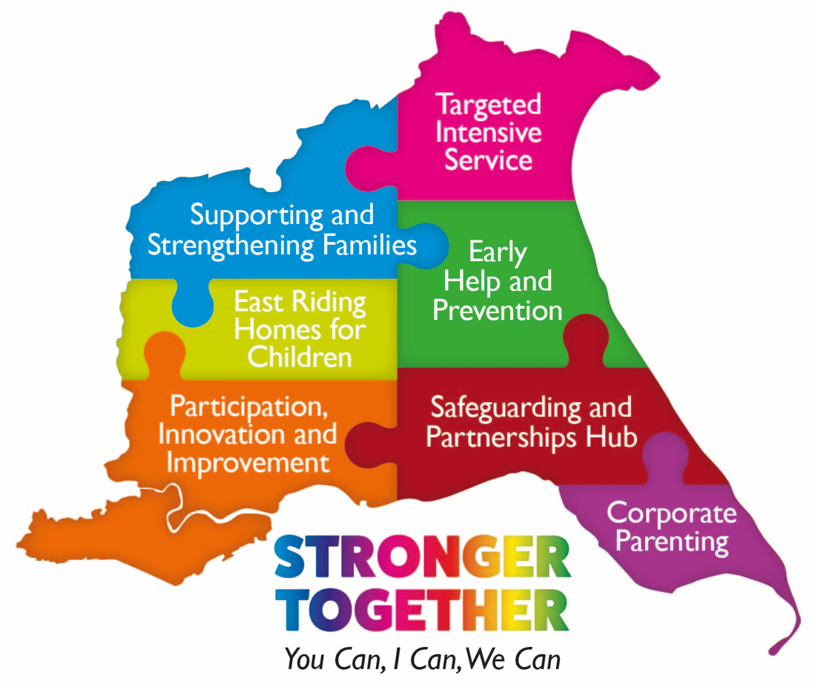

CONTENTS

1. Introduction

Aim and Scope

Classification of Lone Workers

2. Practice guidance & bottom lines

Risk Assessments

Local lone working procedure

Bottom lines

3. Roles and Responsibilities

4. Forms and additional guidance

1. Introduction
   1. Aim and Scope

Lone working refers to situations where staff in the course of their duties work alone in the community, in the homes of individuals or in their own home or may be the only staff member present in an office or other establishment maintained by the Council. They will be physically isolated from colleagues, and without access to immediate assistance.

Under the Health and Safety at Work Act 1974, employers have a duty to ensure that the health, safety and welfare at work of their employees is upheld, so far as is reasonably practicable, the provision and maintenance of a safe working environment, safe access and egress, safe systems of work and provision of suitable information, instruction, training and supervision.

This guidance is designed to alert staff to the risks presented by lone working, to identify the responsibilities each person has in this situation, and to describe general procedures which will minimise such risks. This guidance acts as an umbrella to connect individual teams and service areas local lone working arrangements.

### 1.2 Classification of Lone Workers

Category 1 - **Lower risk** situations include:

* Staff working outside normal hours in an office, library or similar e.g. cleaners, caretakers, security staff;
* Staff who travel alone for significant periods or in circumstances that may give rise to additional risks.

Category 2 - **Medium risk** situations include:

* Use of receptions, counters and interview rooms, and similar where risk of violence and aggression or dangerous situation is reasonably foreseeable and where colleagues cannot be readily called on in the event of an adverse situation arising.

Category 3 - **High risk**situations include:

* Visiting domestic and commercial premises where risk of violence and aggression or dangerous situation is reasonably foreseeable;
* Working out of hours (not in a controlled council facility)

2. Practice guidance & bottom lines

2.1 Risk Assessments

The undertaking of risk assessments, which identify and control the hazards and risks associated with lone working are a legal requirement under the Management of Health and Safety at Work Regulations.

When thinking about lone working, we will carry out static and dynamic risk assessments dependent upon the context, these risk assessments will directly link to local lone working guidance.

In carrying out a lone working risk assessment particular consideration should be given to:

**Task/activity to be carried out:**

* + Timing and whether or not it is appropriate for the task to be carried out alone
  + Level of risk
  + Staff/police response time
  + Complexity of task
  + Training requirements
  + Additional information

**The ability of employees:**

* + Training provision/requirements
  + Relevant qualifications and experience
  + Medical fitness
  + Competence for task including supervision issues for new employees

**The remoteness or isolation of workplaces:**

* + Means of communication
  + Means of raising an alarm
  + Time required for help to arrive
  + Access and egress routes
  + Transport arrangements.

**The risk of injury, violence or criminal activity etc.**

* + Awareness of known associates and/or relatives that may be of concern
  + Information relating to previous visits, social worker concerns etc.
  + Awareness of medication, mental illness, alcohol and/or drugs issues
  + Presence of family pets etc. which may pose a threat or intimidate

**Means of communication:**

* + Mobile phone
  + Landline telephone
  + Personal alarms, and Council issued Orbis devices
  + Buddy system
  + Use of a Duress Phrase (In the event staff are held against their will)

**Emergency and accident procedures, e.g.:**

* + Means of summoning assistance
  + Means of raising the alarm
  + Reporting of accidents, incidents, injuries etc

**The nature of any potential injury or damage and anticipated "worst case" scenario:**

* + Control measures for dealing with the situation
  + Procedures to be followed in an emergency
  + Contact points, including those for 'out of hours' working

**Backup/support contacts:**

* + Line manager
  + Head of Service
  + Emergency Duty Team
  + Emergency services – police, fire, ambulance
  + Property / Orbis fob

2.2 Local Lone Working Procedure

Each team within CYPSSS (including Early Help & Prevention) must have a local lone working procedure.

In each local lone working procedure, the following must be considered;

* Separate procedures in place (where relevant) for lone working during office hours and outside of normal office hours.
* Pre visit checks to be completed prior to visits to enable time to plan to mitigate any risks that may be present, if risks arise this should be discussed with management whether a home or lone visit is appropriate
* Consideration to the blended working approach and how local lone working procedures respond to this and how previous systems such as white boards and extension 13 procedures may be void.
* An identified Manager (this may be on a rota basis) during office hours to be satisfied all staff have safely completed all visits during that day.
* An identified Manager (this may be on a rota basis) during out of hours working to be satisfied all staff have safely completed all visits during their working hours.
* An escalation process in the instance of a manager not being aware of the whereabouts of a staff member and concerns around their safety.
* An escalation process in the instance of a staff member at risk and in an unsafe situation (for staff with an Orbis, this would follow the Orbis procedure)

2.3 Bottom Lines

Electronic Diaries

All staff must ensure that their electronic diaries are up to date and accurate, allowing for relevant colleagues and managers to have access to view said diary.

Information to be included in the diary note:

* Reference number of the child, young person or family to be visited (PID from AzeusCare, ONE or E-start).
* Visit start time and end time
* Locations – if the visit is held at home, transportation of children & young people is included, if the visit is to be held in the community.

Emergency Contact Details

All managers must have emergency contact details for all staff, including the below information (for those staff with an Orbis fob this will be the same information):

* Name, home address and up to date contact number for the staff member
* Vehicle details – Make, model, registration number and colour
* Emergency contact/next of kin – name, relationship and contact
* Any other relevant information – such as medical information.

Information, training, and supervision

Employees must be provided with appropriate information, training and supervision to enable them to carry out their duties in a safe manner and be aware of the procedures in place.

Managers must identify the training requirements of their employees during supervision sessions and give employees the opportunity to have input into this process. Managers must then ensure that relevant training courses are identified and that employees are given the opportunity to attend them. This process should be reviewed during further supervisions.

3. Roles and Responsibilities

|  |  |  |  |
| --- | --- | --- | --- |
| **Lone Working** | | | |
| **Head of Service Responsibilities** | **Area/Strategic Manager Responsibilities** | **Team Managers Responsibilities** | **Employees Responsibilities** |
| Ensuring sufficient resources are made available for the identification and protection of lone workers | Identify any posts that undertake lone working | Ensure that duty of care remains a shared responsibility between worker and employee | Ensure that duty of care remains a shared responsibility between worker and employee and take reasonable care of themselves and others affected by their actions |
| Putting in place suitable lone working protection systems for all activities within their areas | To carry out a lone working risk assessment for employees or work team. Risk assessments to be reviewed at a minimum annually | Following guidance and procedures designed for safe working |
| Ensure that lone working risk assessments are undertaken | To implement suitable control measures as identified in risk assessment | Reporting all incidents that may affect the health and safety of themselves or others |
| Ensuring all staff receive relevant training to ensure competency in safety matters | To monitor lone working protection systems | Taking part in any training designed to meet the requirements of the policy |
| Ensure lone workers are not put at more risk than other employees | Ensure that any accident, hazard and violent incidents are reported, and any control measures identified are implemented | Reporting any dangers or potential dangers they identify, or any concerns they might have in respect of working alone |
|  | Ensuring that identified lone working staff attend relevant training |  |

4. Forms and Additional Guidance

Forms and additional guidance

|  |  |  |
| --- | --- | --- |
| 1. | Employee Personal Protection Assessment |  |
| 2. | Employee Personal Protection Guidance |  |
| 3. | Orbis quick user guide |  |
| 4. | Team Framework – Lone working |  |

|  |  |
| --- | --- |
| **Document owner:** | Paul Elliott |
| **Document number:** | 1 |
| **Document category:** | Workforce |
| **Document location:** | B Drive – CYPSSS_PII |
| **Issued by:** |  |
| Last edited: |  |

Document Control:

Record of Amendments:

|  |  |  |  |
| --- | --- | --- | --- |
| Date | Version | Amended by | Description of changes |
| 24/10/23 | second | Sarah Sherwood/Hollie Troughton | Team framework for lone working- additional document. |
|  |  |  |  |
|  |  |  |  |