Young Persons Guide To
Supported Lodgings




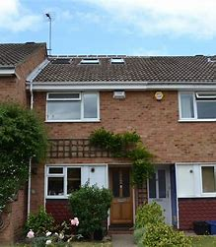
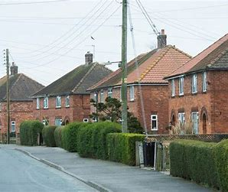





LIST OF IMPORTANT CONTACTS
My Name

Your Social Worker’s Name
Telephone Number
Email

Your Young Person’s Advisor’s Name
Telephone Number
Email

Your Supported Lodging’s Provider
Telephone Number
Email

Supported Lodging’s Provider’s Social Worker’s Name
Telephone Number
Email

Other People I Need to Remember:

Hello,
Many young people need a little helping hand before they feel ready to live on their own. We have produced this guide with young people who have lived in Supported Lodgings and they told us what you might want to know.

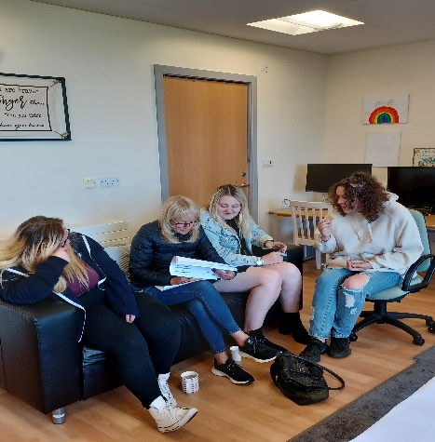
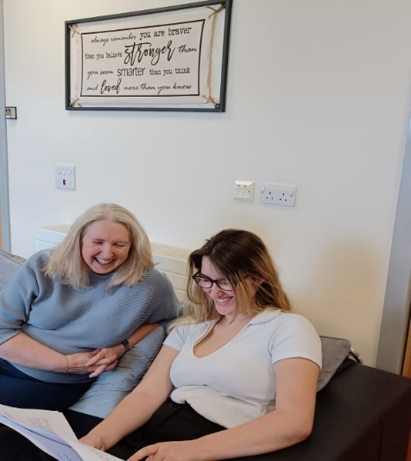

Living with a Supported Lodgings Provider can help you on that step to independence, where you still have someone there who can guide you with anything you might need.
This booklet will help answer some of your questions about living in Supported Lodgings.
Enjoy!
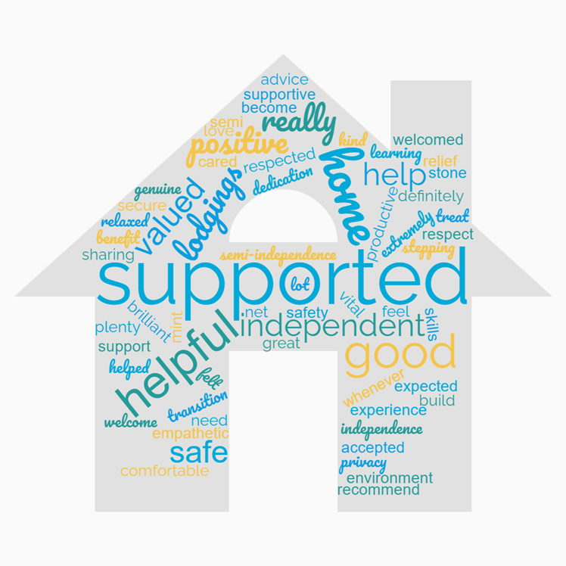

What is Supported Lodgings?

If you are living in Supported Lodgings, you will be offered your own bedroom in a family home. You will share the rest of the main living areas with the family.
The family, who we call Supported Lodgings Providers, might be a single adult or a couple with or without children. There may be another young person living there too and you will get the opportunity to meet them before you make a decision.
There are Supported Lodgings Providers all over County Durham and we will talk to you about which areas would help you feel safe and places you know or need to be able to access easily. Your views and ideas are important to us.
All our Supported Lodgings homes are approved by us, and all providers have had a full assessment, which means we have completed checks and requested references about them and anyone living in the home, including a DBS check because we want you to feel safe.

Who is Supported Lodgings For?



Supported Lodgings is a stepping-stone towards independent living for young people aged between 16 - 21 years old.
Supported Lodgings is for young people who are not quite ready to live on their own. However, they need to be offered a level of independence to gain the right life skills, ready to live in their own home. This might be help with reading/understanding the bills, cooking meals, support with training or work.
Supported Lodgings also helps you feel you’re not alone and it is important to us you have a place you can feel warm, secure and valued.

What Happens?

Your Social Worker or Personal Advisor will talk to you about your ideas and wishes about your preferred housing as part of your pathway plan review.
Should you wish to move into Supported Lodgings your worker will complete an application form and the best Supported Lodgings Provider will be identified making sure they can meet your needs. If we have more than 1 provider we will share both profiles and information/details with you.
Your worker and the provider’s Supported Lodgings Social Worker will arrange for you to meet the person, couple, or family. You can go for tea after this visit and even have an overnight stay to see how you feel before you make up your mind about if it is for you, this is your decision.

Your Personal Information


Your Social Worker/Young Person’s Advisor will only share information with the provider about you to help them understand your needs, interests and future plans.
Your personal information is important and your provider will not talk to anybody who does not have the right to know information about you.
The people who might need to be contacted by your provider are your Social Worker, YPA, School/College and family.
Your provider will not talk about your personal information with any other child or young person living in the home.

What Will Supported Lodgings be Like?
Bedroom
You will have your own bedroom and because this is your space you can design and decorate it with what you like, including posters and photographs. You will have a bed and space to keep all your personal things.
 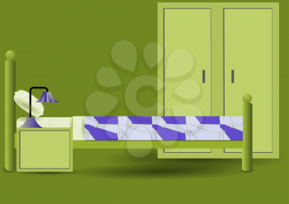 .
Providers will not be allowed to enter your room without permission. They will knock on the door and wait for you to answer if they want to ask you something, as your privacy and safety is important. However, providers do need to make sure your bedroom continues to be safe for you and will let you know when they need to check this. For example, sometimes young people have left hair straighteners on and plugged in, gaming devices on, or windows wide open when the weather has changed.

Other Areas in the House
You will be able to use the kitchen, living room, bathroom and garden. The provider/s you will be living with will want you to feel comfortable and relaxed. So, if you want to put your feet up and watch the television, you might want to do this in the living area, rather than feel you need to spend lots of time in your bedroom – its up to you.
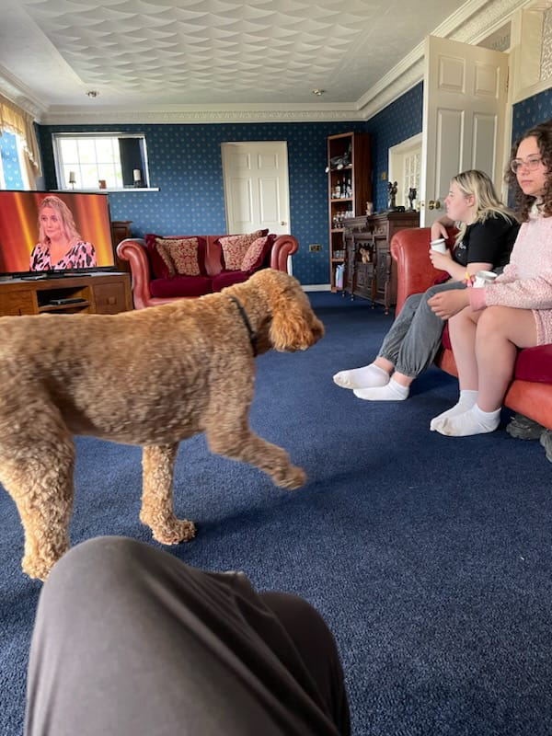
CCTV and Monitoring devices are not used by providers. However, with modern technology some people’s home might have a ‘ring’ doorbell which has a camera facility, this only shows the outside of the property.

Coming, Going and Staying Out
Your provider and Social Worker or Young Person’s Advisor will help you get to know the area and show you how to use public transport to get to the places you need to go to.
You can stay out two nights per week with agreement from your Social Worker and it is further negotiable if you are attending special occasions or have specific plans.
You will be given your own key to the house if you feel ready to keep it safe.

Money
You will be able to budget your own money but if you have any questions about managing or using money you can ask your provider or worker for support.

What Happens if I Say ‘Yes’?

If you agree to move in, your worker will talk to the Supported Lodgings Social Worker and provider to arrange a date and time suitable with you to move in.
Together, we will all meet at the providers home to complete the plan and talk about what your ideas and expectations are and the providers. This is a very relaxed meeting and helps give an understanding of what best suits your needs.
The placement plan is completed during the meeting, and a copy of the fire policy will be given to you. You and the provider will need to sign a licence agreement with the plan once you are both happy with what you’re agreeing. Please don’t worry if this sounds a little confusing, you will be supported throughout the process, and you can ask any questions if needed.
If at any point you feel Supported Lodgings is not for you, it is not a problem, we can look at the issues and try and resolve them. If you are still unhappy you might want to speak to your worker privately who will help and support you in what you decide you want to happen.

What Support Will I Get?

Supported Lodgings accommodation is providing you with a home that will help you make the next steps on your journey to living independently.
The provider/s will support you to have:
- a healthy lifestyle, physically, mentally, and emotionally;

- a warm, friendly, safe and stable home;

- place you feel listened to, respected and cared about;

- Opportunities to move forward with your education, training or employment hopes and plans;

- a chance to develop your confidence, practical skills and encourage positive relationships;

- an advocate – someone there for you to ensure you are getting the right help and guidance;

- skills to live independently and support you to move on when you are ready.


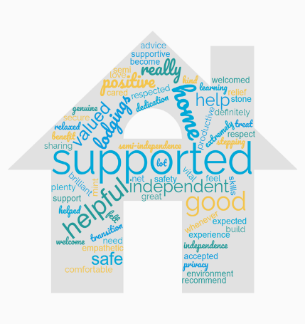

Finances/Income
It is important you feel you can manage and have a say in your own money.
Your Social Worker/Young Personal Advisor will arrange for your income maintenance allowance to be put into your bank account weekly, this is £67.20 to budget and see you through the week. You receive this until you are 18 years old.
Out of this £67.20 per week, you will be asked what type of board you would like to consider.
There are 3 type of boards you can pay to your provider when in supported lodgings:
- Breakfast only - £ 3.30 (Per week)
- Part board, breakfast and evening meal - £17.85 (Per week)
- Full board, all meals- £26.85 (Per week)

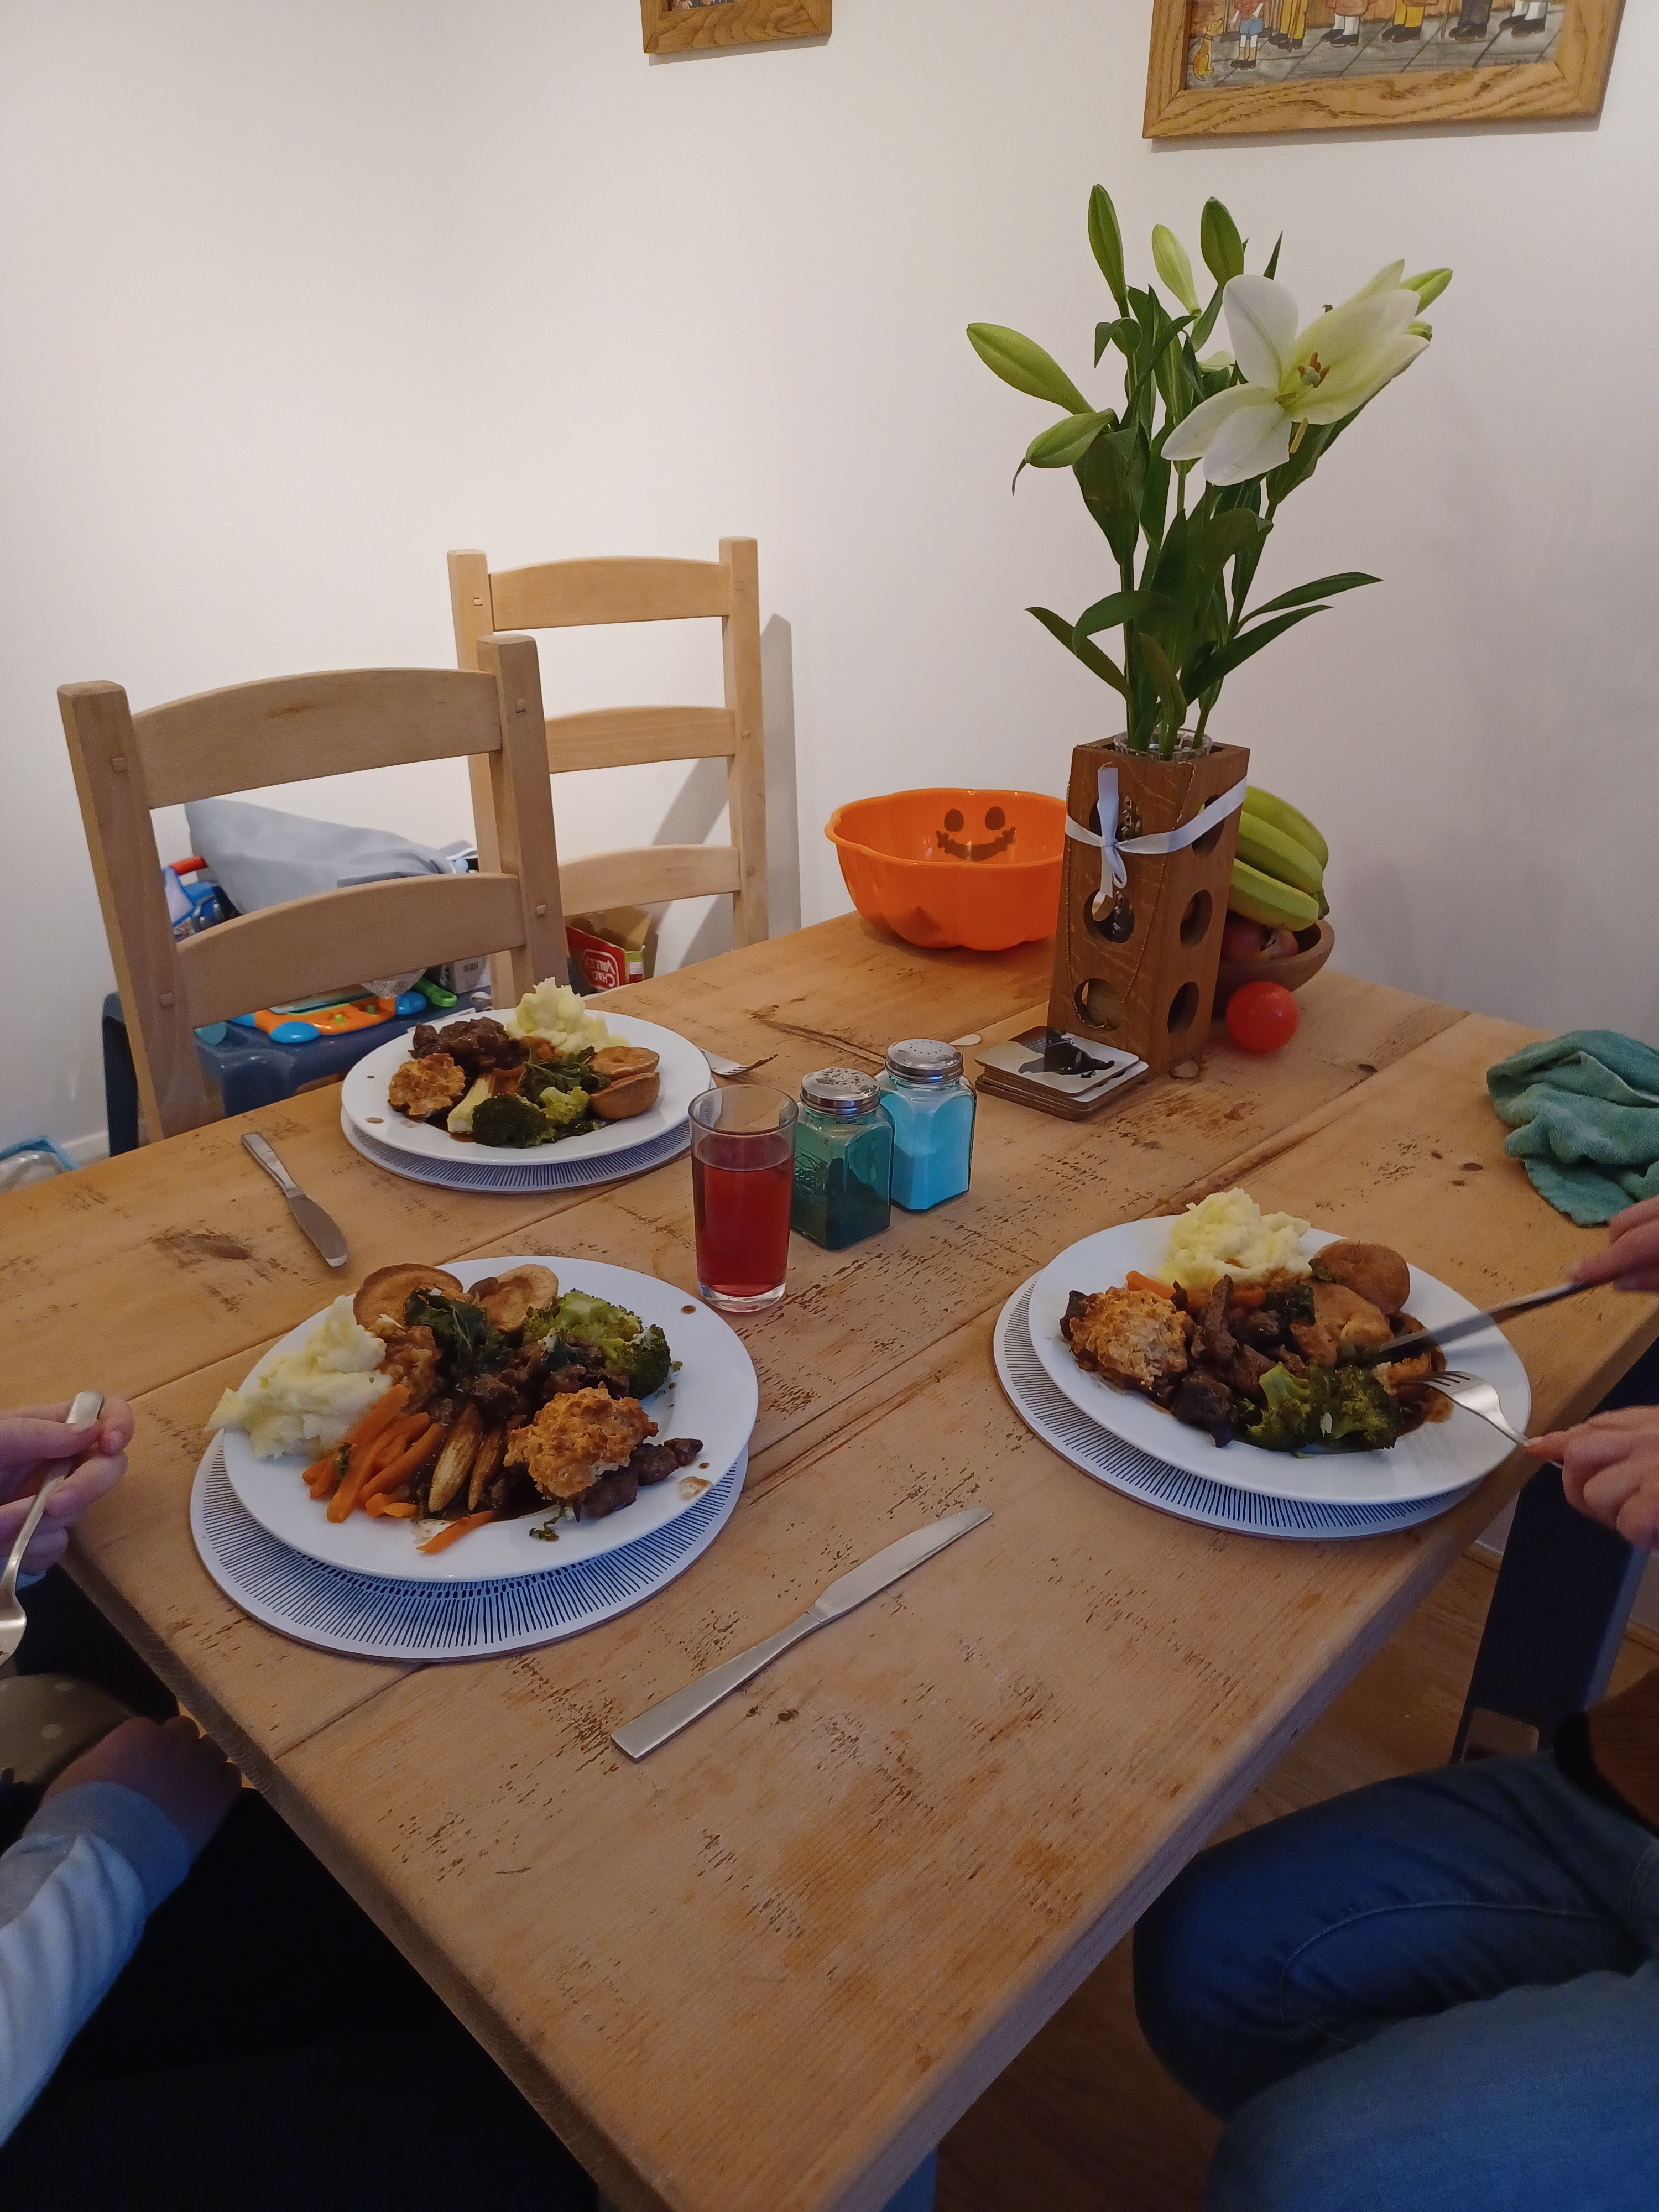

In addition to the board, you will need to keep some of this weekly allowance for your toiletries, clothing and any activities you want to do. This is to help you in preparation for when you will be living on your own.
Alongside, your allowance, there is a Rent payment. However, the Local Authority helps you with this and rent is £55 per week which will be paid directly to the provider by the Local Authority up until you are the age of 18 years old.
After this, you will be helped to claim universal credits to cover your rent. If you are still in education or training these will be paid straight to your provider (after the first instalment). However, if you are working it will be your responsibility to pay the provider on a weekly basis.
You will be supported to budget your money and food shop until you feel ready to do it alone, please do not worry about this as there is always help around.

Skills for Life

It is important you feel you are beginning to understand what you need to become independent. Therefore, you will get help with thinking about life skills needed to look after yourself and your future home.
All young people have different strengths some have more practical skills than others so don’t worry we all have been there and learn as we go along.

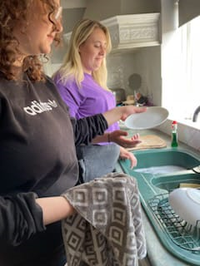
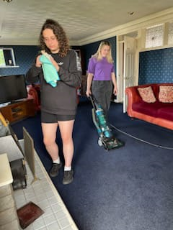




Health


You will be given help to register with a GP, Dentist and Opticians and support with appointments to ensure your health needs are being met.
You can attend appointments alone if you want to and feel confident to do so and that’s okay. However, if you would like someone to pop along to appointments with you please let your worker or provider know.
If you have any worries or are needing some advice please speak to your provider, Social Worker or your Looked After Nurse. There are many services around for you and it is important you are given the right support and know what is available.

Education

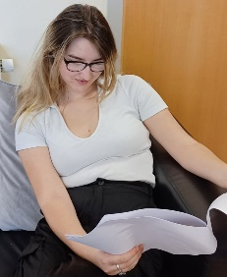


You will be supported with your choice of college, training or university course. Some young people prefer to consider work options instead of going to college and you will be supported with these options too.
If you have any problems/worries about college, university, training or work, please speak to your Tutor, identified Durham Works advisor, provider, or Social Worker/Personal Advisor.


Family & Friendships

The family time you have been used to will probably continue. However, sometimes this doesn’t happen if your Social Worker and the Courts think it would not be safe for you. Equally some young people don’t want to see their family at this time and that is okay too.
Your Social Worker and Personal Advisor are always there for you to talk to about any worries you have about your relationship with family.
We know friends are important to you, and you are still able to keep these friendships and see them when you want to.



Interests/Hobbies


Some young people have hobbies like photography or art, or are interested in sports like football, cycling or horse riding.
Whatever your interests are you will be supported by your provider, Social Worker or Personal Advisor to either continue these or access them within your area.


No Bullying Policy


Bullying is upsetting, whether it is verbal, physical or online. Any form of this is not acceptable.
Bullying might be about, what you wear, your ethnicity, gender, sexual orientation and/or disability. Bullies can make you feel really upset, frightened and angry. We know online bullying can happen when you on your phone, linked to social media or sharing information and pictures amongst friendship groups.
Providers understand that sometimes when young people live together bullying can happen or when you’re at school/college and when using social media. It is important to try and find the courage to tell us if you are worried about anything someone has said or something that has happened.
Should you feel you are getting bullied in anyway, let your Tutor, Provider, Social Worker or Personal Advisor know. We understand it is not always easy telling someone how you feel or about what has been happening but once you make the first step and tell someone, then we can deal with it together.


My Pathway Plan
Your Pathway Plan is a document that you will complete with your Social Worker or Personal Adviser between the ages of 16 and 21 years old. You may also wish for another person to be involved with your plan.
Your plan will set out your needs, views, future goal. It will be an opportunity to have all the support you will need agreed and identified in writing.
Your plan will also consider your education, employment, health, finances, social needs, relationships, and accommodation.
Your plan will be reviewed at least every 6 months alongside your Child in our Care review.
Your Independent Reviewing Officer (IRO) will make sure you have your say about your future and your wishes. You can ask for your Pathway Plan to be reviewed at any time as we all understand things can change. After all, it is your plan!
Our Promise to You!
Durham County Council has made the following promises to young people in our care and care leavers.
- To treat you with respect and as an individual
- To ensure you have the best home, where you feel safe, cared about, and treated well for as long as needed.
- To promote family time and friendships where it is safe and appropriate allow sleep overs at friends/family.
- Listen to your wishes/ feelings and act on them appropriately.
- That you will have a Social Worker/Personal Advisor who will get to know you and build a positive relationship maintaining regular contact.
- To really listen to things, you would like to change about the care system to make your daily life better where there are problems.
- To always work in an open and honest way and share any information or changes with you.
- To involve you in any decisions, plans and changes that may affect you and your Social Worker/Personal Advisor. Independent Reviewing Officer will ensure that this happens.
- To make sure we offer you the opportunities, guidance and support needed at home, education, and all areas of life.
- To help you be the best that you possibly can at college, training, university, or work.
- To give you all the support and help you need to make a success of moving into your own tenancy.
- To work together and support you during every transition in your life whilst being looked after/care leaver and all other areas of your life for example, moving into your own home.




Know Your Rights

You have the right to be listened to and your thoughts and feelings taken seriously.
If there is something you are unhappy about, please talk to your provider to see if they can sort it out – there’s a saying ‘a problem shared is a problem halved’.
If you are still unhappy and feel like people are not listening to you, then you should talk to someone you trust and ask them to help you to complain. This could be your Social Worker, Personal Advisor, a family member, friend, or your tutor, this is your choice.
If you would like to speak to someone outside of the Supported Lodgings Service or Care Leavers Team, there are plenty of people you can get in touch with on the Helpful Information Page.
Durham County Council Supported Lodgings Service is committed to the key principles for young people, which are set out in the Supported Accommodations Regulations 2023 and we want you to be able to say:

1. I feel safe and secure where I live and in my wider environment.
2. My voice is respected, heard and advocated for, so I can influence the support I receive.
3. I have confidence that the adults who support me understand me, are skilled and work effectively together to best meet my needs.
4. I have my own space that I feel proud of and live in a comfortable, well maintained, and stable accommodation.
5. I receive high-quality, tailored support that sustains my health and wellbeing.
6. I have strong, trusting, and meaningful relationships within my support system and can rely on the adults around me.
7. I feel supported to learn and apply skills for independent adult living.
8. I feel positive about my future and opportunities as a result of the support I receive.

Compliments and Complaints!


If you think someone or something has gone really well and you think other young people should receive a similar service as you, then you might want to share a comment or compliment with your Social Worker, Personal Advisor or Provider’s Social Worker.
What to do if you need to complain:
If you are unhappy about the way you are being looked after or feel you are not getting the help that you need, you have the right to complain.
You can ask your Social Worker to help you make a complaint or you can ask the Supported Lodgings Social Worker who visits your Provider to help you.
You can also contact the Children & Adult Services complaints team by emailing cascomplaints@durham.gov.uk or by calling 03000 268 422.
This will go straight to the Director of Children & Adult Services and will be dealt with by someone who has nothing to do with the Supported Lodgings team.
All complaints are taken seriously and are treated in confidence.
http://www.durham.gov.uk/media/1711/Childrens-Services---Compliments-Comments-Complaints/pdf/ComplimentsCommentsComplaintsChildrensServices.pdf

Helpful Information 
To find out more about your rights and get help with your views and wishes being heard look at:
The Supported Lodgings Team
The Supported Lodgings Team is situated within the Fostering Service. There is a Team Manager, Project Coordinator and 2 Supported Lodgings Social Worker’s. The Supported Lodging’s Social Worker’s visit the providers and make sure they are doing everything to support you and your needs.
Tel: 03000 269291
Email: helen.milliken@durham.gov.uk & jane.bateson@durham.gov.uk

Office of Children’s Commissioner
Dame Rachel de Souza is the Children’s Commissioner
Tel: 0800 5280731
Email: help.team@childrenscommissioner.gov.uk

Investing in Children
Supports young people have a voice, be listened to, and see change happen. They also run the Children in Care council.
Tel: 0191 372 9200
Email: info@investinginchildren.net

Children in Care Council
A group for looked after young people to be actively involved in sharing the care they receive in County Durham, as well as having an input into how wider services operate.
Tel: 0191 372 8200
Email: info@investinginchildren.net

Who Cares Trust
An independent voice for children in care.
Tel: 0207 251 3117
Web: www.thewhocaretrust.org.uk

Independent Visitors Scheme
Mark Den Hollander is the Co-ordinator
Email mark.denhollander@durham.gov.uk

National Youth Advocacy Services (NYAS)
Listen to your problems, advocates on behalf of you and tries to help.
Tel: 0808 808 1001
Web: www.nyas.net

Childline
If you are worried about something big or small, you can talk to someone confidentially.
Tel: 0800 1111
Web: www.childline.org.uk

Independent Reviewing Officer
You will have your own Independent Reviewing Officer and you can talk to them about any issues you want raising about your future pathway plan. They are there to ensure your views are understood and taken into account.
Tel: 03000 268 296

Virtual School (Education Professionals)
If you need more information about opportunities for further education and/or training, then the experts are part of the virtual school.
Tel: 03000 261562
Email: durhamvirtualschoollac@durham.gov.uk

Nurses
There are specific Nurses you might like to contact if you have a particular health question and you need further advice or information.
Lisa Moore
Tel: 07584274044
Email: lisa.moore13@nhs.net
Ashley Parker
Tel 07392194243
Email: ashley.parker@nhs.net

Ofsted
Under the Department for Education, Ofsted is appointed to inspect services such as Children’s Services and Supported Lodgings Providers to ensure things are being done properly.
Tel: 03000 123 1231
Email: enquiries@ofsted.gov.uk

Links:
Managing Behaviour:
Safeguarding Procedures:
Welcome to the Durham Safeguarding Children Partnership Procedures Manual (proceduresonline.com)

