**Protocol for the assessment of**

**Bruising in Non-Mobile Children**

Bruising in non-mobile children is rare and therefore there is a significant risk that bruising may indicate abusive or neglectful care. Unfortunately nationally and locally bruising is not always responded to appropriately by Health Visitors, Doctors, GPs and other health professionals. As a result a significant number of abusive events have been missed resulting in children being placed at risk, resulting in serious untoward incidents and serious case reviews.

The above protocol sets out to address this by requiring all professionals to refer bruising in non- mobile children for assessment by a **Paediatric Registrar (with *specialist* level 3 Paediatric Safeguarding Training) or Paediatric Consultant** and Social Care.

Non-mobile children are defined as not yet rolling, crawling, cruising or walking independently or are older children who are not mobile because of a disability. Practitioners should include all children under 6 months.

**Practitioner observes a mark on a child**

Practitioner is confident that it is a birth mark of some type including Blue Spot (Congenital dermal melanocytosis) or a documented birth injury eg forceps marks.

Practitioner thinks it is likely that it is a birth mark or Blue Spot (Congenital dermal melanocytosis) but is not sure.

Practitioner is concerned that it may be a bruise rather than birth mark or a Blue Spot (Congenital dermal melanocytosis)

**Action:**

Check Medical / Health Records to see if mark has been recorded previously. If it has been recorded no further action is required.

**Action:**

Check Medical / Health Records to see if mark has been recorded previously. If it has been recorded no further action required.

**Action:** Immediate

Follow the Protocol for Assessment of Bruising in Non-Mobile Children. Referring to Children's Social Care and inform the Hospital Consultant Paediatrician on call.

If there is no record of the mark, ask GP to see child non-urgently (within a week to 10 days) and to document in child’s records.

If there is no record of the mark, ask GP to see child Within 24 hours to clarify whether or not it is a birth mark or Blue Spot (Congenital dermal melanocytosis)

**GP Assessment**

**If there is further concern that it may be a bruise then immediately:**

**If it is a birth mark or Blue Spot (Congenital dermal melanocytosis) record mark in child records and request review within one week.**

Any other injuries or unexplained bruising follow Safeguarding Procedures and seek advice from Safeguarding Supervisor.

Unfortunately issues around birth marks including ***Blue Spots (Congenital dermal melanocytosis)*** have led to a small number of families being inappropriately referred causing significant distress. Such birth marks are sometimes not being recognised and are not documented in the child’s records when first seen.

**It is therefore essential to learn how to recognise birth marks** in small infants and to document them in the CHILD’S HEALTH RECORDS, including the PARENT HAND HELD RECORD. New guidelines and processes are being devised to support this in Maternity practice and during “baby checks” in the community. All birth marks and any other marks/ injuries noted prior to discharge from hospital should be recorded. **A body map should be completed within the parent handheld record and in the child’s health record.** When there are no visible marks the records should reflect this.

**Hopefully this will reduce the incidence of confusion** and it makes it even more important that new bruising in non-mobile children is referred for expert assessment.

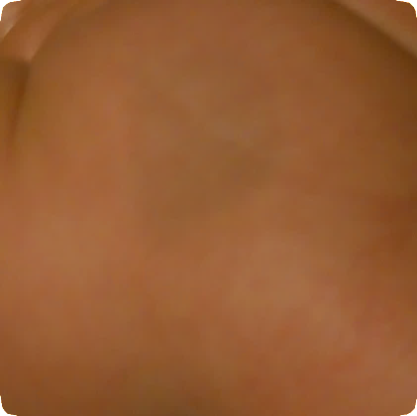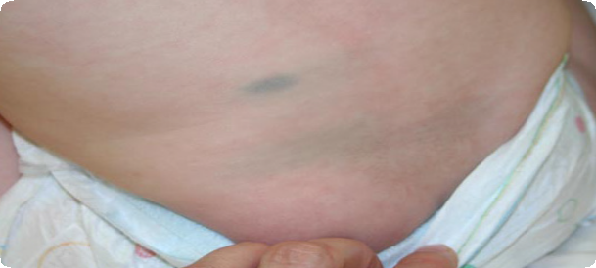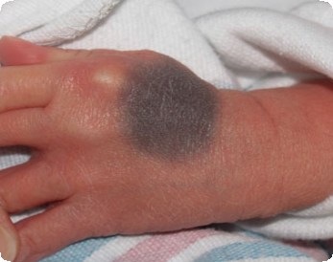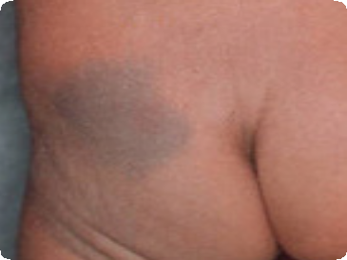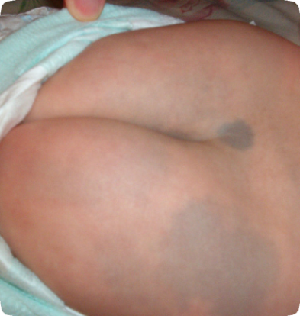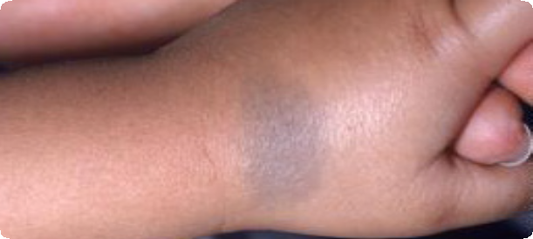

**What are Blue Spots? (Congenital dermal melanocytosis)**

* Hyperpigmented skin areas
* Usually seen at birth or early life
* Often familial
* Common in children of Asian / African descent
* Rarer in Caucasians
* Usually bluish / slate-grey in colour
* Usually flat and not raised, swollen or inflamed
* Usually round / ovoid but can be triangular, heart- shaped or linear
* Can be single or multiple marks
* Usually on the lower back / sacrum / buttocks
* Trunk, extremities (rarer)
* Face or scalp (extremely rare)

**Differentiating Blue Spots(Congenital dermal melanocytosis) from Bruising:**

* Typical sites
* **Non-tender**
* Usually homogeneous in colour
* Don’t change colour and take months / years to disappear
* Must always document presence of Blue Spots, including how extensive, site and shape.

***(refer to photographs for examples)***



# Protocol for the assessment of bruising in

# “Non-Mobile” Children

#### Any Health Professional observes bruise in a non-mobile child.

**(See definition of non-mobile child)**

#### Image result for blue down arrow

#### Record the explanation given, however a referral must still be made.

#### Document bruise on body map (position, size, colour and shape)



**Explain to the family the reason for immediate referral to Children’s Services and Hospital Paediatricians and provide them with the “What’s Going On’ leaflet**



**Immediate Telephone Referral**

**To Children’s** **Services**

Risk Assessment of method of transport to Hospital to be discussed and decision made if Children’s Services need to transport child or parents can take child for medical (see expectations)



**Immediate Telephone Referral To Hospital**

**Paediatric Registrar (with specialist level 3 Paediatric Safeguarding Training) or Paediatric Consultant. A medical will be considered between referring practitioner and paediatrician.**



**The Paediatrician and Children’s Services will decide if a strategy meeting and a safeguarding medical is required - if if neither has not already taken place.**



#### Inform GP and Health Visitor & also the Midwife (if within 28 days of delivery), of Referral and Outcome.

**For Children’s Services phone:**

**DURHAM DARLINGTON DARLINGTON**

First Contact Children’s Front Door Emergency Duty Team

**24 Hour line During office hours Out of Office Hours**

**03000 267979** **01325 406252** **0870 2402994**

**To contact a Paediatrician:**

**Please call the appropriate switchboard and ask to speak to the on call Paediatrician.**

**DURHAM DARLINGTON**

University Hospital Darlington Memorial

North Durham Hospital

**0191 333 2333** **01325 380 100**

**References:**

NICE clinical guidelines 89: When to suspect child mistreatment, July 2009 <https://www.nice.org.uk/guidance/cg89>

Royal College of Paediatrics and Child Health (2013), Child Protection Companion 2013 2nd Edition <https://www.rcpch.ac.uk/key-topics/child-protection>

**Links:**

[www.durham-scp.org.uk](http://www.durham-scp.org.uk)

[FirstContact@durham.gov.uk](mailto:CYPSFirstContact@durham.gov.uk)

[www.darlington-safeguarding-partnership.co.uk](http://www.darlington-safeguarding-partnership.co.uk)

[childrensaccesspoint@darlington.gov.uk](mailto:childrensaccesspoint@darlington.gov.uk)

<https://www.rcpch.ac.uk/resources/child-protection-evidence-bruising>

<https://www.nice.org.uk/guidance/cg89>

<https://adc.bmj.com/content/100/5/426>

<https://www.durham-scp.org.uk/wp-content/uploads/2018/12/Brusing-A4-folded-to-1-3-A4-information-for-parents-and-carers-V3.pdf>

What’s Going on leaflet for parents

<https://youtu.be/dSGgpFdvWpA>

Nottingham video on Bruising in non-mobile babies for professionals

**MANAGING BRUISES IN NON-MOBILE BABIES AND NON-MOBILE CHILDREN**

**Roles and Responsibilities**

**This guide should be used in conjunction with the DSCP safeguarding practice guidance:** [**https://durhamscp.trixonline.co.uk/chapter/bruising-in-babies-and-children**](https://durhamscp.trixonline.co.uk/chapter/bruising-in-babies-and-children)

**If the child, siblings or anyone else is in immediate danger contact the police on 999**

**Non-mobile children are defined as not yet rolling, crawling, cruising or walking independently or are older children who are not mobile because of a disability. RCPCH (2013). Practitioner should include all children less than 6 months.**

Information gathering, while important, should not delay medical assessment or referral to the safeguarding hub

|  |  |
| --- | --- |
| **ROLE** | **RESPONSIBILITY** |
| Professional who is **informed of the bruise by a parent or carer but has not seen it** (for example - telephone triage) | **When abuse is suspected in a seriously ill or injured child, that child should be referred immediately to hospital and transported by ambulance. A referral should be made as soon as possible to Children’s Services.**   * Explain, to the parent/carer, the Durham procedure for bruising in non-mobile children and that a referral will be made to the Local Authority if there is a bruise when the child is seen, regardless of whether or not the explanation appears reasonable and social care will discuss with a Paediatrician to determine whether a child protection medical is required. * Document explanation given for the bruise * Make arrangements via telephone with parent/carer to visualise the bruise for assessment the same day * Document findings from assessment and follow procedural flowchart appropriately |
| Community health professional (for example - Health Visitor, Early Years worker ,GP, Community Midwife, Community Paediatrician, pharmacist **who sees the bruise** | **Any bruising in a non-mobile child should raise suspicion of maltreatment and must result in an immediate referral to Children’s Services and inform the duty Paediatric Registrar or Paediatric Consultant. This referral is the responsibility of any professional who has observed or been made aware of a bruise on a non-mobile child. A discussion should be held between the professional concerned and Children’s Services as to the safe transport and escort of the child to hospital.**   * Check parents hand held record for any bruising recorded at birth. * Clarify if there is a history of trauma (will need to be seen in ED in the first instance) or not (will need to be seen by the Consultant Paediatrician). Document any explanation given by the parent/carer * Explain (to the parent/carer) the Durham protocol for bruises in non-mobile children and that a referral will be made to First Contact if there is a bruise when the child is seen, regardless of whether or not the explanation appears reasonable. Children's Social Care will liaise with the Paediatrician on call to determine if a Child Protection medical is required. **Give ‘What’s Going On’ leaflet (see link above)** * Identify any siblings (including those living elsewhere) – names, dates of birth, current location. * Record the identity of all members of the household and non-resident parents * Before leaving/letting child or child leave (unless urgent transfer to ED), make a verbal referral to First Contact. Agree a plan with the Social Worker regarding transport of the child to hospital. Remember to share details of siblings. * If a child medical is agreed, then the referrer must check that the baby has presented at hospital **within 2 hours** of the agreed time. Referrer must inform the parents that if they do not attend hospital within given timescale Police and Social Worker will attend the family home to escort to hospital. * Contact the Consultant Paediatrician to share clinical information as appropriate and arrange a medical. * Complete First Contact referral to confirm verbal referral as soon as possible to ensure full information available, but certainly within 24 hours to add to child’s record. * Advise Safeguarding Children team of referral. |
| Emergency Department Team | **An urgent safeguarding medical must be undertaken by a Paediatric Registrar (with *specialist* level 3 Paediatric Safeguarding Training) or Paediatric Consultant.**   * Assess child for trauma and treat as appropriate. Ensure non mobile child is fully undressed for examination and document/ body map any bruises. * Apply CWILTED assessment tool * Record any explanation given by parent/carer * Explain (to the parent/carer) the Durham protocol for bruises in non-mobile children and that a referral will be made to First Contact if there is a bruise when any child is seen, regardless of whether or not the explanation appears reasonable and a Paediatrician will be asked to complete a full assessment. Check that parents have received the leaflet on Bruising in non-mobile children and if not give parents leaflet. * Contact First Contact/EDT and make an urgent verbal referral. Contact the on call Paediatric Registrar or Paediatric Consultant in the first instance, although SW Team Manager /EDT will always need to liaise with the Paediatrician to determine if a Child Protection Medical is required. * Document clearly in records all actions and site of bruising. |
| Consultant Paediatrician | **Following this medical the paediatric registrar/ paediatrician will liaise with Children’s Services.**   * Liaise with First Contact/Safeguarding MASH /Social Worker to support their decision making regarding next steps.   **The Paediatrician and hospital will give a view and feed back to Health Visitor/First Contact that they are either ;**   1. Satisfied with the mark bruise was caused by birthing injury, parental explanation or is an organic mark not recorded in records and the matter will close. Overview of presenting bruise/mark only is required not a full CP medical report.  **OR** 2. The Paediatrician is not happy with the explanation for the bruise, mark or  mechanism for the accidental injury and determine that the Bruise/ injury is  Non accidental  they will feed back to First Contact/EDT  and they will progress to a statutory team for a strategy meeting to be held.  * In consultation with social care ascertain contact/ supervision arrangements for parents/ carers * Complete Paediatric Assessment /Child Protection Medical(s) and participate in strategy discussion * Provide written medical report and include body map to Children's Social Care to support the evidential framework and allow child protection procedures to be followed. |
| Children’s services / Multi-agency Safeguarding Hub / Emergency Duty Team | **It is the responsibility of Children’s Services and the Paediatric registrar/Paediatrician to decide, through consultation if bruising is consistent with an innocent cause or not and whether the social worker is required to attend to convene a strategy.**   * First Contact will review the details of the worry. * Undertake a system check to see if there are known risks or vulnerability factors and will determine and inform health practitioner that we remain in agreement that the parents can self-present to the Paediatrician appointment at the hospital within an agreed framework. ( Ideally 2 hours but recognise that an appointment time may be given by Paediatrician to the Health Visitor) * Children’s services will aid the practitioner in determining if the vulnerabilities are so significant a SW will need to attend or if they agree parents should take child to attend A and E for paediatric view within a timescale. * To assist in identifying siblings if the child is known on the system. * Following outcome of paediatric view and indicator that bruise is a result of a non - accidental injury a case file will be opened to progress to a Statutory Children’s team and a Strategy will be held including Paediatric Registrar/ Paediatrician and Police attendance to determine if a S47 enquiry is required and if this will be either single agency or a joint investigation. * If a paediatric view is inconclusive and there is no non - accidental injury, discussion will take place between First Contact or EDT (on unopened/closed cases), or Children’s Services team if an open case, with health staff to ensure that the process has been followed. The team will ascertain there are no further risk vulnerabilities linked to neglect, lack of supervision prior to the Contact being closed. This will include the confirmation of the child has been assessed by a Consultant Paediatrician, and noting that a bruise in a non-mobile child has been explored and no evidence that the bruise is non - accidental in nature and meets the threshold for Child protection procedures to be instigated * When instances occur outside of working week hours, and where the child is well and there are no siblings that could be at risk, Emergency Duty Team Social Worker will discuss with On-Call Paediatric Regisrar / Consultant Paediatrician and police to decide if an urgent assessment and strategy is required or if it is safe for child to be admitted overnight for further actions to take place “in hours”. * Where there are siblings that could be at risk to agree how their safety will be assured. This may take the format of an initial safety plan/ or strategy discussion with a further strategy, meeting planned for the following day. * The Emergency Duty Team will progress the referral to the statutory area children’s Families First team who will arrange a strategy meeting in which the Paediatric Registrar/ Paediatrician will be a participant, along with a safeguarding Health lead. The strategy will determine if a further in depth Child Protection medical is required including siblings dependent upon the concerns presented. |

**Please note: Following implementation of this protocol the parents/carers may require further support at the point of step down or case closure. There should be a multi-agency discussion as to who is most appropriate to provide this. It could be provided by one service such as the Health Visiting Service or the family may have additional vulnerabilities and the case could be stepped down to Early Help.**