Welfare Rights  Resources  Durham County Council | 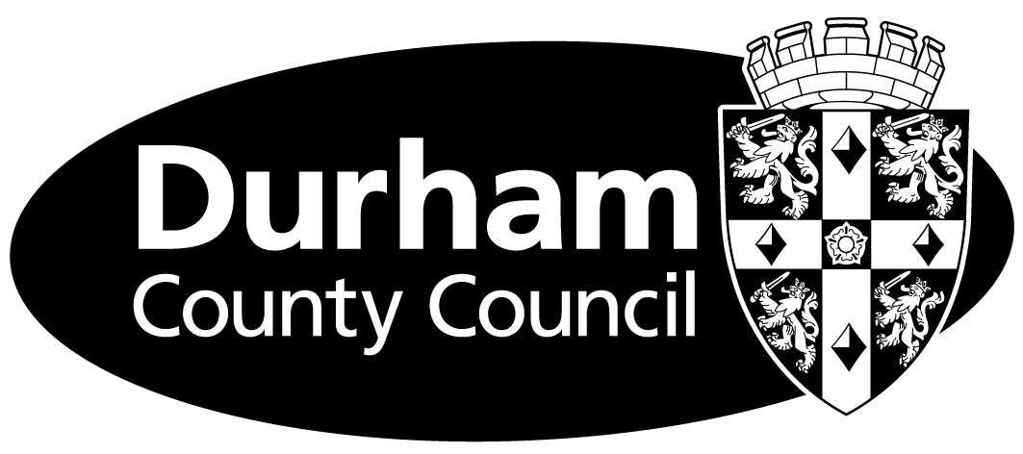

So we can contact the various agencies, please fill in this form, which gives permission for Welfare Rights to act for you. It also gives permission for us to share information with other services within the Council.

This authorisation does not allow Welfare Rights to make claims for you. Making claims and supplying evidence in support of your claim is your responsibility.

Authorisation to Act Declaration

I (Your name)

of (Your address)

authorise Durham County Council’s Welfare Rights Service to act for me concerning any claim that I have made for Social Security benefits, Tax Credits or Housing and Council Tax benefits.

Welfare Rights may appeal (where appropriate) a decision on my claim and make any other appeal to the Upper Tribunal or other higher authorities. I am happy for my case to be listed at any venue currently attended by DWRS.

I authorise the Department for Work and Pensions, HM Revenue and Customs (including the Child Benefit Office), Revenue and Benefit Section, Courts and Tribunals Service to provide details of any decisions related to my claim including details of the benefits or Tax Credits I have been paid.

I authorise Welfare Rights to share information about my claims to benefit with other services within the Council.

I have read and understand the information shown above

Signed Date

Date of birth NI No.

