Appendix 7

People Directorate
Adolescent Response Team, c/o The Council House, Priory Road, Dudley, DY1 1HF
Tel: 01384 815676

Hi,

My name is .................................................

I have attempted a visit today to talk to ........................................about being missing. I will be trying to make contact again however you can call me to arrange an appointment or a chat on .............................................................

I look forward to meeting with you to talk through any concerns you may have. If in the meantime you need help there is a link to further support from the ‘Runaway Helpline’ service below.
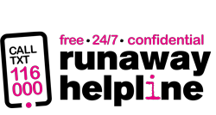
If you are still confused, still want to run away or are already away from home, you can call or text for free on 116 000 or email us 116000@runawayhelpline.org.uk... 24 hours a day, 365 days of the year and we are confidential.
When you call our helpline on 116 000, the team will answer the phone saying, “Hello Services Team”.
They are a team of staff and volunteers who are experts at listening and supporting young people and adults who are worried about leaving or who are away from home already.
Kind Regards,

……………………………..

