Skip to content
- Home
- Contents
- Resources
- Local Resources
- Using this Manual
- SCP Website

Search

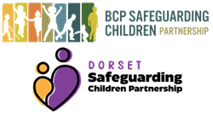
BCP Safeguarding Children Partnership and Dorset Safeguarding Children Partnership Procedures Manual
Resources
Related guidance
- Glossary
- National Contacts
- Regulatory Framework
- Working Together to Safeguard Children (trix please link to https://workingtogetheronline.co.uk/)
- Keeping Children Safe in Education
Last Updated: February 23, 2022
v1
- Contents
- Resources
- Local Resources
- Using this Manual
- SCP Website
- tri.x Policy
- Cookie Policy
- Accessibility Statement

