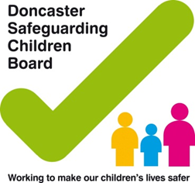
Practitioners address to go here

Date:

Dear,

I would like to inform you that (name of child/ren) (DOB) is now subject to a Child & Family Assessment under Child in Need (CIN), Section 17 of the Children Act 2004.

I am the allocated Social Worker for the family and would appreciate your acknowledgement of this letter by signing the declaration at the bottom and posting it back to me please at the above address. If you have any information that you feel may be relevant for me to know, please indicate below and I will make contact with you.

If the outcome of the Child and Family Assessment recommends continued involvement of Doncaster Children’s Services Trust, I will make contact with you to provide further details, subject to receipt of the declaration below.

I have attached a copy of the signed consent from parents/carers for your records.

Yours sincerely

(Name and signature)
Social Worker

---------------------------------------------------------------------------------------------------------------------

This is a declaration of any information to be shared is to be returned to the above address.

I (Name of GP) declare that I have received this letter in acknowledgement of the above named child and have shared relevant information.

I do / do not hold relevant information in respect to this child or family at this time.

Please contact the GP for all relevant information sharing

Telephone: ………………………………………………………………………………………………………

Email: ……………………………………………………………………………………………………

