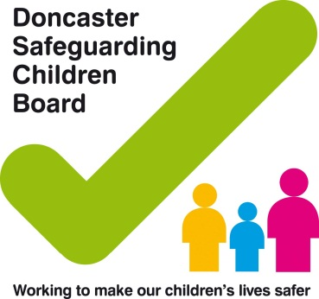
Practitioners address to go here
Date:

Dear,

I would like to inform you that name of child and dob is now subject to an Early Help Assessment, (EHA). This assessment was completed on date and the family are now supported at Team Around the Child ( TAC).

I am the lead professional for the family and would appreciate your acknowledgement of this letter by signing the declaration at the bottom and posting it back to me please at the above address. If you have any information that you feel may be relevant for me to know, please indicate below and I will make contact with you.

I have attached a copy of the signed consent for your records.

Yours sincerely

(Name)
Lead Professional

---------------------------------------------------------------------------------------------------------------------

This is a declaration of any information to be shared is to be returned to the above address.

I Name of GP declare that I have received this letter in acknowledgement of the above named child and have shared relevant information.

I do / do not hold relevant information in respect to this child or family at this time.

Please contact the GP for all relevant information sharing

Telephone: ………………………………………………………………………………………………………

Email: ……………………………………………………………………………………………………

