*Voice of the child,*

*Good Practice*

*Guidance*

|  |  |  |
| --- | --- | --- |
| **Section** | **Heading** | **Page** |
| 1 | Foreword | 3 |
| 2 | Introduction | 3 |
| 3 | The Role of the Children’s Rights Service | 4 |
| 4 | The Legal Context | 4 |
| 5 | Promises to our Children and Young People | 5 |
| 6 | Adopting the Right Approach | 5 |
| 7 | Use of Language | 7 |
| 8 | Use of Tools | 9 |
| 9 | Observations | 10 |
| 10 | Capturing the Child’s Voice  **7.1 Assessments**  **9.2 Recording and Maintaining Records** | 11  13 |
| 11 | The Importance of the Venue | 14 |
| 12 | Capturing the Voice of the Child throughout the Legal Process  **11.1 Pre-Court and Court Work within children’s social care**  **11.2 The Role of the Children’s Rights Service**  **11.3 Asylum Seeking Children** | 15  15  16 |
| 13 | Overcoming Barriers to Effective Communication | 16 |
| **Appendices** | Appendix 1: Capturing the Voice of the Child Guide  Appendix 2: Practice Promises  Appendix 3: Language that Cares | 18  20  20 |

1. **Foreword**

Welcome to the Voices of Children, Young People and Families Practice Guidance. This guidance has been produced as the voices and improved outcomes for the children and young people and families.

Listening and responding to the voices of children, young people and families is the responsibility of all staff in Children, Young People, and family’s directorate. Whether you work daily with children, young people and families or not, incorporating voices is a vital part of your work. It allows our services to be responsive to the needs of those we work with, making them more efficient, as well as providing a good basis for children, young people and families to engage with us and achieve better outcomes.

At the end of this guidance, you will find Capturing the Voice of the Child Guide, Practice Promises and The Language that Cares, as this guidance is implemented you may see some changes to help us all to do this, these will help us to ensure that evidencing the impact of voices becomes as routine for us as collecting them.

1. **Introduction**

Gathering the views of children and young people is an essential part of planning interventions to safeguard children and promote their welfare. Everyone working with children and families in Doncaster must seek the voice of the child and ensure their views are respected and, wherever possible, reflected in services and support which are provided to safeguard and promote their welfare. This guidance explains why children and young people feel it is so important to have their voices heard and then goes to on to provide advice for practitioners on how to talk to children and young people and how to ensure the child's views and needs are paramount.

Day to day direct work should focus on listening to and responding to what children and young

people say is important to them, take their views into account and consider their wishes.

This Practice Guidance has been written to assist Social Workers/ Practitioners within children’s services in capturing the child’s voice by ensuring that it is placed at the heart of any planning, decision-making, and service delivery.

It supports how Social Workers/Practitioners within children’s services should interact with children and young people to ensure that their views and opinions are always considered when it comes to responding to supporting and delivering services that affect them and their families.

It also aims to improve the quality of decisions being made by professionals in their day-to-day work, resulting in improved outcomes along with the better use of resources and greater consistency across the service.

Children’s Services must demonstrate that they listen to children and young people, both in relation to their own individual circumstances, as detailed in this guidance, and in terms of influencing the design and delivery of services. Doncaster has a separate participation and voice strategy, which reflects the number of different ways we encourage young people to have a voice and influence in the services that are delivered.

1. **The Role of the Children’s Rights Service**

The purpose of the Children’s Rights Service is to optimise and empower children and young people’s involvement in strategic, local and day to day decisions that affect their lives. They challenge and champion children and young people’s rights to ensure that when decisions are made children and young people are involved, consulted, and listened to.

Doncaster operate an opt-out advocacy policy for young people who become cared for and those young people who are supported by a child protection plan. They offer issue-based advocacy for children in care, care leavers and support to children and young people within the child protection process.

An advocate’s remit allows them to independently focus solely on the needs of the child and not be districted from other factors or wider influences.

Advocates provide a safe space to look at concerns and consider all the options available to a child or young person, whilst acknowledging issues and disagreements to move forward whilst building skills to self-reflect, communicate and challenge where needed.

The team can be contacted on Freephone 0345 002 0302

1. **The Legal Context**

Children’s Services have a legal duty to listen to the wishes and feelings of all children, including children in care. This is outlined in the landmark Children Act of 1989, which established this requirement as a ‘paramount principle’. All subsequent legislation and practice guidance has sought to reinforce this message as a key aspect of social care provision.

Children and young people have a right to be heard. This is reinforced in the UN Convention on the Rights of a Child (1989) which states that it is a child’s right to be heard and to have their views considered regarding decisions that affects them.

Within court, whilst the child is represented by the Guardian, the social work evidence template and care plan explicitly asks for the child’s views. As in the case of assessments, the child should have an age-appropriate understanding of why proceedings are taking place and the range of options available to the Court and what is being recommended. In the instance that their wishes and feeling cannot be given precedence it should be clear that this has been explained to them; the child’s own words should be used.

Some children will seek to attend Court hearings or wish to write to the Judge and their right to do so should be made clear. The Social Worker should consider the person who is best placed to support the child to take an active role in Court proceedings which will determine their future care arrangements where appropriate. As in other areas of voice of the child, their own words are to be used.

[(https://www.unicef.org.uk/ what-we-do /un-](file:///C:\Users\kevinly\AppData\Local\Microsoft\Windows\INetCache\Content.Outlook\LP864JDE\(https:\www.unicef.org.uk\%20what-we-do%20\un-)

(http://www.workingtogetheronline .co.uk/).

1. **Promises to our Children and Young People**

* Listen to and value the thoughts, feelings and opinions of all children, young people and families who use our services. We ensure that we consider these views when making decisions and explain why decisions are made.
* Involve children, young people and families in the planning, development, improvement, and delivery of our services.
* Use simple and creative ways for all people to be involved.
* Be open-minded and ambitious about what can be achieved. We will be clear from the start and throughout about what we can do allowing time, resources, and the law. We will be clear why things are happening.
* Communicating clearly in a way that is suitable for the people we are working with.
* Learning from compliments, complaints, and comments to improve our services and providing feedback.

1. **Adopting the Right Approach**

Every professional working with children and young people should ensure that the child’s voice is heard, considered, and taken into account on matters that affects them and those that impacts on their families.

Meaningful engagement, negotiation and interaction leads to more successful outcomes. This approach should therefore be from the perspective of relating to children and young people as individuals with whom Social Workers/Practitioners in children’s services can work alongside as active supportive social agents whose views are welcomed.

Increased consideration of a child’s views in decisions that affects them will result in a greater understanding of their circumstances.

Decisions will be more closely aligned to what the child needs leading to improved service delivery, more effective use of resources and result in better outcomes. Getting things right early will ensure fewer disruptions in their care planning and demonstrate a responsive listening provision to our children and young people.

Indicators of effective engagement include children:

* Building strong relationships with their Social Worker/Practitioner where there is a feeling of trust and where they are encouraged to express their views.
* Are able, to take part in decisions made about them and are aware of their right to be heard and the process that supports this.
* Have a full understanding of their situation and the options available to them for the future. In the case of children in care, the role of Social Worker/Practitioners play a crucial role here. This function is further supported by IROs who have a Quality Assurance function by ensuring that this is undertaken as part of the Social Work assessment and care planning for the child.
* There is good quality recording and reporting of their circumstances in plans and assessments which includes their views.

The following diagram: The **Hallmarks of Effective Participation: Evidencing the Voice of the Child**1 highlights what effective participation should look like when evidencing the Voice of the Child. It also sets the criteria set by Ofsted when conducting inspections for children’s services and should be evidenced in all assessments in children’s services.

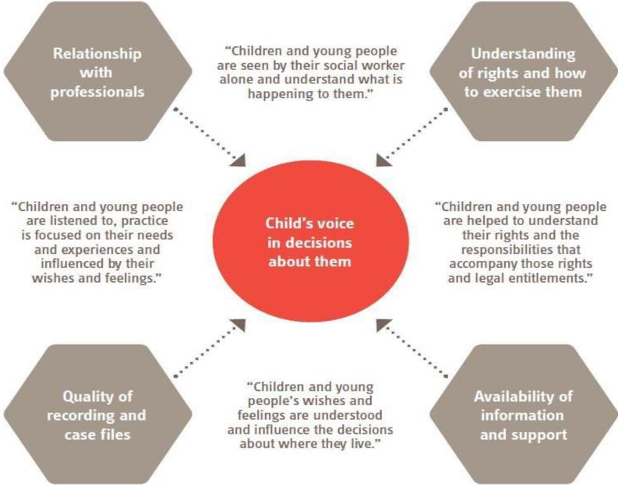

1. **Use of Language**

The views of all children, including young children, can be effectively captured if they are approached at the right level and in a way that is reflective of their ability to understand their situation. This approach should be based and focused on them as individuals and Social Workers/Practitioners/Practitioners should consider the developmental stage of the child as well as the chronological age.

Engagement should focus on capturing meaningful information that serves to inform the Social Worker/Practitioner about the child so that decisions can always be made in the child’s best interests, based on what is known about them, their experiences, views and wishes.

Research in Practice - Voice of the Child: Meaningful Engagement with Children and Young People.

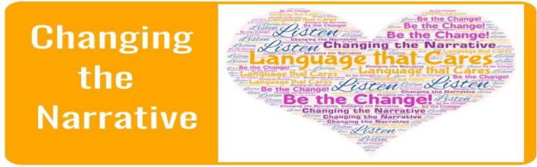

Social Workers/Practitioners/Practitioners should consider the language being used and how this can be adapted in a way in which the child understands, especially when considering any special needs e.g., language, hearing impairment, mental health issues. The use of communications should be clear and focused and where needed supported by tools to assist the process.

**Communication Symbols**

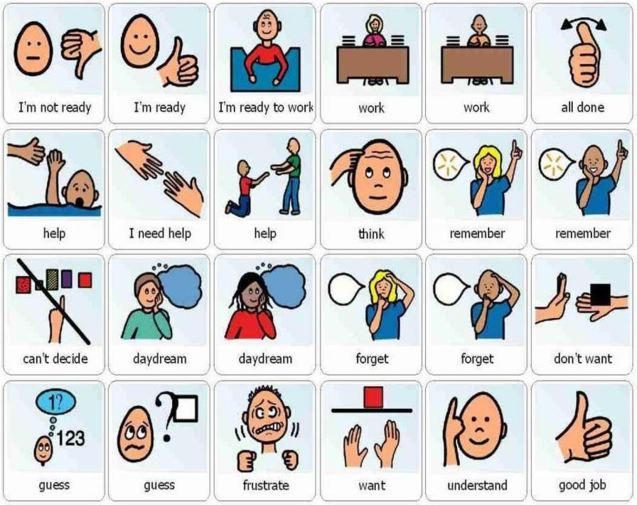

Social Workers/Practitioners/Practitioners should build on our social work practice model, Signs of Safety and aim to develop their relationship-based practice in their conversations with all children by negotiating issues such as the language to be used right at the start of any meetings. This will set a clear purpose of understanding from the outset.

Social Workers/Practitioners should not lose sight of the need for respect, privacy, and discretion. They should never assume that the child knows everything about their situation and should be careful in their approach around asking questions on matters if the child is unaware of the full facts. They should always be open and honest with children and young people as well as mindful about information that could impact negatively if it was disclosed to them. Efforts should be made to ensure that the child feels safe and confident with the social work process. Social Workers/Practitioners should be knowledgeable about what information can be shared before discussing matters of a personal or confidential nature where others are present.

A commitment to building relationships is integral throughout the process and should consist of a two-way dialogue between the child and their allocated Worker.

Social Workers/Practitioners should make it clear how and when they can be contacted and ensure that they respond in good time to missed phone calls, texts etc. This approach will help to build good lasting relationships that will aid the Voice of the Child process.

1. **Use of Tools**

All children have a right to provision which enables them to develop their personalities, talents, and abilities irrespective of ethnicity, culture, religion, home language, family background, learning difficulties, disabilities, or gender. These rights are laid out in the United Nations Convention on the Rights of the Child.

Because each child is unique the methods used to engage with them should be creative and based around their individuality. The tools used should focus on the stage of social work involvement i.e., EH, DCT, Youth Services, CIN, CIP, CIC, so they can specifically focus around the child’s individual circumstances.

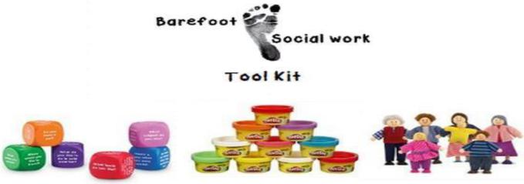

Not all children respond well to verbal communications so other established methods should be used when assessing their emotional responses to their situation, parents/carers, siblings etc. There are many tools that can be used to find the Voice of the Child in a way which is easy for them to engage with Social Workers/Practitioners.

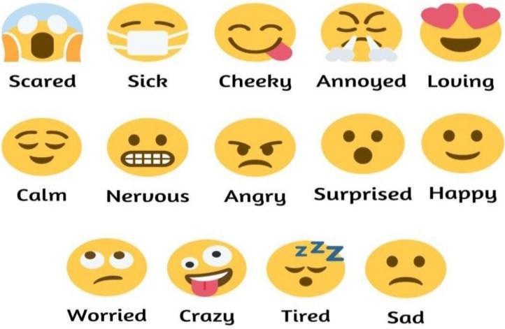

Social Workers/Practitioners can access a variety of resources online. It is their responsibility and part of their ongoing personal development to keep themselves up to date in this area. Each Social Worker/Practitioner should also have access to a bag of tools. Here is the link to the [https://www.ccinform.co.uk/](https://for) for some tips on direct work.

Resources can also be created very easily via the use of photographs, clip art and images from magazines. The Social Worker should be as creative as possible in order to create an environment where the child is able to connect with them in a meaningful way wand enables that child to feel safe and emotionally able to express themselves freely.

1. **Observations**

Observing how a child interacts with their parent(s) and how their parent(s) responds to them and their emotional needs is an important way in which the child’s voice can be captured. Social Workers/Practitioners should record what they have seen. This information should be fact based and can be just as important as what the child tells them.

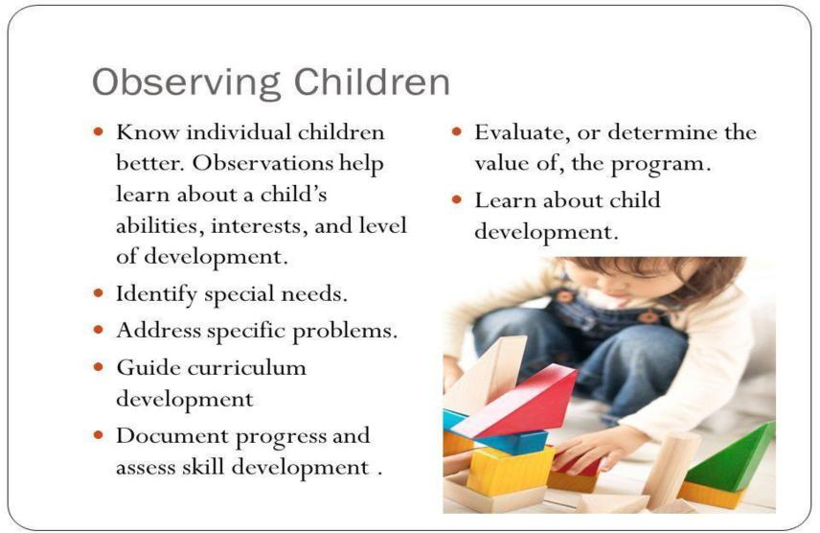

When asking questions, Social Workers/Practitioners should listen carefully to responses and consider the tone, facial expressions, and body language of the child. This information will be useful in helping to inform views and helps to assess situations more accurately so that the right level of support can be provided.

In particular, assessments are an important way of demonstrating how obtaining the right levels of understanding from the onset can lead to better support plans being implemented in a timelier manner.

Direct observations such as pictures, photographs, playing, role play and/or use of puppets can result in some good information about the child. Questions should be open ended and age appropriate. The Social Worker/Practitioner should use descriptive commentary whilst the child is playing as this is a useful way to encourage the child to openly comment. This type of play is also more effective at the child’s level and eye contact should be sought as much as possible, along with a genuine interest in what the child is saying.

Assessments should clearly show what an observation is, what the child has said in actual words and how this information was collated. The language should be kept pure and Social Workers/Practitioners should not correct what they say and how they say it, including any grammatical errors, as changing this can often take away the true and emotional meaning of what the child is trying to convey.

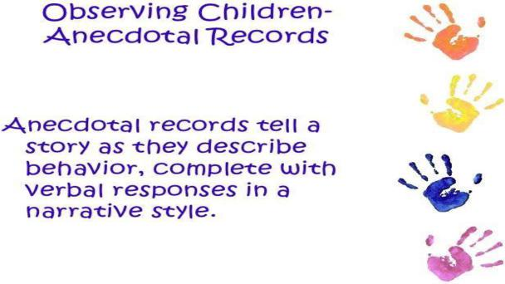

1. **Capturing the Child’s Voice**

**7.1 Assessments**

In respect of gathering information for assessment, we need to ensure that the child has an age-appropriate understanding of why we are involved and what we are worried about and why. Visits to them at home and in school (or other chosen venues) should always include some discussion on this and an understanding of any safety planning that is in place (subject to age/understanding). The child’s voice is powerful and often when shared with parents resonates more strongly than the social worker summarising professional concerns.

Information should also be sought about the child’s hopes and aspirations and what they would like to change, stay the same or have more of. Where possible this should be evident in the plans that are then formulated.

Throughout the child’s journey, there are several opportunities for their voice to be heard and recorded.

Every time there is engagement with the child this should be used to capture information about them, their feelings, views etc. In particular, each and every stage of the assessment and review process plays an important role for this to happen as they create new opportunities to have meaningful engagement with the child.

Working Together to Safeguard Children (2018) states that:

*‘Children should be seen and listened to and included throughout the assessment process. Their ways of communicating should be understood in the context of their family and community as well as their behaviour and developmental stage.’*

*‘Children should be actively involved in all parts of the process based upon their age, developmental stage and identity. Direct work with the child and family should include observations of the interactions between the child and the parents/caregivers.’*

**The key objective of any assessment is to improve the outcomes and life chances of every child in contact with our services.** It is therefore important that the child’s voice is captured in every assessment undertaken. Each provides an opportunity for the Social Worker to understand the impact of the issues affecting the child by capturing and reviewing their understanding of their situation, views, feelings, and emotions. This is achieved by Social Workers/Practitioners focusing on improved child focused practice and in doing so should use every and all opportunities they have with the child to evidence their assessment and planning. This approach should be reflected in and tested in the usual quality assurance process which enables us to review and measure how objectives in plans are being met in response to the child’s needs and what they tell us.

The key responsibility for enriching the assessment by fully understanding and incorporating the Voice of the Child is the responsibility of the Social Worker/Practitioner who must demonstrate and evidence that it has been informed by the child’s views.

Throughout the child’s journey, there are several opportunities to record and review the child’s voice and it is the Social Worker/Practitioners responsibility to bring all this information together in order to achieve a meaningful analysis of the child/young person’s views and feelings. These include:

* + - The initial LAC review meeting (during the first 28 days)
    - 2nd LAC review at 3 months
    - 3rd LAC review at 6 months
    - The initial referral stage (if the child is the referrer)
    - Initial assessment
    - Section 47 Child Protection (CP) Meeting
    - CP Conference
    - Before every CIN meeting (every 20 days)
    - CP, CIN and LAC meetings (every 20 days)
    - CP and LAC planning meetings
    - Direct work
    - Social Worker and Practitioner visits
    - Family Group Conferences
    - Telephone calls
    - Social Media contacts
    - MOMO
    - General feedback
    - Wellbeing Assessments
    - Team Around the Family meetings
    - Education, Health and Care Plans
    - Annual Reviews

The information in the assessment should be complemented by the parents/carers views and also the views of any other professionals working with the child/family. The child’s, parents/carers and professionals’ views should be regarded as of equal importance to each other, and one set of views should not be substituted with another.

The views of different professionals can also help to inform the planning process as each will have a unique and different relationship with the child e.g., teacher, health worker, youth worker, children’s center worker, family support worker. Collectively the right support plan will avoid matters escalating in the future resulting in more successful outcomes.

Return home interviews also play a vital opportunity to listen and record the child’s voice. It helps to identify the reason why they went missing, records their experiences while they were missing and identifies what needs to be undertaken to resolve any issues identified to avoid further missing episodes happening.

**9.2 Recording and Maintaining Records**

Social Workers/Practitioners should get to know the child by finding out what makes them happy, sad etc. as their work with them forms the core of activity for the child. However, the role of other professionals involved in the child’s life can also contribute to the child’s voice. For example, the views of a child’s foster carer, teacher, nurse, health worker, youth worker etc., should always be sought. Teachers, often have an important and unique relationship with the child based on trust and familiarity. Something that a child can tell their teacher may not always be something they feel confident repeating to a Social Worker/Practitioner, particularly when they are not known to them. In order to avoid such important information being lost, a statement from their teacher in this situation would be just as important as the child’s actual voice and should be routinely sought. Teachers, as well as other professionals, are trusted, credible witnesses who are able to add considerable weight to a child’s voice.

When recording information in the assessment, assumptions should never be made about a child. All information should be fact based. Evidence and statements should be invited from all relevant professional sources who have had contact with the child e.g., IRO, teacher etc.

There are often professionals involved in making decisions about children who have never met or seen them in person. It is therefore important that the detail in the assessment enables anyone reading the child’s file to have a full and detailed understanding about them and their response to the situation they are in. The child’s views should leap off the page in all contacts and specifically the Social Work report to the CIC review, as this should provide a detailed lived experience of the child. **This should be the same for every child and not just complex cases**.

It is good practice to ensure that when a transfer status in life for the child takes place this information is completed beforethe transfer takes place and that this is clearly reflected in the child’s chronology.

**It is important to keep records professional, fact based and respectful at all times, even where professional disagreements may exist.** Records form an important part of a child’s and they should therefore be sensitively written in a way which is easy for the child to read and understand. The focus on events to be celebrated as well as any challenges, to be captured. The child’s files are official records which may be used in court at any time and can also be accessed by the child from their 18th birthday following completion of a Subject Access Request (SAR).

1. **The Importance of the Venue**

The venue chosen for interacting with the child affects the tone and flow of information. In order to get the best out of assessments, Social Workers/Practitioners should consider environments where the child is more likely to feel relaxed and comfortable.

Getting the environment right will have an enormous impact on the quality of the assessment. It should not be assumed that the child feels comfortable in the traditional school, care home or other familiar environment. Social Workers/Practitioners should ask the child where they would like to meet in circumstances where this can be accommodated, and if they choose to meet in a less formal environment e.g., library, church, coffee shop, this should be accommodated wherever possible.

The time of the meeting and who is in attendance also have influencing factors on the child. Social Workers/Practitioners should consider how much a parent can influence the voice of a child, even when they are not in the same room.

1. **Capturing the Voice of the Child throughout the Legal Process**

**11.1 Pre-Court and Court Work within children’s social care**

It is inevitable that some cases will escalate to court. It is an emotional time for the child and assumptions about their feelings and wishes should not be made, particularly as this may change during the process. Regularly reviewing the child’s response is therefore good practice.

The outcome of the final review assessment should be recorded on the Social Work Evidence Template (SWET). IROs should always be invited to contribute to the SWET, as this is an important opportunity for the Voice of the Child to be heard and considered at this crucial stage.

The Children and Family Court Advisory and Support Service, referred to as Cafcass, represents children in family court cases.

Their role is to ensure that every child’s voice is heard and that decisions are being taken in their best interests. They ensure that assessment and care plans are robust in demonstrating that this is happening as part of their ongoing work with children and their families. Social Workers/Practitioners therefore need to ensure that all such information provided to Cafcass contain evidence that this is taking place. More about Cafcass is available [here.](https://www.cafcass.gov.uk/)

**11.2 The Role of the Children’s Rights Service**

The purpose of the Children’s Rights Service is to optimise and empower children and young people’s involvement in strategic, local and day to day decisions that affect their lives. They challenge and champion children and young people’s rights to ensure that when decisions are made children and young people are involved, consulted, and listened to.

Doncaster operate an opt-out advocacy policy for young people who become cared for and those young people who are supported by a child protection plan. They offer issue-based advocacy for children in care, care leavers and support to children and young people within the child protection process.

An advocate’s remit allows them to independently focus solely on the needs of the child and not be districted from other factors or wider influences.

Advocates provide a safe space to look at concerns and consider all the options available to a child or young person, whilst acknowledging issues and disagreements to move forward whilst building skills to self-reflect, communicate and challenge where needed.

The team can be contacted on Freephone 03450 020 302

**11.3 Asylum Seeking Children**

Capturing the views of asylum-seeking unaccompanied children and adolescence in the court system may be particularly challenging. However, effort should be made by Social Workers/Practitioners to develop an understanding of each child/young person’s strengths and vulnerabilities’ and the protective and destructive factors in their lives that have led them to where they are. All will have a back story to tell; some will have experienced child and adolescent human rights abuses during their childhood or adolescent years and may suffer from significant mental health and emotional difficulties as a consequence. Many will have experienced violence and or the loss of parents/carers, or other key attachment figures in their lives, torture and more.

These children are protected under the UN Convention on the Rights of the Child. In particular, articles 2, 22 and 39 are concerned respectively with Best Interests, the Right of Refugees and Rehabilitation.

This group of vulnerable young people tend to need a long time to explore their difficulties and build new resiliencies or to reconnect with old resiliencies.

Specialist community-based organisations and charities will often be able to assist in the production of specialist reports for appeal hearings and their contribution will support the general understanding of the child. The asylum- seeking process can be a lengthy process and community organisations like these can serve as valuable agents to support the child in finding their voice as well as other ongoing support to the individual.

Social Workers/Practitioners should bear in mind that there are often gaps between their chronological age and the levels of maturity for children from such traumatic backgrounds.

Interpreters should always be used in order to overcome communication difficulties caused by language barriers.

1. **Overcoming Barriers to Effective Communication**

The norms of social interaction vary greatly in different cultures, as do the way in which emotions are expressed. For example, the concept of personal space varies between cultures and between different social settings. Children from cultures where eye contact and speaking about their feelings with adults can often find it very challenging sharing information about themselves with Social Workers/Practitioners. Social Workers/Practitioners should therefore be mindful of any barriers which could impact on a child’s ability to communicate effectively with them. In particular, Social Workers/Practitioners should be honest about their own professional ability to receive and analyse information from the child in an impartial way.

The following examples are barriers to effective communications which will have a negative effect on the quality of information being obtained about the child in any interview setting.

* Not listening carefully to what is being said
* Not understanding the impact for children with disability such as ASC, poor eye contact, poor theory of mind, rigidity of thought
* Noting only words rather than other non-verbal communication
* Being unable to suspend judgement or pre-conceived views
* Using unsuitable or unfamiliar language
* Being unable to be impartial on topics regarded as 'off-limits' or taboo e.g., politics, religion, disabilities (mental and physical), sexuality and sex, racism
* Lacking attention, interest, being distracted or rushed
* Differences in perceptions and viewpoint
* Physical disabilities e.g., hearing problems, speech difficulties
* Being unable to identify non-verbal cues, gestures, posture and general body language which can make verbal communication alone less effective
* Language differences and difficulties understanding unfamiliar accents
* Expectations and prejudices which may lead to false assumptions or stereotyping

Social Workers/Practitioners should continually review a child’s understanding by offering clarification throughout interviews.

Phone calls, text messages and other communication methods that reply on technology are often less effective than face to face communication, however they can be a useful supplement to the voice of the child.

**Appendix 1: Capturing the Voice of the Child Guide**

|  |  |  |
| --- | --- | --- |
| **Area** | **What to look for/Ask the child** | **Considerations** |
| Direct Contact | What are the child/young person’s views, opinions and wishes? | Is the level of engagement age  appropriate and reflective of the  child’s understanding?  How well do they understand the situation they are in and their circumstances?  What do they want to happen? |
| Communication | Is the child able to communicate effectively?  Do they need support to communicate effectively e.g., language barrier, ability, disability, trauma, culture? | Is an interpreter or advocate needed?  The use of photographs/images or other communication tools may assist.  Are there known past events about the child that could affect their ability to talk freely? |
| Observations | What is the child’s behaviour like? Consider whether they are happy, sad, lively, tired/lethargic. Give examples.  Are there any health issues that impacts on the child’s ability to engage/ interact? If so what?  What makes the child happy and sad and what makes them feel better when they are sad?  What is the child’s relationship like with their parents/carers? Does their behaviour change in their presence?  How does the child react to other family members, adults?  Does the child demonstrate strong attachments? | Use of role play activities, puppets, clip art, pictures, photographs, feelings box/images can be of assistance.  Consider the facial expressions and body language of the child, parents/ carers etc. Does this match verbal responses?  Does the child display any behaviour which is of concern? If so further investigation should be sought.  Consider interviewing the child with and without their parents/carers. |
| Venue | Is the meeting informal or formal?  Is it taking place in a location that is in the best interests of the child or in response to where they say they would like it to take place?  Is the time convenient for the child?  Who else is in attendance? | The venue and location of meetings will have an important influence on the outcome. If informal, consider how this can be accommodated.  Look at alternative meeting locations to aid the purpose and objectives of the meeting.  Do not make assumptions about where meetings should take place. When requests from the child can be accommodated, this should be considered.  Think carefully about who needs to be there and how this will add value to the meeting. |
| Recording | Does the meeting and subsequent plan acknowledge the views of the child? | Has the voice of the child been recorded in a clear and concise way?  Where the views or wishes cannot be accommodated this should be stated and the reason why so that there is a clear understanding for all parties concerned. |
| Other factors | Are there any social relationships that can be used to support the child?  Are there any other professional relationships whose views can assist with the voice of the child? | Consider informal relationships e.g., community based.  Consider input from other professionals e.g., teacher. |