2025 - 2029
Placement Sufficiency Strategy
Derbyshire County Council

Table of Contents

Executive Summary 3
Stronger Families team 6
Reunification 7
Commissioning 7
Children’s Homes 9
Fostering 9
Supported Accommodation 10
Cost of Placements 11
Total Cost of Placements: 11
Average Cost of Placements: 13
Challenges in Providing Placements and Related Services 15
Projections on Demand for Placements 16
Strategic Context & Plan 19
Governance 19
Stakeholders and Dependencies 22
National Policy Context 23
Alignment with the Medium-Term Financial Strategy (MTFS) 23
Achievements & Next Steps 24
Appendix 1 – Cohort Data: 27
Children in Care Population: Total and proportional trends 27
Children in Care by Age Group: As a proportion of total children in care population 28
Children in Care by Ethnicity: 29
Children in Care by Legal Status: 30
Children in Care by Category of Need: 31
Unaccompanied Asylum-Seeking Children: 32
Children in Care with Special Educational Needs and Disabilities: 33
Children in Care’s Strengths and Difficulties: 34
Care Leavers: 37
Admissions into Care by Age Group 39
Admissions into Care by Legal Status 40
Admissions into Care by Category of Need 42
Admissions of Unaccompanied Asylum-Seeking Children 44
Needs Assessment: Placements 45
Children in Care by Type of Placements: 45
Children in Care by Placement Provider: 46
Length and Stability of Placements: 48
Location of Placements: 49
Quality of Placements: 50
Appendix 2 – Market Position Statements: 52
Appendix 3 – Methodology 52

Executive Summary
Key Information:
On 31 March 2024, Derbyshire had 1057 children in care.
- Greatest demand is in the 10-15 category, followed by 16+

- Children in care are predominantly white, reflecting the population as a whole. Though ethnic minorities are overrepresented, this is still small numbers. Some pockets may be relevant, particularly UASC teenagers.

- Half of children in care are on a full care order with 23% under S20 - 4% higher than the national average.

- Half of children in care have suffered abuse or neglect, though national recording categories are not suitable for capturing the complexity of adverse childhood experiences many children in care will have been exposed to.

- There has been a steep increase in UAS children in care, bringing Derbyshire in line with the national average.

- 60.3% of children in care have a special educational need or disability, half of which are social, emotional or mental health needs. This is in line with the national picture.

- Derbyshire's children in care have a higher prevalence of emotional, behavioural and mental health difficulties than nationally.

- 67.7% of child protection plans were initiated for reasons of neglect, compared to 49.8% nationally.

- Accommodation and educational outcomes for care leavers in Derbyshire are very strong and above national averages:

  - 98% of care leavers (17-18) and 97% of care leavers (19-21) live in suitable accommodation compared to 88% nationally for 17-18 and 19-21

  - 78% of Derbyshire care leavers aged 17 to 18 are in Employment, Education or Training (compared to 64% nationally). This figure reduces to 66% for Derbyshire care leavers aged 19 to 21 (compared to 54% nationally).

- Admissions to care have steeply increased since 2019, 7.3 times more in Derbyshire than nationally.

- 16+ admissions have increased 107% between 2019 and 2024. with a 69.6% increase for 10-15 year olds.

- 59% increase in children coming into care under S20 in the last 5 years compared to 19% increase nationally

- Between 2020 and 2024 the largest percentage increase in primary need for children coming into care has been absent parenting – an increase from 43 children coming into care during 2019 to 79 children during 2024. This will reflect increasing UAS children coming into care over this period. Abuse and neglect remains by far the largest category – the primary need for half of all children coming into care during 2024.

- 62% of our children in care are in a foster placement compared to 67% nationally

- 16% are in secure homes and children's homes compared to 10% nationally

- DCC provides 40% of all CiC placements (36.7% fostering, 3.2% residential) compared to 43% nationally, with 41% being in private provision (25.6% IFA, 12.3% private residential) compared to 37% nationally.

- Placement stability in general is a strength but needs to improve for U16s.

- At 30% we are higher than the national average (22%) for children placed more than 20 miles from home though with our geography this is unsurprising.

- At (48%) we have a higher than average number of children placed outside our boundary compared to national (45%)

- The average weekly spend on external residential is £7326 (March 2025)

- The average weekly spend on internal mainstream residential is £3,770 (March 2025)

- The estimated average weekly spend on external fostering is £974

- The estimated average weekly spend on internal fostering is £634

- If trends continued, residential placements would rise by 127% between 2025 and 2035

- As of December 2024, 80% of externally commissioned foster placements were via the D2N2 framework compared to 35% for residential placements due to instability within the market.

Derbyshire children’s services department aspires to only have the right children in care (CiC) for the right length of time, at the right time, and to be creative in its care and support planning. Those children entering care to have safe and stable homes built on love. Derbyshire’s vision for its children in care population is to maintain sufficient high-quality placements for children, young people and care leavers, which enable them to achieve their full potential.

Derbyshire’s ‘placement mix’ includes 18% of children in residential provision. It is the overarching goal of this strategy to reduce this mix to 11% by 2030; a figure seen in a statistical neighbour rated ‘outstanding’. Achieving this goal should result in improved outcomes for children, and a reduction in spending of up to £10m per annum.

Introduction
Section 22G of the Children Act 1989 sets out the duty for local authorities to have enough suitable homes for children in care (looked after children). Derbyshire experiences many of the challenges that research has identified are faced nationally, namely:
- the rising numbers of children in care and an older profile of children
- an increase in children who require specialist provision that can support complex needs and, in particular, mental health needs
- a lack of secure provision for children nationally, meaning alternative places need to be found for children with complex needs
- issues with recruitment and retention of foster carers, residential care workers and other social care and wider children’s professionals
- not having the right quantity and mix of provision for the children in their area
- difficulties in working in the private market, where private providers have more power and local authorities have little choice

How local authorities should meet their sufficiency duty is outlined in statutory guidance. Despite this, few if any local authorities meet their sufficiency duty. There has been research into how local authorities plan for sufficiency of accommodation, a report from the Competition and Markets Authority and an independent review of children’s social care, all of which outline the scale of the challenges being faced and the ‘broken market’ within this sector.
Where there is reference in this strategy to ‘placements’ or ‘beds’, we are clear this refers to stable, loving homes for children with adults they can trust. Language is a sensitive issue which children and young people will hold a variety of views on. There are similar sensitivities with language in relation to the legal term ‘care leavers’ and the preferred ‘care experienced’, and the legal term ‘unaccompanied asylum-seeking children’ (UASC) and the preferred ‘separated children’. Terms may be used interchangeably throughout this strategy.
This strategy will present a needs assessment, including demographic trends, data relating to admissions and exits from care, and the needs of Derbyshire children in care. Current provision will be outlined, including the mix of internal and external provision, geographical spread, sufficiency, quality and stability; specific areas will be identified where sufficiency is a challenge.
The strategy is governed within the framework of the council plan 2025-29, particularly the strategic objective to: “Achieve sufficiency of accommodation to ensure children are cared for in the right home at the right time”. The strategy is produced in collaboration across children’s services and coordinated by the relevant assistant director.

The year 1 review of the strategy will take place in Q3 2025/26 and annually thereafter. Though not aligned with the financial year, this ensures the strategy is reviewed with the latest DfE submission data to ensure the most effective monitoring of progress using data that is as current as possible. Data runs to the end of the financial year but is published in November. Wherever possible, data in this document is based on the most recent outcomes as published by DfE (31st March 2024). The date of any other data used will be stated.
Actions will be outlined that aim to increase capacity, stability and provide better outcomes for children. Specific focus will be paid to commissioning, market management and the quality assurance of placements.
Work that is being undertaken to continually improve our internal matching and decision making in this complex area will also be summarised in this strategy.

Stronger Families team
The Stronger Families Team is an intensive, evidence-based team firmly rooted in Derbyshire’s “Stronger Families, Safer Children” operating model alongside utilising systemic, person centre and social pedagogy approaches to practice. The Stronger Families Team upholds the value base of the SFSC operating model through commitment to thinking, being and doing.
The Stronger Families Team is founded on the idea that most families want to stay together but aren’t able work things out for themselves at this time with the resources they currently have.
We see the family are the experts in their own situation and therefore work collaboratively with them throughout our involvement toward positive change.
For families we support directly, we invest time and effort into building a relationship and understanding their journey to today. In our approach, we believe that if solutions were straight forward, the families would likely have already made changes themselves. We therefore spend time listening and learning about the family before moving to any change work, as we believe that each family is unique and requires a bespoke and flexible approach to the needs of their family.
The Stronger Families Team offer support through varying workstreams including direct work: through Edge of Care where there is a risk of a child being accommodated by the local authority due to family breakdown, within this work stream we utilise our FAMILY model to direct our support to families.
Reunification; where support is required to promote a positive reunification to family, a connected person or a Local Authority home which meets their needs. We also offer crisis involvement where there is an immediate risk of a child entering local authority care in an unplanned way without support.
We also offer support indirectly to practitioners working with families offering tools and advice either through case consultations or through systemic case formulations.

Reunification
2025 has seen the development of a specific reunification strategy, to help children return to the care of their family networks when safe to do so. This is something we should always be striving for to promote the best outcomes for our children in care. Reunification encompasses the THINK FAMILY approach and Stronger Families Safer Children practice model to balance the risks, protective factors and to bring in the whole system to support the child and family. Achieving and promoting successful reunification for children and families is everyone’s responsibility.
As corporate parents, reunification is and should always be an important aspect of care planning for a young person. This is something that requires a fluid approach and recognising that although reunification may not be possible at that time, that this does not mean that this is not possible in the future. Reunification should be based on a robust assessment of risk and protective factors, with a clear support plan incorporating the family network and multi-agency partners with clear identified outcomes and requirements for change being made clear to the family network.
Successful reunification not only leads to positive outcomes for children and families, it also supports placement sufficiency and enables the targeting of resources on those with the greatest need.

Commissioning
The council continues to find it difficult to place children in suitable accommodation and is not always able to do so. The market position statements in appendix 2 illustrate some of the challenges faced. Sufficiency of placements continues to pose difficulties for children in care as demand rises, though local strategies have been implemented to address these challenges with some success.
Initiative 1: Forward to Foster
This programme has supported children to move from residential into fostering settings when appropriate since 2021. This was more successful in its first year of implementation than any subsequent years, therefore indicating that sufficiency continues to be a challenge. In 2021-22, 7 children were moved from residential into foster families through this initiative. In 2022-23, a further 4 children were placed in foster families via this initiative. Since then, no further children have received a successful placement via this route. This saved the council approximately £750,000 per year in placement costs during 2021-22 and a further £290,00 per year in 2022-23. This also ensured children were in placements more in line with their care plans. No further children were successfully placed via this initiative in 2023-24, and approximately 50% of the placements that were sourced have now ended due to a number of reasons. This suggests that the sustainability of these placements must be considered more to ensure resilience and success for our children in care.
Initiative 2: D2N2 Framework
The council works closely with neighbouring authorities Derby, Nottingham and Nottinghamshire, to form the D2N2 framework to source placements for children in care, and this again, had more success at the beginning of its implementation, when local sufficiency was higher.
Fostering placements are often commissioned via this framework (as of December 2024, approximately 80% of externally commissioned foster placements were via the D2N2 framework), whereas residential placements are becoming more common to be commissioned via a non-framework or spot purchase arrangement (as of December 2024, approximately 35% of externally commissioned residential placements were via the D2N2 framework). This further demonstrates the fluctuation and instability within the residential sector.
The framework is due for review in 2025/26 and the positive working relationships between the four councils is seen as, and continues to be, a real strength. Derbyshire County Council will be the lead commissioner of the revised framework that will commence on 1st April 2026.
Initiative 3: External Provision
There are upcoming tender opportunities for residential providers such as a block contract opportunity for between 6 and 9 beds across several homes, there are also engagement events planned with independent fostering agencies and discussions around contracting opportunities to support a more robust and revised ‘Forward to Foster’ package. The current supported accommodation block contract is due for renewal and the new contract will be in place from 1st October 2025.
Derbyshire County Council has few block contracting opportunities currently with the local external market and it is the intention that this is increased as a more successful way of contracting between the external market and the Council.

Children’s Homes
The council operates 12 internal residential children’s homes in Derbyshire, with 4 specifically for children with disabilities, this allows us to support up to 47 children in our homes at any one time. As of March 2025, all homes are rated ‘good’ or ‘outstanding’.
Over the last 12 months adaptations have taken place to increase the number of long-term beds, and work is ongoing through further adaptations to provide more. Spire Lodge short breaks children’s home is currently being replaced by a new build which will also incorporate some long-term beds.
In January 2025, £7.5m capital funding was secured to grow the estate by a further 16 beds over the next 5 years. This is a long-term project that is tied into the 2025-29 council plan.
Analysis in March 2025 indicated that for homes of any size, including one bed specialist placements, external provision was significantly more expensive than internal provision. This remains the case, even if a bed is blocked in internal provision. The more beds a home provides, the cheaper the average bed cost, however this is offset by the increased complexities of matching in larger homes. It is important to note that cost is not the only criteria when assessing effectiveness. Internal placements provide significantly more control over the quality and stability of care. Analysis has shown that there is a relatively small impact of underutilisation on the overall average cost, indicating that it would be more effective to ensure a good match and sustainable placement, rather than filling a gap quickly without sufficient matching.

Fostering
Internal fostering provision is the most cost-effective option for children in care to grow up in a loving family environment. Derbyshire’s fostering service has 230 carers supporting 308 children in placements as of April 2024.
Derbyshire County Council is part of a regional fostering hub ‘Foster for East Midlands’ that was launched in March 2024. The collaboration also includes councils in Derby, Nottingham and Nottinghamshire and is funded by £1.626m in government funding through the DfE Recruitment and Retention Programme. The funding also supports the creation of a ‘Mockingbird constellation’ in each local authority area.
The DfE Recruitment and Retention Programme aims to increase the recruitment of foster carers and provide the support carers need to continue in the role. With more carers in children’s own communities, less young people would need to be placed in unfamiliar areas.
Foster for East Midlands is a recruitment hub which engages with prospective foster carers from their initial enquiry through to submission of their full application. The funding also helps improve the support available for existing foster carers across the region, empowering them to create loving, stable homes for children in need.
The recruitment and retention of foster carers is a national and local problem, with generally aging populations of foster carers which means recruitment cannot keep pace with those leaving. Independent fostering agencies usually pay higher fees to carers, funded by the charges they pass on to local authorities.
A significant change programme is underway to modernise the fostering service and address issues in relation to recruitment and retention. Between 2018-2024, Derbyshire experienced a 27% reduction in the number of fostering households 359 to 262. Between 2018 and March 2025, the number of children in care has increased by 42% from 719 to 1022.
There has been a significant increase in our friends and family (kinship) carers. Data for 23/24 show that 71% of all fostering approvals were friends & family carers. We are strengthening our package to our friends and family carers to ensure this cohort of carers is suitably supported and that their specialism as kinship carers is acknowledged. We are also strengthening our package of support to special guardians to enable our friends and family carers, and our foster carers to provide permanency for children outside of local authority care. Converting from caring for a child as a foster/kinship carer to outside of local authority involvement can be daunting. Our support package bridges the gap to enable special guardians to continue their contact and support with the local authority.

Supported Accommodation
Supported accommodation has faced a lot of recent changes, especially the regulatory changes around Ofsted registration.
Appendix 2 includes a market position statement that identifies a cohort of children in residential, who would be ready for appropriate supported accommodation but due to sufficiency in their local areas are unable to do so. This has had an impact of the availability and suitability of placements for children aged 16-18. We have a further 6 children (16+) in supported accommodation where ideally, they would be in a residential setting. There are also a shortage of homes for when a child turns 18 which causes further pressure.
Derbyshire's internal block contract (StepUp) provides support for children in care and care leavers aged 16-24, offering various types of accommodation with the primary aim of preparing them for independent living at 18.
However, there is a shortage of suitable accommodation options available through the social housing bidding process and housing associations. As a result, a significant number of those over 18 remain in StepUp accommodation, despite, some being ready for independent living, and experiencing frustration due to unsuccessful bidding for independent accommodation. This can result in an oversubscription and shortage of sustainable homes for those over 18, leaving young people approaching 18 without a clear plan for the transition to independent living. For children's services, this leads to financial consequences, reliance on the D2N2 Framework and spot contracting placements for young people unable to move into StepUp provision.
There has been impactful joint working which has achieved opportunities for care experienced young people to have ringfenced homes with some adult accommodation providers, and working relationships with district councils have been developed, with direct matching successfully moving over 20 young people into their first home.
Staying Close Derbyshire is a joint approach between Derbyshire Leaving Care Service and the DECC, a therapeutic support service provided by Action for Children. Our specialist staying close workers work closely with lead therapeutic practitioners from Action for Children, to ensure a trauma-informed approach is embedded across all that they do. Staying close will work with partners inside and outside of Derbyshire County Council to support young people in the area over the next two years, focusing on those with high levels of need to ensure inclusivity and diversity is embedded.
The re-procurement of Derbyshire's supported accommodation block contract is currently underway and is expected to be completed during 2025. The new contract will provide an opportunity to expand on the success of the current contract, creating and improving capacity and specific accommodation to meet the needs and requirements for young people including accommodation for over 18s.
Derbyshire has its own supported lodgings provision, which sits within the leaving care service. There are 9 beds for children in care and approximately 25 for care experienced young people. A concerted effort is being made to increase the number of supported lodgings providers. The scheme has been registered with Ofsted under the 2023 supported accommodation regulations.
A high number of our separated children, aged over 16 live in supported accommodation with 25 children in a block contracted arrangement with an external provider and a further 52 children in other externally commissioned arrangements (framework and non-framework). A challenge for our separated children is that until they receive an asylum decision, they cannot access universal accommodation. A seconded commissioning manager has focused on this cohort in the last twelve months, reducing provider costs and implementing more rigorous oversight of move-on plans post successful asylum claim. This has helped reduce financial burdens and increase our own sufficiency.

Cost of Placements

Total Cost of Placements:
The annual costs of fostering and residential placements have continued to rise, with considerable increases seen for agency placements. Spend on internal residential provision has plateaued since 2022/23, however the success of securing capital funding for the expansion of internal homes will result in increased costs, offset by the cost avoidance of external placement use.

The % increase in annual costs between 2021/22 and 2023/24 can be seen below.

Total Annual Spend | 2021/22 £ | 2023/24 £ | % Increase
Agency Residential | 23,727,642 | 39,326,708 | 66%
Agency Fostering | 13,139,936 | 16,347,452 | 24%
Internal Fostering (including fostering service) | 8,405,594 | 10,089,324 | 20%
DCC Children’s Homes | 7,444,960 | 8,467,758 | 14%

Table 3: £ & % increase in total annual spend
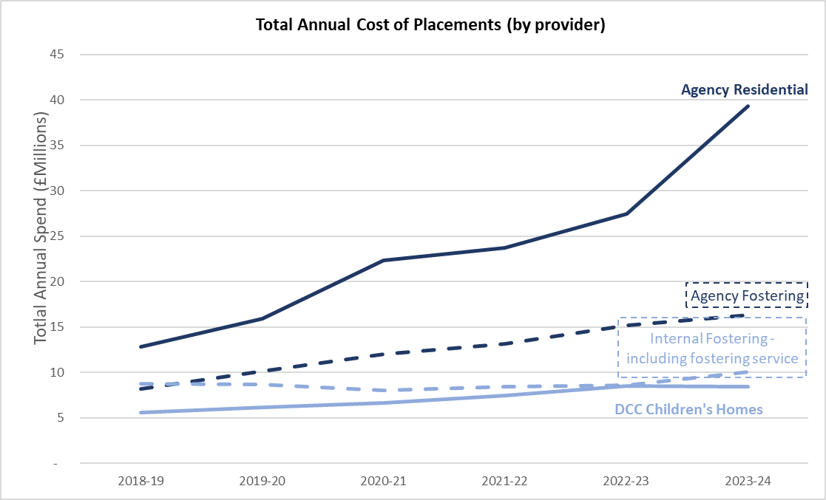
Data Source: Derbyshire County Council Finance & ICT Services, Corporate Services & Transformation
Table 4: Total cost of placements based on provision

Table 5 illustrates the dysfunctional nature of the external placement market using a sample of local authorities, with the fees charged by private providers bearing little correlation to the assessed level of need. The fact that local authorities are paying substantial fees for children with a lower level of need show that this is a provider’s market, with local authorities desperate for beds.
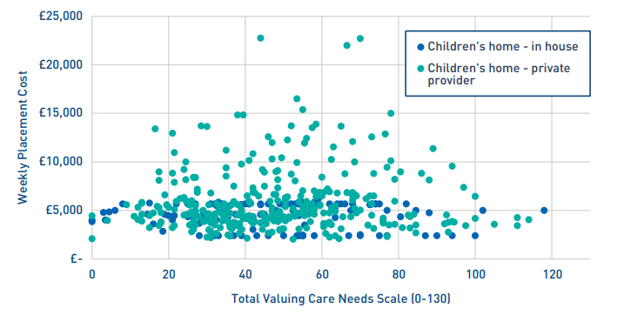
Table 5: Example weekly residential cost and need analysis (Impower, 2024) Total cost of placements based on provision

Average Cost of Placements:
Identifying the average cost of placements and comparing the cost of internal with external placements is fraught with difficulty and figures need to be treated with caution. The Competition and Markets Authority’s review of the social care market stated that the average cost of local authority residential provision was higher than that of the private sector (based on a sample of 29 local authorities using data up to 2020) due to higher staffing ratios and pay. They did, however, acknowledge that this may indicate that local authorities care for children with the most challenging needs and was also indicative of higher quality provision. This report also focused on the fees and profit margins of large private companies, and did not consider the additional cost to local authorities outside of fees; namely commissioning and quality assurance. The methodology used is somewhat opaque and it is not clear whether the percentage of specialist/disability placements compared were equal across the private sector and local authorities.

The demand for residential care has surged. Derbyshire data in March 2025 highlighted 143 children were placed in external residential provision at an average weekly cost of £7,402 (as of 20th March 2025) — nearly double the cost of internal mainstream provision at £3,770 per week. This equated to an annual expenditure of approximately £54.5 million for external residential provision, representing nearly one-third of the children’s services budget.

Reasons for the increase in costs in placements include:
- High demand and limited supply
- Private sector profit margins
- Increased complexity of need
- Rising staffing and recruitment costs
- Inflation and operational expenses
- Local authority reliance on private providers

In relation to fostering, the average price per week for internal fostering (£634) is cheaper than independent fostering agencies (£974), with both being significantly cheaper than residential provision. Any attempt to reduce expenditure on placements should focus on growing and retaining more internal foster carers and ensuring there is sufficient internal residential provision. There will always be a role for external fostering and residential, however the balance needs tipping to greater internal provision.

The fact that prices in the external market are so dynamic poses problems when trying to establish savings or cost-avoidance. Any prediction will be based on the current market rate, which has been on a steeply increasing trajectory for a number of years. If this trend continues, proposals using the market rate may undersell the actual benefit realisation.

Challenges in Providing Placements and Related Services
Derbyshire’s children in care population has been rising for many years, with the rate of increase being slightly above the national profile. Derbyshire shows a higher than national percentage for children placed with private provision and children placed at a distance.
When comparing the utilisation rate of Derbyshire provision, we can see negligible change in the use of DCC residential care, which runs at near capacity for most of the time.
Whilst there has been an increase in the child in care population, the proportional increase in care numbers pertain mostly in the 16+ age groups (24.4% increase between 2022 and 2024) which provides evidence of a need for more alternative local provision such as semi-independent provision for example.
The quantity of Derbyshire foster care placements (number of fostering households) has seen a continued annual reduction since 2017/18 - there being a nationally recognised challenge relating to the recruitment and retention of foster carers. However, utilisation of Derbyshire’s foster placements is consistently strong (95% in March 2025). Derbyshire’s trend of increased use of commissioned provision is similar to the national trend. Appropriately placing children with complex needs is a key challenge. There are not enough suitable homes, or staff with multidisciplinary skills, to care for children who may be a danger to themselves or others, or who are being exploited. Many registered children’s homes are reluctant to accommodate these children as they believed it could have a negative impact on their Ofsted rating, despite assurances to the contrary.
Support for children with complex needs continues to be an area where provision in the local area is sparse. Work with neighbouring councils is in place to look at block contracting opportunities to support this cohort further and is anticipated to alleviate this pressure and stimulate market growth. A current piece of work is underway to explore the possibility of a block contracting opportunity between Derby City Council, Derbyshire County Council and Derby and Derbyshire Integrated Care Board to try and address this shortage. A capital funding bid has also been submitted to DfE for homes for children with complex needs.
Certain categories of need provide greater difficulty when trying to find suitable placements than others. Whilst Abuse or Neglect (50% - children who started to be looked after during the year ending 31 March 2024), Absent Parenting (16%), Family in Acute Stress (11%) and Family Dysfunction (8%) represent common primary categories of need for admissions into care, they are often not the most difficult to source suitable placements for. Children with disabilities (5%), as well as those demonstrating socially unacceptable behaviour (2%) are the most difficult to provide placements for in Derbyshire due to these children often having complex needs. However, this difficulty is mirrored across England.
The Competition and Markets Authority (CMA) has expressed concern about the risk of unmanaged exit by large children’s home providers due to their levels of debt and dominance of the market. With over 83% of the residential care market owned by the private sector, and within that a majority of homes being owned by a few very large providers (CMA, 2022), many children are at risk of being affected by a Southern Cross type collapse. Whilst the fostering market has different risks to the children’s residential home market, fostering is on the same trajectory of becoming increasingly privatised and consolidated in the hands of a few large providers (CMA, 2022). The market share of independent fostering agencies (IFAs) is 41%, and the top six IFAs account for 51% of all foster homes that are through an agency and 18% of all fostering households nationally (Ofsted, 2020).

Projections on Demand for Placements
This section includes forecasts on demand for placements from 2026 to 2035. These forecasts are straight-line statistical predictions based on the historic trajectory of children in care numbers within Derbyshire. They provide a baseline estimation of future children in care numbers based purely on historical trends and where demand is likely to be if we do nothing. They do not take account of any potential impacts on numbers such as departmental or wider initiatives.

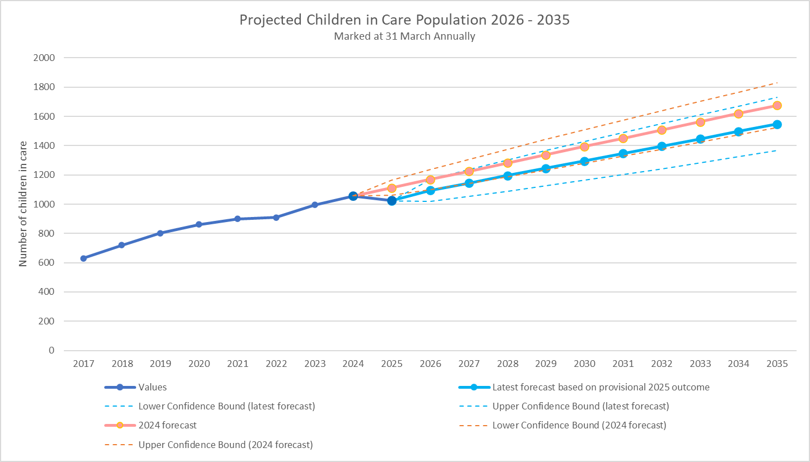
Data source: Internal forecast. Latest forecast includes provisional end of March 2025 outcomes.

Upper and lower confidence bounds for each forecast are shown with are based on 95% statistical confidence levels. This chart includes the latest forecast of children in care numbers based on the provisional end of March 2025 figure.
Overlaid is the previous 2024 prediction which shows that the actual number of children in care as at the end of March 2025 (1024) was 7.9% below the 2024 forecast of 1112 and 3.6% below the 2024 lower confidence bound forecast (1062). The over prediction of the 2024 forecast is likely to be due to numerous factors during 2024 and 2025 which have suppressed children in care numbers. These include a fall in the number of UASC and the increased focus on the preventing children coming into care and successful reunification during 2024 and 2025.
If we assume that similar activity around reunification, diversions from care and UASC trends continue through 2025-26 and that this has a similar impact on overall children in care numbers, then we can refine the base forecast for 2026 by applying the same % reduction (see table below).

Forecast v Actual Children in Care Numbers (all children in care) | Lower Confidence Bound | Mid-Range Forecast Number of CIC | Upper Confidence Bound
End of March 2025 – 2024 forecast | 1062 | 1112 | 1163
End of March 2025 – Actual (provisional outcome) | 1024
Number difference from forecast | -38 | -88 | -139
% difference from forecast | -3.6% | -7.9% | -12.0%
End of March 2026 - 2025 forecast | 1021 | 1094 | 1168
Predicted number of CIC reduction applying same % reduction as 2025: | -37 | -86 | -140
Revised end of March 2026 forecast | 984 | 1008 | 1028

Unaccompanied Asylum-Seeking Children (UASC)
Derbyshire County Council has been actively involved in accommodating separated children as part of the government’s National Transfer Scheme since 2016, with the council agreeing to accept up to 0.07% of the county’s child population as separated children (97) with government funding accompanying them. There can be significant spikes in demand linked to national policy decisions, such as those relating to asylum hotels which pose challenges for the department. The proportion of admissions to care that are UASC has increased considerably since 2021, and though the rate of increase is similar to the national picture, actual proportions in Derbyshire have been consistently lower than those seen nationally (16% of admissions in Derbyshire in 2024 compared to 22% of admissions nationally).
Provisional figures show that UASC numbers at the end of March 2025 were 22% (20 children) lower than at than at the end of March 2024.

The chart below compares the straight-line statistical prediction based on provisional 2025 outcomes for all children in care shown above with the same prediction for children in care excluding UASC.
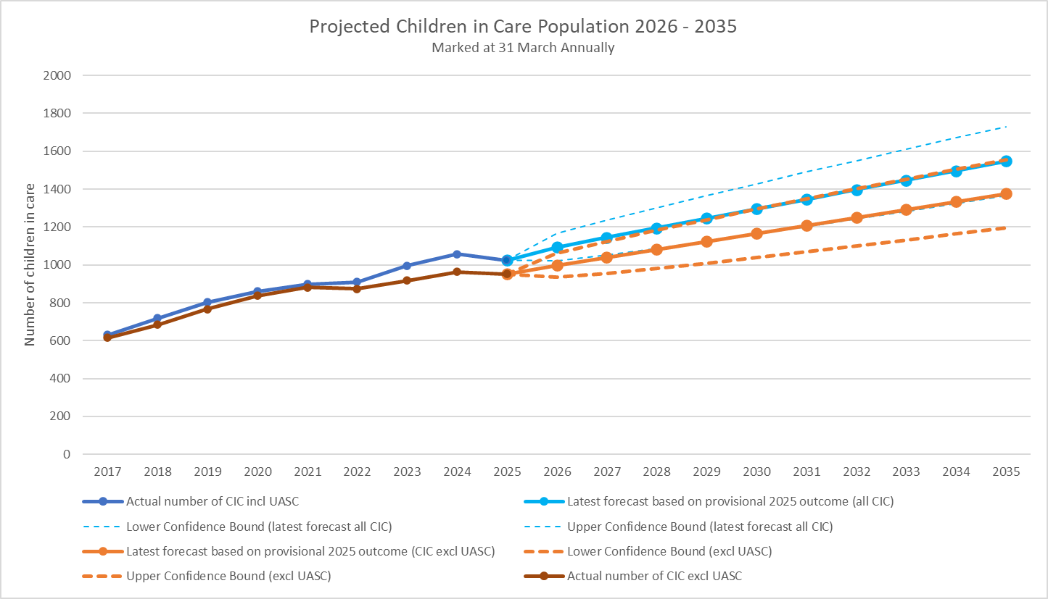

If we assume that similar activity around reunification and diversions from care continue through 2025-26 and that this has a similar impact on overall children in care numbers, then we can refine the base forecast of numbers of CIC excluding UASC for 2026 by applying the same % reduction (see table below).

Forecast v Actual Children in Care Numbers (children in care excluding UASC) | Lower Confidence Bound | Mid-Range Forecast Number of CIC | Upper Confidence Bound
End of March 2025 – 2024 forecast | 959 | 1011 | 1063
End of March 2025 – Actual (provisional outcome) | 951
Number difference from forecast | -8 | -60 | -112
% difference from forecast | -0.8% | -5.9% | -11.0%
End of March 2026 - 2025 forecast | 936 | 998 | 1061
Predicted number of CIC reduction applying same % reduction as 2005: | -7 | -59 | -117
Revised end of March 2026 forecast | 929 | 939 | 944

Projections on demand by Placement Type
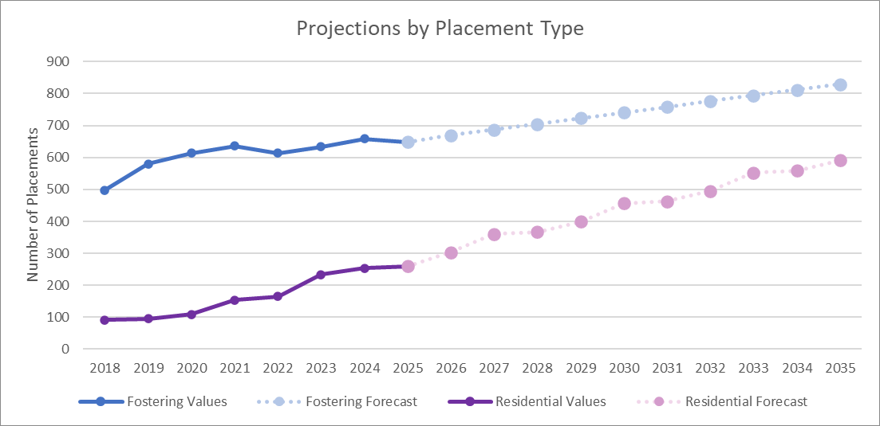
These forecasts are straight-line statistical predictions based on historic trajectory of numbers of children in care within these placement types at the end of March each year. They do not take account of placement sufficiency or changing needs of the children in care population. Upper and lower confidence bounds for each forecast are shown with are based on 95% statistical confidence levels. Based on historic trends, fostering and residential* placements are forecast to continue to increase significantly, with fostering placements expected to rise by approximately 28% between 2025 and 2035 and residential placements expected to rise by approximately 127% during the same period.
Data source: Internal forecast. Latest forecast includes provisional end of March 2025 outcomes.

*In 2024 the DfE replaced the placement type ‘secure units, children's homes and semi-independent living accommodation’ with the separate placement types of ‘secure homes and children's homes’ and ‘independent and semi-independent living arrangements/supported accommodation’.
Residential placements therefore includes ‘secure units, children's homes and semi-independent living accommodation’ for 2018 to 2023 and ‘secure homes and children's homes’ and ‘independent and semi-independent living arrangements/supported accommodation’ in 2024. Placement types ‘other residential settings’ and ‘residential schools’ are not included as numbers are suppressed.

Strategic Context & Plan

Governance
The 2025-2029 council plan includes the following strategic objective, led by children’s services:

“To achieve sufficiency of accommodation to ensure children are cared for in the right home at the right time”.

Work to achieve this objective sits under the Children in Care and Care Leavers Programme Board, which reports to the Children’s Change Board, and in turn to the Portfolio Direction Group.

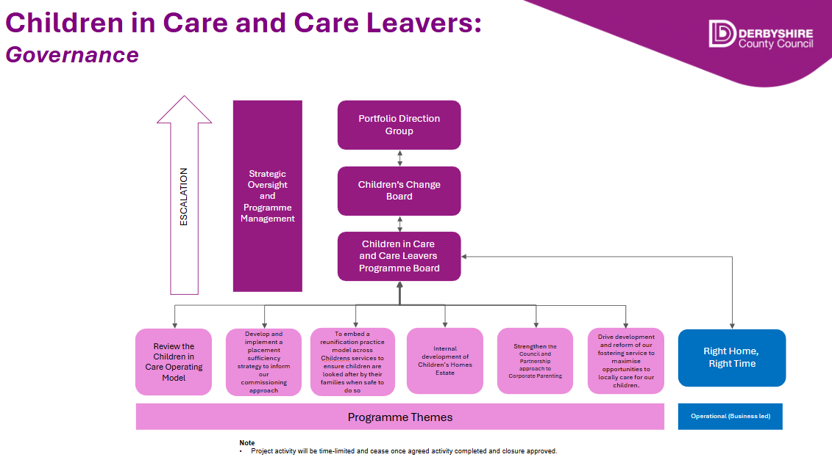

Seven workstreams report to the board:

- Review of the children in care operating model – to ensure our organisational structure for children in care work is optimised to support best outcomes
- Develop and implement a placement sufficiency strategy – to clearly articulate our needs assessment and SMART targets to ensure sufficiency of accommodation
- Embedding a reunification practice model – to ensure children in care can return home where it is safe and appropriate for them to do so
- Internal development of children’s homes – to increase capacity and ensure quality of our internal children’s home provision
- Strengthening the council approach to corporate parenting – to ensure the whole council is actively delivering high quality corporate parenting to children in care and care leavers
- Fostering service reform and development – to recruit and retain more foster carers and ensure they receive the best support possible
- Right Home, Right Time – to ensure our processes and use of data are as effective as possible and are supporting placement and commissioning decisions

Work to achieve the strategic objective of achieving sufficient accommodation is multifaceted, and the above workstreams address different aspects of a potential journey through care. There is no quick solution to this complicated and complex national issue, however, achieving this objective is crucial to securing long-term financial sustainability for the council and achieving best outcomes for children and young people.

Stakeholders and Dependencies
To deliver the right homes for children in care requires input from corporate parents across the council, and commitment to a shared strategic direction by senior leaders. The challenges faced in relation to the placements market are strategic risks for the council and are not solely the responsibility of children’s services. Those responsible for finance and property services will have key roles in supporting investment in placements and wider support. Project management support will be crucial in transformational change projects, and the use of effective performance data will be crucial throughout. Colleagues in human resources and learning and development are essential in supporting recruitment and retention, alongside workforce development.

Though the council retains its corporate parenting responsibility, partners across the county should be encouraged to recognize the challenges faced by children in care and care leavers as ‘corporate aunties and uncles’. District and borough council colleagues should be engaged in relation to housing, planning, and in relation to council tax exemptions. Health colleagues have a key role to play in ensuring the physical and emotional health needs of children in care and care leavers are met, with particular support needed for those with complex needs.

A role can also be played by the private and voluntary sector in conjunction with the commissioning team in ensuring that placements are offered which provide the right support, tailored to need. Partnerships between the sector and the department can also support the development of supported accommodation options for care leavers, alongside employment, skills and other opportunities to support the council’s corporate parenting duty. Proactive conversations should be taking place with the sector in relation to the care leaver covenant, and other ways in which children in care and care leavers can be supported. Elected members and senior leaders can play a key role in advocating for Derbyshire’s children with the sector.

National Policy Context
There are two significant national policy imperatives that will impact on children’s social care over the period of this strategy, though the exact implications are not currently known.

Local Government Reform
The English Devolution White Paper was published in December 2024, outlining government’s plans to spread devolution to more areas across the country – unlocking growth as set out in the government’s Plan for Change. It set out a plan to see full devolution in England and an ambitious programme of local government reorganisation. The current two-tier system will be replaced with strong unitary councils that can form the building blocks to support effective mayoral strategic authorities.

Derbyshire County Council elections will go ahead as planned in May 2025, whilst work with partners continues to draw up unitary arrangements for Derbyshire. Proposals will be submitted by November 2025, which will have broad ranging implications for strategic planning beyond 2026, in respect of both service and workforce planning.

Children’s Social Care Reform
In November 2024, the Department for Education (DfE) published a policy paper: ‘Keeping Children Safe, Helping Families Thrive’. The aim of this paper was to rebalance children’s social care by increasing early intervention, increasing care within families and fixing the broken care market. Initial guidance was published in March 2025, with progressive change to be implemented post April 2025, necessitating significant structural and practice reforms. The reforms should hopefully lead to a reduction in children in care in the long term, however the impact of changes at a local level will need close monitoring and considering when this strategy is reviewed.

Alignment with the Medium-Term Financial Strategy (MTFS)
The financial impact of projected placement demand will be reflected in the department and council MTFS to ensure financial planning and placement sufficiency strategy are aligned.

Achievements & Next Steps

Since the publication of the previous sufficiency statement there has been a significant amount of work undertaken to help us meet our sufficiency duty. For example:

- The new-build Spire Lodge home for children with disabilities will be completed in Q3 25/26, increasing to number of long-term beds for children in care
- Robin’s Nest opened in Q3 24/25, converting a short breaks home for children with disabilities to providing three long-term beds and rated ‘Good’ by Ofsted – plans are in place to increase this to a four-bed home
- The securing of £7.5m capital funding from DCC to develop 16 new internal beds over 5 years
- Improved management oversight of internal children’s homes’ financial and workforce operations
- Improved oversight of internal fostering financial and workforce operations
- Strong links with our peer local authorities to strengthen our fostering recruitment and retention packages
- Improved management oversight of foster home utilisation resulting in improved rates of utilisation of our carers
- Strong training and development package for our foster carers to ensure our children's individual needs are well met
- A clear structure developed for best outcomes for our children, focussing on good quality care and increasing the number of foster homes as we know most children will have better outcomes if they grow up in a family environment
- Increased number of fostering applications since 2022
- The Commissioning team continues to forge new partnerships with the external market and promote local sufficiency. Ofsted’s “Social care providers list for LA’s” identified 69 registered residential children’s homes and 31 registered supported accommodation providers in June 2024. By June 2025, this had increased to 78 and 99 respectively. Both therefore evidence an increase in sufficiency. it is important to consider that the supported accommodation exponential increase will mostly be a result of regulatory changes, but nonetheless, identifies increases in sufficiency of appropriate provision for our children in care.
- We are working in partnership with neighboring local authorities to identify areas of service need where joint commissioning can improve placement sufficiency, including Derbyshire leading on the re-procurement of the children in care framework in 2026
- The commissioning team are leading work on ensuring data integrity and systems, for example, working with the leaving care service to implement a new monitoring system and workflow.
- Engagement with a local provider who have responded to the market position statements has resulted in one child in a residential setting move to a foster family.
- Innovative approaches are being taken to support care leavers in their move on accommodation, including access to enhanced housing benefit, and working with a charity who have agreed to provide 3 x 2 bed properties to offer low level supported accommodation to care leavers
- Bespoke approaches are being taken with care leavers, such as carefully matching former separated children and young people who wanted to continue living together into houses of multiple occupancy

Previous sufficiency statements have not articulated clear targets or future plans, instead presenting the situation as it stood. This strategy is clearly articulating SMART targets to help us achieve our vision and meet our sufficiency duty. Having these targets will support in evaluation of the strategy and enable progress and impact to be monitored.

Actions to Increase Sufficiency

Derbyshire’s ‘placement mix’ includes 18% of children in residential provision. It is the overarching goal of this strategy to reduce this to 11% by 2030; a figure seen in a statistical neighbour rated ‘outstanding’. Achieving this goal should result in improved outcomes for children, and a reduction in spend of up to £10m per annum.

Aim | Action | Lead | Timescale
Reduce dependence on external residential | Grow internal residential provision by 22 beds | Head of Children’s Homes | 25/26 – 6 beds  26/27 – 4 beds  27/28 – 4 beds  28/29 – 8 beds
Reduce the use of agency staff utilizing private accommodation in an emergency | Develop 4 emergency ‘pods’ to support children in crisis with internal staff | Head of Children’s Homes | 25/26 – 2 beds  26/27 – 2 beds
Support effective transition to independence and maximise utilisation | Develop 2 Staying Close ‘pods’ to support transition to independence | Head of Children’s Homes | 25/26 – 1 bed  26/27 – 1 bed
Reduce the need for foster placements through strengthened Kinship and SGO support | Creation of an SGO support team | Head of Fostering | Q3 25/26
Reduce the need for foster placements through strengthened Kinship and SGO support | Providing specialist support for kinship carers | Head of Fostering | Q3 25/26
Reduce demand for residential placements | Strengthening our specialist package to prevent admissions to residential provision and support reintegration into foster care | Head of Fostering | Q3 25/26
Increase the number of foster care bed with specific targets in relation to recruitment including: Conversion target for enquires to applications 25%. The foster for east midlands conversion target for applications to approvals is 13% | Targeted recruitment activity with D2N2 utilising the DCC comms team and dedicated staff from the fostering service | Head of Fostering | Q3 25/26
Lead the re-procurement of the D2N2 Framework – due to commence on 1 April 2026 and ensure it supports local placement sufficiency. | Increase external providers on the D2N2 framework 2026 and reduce non-framework purchasing of placements. | Head of Commissioning | Q1 26/27  Q1 27/28  Q1 28/29
Ensure key relationships with providers remain, improve and promote sustainability of placements within the external provision offer | Increase block contract arrangements to increase residential and supported accommodation stability and local placement sufficiency. | Head of Commissioning | Q4 25/26  Q4 26/27
Improve local sufficiency within the external provision offer to ensure that it meets the needs of the local area and complements the internal provision offer. | Increase, improve and formalise contracting arrangements with external providers to increase sufficiency and opportunities for children in care to move from residential to foster care | Head of Commissioning | Q4 26/27  Q4 27/28
Care leavers

Appendix 1 – Cohort Data:

Children in Care Population: Total and proportional trends

- The children in care population is increasing.

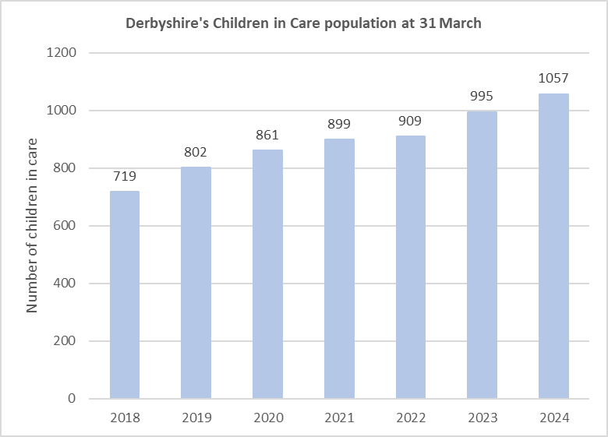

Data Source: DfE Children looked after in England including adoption: 2023 to 2024

- As of 31 March 2024, there were 1057 children in care in Derbyshire. This is an increase of 6.2% from the same point in 2023 (995). Nationally, a decrease of 0.3% was seen during the same period.

- Derbyshire has seen an increase of 32% over the past 5 years (802 CiC in 2019).

- Between 2019 and 2024, Derbyshire’s children in care population has risen an average of 6.7% per year. If the same increase is seen over the next 5 years, Derbyshire’s children in care population would be 1461 by 2029. However, many variables could influence this increase (or decrease) including changing rates of UASC admissions and strategies to prevent children coming into care.

- Derbyshire’s total child in care population per 10,000 of population is 68, which remains below the England average of 70 per 10,000,and 72 per 10,000 for Derbyshire’s statistical neighbours (March 2024).

- 43% of Derbyshire’s children in care are female, with males representing 57%.

- There has been a steady but substantial increase to the proportion of children in care as a proportion of the total child population. Children in care as a proportion of child population has risen by 0.16 percentage points from 2019 (0.52%) to 2024 (0.68%). Derbyshire’s proportion of children in care has consistently remained below the national average, however the difference between the two has increasingly narrowed.

Data Source: DfE Children looked after in England including adoption: 2023 to 2024

Children in Care by Age Group: As a proportion of total children in care population

- The largest age cohort of children in care at 31 March 2024 were 10 – 15-year-olds, with 38% (403) of all of children in care being within these ages , reflecting national trends.

Data Source: DfE Children looked after in England including adoption: 2023 to 2024

Children in Care by Ethnicity:
As a proportion of total children in care population

- Children in care in Derbyshire are mainly from white backgrounds (83%). The proportion of children in care from white backgrounds is lower than the 94% found in the overall 0-17 Derbyshire’s population (ONS 2021 Census).

- Conversely, the proportion of children from Asian (5%), Black (4%) and Mixed (5%) backgrounds are higher than that found in the overall Derbyshire population (2%, 1% and 3% respectively), indicating that children from non-white ethnic backgrounds in Derbyshire have a greater likelihood of entering care than white children.

Data Source: DfE Children looked after in England including adoption: 2023 to 2024 & 2021 Census

* Data excludes ethnic groups 'other ethnic group' & 'refused or information not yet available' for Derbyshire due to the suppression of low numbers.

Children in Care by Legal Status:

- Being on a full care order has consistently been the most common legal status of children in care in Derbyshire. Of the 31 March 2024 children in care population, 50% were subject to full care orders (51% at 31 March 2023).

- From 31 March 2022 to 31 March 2024, interim care orders as a proportion of admissions have decreased by 2 percentage points, however, they continue to represent a significant proportion of children in care (32% admissions during 2023/24 / 20% total children in care at 31 March 2024).

Data Source: DfE Children looked after in England including adoption: 2023 to 2024

*Data excludes categories 'detained for child protection' & 'youth justice legal statuses' as Derbyshire outcomes are 0% & national percentages are suppressed.

Children in Care by Category of Need:

- The main primary category of need of children who started to be looked after in 2023/24 was ‘abuse or neglect’ (50%), with the next most common category being ‘absent parenting’ (16%).
- Derbyshire’s profile of need broadly mirrors that seen nationally.

Data Source: DfE Children looked after in England including adoption: 2023 to 2024

* Data excludes category of ‘N7 Low income’ due to suppression of low percentages.

Unaccompanied Asylum-Seeking Children:
As a proportion of total children in care population

- UASC, as a proportion of the total children in care population in Derbyshire, has risen over the last 3 years from 2% at 31 March 2021 to 9% at 31 March 2024.

- In previous years, Derbyshire has consistently maintained a lower UASC population as a share of the total children in care population than the national average, however the gap has been narrowing steeply since 2021, and in 2024, the proportion of UASC children in care in Derbyshire (9%) was the same as that seen nationally (9%).

Data Source: DfE Children looked after in England including adoption: 2023 to 2024

- Derbyshire are part of the National Transfer Scheme (NTS) for UASC and have been actively participating in supporting UASC to move from other LA’s that have a high percentage of UASC in their care. However, over the last couple of years, asylum hotels have opened either in the county or on its borders, this has caused an increase in the number of UASC coming into the care of the local authority.

Children in Care with Special Educational Needs and Disabilities:
As a proportion of total children in care population

- Children with special education needs or disabilities (SEND) represented 60.3% of children in care that had been looked after for 12 months as at 31 March 2023, of which:
  - 26.6% had SEN support.
  - 33.6%. was made up of those who qualified for an education, health and care plan (EHCP).
- The most common primary type of need for children in care with SEN was social, emotional and mental health needs (50.8%).
- Proportions are broadly in line with those seen nationally.

Data Source: DfE Outcomes for children in need, including children looked after by LAs in England (reporting year 2023)
* Available published data is for CiC with SEN relates to those who have been in care for 12 months or longer as at 31st March 2023 (published April 2024). The next published data will be released in April 2025.

Children in Care’s Strengths and Difficulties:
As a proportion of total children in care population

A SDQ score of 13 or below is normal; between 14-16 is borderline; and 17 and above is a cause of concern.

- The average SDQ score of children in care in Derbyshire is consistently higher than the average seen nationally.

- For the 12 months to 31 March 2024, 52% of children in care in Derbyshire had a score of 17 and above (cause for concern) compared to 41% nationally, 15% had a score of 14-16 (borderline) compared to 13% nationally and 34% had a score of 13 or below (normal) compared to 46% nationally.

- Positively, a higher percentage of children in care in Derbyshire (89%) had an SDQ completed in 2023 than seen nationally (77%).

Data Source: DfE Children looked after in England including adoption: 2023 to 2024

Reasons for and Duration of Child Protection Plans:

- Between the 2021/22 and 2023/24 financial years, increases in reasons for a child protection plan (CPP) were seen in Derbyshire for sexual abuse (34.5 percentage increase), emotional abuse (16.1 percentage increase) and neglect (2.1 percentage increase). Nationally, only neglect saw an increase during the same time period (2.2%).

Data Source: DfE Children in need: 2023 to 2024

- Between the 2021/22 and 2023/24 financial years, increases in duration of child protection plans (CPP) in Derbyshire were seen for the 3 months or less category (40.2 percentage increase compared to a 7.5 percentage decrease nationally) and in the 2 years or more category (7.7 percentage increase compared to a 1.7 percentage increase nationally).

Data Source: DfE Children in need: 2023 to 2024

Care Leavers:
As a proportion of total population of care leavers

- There were 169 care leavers (aged 17-18) and 367 care leavers (aged 19 – 21) as of 31 March 2024.

- 98% of care leavers aged 17 to 18 were living in suitable accommodation compared to 91% nationally, whilst 97% of care leavers aged 19 to 21 were in suitable accommodation, compared to 88% nationally.

Data Source: DfE Children looked after in England including adoption: 2023 to 2024
* Data excludes categories ‘not suitable accommodation’ and ‘not known’ for Derbyshire due to the suppression of low numbers.

Data Source: DfE Children looked after in England including adoption: 2023 to 2024

- 78% of Derbyshire care leavers aged 17 to 18 are in Employment, Education or Training (compared to 64% nationally). This figure reduces to 66% for Derbyshire care leavers aged 19 to 21 (compared to 54% nationally).

Data Source: DfE Children looked after in England including adoption: 2023 to 2024

- Derbyshire Leaving Care Service continue to work with our commissioned providers and the 8 district and borough councils to ensure there are sufficient homes for care experienced young people to transition to as they reach adulthood. Whilst we have excellent links and working relationships, we wish to gain agreement for a consistent banding for all care experienced young people.
- Currently (11 July 2025), this is a real challenge with 72% of a supported accommodation block contract arrangement being occupied by over 18s and voids therefore only able to supply the remaining 28% to 16–18-year-old CiC.

Admissions into Care by Age Group

- Across all age groups, admissions in Derbyshire have increased by 29.3%, compared to a 4.0% increase across England (2019 – 2024).

- Derbyshire’s children in care admissions are growing fastest amongst young people aged 16 years and over - admissions increasing by 107% between 2019 (57 admissions) and 2024 (118 admissions).

- Between 2019 and 2024, children admitted aged 10 and over amounted to an 85.3% increase compared to a decrease of 2.5% amongst children aged under 10.

Data Source: DfE Children looked after in England including adoption: 2023 to 2024

Admissions into Care by Legal Status

Complexity of need is also a driver for placement demand.
- Between March 2019 and March 2024, interim care orders (ICOs) continue to represent a significant proportion of admissions, with a 5.4% increase of ICOs as a proportion of all admissions (147 admissions in 2019, 155 admissions in 2024). These are used where there are serious safeguarding concerns but the long-term plan is still being formed.

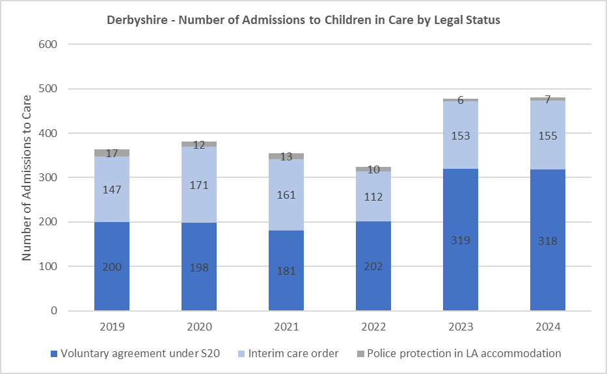
Data Source: DfE Children looked after in England including adoption: 2023 to 2024
* Graph does not show categories where low numbers are suppressed.
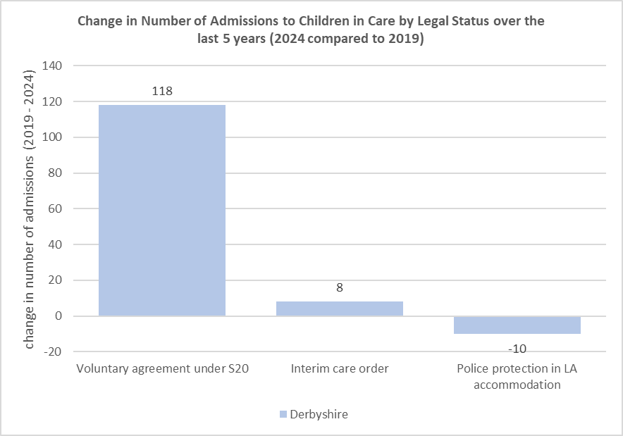

- A greater proportional increase was seen where children have been placed under Section 20 - Voluntary Care Entry, with 200 admissions in 2019 and 318 admissions in 2024. This is often used for family breakdowns, parental ill-health or temporary respite.

- The only legal status to decrease significantly was children and young people in police protection but placed in LA accommodation, which decreased 50.4 percentage points more in Derbyshire (58.8% decrease) than across England (8.4% decrease).

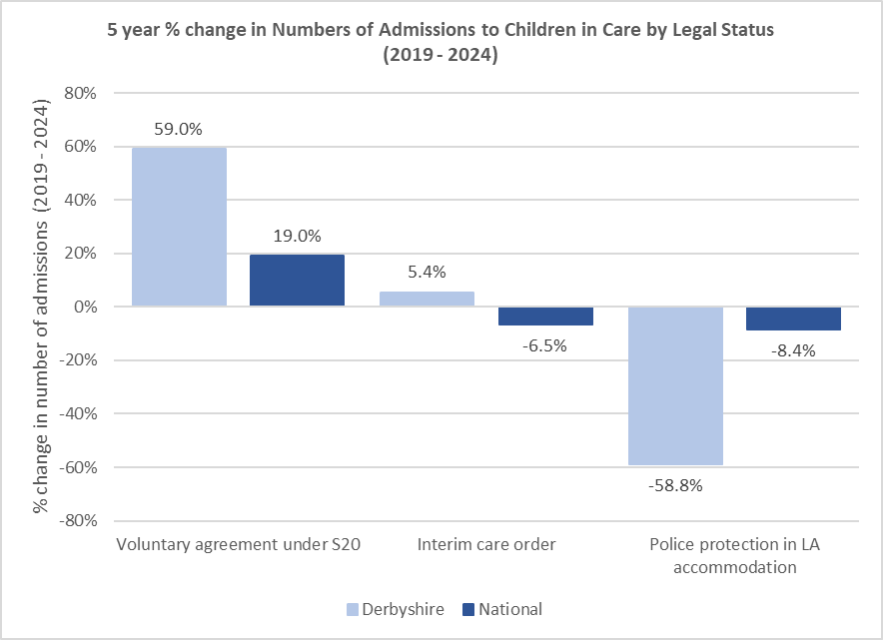
Data Source: DfE Children looked after in England including adoption: 2023 to 2024
* Graph does not show categories where low numbers are suppressed.

Admissions into Care by Category of Need

- Between March 2020 and 2024, admissions due to ‘absent parenting’ increased by 276% (21 admissions in 2020, 79 admissions in 2024), admissions due to ‘child’s disability’ increased by 178% (9 admissions in 2020, 25 admissions in 2024), admissions due to ‘parental illness or disability’ increased by 91% (22 admissions in 2020, 42 admissions in 2024) and ‘family in acute stress’ admissions increased by 24% (41 admissions in 2020, 51 admissions in 2024). There was also a marginal increase in admissions due to ‘socially unacceptable behaviour’ (data suppressed in 2020, 9 admissions in 2024).
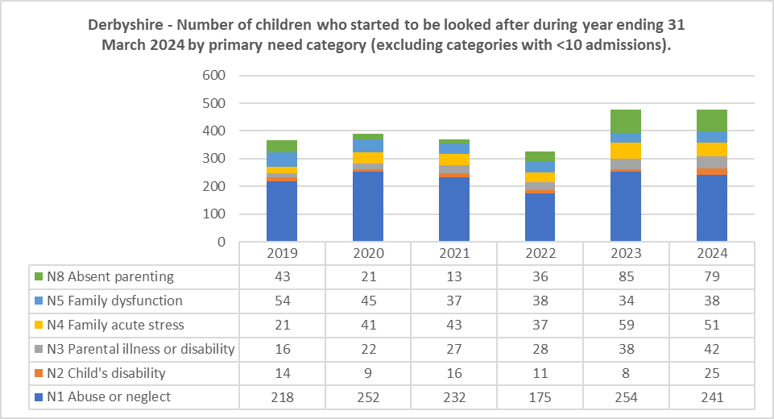

- Conversely, admissions due to ‘family dysfunction’ decreased by 16% (45 admissions in 2020, 38 admissions in 2024) as did admissions due to ‘abuse or neglect’ (4% decrease – 252 admissions in 2020, 241 admissions in 2024).

- There were no admissions due to ‘low income’ in 2024 (data was suppressed in 2020), however, it is likely it is a contributory factor to other categories of need

Data Source: DfE Children looked after in England including adoption: 2023 to 2024

Admissions of Unaccompanied Asylum-Seeking Children

The proportion of admissions to care that are UASC has increased considerably since 2021, and though the rate of increase is similar to the national picture, actual proportions in Derbyshire have been consistently lower than those seen nationally (16% of admissions in Derbyshire in 2024 compared to 22% of admissions nationally).

The percentage point gap between admissions in Derbyshire compared to UASC admissions nationally increased from 5 percentage points in 2023 to 6 percentage points in 2024.

Data Source: DfE Children looked after in England including adoption: 2023 to 2024

Needs Assessment: Placements

Children in Care by Type of Placements:
As a proportion of total Children in Care Population

- The majority of Children in Care in Derbyshire are in a foster care placement (659 children - 62% as of 31 March 2024).

- This is slightly lower than the 67% seen nationally.

- The next most common type of placement is ‘secure homes and children’s homes’, which represents 166 children (16%).

Data Source: DfE Children looked after in England including adoption: 2023 to 2024
*Placement types ‘other residential settings’ & ‘residential schools’ have been suppressed due to low numbers.

Children in Care by Placement Provider:
As a proportion of total Children in Care Population

- Derbyshire County Council provides 40% of all CiC placements compared to 43% nationally.

- Conversely, private provision constitutes 41% of all placements in Derbyshire compared to 37% nationally.

Data Source: DfE Children looked after in England including adoption: 2023 to 2024
*Place providers ‘other LA provision’ & ‘other public provision (e.g. by a PCT etc)’ have been suppressed due to low numbers.

Fostering and Residential Placements by Provider Type:

- 36.7% of all placements are Derbyshire County Council owned foster provision. 25.6% all of placements are agency foster provision. 3.2% of all placements are Derbyshire County Council owned residential provision whilst 12.3% all of placements are agency residential provision.

Children in care by placement provider (as a share of the total CiC population) as at 31 March 2024

Data Source: DfE Children looked after in England including adoption: 2023 to 2024 & internal monitoring

Length and Stability of Placements:
As a proportion of total Children in Care Population

- The percentage of children being looked after for at least 12 months increased by 2 percentage points between 2023 (62%) and 2024 (64%) but remains below the national average (71%).

- Decreasing by 3 percentage points to 9% in 2024, the percentage of Children in Care with three or more placements during the year was below the national average (10%).
- There was a 3 percentage point decrease between 2023 (60%) and 2024 (57%) in the number of children who had been living in the same placement for at least 2 years (for children that have been in care continuously for at least 2½ years). Outcomes remain below the national average which was 68% in 2024.

Stability of Placements for Children Looked After  As at 31 March | 2022 | 2023 | 2024
Children looked after for at least 12 months | 71%  (National: 71%) | 62%  (National: 70%) | 64%  (National: 71%)
Children looked after with three or more placements during the year | 12%  (National: 10%) | 12%  (National: 10%) | 9%  (National: 10%)
Children looked after continuously for at least 2.5 years aged under 16 who were living in the same placement for at least 2 years | 67%  (National: 71%) | 60%  (National: 69%) | 57%  (National: 68%)
Data Source: DfE Children looked after in England including adoption: 2023 to 2024

Location of Placements:
As a proportion of total Children in Care Population
- 61% of Children in Care were placed within 20 miles of their home at 31 March 2024, a decrease from 62% at 31 March 2023 as well as being below the national average (69%).
- When comparing the above data to Nottinghamshire as a neighbouring shire authority, the trend is similar. Of placements made via the D2N2 framework in 2024-25, 63% of residential placements and 44% of fostering placements for Derbyshire children were within D2N2 boundaries, and 62% of residential placements and 37% of fostering placements for Nottinghamshire children.
- Whilst every effort is made to place children close to their homes, 30% of children were placed more than 20 miles from their homes (22% nationally).

Data Source: DfE Children looked after in England including adoption: 2023 to 2024

- 52% of Children in Care were placed within Derbyshire at 31 March 2024, a small increase from 51% the previous year. Nationally, 55% of Children in Care were placed within their home local authority boundary (56% at 31 March 2023).

Data Source: DfE Children looked after in England including adoption: 2023 to 2024

Quality of Placements:
At 4 November 2024, the majority of providers of Children in Care residential placements in Derbyshire had been judged to be good or outstanding at their latest Ofsted inspection. All eleven DCC children’s homes were rated good or outstanding as of March 2025. The agency placements that require improvement are regularly reviewed and alternative placements have been identified when necessary.

Quality of Placements based on latest Ofsted Inspections | Outstanding | Good | Requires Improvement  to be good | Inadequate | Not yet inspected
Latest overall effectiveness
Children’s homes – local authority | 7 | 4 | 0 | 0 | 0
Children’s homes - private | 15 | 37 | 4 | 0 | 6
Residential special schools – local authority | 1 | 0 | 0 | 0 | 0
Residential special schools – academy | 0 | 1 | 0 | 0 | 0
Residential family centre – private | 0 | 1 | 0 | 0 | 0
Independent fostering agency | 0 | 2 | 0 | 0 | 0

Data Source: DfE Social care providers list for LAs – 04 November 2024. Includes all active care providers.

Appendix 2 – Market Position Statements:

Appendix 3 – Methodology

Taken from Children in Care Dashboard: Children In Care Placements - Power BI on 28/3/25

Rounded to the nearest whole number

Mix:
18 Adoption 2%
300 Agency fostering 29%
140 Agency residential 14%
345 DCC fostering 34%
39 DCC residential 4%
3 Mother baby placement 0%
50 Other 5%
80 Supported accommodation 8%
43 with parents 4%
2 -YOI 0%

1020 CiC

Residential mix = 18%
Fostering mix = 63%
Other mix = 19%

Based on the provisional number of children in care at the end of March 2025 of 1024, 11% of the placement mix would be to aim for a maximum of 113 children in residential. As at the end of March 2025, this are 176 children in residential placements (17%).

The target is to reduce the residential mix from 17% in 2025 to 11% by 2030/31,

Target Date | Target residential mix
Beginning of 26/27 | 16%
Beginning of 27/28 | 15%
Beginning of 28/29 | 14%
Beginning of 29/30 | 13%
Beginning of 30/31 | 11%

The following table provides an indication of what this may mean for placements in 2026/27 based on the children in care forecast which assumes the same % reduction in CIC as seen during 2025 through reunification, diversion from care and lower UASC numbers.

Forecast Children in Care Numbers (all children in care) | Lower Confidence Bound | Mid-Range Forecast Number of CIC | Upper Confidence Bound
Revised end of March 2026 forecast applying same % reduction as 2025: | 984 | 1008 | 1028
Max number of children in residential placements (residential mix = 16%) | 157 | 161 | 164

Relevant/Former Relevant – previously looked after for at least 13 weeks after their 14th birthday including some time after their 16th birthday
Former Relevant – previously looked after for at least 13 weeks after their 14th birthday including some time after their 16th birthday

