**PLACEMENT WITH PARENTS PROCEDURE CHECKLIST**

**PLACEMENT OF CHILDREN WITH PARENTS REGULATIONS (1989) AND AMENDMENTS CONTAINED IN THE CARE PLANNING REGULATIONS (2010)**

**Please complete the following pro-forma when requesting agreement for the planned placement of a child(ren) / young person(s)**

|  |  |
| --- | --- |
| **Child name** |  |
| **Age and date of birth** |  |
| **Photo** |  |
| **Parent(s) name who we are proposing placing with, date of birth, address and ethnic origin** |  |
| **How long has the child been in care** |  |
| **Age at which the child became looked after** |  |
| **Current legal status** |  |
| **How many placements over what period of time** |  |
| **Latest single assessment and did this consider reunification. If not, what other assessments have?** |  |
| **FGC to consider family / friends support** |  |

|  |
| --- |
| **Introduction and purpose of report** |
| *Make reference to the requirements of schedule 1 of the placement with parents regulations* |

|  |
| --- |
| **Summary of the assessment process** |
| *Meetings held*  *Family time observed – formal/informal*  *LAC reviews that have considered reunification*  *PPMs held where reunification has been explored*  *Include detail of any other agency risk assessment reviewed/considered (i.e. Probation)* |

|  |
| --- |
| **Summary of significant events, and/or reason for entry to care/accommodation. Including reference to parental alcohol/drug misuse, domestic violence, and mental ill health. View on who was responsible for abuse or neglect** |
|  |

|  |
| --- |
| **Summary of any significant events since entry to care/accommodation** |
| *Include any previous attempts at reunification and reasons this did not work* |

|  |
| --- |
| **Family composition before entry to care/accommodation and currently, commenting on child’s attachments. Are there any changes to family composition and are these likely to be positive or negative for the child?** |
| *Also attach a genogram* |

|  |
| --- |
| **Accommodation details** |
| *Home safety*  *Tenancy type*  *History of maintaining tenancy* |

|  |
| --- |
| **Heritage pledge and life story work** |
| *Life story work undertaken to date with the child.*  *Any cultural issues that may have a negative impact on the child’s well-being if returned home, for example, instances where parents may misuse culture to harm the child.* |

|  |  |  |
| --- | --- | --- |
| **Agency checks for all adults in the home or regular visitors** | | |
| **Agency** | **Detail** | **Date obtained** |
| **Derby CSC** |  |  |
| **Other LA** |  |  |
| **CAFCASS** |  |  |
| **School(s) including for siblings** |  |  |
| **Health** |  |  |
| **Housing** |  |  |
| **Youth Justice Service for all persons over 10 years old** |  |  |
| **Probation** |  |  |
| **Police including DBS for all household members over 16** |  |  |

|  |  |
| --- | --- |
| **Risk factors identified for each individual child on entry to care/accommodation. Highlight any that should be given extra weight** | **Protective factors identified for each individual child on entry to care/accommodation. Highlight any that should be given extra weight** |
|  |  |

|  |  |
| --- | --- |
| **Risk factors identified for each individual child when considering reunification. Including particular vulnerabilities of the child. Highlight any that should be given extra weight** | **Protective factors identified for each individual child when considering reunification. Including any particular strengths of the child. Highlight any that should be given extra weight** |
|  |  |

|  |
| --- |
| **Evidence of parental capacity to change and views on capacity to change in time to meet child’s needs** |
| *Attendance, attitude and motivation in relation to taking part in the assessment*  *Whether the problems that initially resulted in the child coming into care/ accommodation are acknowledged and are being addressed*  *Whether the parents/carers acknowledge and are ready and able to address any remaining or new risk factors*  *Whether they are likely to be able to make the necessary changes within the child’s timescale taking account of the child’s age and developmental needs as well as any additional needs for the parent*  *Have there been any parental changes/ if so, what are these, how long have they been sustained and what impact are these likely to have for child/ren being reunified* |

|  |
| --- |
| **Child’s views and motivation in relation to reunification (and views on any previous failed reunifications)** |
| *The child/young person’s level of attachment to the birth parent/s.*  *Regularity and quality of contact between birth parents and child/young person whilst Looked After.*  *The child/young person’s relationship with and attachment to the current caregivers.*  *The child/young person’s understanding of why they are Looked After.*  *The child/young person’s awareness of changes that have taken place in the birth family whilst in care/accommodation.*  *The child/young person’s understanding of what life would be like should they return home.*  *Which relationships are important to the child/young person including sibling relationships.*  *Child’s view of parent’s new partner (if applicable)*  *What does the child/young person feel needs to change in order for them to return home.*  *The child/young person’s view of whether they should return home*  *The nature and severity of the child’s emotional and/or behavioural needs*  *Children who have been carers for their parents, before becoming looked after. The worker should understand the impact on the child of returning to this dynamic with their parent/s.* |

|  |  |
| --- | --- |
| **View/feelings of significant adults, including current caregivers and schools, about the child/young person returning to the care of their birth parent/s.** | |
| **Parents’ views and motivation in relation to reunification** |  |
| **Other person(s) with PR** |  |
| **Current carer(s)** |  |
| **Other involved LA** |  |
| **Other LA departments including Youth Justice** |  |
| **Any family members involved** |  |
| **IRO / CPM** |  |
| **Guardian** |  |
| **School(s)** |  |
| **Health** |  |
| **Probation** |  |

|  |
| --- |
| **Social worker analysis of risk and protective factors** |
| *Ensure that sufficient analysis is given where substance misuse was a factor (see messages from research)* |

|  |
| --- |
| **Summary of support services in place for the reunification and work everyone will be undertaking. Please also summarise the family led plan from Family Group Conference.**  NB: Research shows that when reunifications happen without enough time to support parents to change, the children are more likely to re-experience abuse and neglect, and to come back into care. |
| *Also be clear about the multi-agency contributions to supporting the family* |

|  |
| --- |
| **Contingency plan** |
|  |

|  |
| --- |
| **Social workers recommendation and rationale** |
|  |

**Please attach genogram, chronology, PWP agreement, most recent assessment, voice of the child tool, and proposed transition plan.**

|  |  |  |  |
| --- | --- | --- | --- |
| **Endorsed by** | | | |
| **Role** | **Signature** | **Comments** | **Date** |
| **Social worker** |  |  |  |
| **Team Manager** |  |  |  |
| **Deputy Head of Service** |  |  |  |
| **Head of Service** |  |  |  |

**APPENDIX 1 – taken from the NSPCC reunification framework**

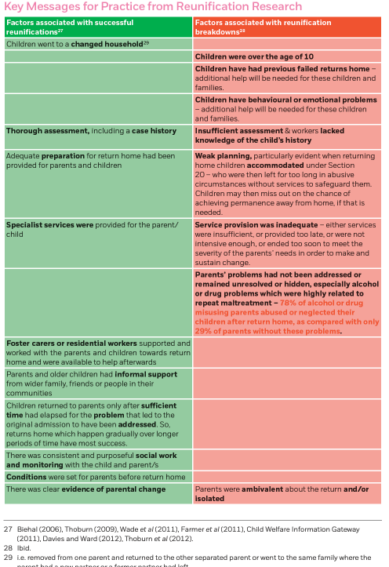

**APPENDIX 2 – Other key messages from research – taken from the NSPCC reunification toolkit**

* Returning home to a parent or relative is the most common outcome for children in care/accommodation.
  + 34% of all children who ceased to be looked after in 2013–14 returned home. However, data from the Department for Education shows that of the 10,270 children who returned home from care in England in 2006–07, 30% had re-entered care in the five years to March 2012. So for almost a third of the children who had returned home, the arrangement had not lasted.
* Research studies have shown high rates of further maltreatment following a child’s return home, with many returns breaking down and children subsequently being taken back into care or becoming accommodated again.
  + Almost half (47%) of the returns home in Farmer et al’s study (2011) broke down within two years and a third of the children in this study experienced two or more failed returns.
* Multiple failed returns are strongly associated with poor outcomes for children and also involve particularly high costs.
  + Reunification breakdown is not the only indicator of a poor quality return home. In the study just cited, almost half (46%) of the children were abused or neglected in the two years after they returned home and Sinclair et al (2005) had similar findings.
  + Linked to this, in Wade et al’s (2011) study, six months after the decision for reunification had been made, this was judged to have been appropriate for less than half the children (47%).
  + Thoburn and colleagues (2012, p12) in their review of recent reunification research from the UK, US and Australia, concluded: ‘There is a consistent finding that a high proportion of maltreated children who return home will return to care and others will remain at home but continue to be exposed to poor parenting, neglect and/or abuse’.
* Research highlights the need for robust assessments to decide whether or not reunification would be in a child’s best interests and proactive case management and support services for those who do return.
* If Children’s Services are involved during pregnancy and parents have not made substantial changes within 6 months of a baby’s birth, real change is unlikely to occur.
* Children who experienced previous failed returns home were more likely to experience a subsequent return breakdown, and these children experienced the worst outcomes.
* Attempts to support parents sometimes continue for too long – in 38% of cases professionals in one study gave parents ‘too many chances’ to show they could care for their children.
* Looked after children who have experienced chronic neglect or emotional abuse do significantly worse than others if returned home.
* Alcohol and/or drug problems are highly related to repeat maltreatment. In one study, 78% of alcohol or drug misusing parents abused or neglected their children after return home, as compared with only 29% of parents without these problems. Wade et al (2011) found that 81% of children reunified with alcohol or drug misusing parents experienced a return breakdown.
* There is evidence to suggest that parent courses and training programmes, home-based interventions and supportive peer networks can potentially support adults with learning disabilities to parent adequately.
  + If the parent also has mental health problems alongside a learning disability, this represents a significant risk factor for future harm.
  + There are mixed research findings about the ability of parents with learning disabilities to retain parenting skills and adapt to new situations.
  + All parents with learning disabilities are likely to need ongoing support to adapt to new challenges as their children grow.

**APPENDIX 3 – taken from the NSPCC reunification toolkit**

