Notification of a Child Missing Education
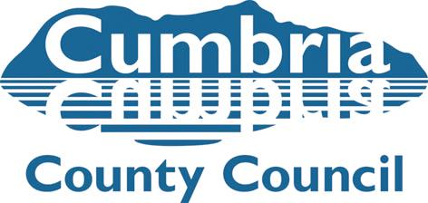
CME 1

This form should be completed for any child living in Cumbria who is apparently of school age but does not appear to be receiving an education. Please complete as much of the form as possible. For further information feel free to contact a member of the Children Missing Education (CME) team below.

Name of referrer: |  | Date:
Organisation (if applicable): |  | Phone no:
Email address:

Name(s) of child(ren) | DOB | Year group | Also known as | M/F | Special education needs? Y/N | Looked After Child? Y/N

Name of parent / carer: |  | Relationship to child:
Contact no: |  | Relationship to child:
Home address: (please provide as much information as possible)
School last attended: (please provide as much information as possible)
Other professionals working with child: (if known)
Any safety factors to be acknowledged when visiting the family:
Any other information: (including any previous safeguarding concerns about family)

Completed forms to be returned to the CME team:  Allerdale and Copeland:  janice.ogilvie@cumbria.gov.uk  01946 505558  Carlisle Area:  isobel.graham@cumbria.gov.uk  01228 221430  Furness Area:  margaret.williams@cumbria.gov.uk  01229 407418  Eden and South Lakeland:  laura.fitzgerald-park@cumbria.gov.uk  01539 713457 | CME Officer checks only: (date checked)  ICS……  One…  Health………………………………………...  Housing………………………………………  Police…………………………………………  Other (e.g Inspira)……………………..  ………………………………………………..  Home visit…………………………………...  CIC form completed ………………………..

Missing Pupil Referral Checks

Missing pupils – pupils on school roll who have left (or failed to attend) and destination is unknown

To be completed prior to referral to CME Officer

Telephone call to parent/carer (date and outcome)

Home visit (date and outcome)

Enquiries with neighbours (date and outcome)

Any other relevant information

Please complete CME1 details overleaf

