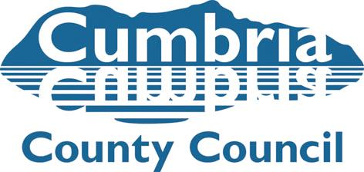
Team Manager Submission for Child to Adoption Panel Matching

Name of Child/ren and Adopters
Name of Social Worker and Team Manager

Date of Adoption Panel

The following paperwork is required for a match to be presented to Panel.

- SHOBPA – Agency Decision for child (Panel administrator)
- Matching Meeting Minutes and Pre-Panel minutes (Family Finder)
- PAR (Family Finder)
- Minutes and Agency Decision for Approval (Family Finder)
- Review report or addendum to PAR if applicable (Family Finder)
- Team Managers’ submission forms x 2 – Children’s Adoption Team and Adoption Agency (Child’s SW)
- Medical Adviser’s report following consultation with prospective adopters (Child’s SW)
- CPR (Child’s SW)
- Placement Report (Child’s SW)
- APR – Adopter/s’ response (Child’s SW)
- Support Plan (Child’s SW)
- Any Name Change Request form (Child’s SW)
- Any early ADM request form (Child’s SW)

I confirm I have read all matching documents, and quality assured the Social Work reports above for Panel in respect of the above child/ren:

I confirm the timescales for the recommended match have been met (explain if not met):

The reason for my decision is based on the following analysis and evidence:

The strengths of the Match are:

The vulnerabilities of the Match are:

The supports identified are:

Name: Date:

Signature:

