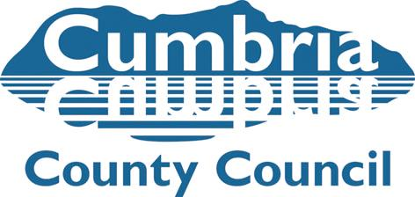

Team Manager Submission for Child to Adoption Panel Matching

|  |  |
| --- | --- |
| Name of Child/ren and Adopters |  |
| Name of Social Worker and Team Manager |  |
| Date of Adoption Panel |  |

**The following paperwork is required for a match to be presented to Panel.**

* SHOBPA – Agency Decision for child **(Panel administrator)**
* Matching Meeting Minutes and Pre-Panel minutes **(Family Finder)**
* PAR **(Family Finder)**
* Minutes and Agency Decision for Approval **(Family Finder)**
* Review report or addendum to PAR if applicable **(Family Finder)**
* Team Managers’ submission forms x 2 – Children’s Adoption Team and Adoption Agency **(Child’s SW)**
* Medical Adviser’s report following consultation with prospective adopters **(Child’s SW)**
* CPR **(Child’s SW)**
* Placement Report **(Child’s SW)**
* APR – Adopter/s’ response **(Child’s SW)**
* Support Plan **(Child’s SW)**
* Any Name Change Request form(**Child’s SW**)
* Any early ADM request form (**Child’s SW**)

**I confirm I have read all matching documents, and quality assured the Social Work reports above for Panel in respect of the above child/ren:**

**I confirm the timescales for the recommended match have been met (explain if not met):**

|  |
| --- |
| **The reason for my decision is based on the following analysis and evidence:**  **The strengths of the Match are:**  **The vulnerabilities of the Match are:**  **The supports identified are:** |

Name: Date:

Signature: