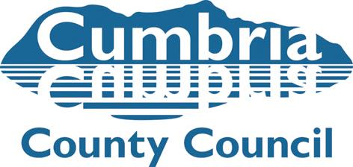

Team Manager Submission Adopter/s to Adoption Panel Matching

Name of Adopter/s and Child/ren

Name of Social Worker and Team Manager

Date of Adoption Panel

I confirm I have read the Social Work reports for Panel in respect of the above adopters:

I confirm the timescales for the recommended match have been met (explain if not met):

The reason for my decision is based on the following analysis and evidence:

The strengths of the match are:

The vulnerabilities of the match are:

The supports identified are:

Name: Date:

Signature:

